***********************Draft***********************
Multi (5) QEMU Ultibo Bare Metal
JPEG2000
with
Remote Shell
07/30/21
***********************Draft***********************

Note:
https://ultibo.org/forum/viewtopic.php?f=13&t=1303&p=11632#p11632

By Ultibo Wed Jul 21, 2021 9:01 pm

I suspect the version of QEMU that you have on the RPI3B+ is later than the one on the RPi4, try doing qemu-system-arm -version on each one.
We recently discovered that the Ultibo SD card driver was not compatible with the latest versions of QEMU, a fix for this is included in the release from today (Ultibo core 2.1.079) so if you update your RTL to the latest either using the RTL Builder or by rerunning the ultiboinstaller script then it should work now.
https://en.m.wikipedia.org/wiki/QEMU. On the pi400-1 I ran
./ultiboinstaller.sh on pi400-1.

QEMU is a hosted virtual machine monitor: it emulates the machine's processor through dynamic binary translation and provides a set of different hardware and device models for the machine, enabling it to run a variety of guest operating systems. It also can be used with Kernel-based Virtual Machine (KVM) to run virtual machines at near-native speed (by taking advantage of hardware extensions such as Intel VT-x). QEMU can also do emulation for user-level processes, allowing applications compiled for one architecture to run on another.[3]

Note : Additional software is needed to run QEMU “sudo apt-get install qemu-system-arm”.
The following programs are added.

/usr/bin/qemu-img /usr/bin/qemu-nbd /usr/bin/qemu-system-aarch64
/usr/bin/qemu-io /usr/bin/qemu-pr-helper /usr/bin/qemu-system-arm

The command line for starting Lazarus IDE (Ultibo Edition) “~/ultibo/core/lazarus.sh”

Testing on pi400-1 with 40in Sony TV.

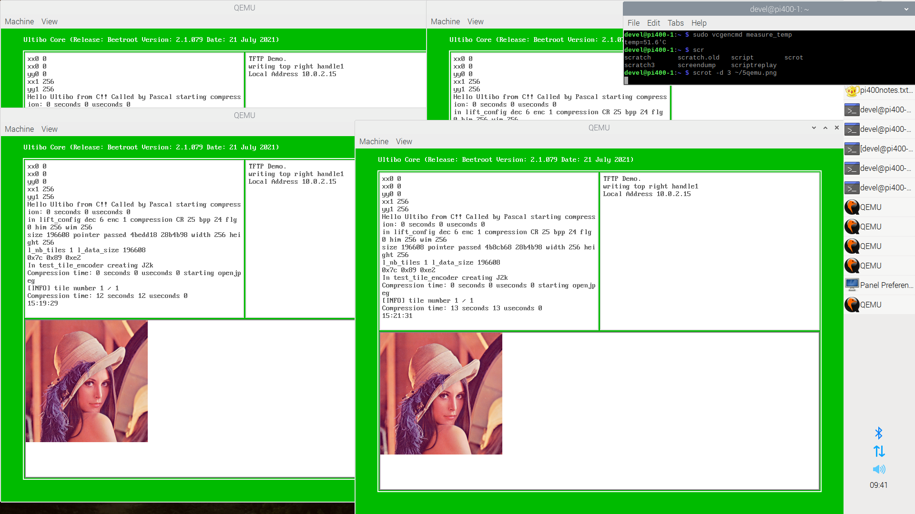
Step1 to create a kernel.bin

git clone git@github.com:develone/Ultibo_Projects.git

devel@pi400-1:~/Ultibo_Projects/jpeg2000/src $ ./compile_ultibo.sh
The word count here should be 22
the word count in /home/pi/jpeg-2000-test/bare-metal/openjp
when ./libbuild.sh is executed should be 22
22 22 182 libopenjp2_obj.txt

devel@pi400-1:~/Ultibo_Projects/jpeg2000/QEMU $ ./libbuild.sh
dwtlift.c: In function 'decompress':
dwtlift.c:658:3: warning: implicit declaration of function 'octave_write_byte'; did you mean 'opj_write_tile'? [-Wimplicit-function-declaration]
octave_write_byte(r_decompress_fn,r_decompress,da_x1*da_y1);
^~~~~~~~~~~~~~~~~
opj_write_tile
when ./libbuild.sh is executed should be 23
23 23 192 libdwtlift_obj.txt

A greater detailed on the above steps is found in QEMU-JPEG2000.odt.

Project/Open Project

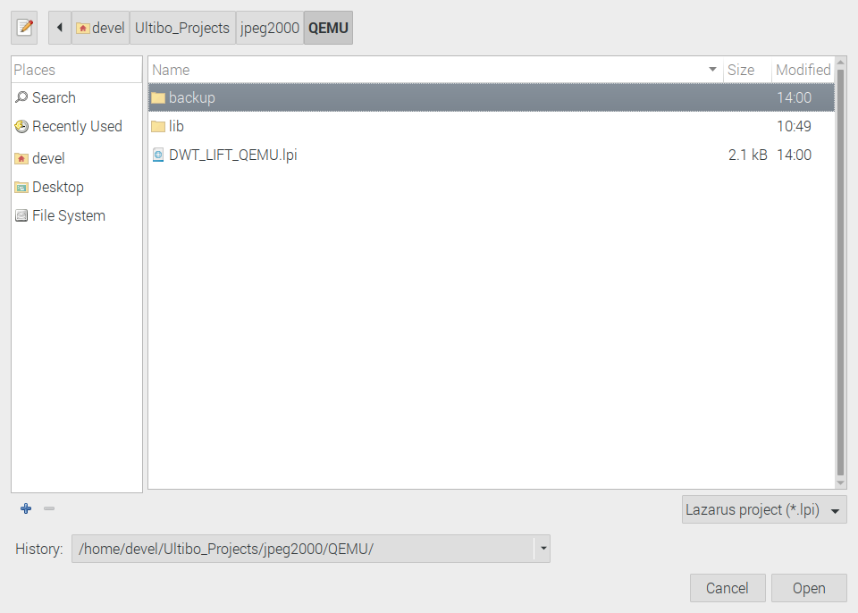
Select DWT_LIFT_QEMU.lpi

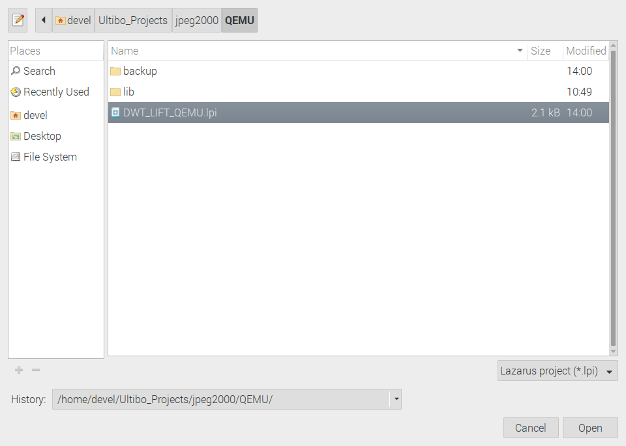
Depress Open

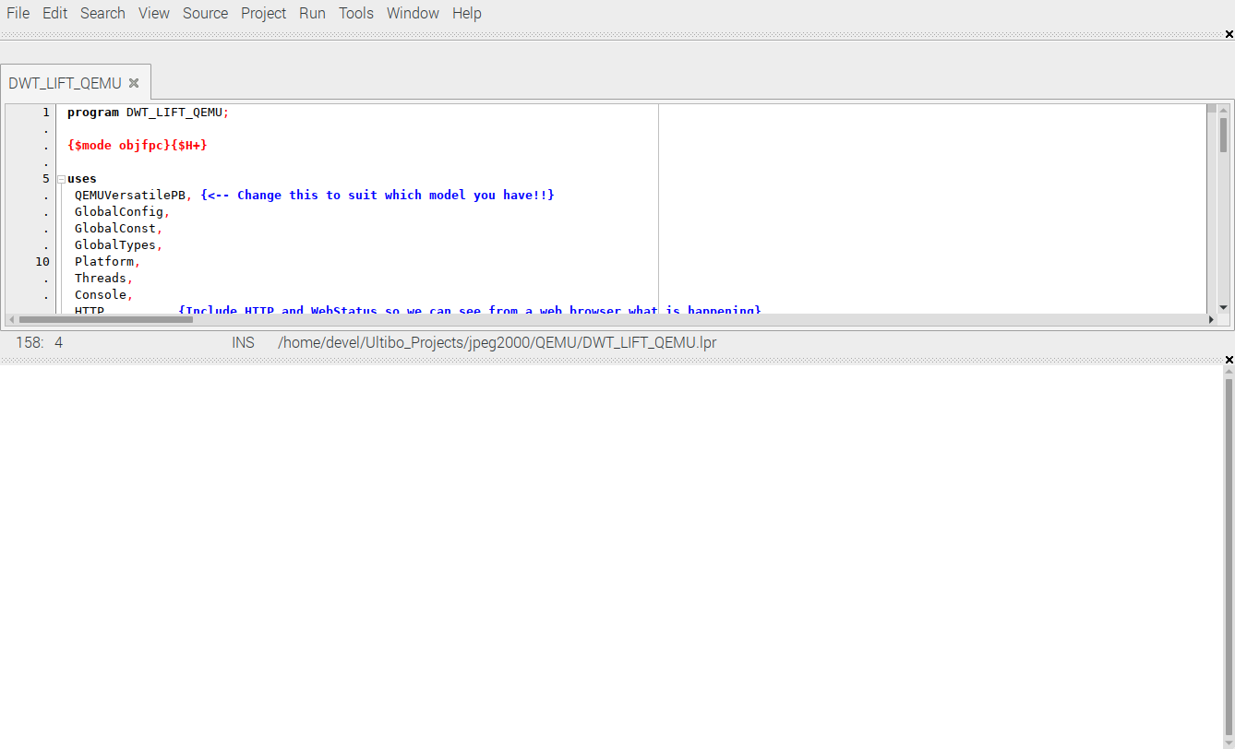

Run/Compile The kernel.bin is created when the Grean bar appears.

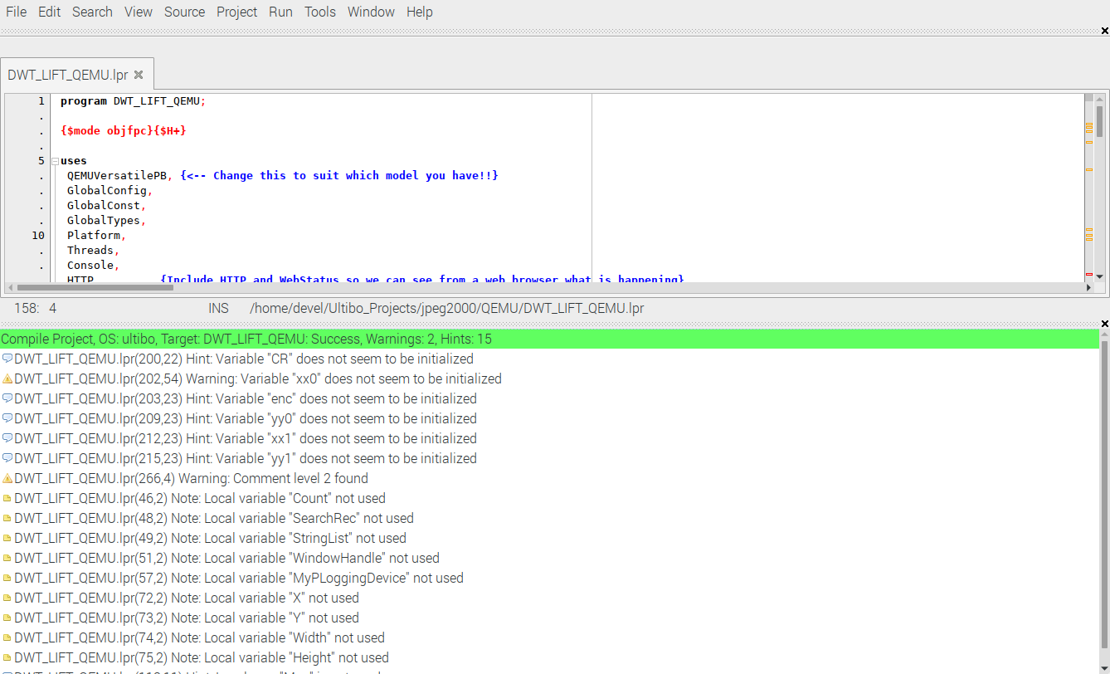
devel@pi400-1:~/Ultibo_Projects/jpeg2000 $ cp -R QEMU/ QEMU1
devel@pi400-1:~/Ultibo_Projects/jpeg2000 $ cp -R QEMU/ QEMU2
devel@pi400-1:~/Ultibo_Projects/jpeg2000 $ cp -R QEMU/ QEMU3
devel@pi400-1:~/Ultibo_Projects/jpeg2000 $ cp -R QEMU/ QEMU4

devel@pi400-1:~ $ sudo vcgencmd measure_temp
temp=31.6'C

The heat sync on pi400 maitains a good temperature.

sudo vcgencmd measure_temp
[sudo] password for devel:
temp=44.3'C

