****************************Draft****************************
QEMU RPi3 & Pico
05/14/22
****************************Draft****************************

. Ultibo_Projects/picoultibo.sh

cd rp2040-freertos-project/build/

devel@pi4-27:~/rp2040-freertos-project/build $ openocd -f interface/raspberrypi-swd.cfg -f target/rp2040.cfg -c "program test-read/test-read.elf verify reset exit"
Open On-Chip Debugger 0.11.0-g610f137-dirty (2022-05-03-08:59)
Licensed under GNU GPL v2
For bug reports, read
http://openocd.org/doc/doxygen/bugs.html
adapter speed: 1000 kHz

Info : Hardware thread awareness created
Info : Hardware thread awareness created
Info : RP2040 Flash Bank Command
Info : BCM2835 GPIO JTAG/SWD bitbang driver
Info : clock speed 1001 kHz
Info : SWD DPIDR 0x0bc12477
Info : SWD DLPIDR 0x00000001
Info : SWD DPIDR 0x0bc12477
Info : SWD DLPIDR 0x10000001
Info : rp2040.core0: hardware has 4 breakpoints, 2 watchpoints
Info : rp2040.core1: hardware has 4 breakpoints, 2 watchpoints
Info : starting gdb server for rp2040.core0 on 3333
Info : Listening on port 3333 for gdb connections
target halted due to debug-request, current mode: Thread
xPSR: 0xf1000000 pc: 0x000000ee msp: 0x20041f00
target halted due to debug-request, current mode: Thread
xPSR: 0xf1000000 pc: 0x000000ee msp: 0x20041f00
** Programming Started **
Info : RP2040 B0 Flash Probe: 2097152 bytes @10000000, in 512 sectors

target halted due to debug-request, current mode: Thread
xPSR: 0x01000000 pc: 0x0000012a msp: 0x20041f00
target halted due to debug-request, current mode: Thread
xPSR: 0x01000000 pc: 0x0000012a msp: 0x20041f00
target halted due to debug-request, current mode: Thread
xPSR: 0x01000000 pc: 0x0000012a msp: 0x20041f00
target halted due to debug-request, current mode: Thread
xPSR: 0x01000000 pc: 0x0000012a msp: 0x20041f00
target halted due to debug-request, current mode: Thread
xPSR: 0x01000000 pc: 0x0000012a msp: 0x20041f00
Info : Writing 94208 bytes starting at 0x0
target halted due to debug-request, current mode: Thread
xPSR: 0x01000000 pc: 0x0000012a msp: 0x20041f00
target halted due to debug-request, current mode: Thread
xPSR: 0x01000000 pc: 0x0000012a msp: 0x20041f00
target halted due to debug-request, current mode: Thread
xPSR: 0x01000000 pc: 0x0000012a msp: 0x20041f00
target halted due to debug-request, current mode: Thread
xPSR: 0x01000000 pc: 0x0000012a msp: 0x20041f00
target halted due to debug-request, current mode: Thread
xPSR: 0x01000000 pc: 0x0000012a msp: 0x20041f00
target halted due to debug-request, current mode: Thread
xPSR: 0x01000000 pc: 0x0000012a msp: 0x20041f00
target halted due to debug-request, current mode: Thread
xPSR: 0x01000000 pc: 0x0000012a msp: 0x20041f00
target halted due to debug-request, current mode: Thread
xPSR: 0x01000000 pc: 0x0000012a msp: 0x20041f00
target halted due to debug-request, current mode: Thread
xPSR: 0x01000000 pc: 0x0000012a msp: 0x20041f00
target halted due to debug-request, current mode: Thread
xPSR: 0x01000000 pc: 0x0000012a msp: 0x20041f00
target halted due to debug-request, current mode: Thread
xPSR: 0x01000000 pc: 0x0000012a msp: 0x20041f00
** Programming Finished **
** Verify Started **
target halted due to debug-request, current mode: Thread
xPSR: 0x01000000 pc: 0x0000012a msp: 0x20041f00
target halted due to debug-request, current mode: Thread
xPSR: 0x01000000 pc: 0x0000012a msp: 0x20041f00
** Verified OK **
** Resetting Target **
shutdown command invoked

diff --git a/picotransfer/RPi3/QEMU/picoultibo.lpr b/picotransfer/RPi3/QEMU/picoultibo.lpr
index 4abb865..c3253d9 100644
--- a/picotransfer/RPi3/QEMU/picoultibo.lpr
+++ b/picotransfer/RPi3/QEMU/picoultibo.lpr
@@ -11,6 +11,7 @@ program picoultibo ;

uses
RaspberryPi3,
+ USBCDCEthernet,
GlobalConfig, //Add the global config unit
GlobalConst,
GlobalTypes,
@@ -240,9 +241,9 @@ begin
end;
stOpen :
begin
- sleep(1000);
+ sleep(10000);
res := SerialDeviceOpen (SerialDevice, 115200, SERIAL_DATA_8BIT, SERIAL_STOP_1BIT, SERIAL_PARITY_NONE, SERIAL_FLOW_DSR_DTR, 0, 0);
- if res = ERROR_SUCCESS then state := stProcess0
+ if res = ERROR_SUCCESS then state := stProcess2
else if res = ERROR_INVALID_PARAMETER then state := stFind;
end;

@@ -392,8 +393,8 @@ begin
end;
//SerialDeviceFlush(SerialDevice,SERIAL_WRITE_NONE);

-
- state:= stProcess3;
+ sleep(1000);
+ state:= stProcess4;

end;

Project Options

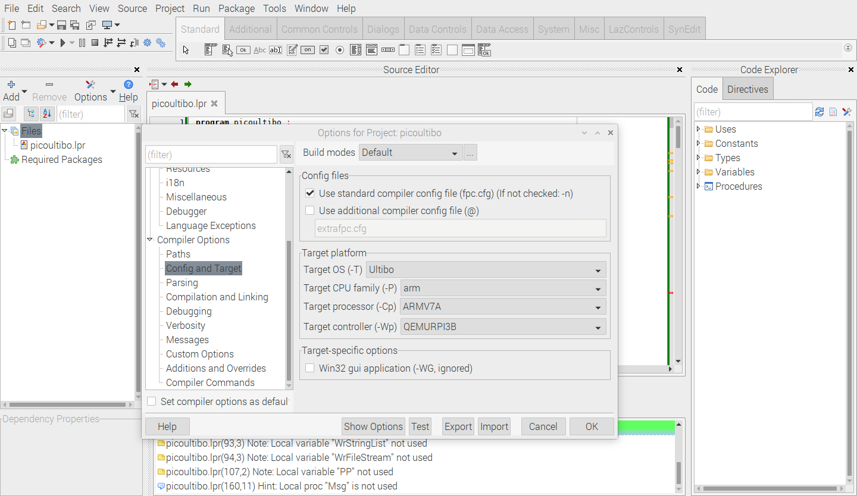
Compile

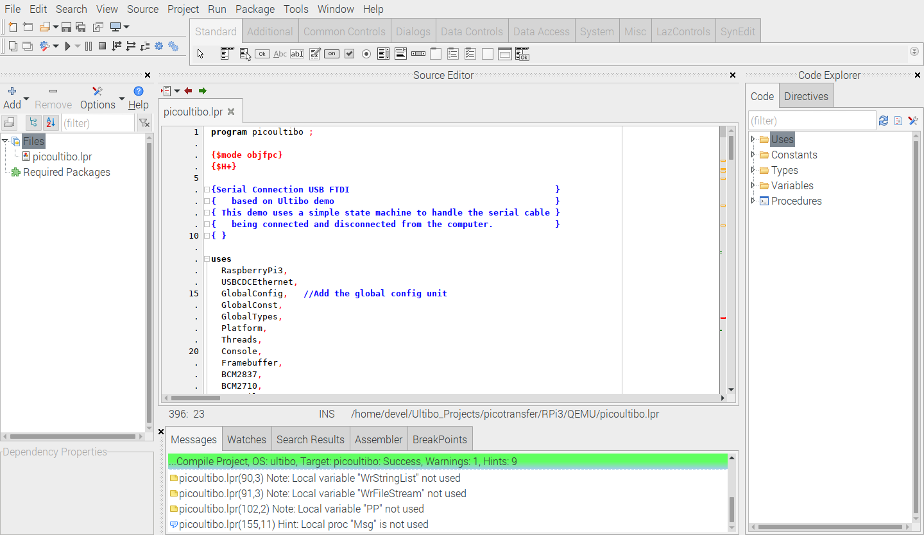
When the green bar the kernel7.qimg is created

Note: These commands need to be run as root.

sudo su

Contents of /home/devel/Ultibo_Projects/picoultibo.sh
export ULTIBO1=/home/devel/ultibo/core
export ULTIBO2=/home/devel/qemu-6.2.0-rpios/bin
export PICO=/home/devel/local/openocd/bin
export PATH=$ULTIBO1:$ULTIBO2:$PICO:$PATH
echo $PATH

. /home/devel/Ultibo_Projects/picoultibo.sh This sets the PATH to find
qemu-system-arm

cd Ultibo_Projects/picotransfer/RPi3/QEMU/

Contents of startqemu.sh

#!/bin/bash
qemu-system-arm -machine raspi2b -cpu cortex-a8 -kernel kernel7.qimg \
-netdev user,id=net0,hostfwd=tcp::5080-:80,hostfwd=tcp::5023-:23,hostfwd=tcp::8050-:5050,hostfwd=udp::5069-:69,hostfwd=tcp::6050-:5050 -device usb-net,netdev=net0 \
-drive file=disk.img,if=sd,format=raw --device usb-host,vendorid=0x2e8a,productid=0x000a

root@pi4-27:/home/devel/Ultibo_Projects/picotransfer/RPi3/QEMU# ./startqemu.sh
usbnet: failed control transaction: request 0x143 value 0xc index 0x0 length 0x0

xxx
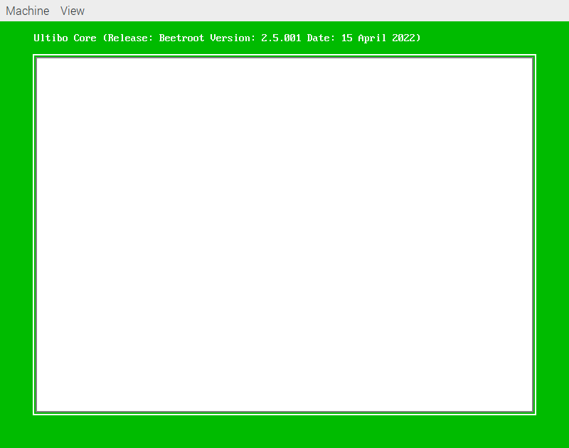

xxx
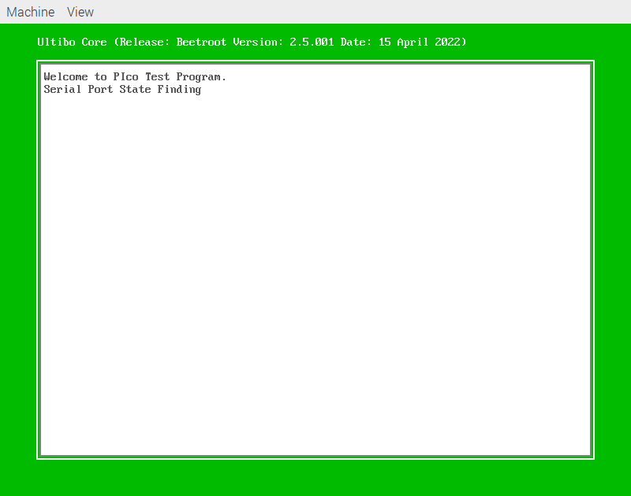

xxx

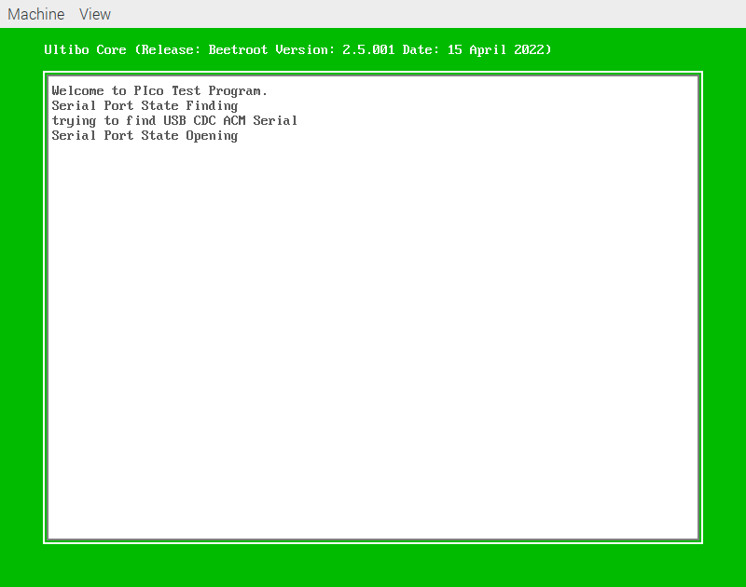
xxx

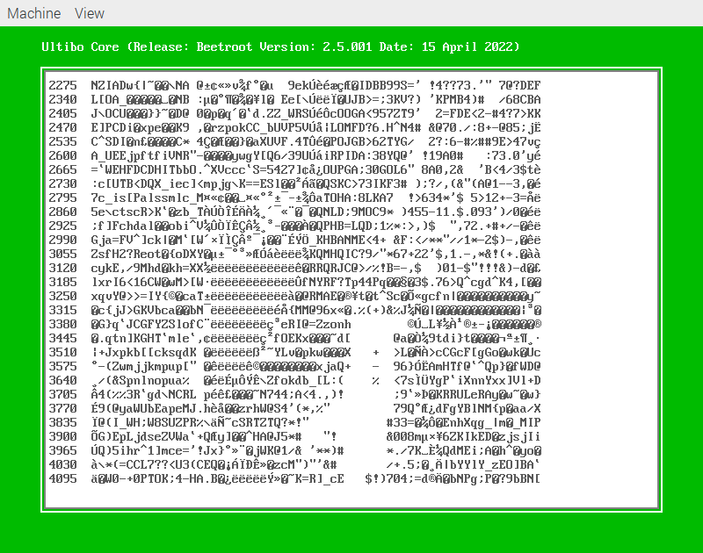
xxx

