***********************Default***********************
RP2040
PIO
Support 4 Uart
2 on PIO0
2 on PIO1
Working as a Transputer
08/10/21

***********************Default***********************

Raspberry Pi Pico was released in January 2021 with a retail price of $4.
It was Raspberry Pi's first board based upon a single microcontroller chip;
the RP2040, which was designed by Raspberry Pi in the UK.

The RP2040 datasheet chapter 3 has the overview of the PIO.
The RP2040 has 2 PIO0 & PIO1

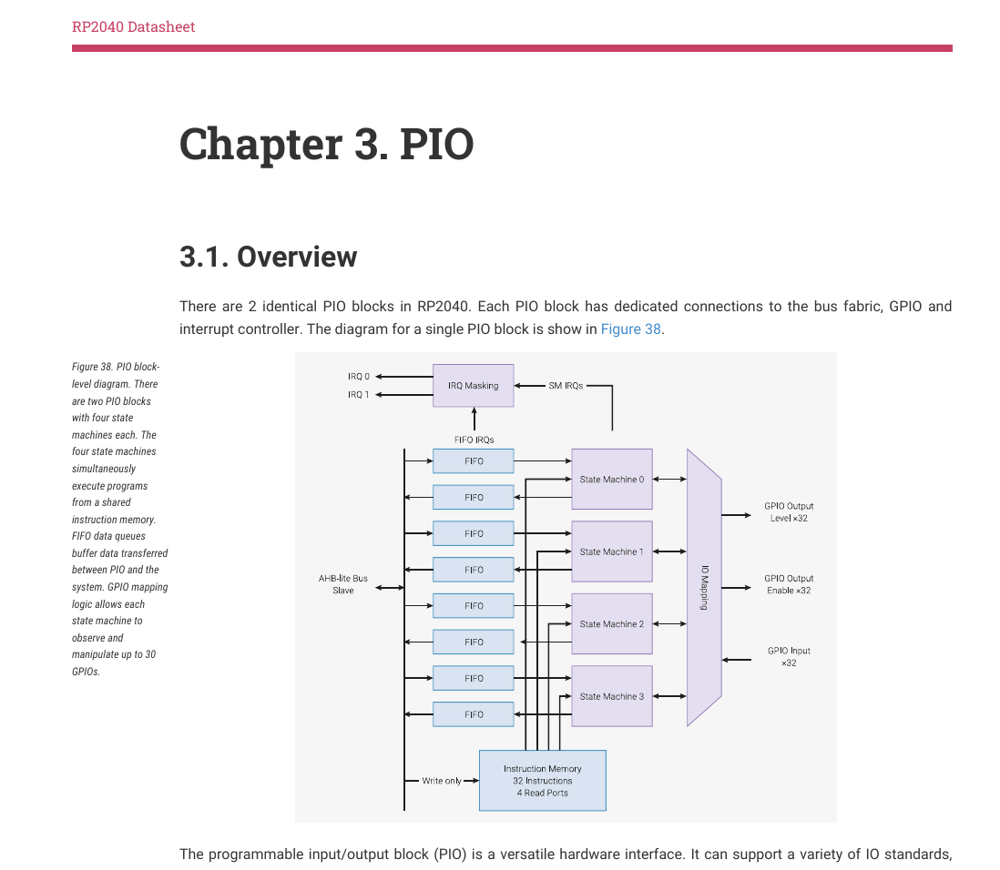

picoputer part 1
https://www.youtube.com/watch?app=desktop&v=MV_q7ltG8gY
There 6 parts on youtube.

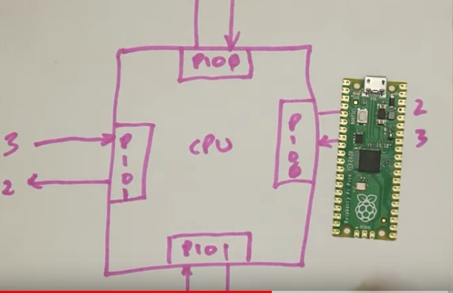

The sites below provide examples of uart_rx & uart_tx with C and PIO files.

https://github.com/raspberrypi/pico-examples/tree/master/pio/uart_rx
https://github.com/raspberrypi/pico-examples/tree/master/pio/uart_tx

https://en.m.wikipedia.org/wiki/Transputer
The transputer is a series of pioneering microprocessors from the 1980s, featuring
integrated memory and serial communication links, intended for parallel computing.
They were designed and produced by Inmos, a semiconductor company based in Bristol,
United Kingdom.[1] T414 transputer chip
IMSB008 base platform with IMSB419 and IMSB404 modules mounted

For some time in the late 1980s, many[2] considered the transputer to be
the next great design for the future of computing. While Inmos and the transputer
did not achieve this expectation, the transputer architecture was highly influential
in provoking new ideas in computer architecture, several of which have re-emerged
in different forms in modern systems.

