*************Default*************

SWD
08/22/21

*************Default*************

Serial Wire Debug (SWD)

https://community.silabs.com/s/article/serial-wire-debug-swd-x?language=en_US

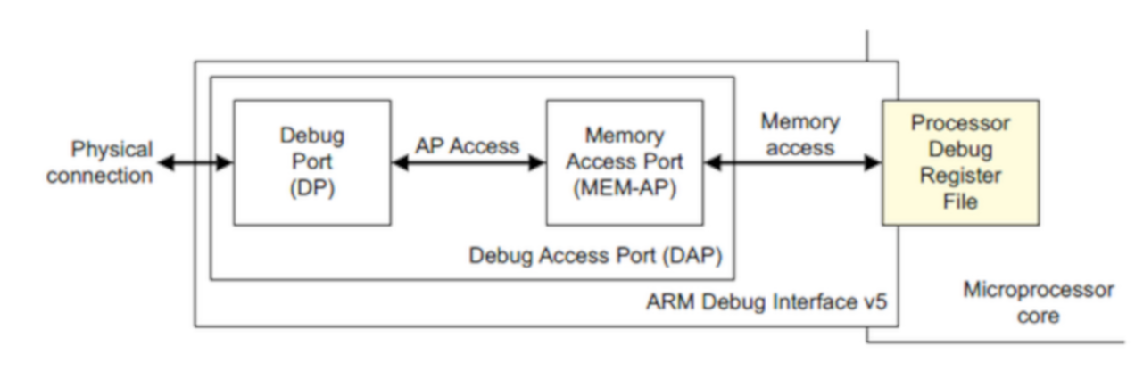

https://community.silabs.com/s/article/serial-wire-debug-successful-write-operation?language=en_US

Serial Wire Debug successful write operation

