06/20/20
Forked the project from
"https://github.com/cejasmasmas/software-rasterizer-ultibo-"
commit ad8fd4c4881a9d0213a427dd2adeb5ab4c527ef9 (HEAD -> master, origin/master, origin/HEAD)
Author: cejasmasmas <65371443+cejasmasmas@users.noreply.github.com>
Date: Sat Jun 20 22:33:35 2020 -0600

Add files via upload

Since my original forked “ad8fd4c4881a9d0213a427dd2adeb5ab4c527ef9” had gone thru several modifications. A merge was required.

git remote add upstream https://github.com/cejasmasmas/software-rasterizer-ultibo-
git fetch upstream
git merge upstream/master

git push origin master

This update the project to the same as Ultibo member JRsamyoa “57fc04fa13fe90c0cdca9ff6cd37b0a74bc5561c” on github.

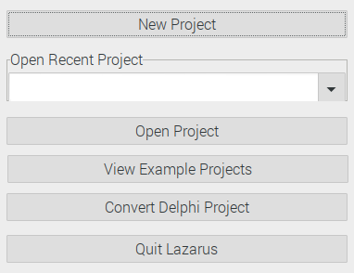

Depress New Project

This project will be for a Raspberry Pi 3

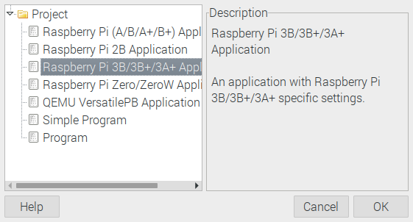

Depress OK

Lazarus IDE (Ultibo Edition)
In my Ultibo_Projects
soft-rast-ultibo/Rpi3

Note: The name was project1.lpr. This was the name Ultibo member JRsamyoa used in his project. This is the point where a new name could have been selected.

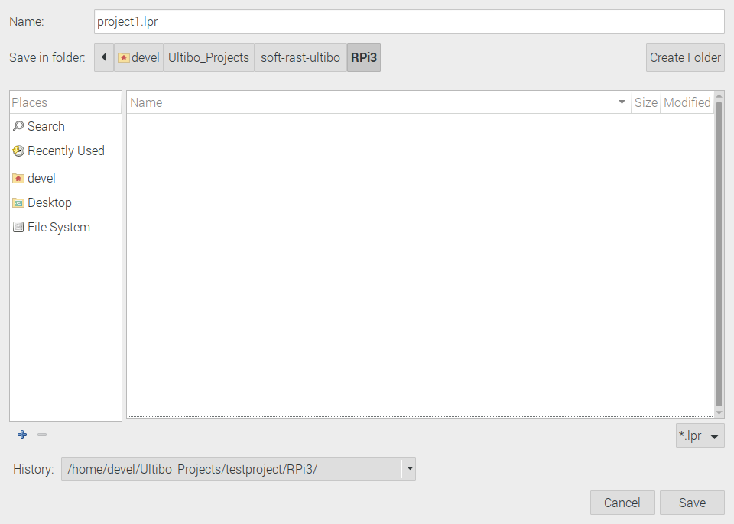
Over wtite the project1.lpr with the file from software-rasterizer-ultibo-/project1.lpr

cp software-rasterizer-ultibo-/project1.lpr Ultibo_Projects/soft-rast-ultibo/Rpi3/

This will prompt to Reload from disk

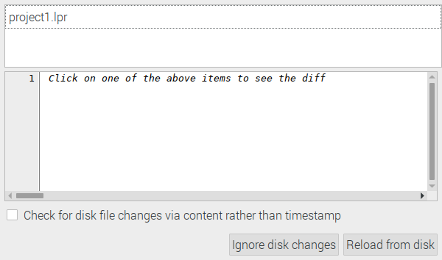
Depress Reload from disk

At this point the project needs to several C libraries.
{$linklib Testnanogl}
{$linklib t3dlib1}
{$linklib t3dlib4}
{$linklib t3dlib5}
{$linklib t3dlib6}
{$linklib t3dlib7}
{$linklib t3dlib8}
{$linklib t3dlib9}
{$linklib t3dlib10}
{$linklib t3dlib11}
{$linklib t3dlib12}
{$linklib t3dlib13}

The above C & headers are in a folder “t3eng”
In additon the main C library is needed.

procedure test; cdecl; external 'libTestnanogl' name 'test';

