******************DRAFT******************

New testing with svd_rgb added to th_svd.
04/01/20

Single Value Decomposition SVD using threads
RaspBian & Ultibo bare metal
07/03/19
******************DRAFT******************

The first step is to create “libsvd.a” with the script “buildlib.sh”. This is used to compile & link several C files. The main() found in svd_rgb/src/master.c becomes test_svd() called by Pascal in Ultibo.

disp_mat.o mul_mat.o pnmio.o trans_mat.o
error.o mythread.o svd.o ultibo_th_svd.o

Lazarus IDE (Ultibo Edition)

Use Lazarus IDE (Ultibo Edition) to create kernel7.img

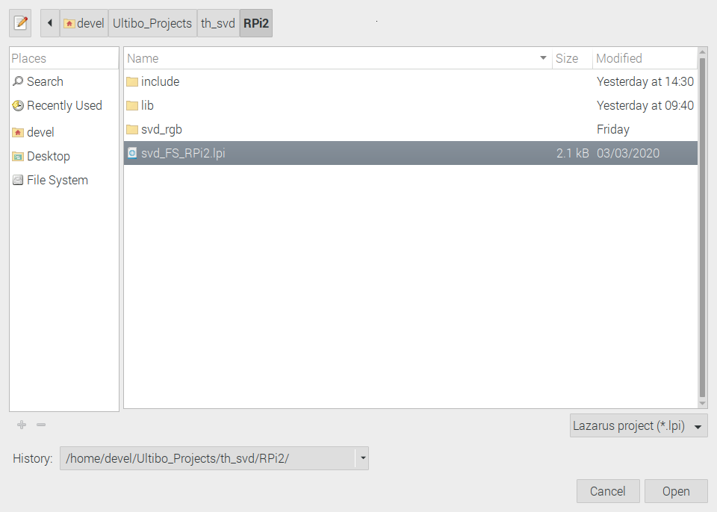

Depress Open

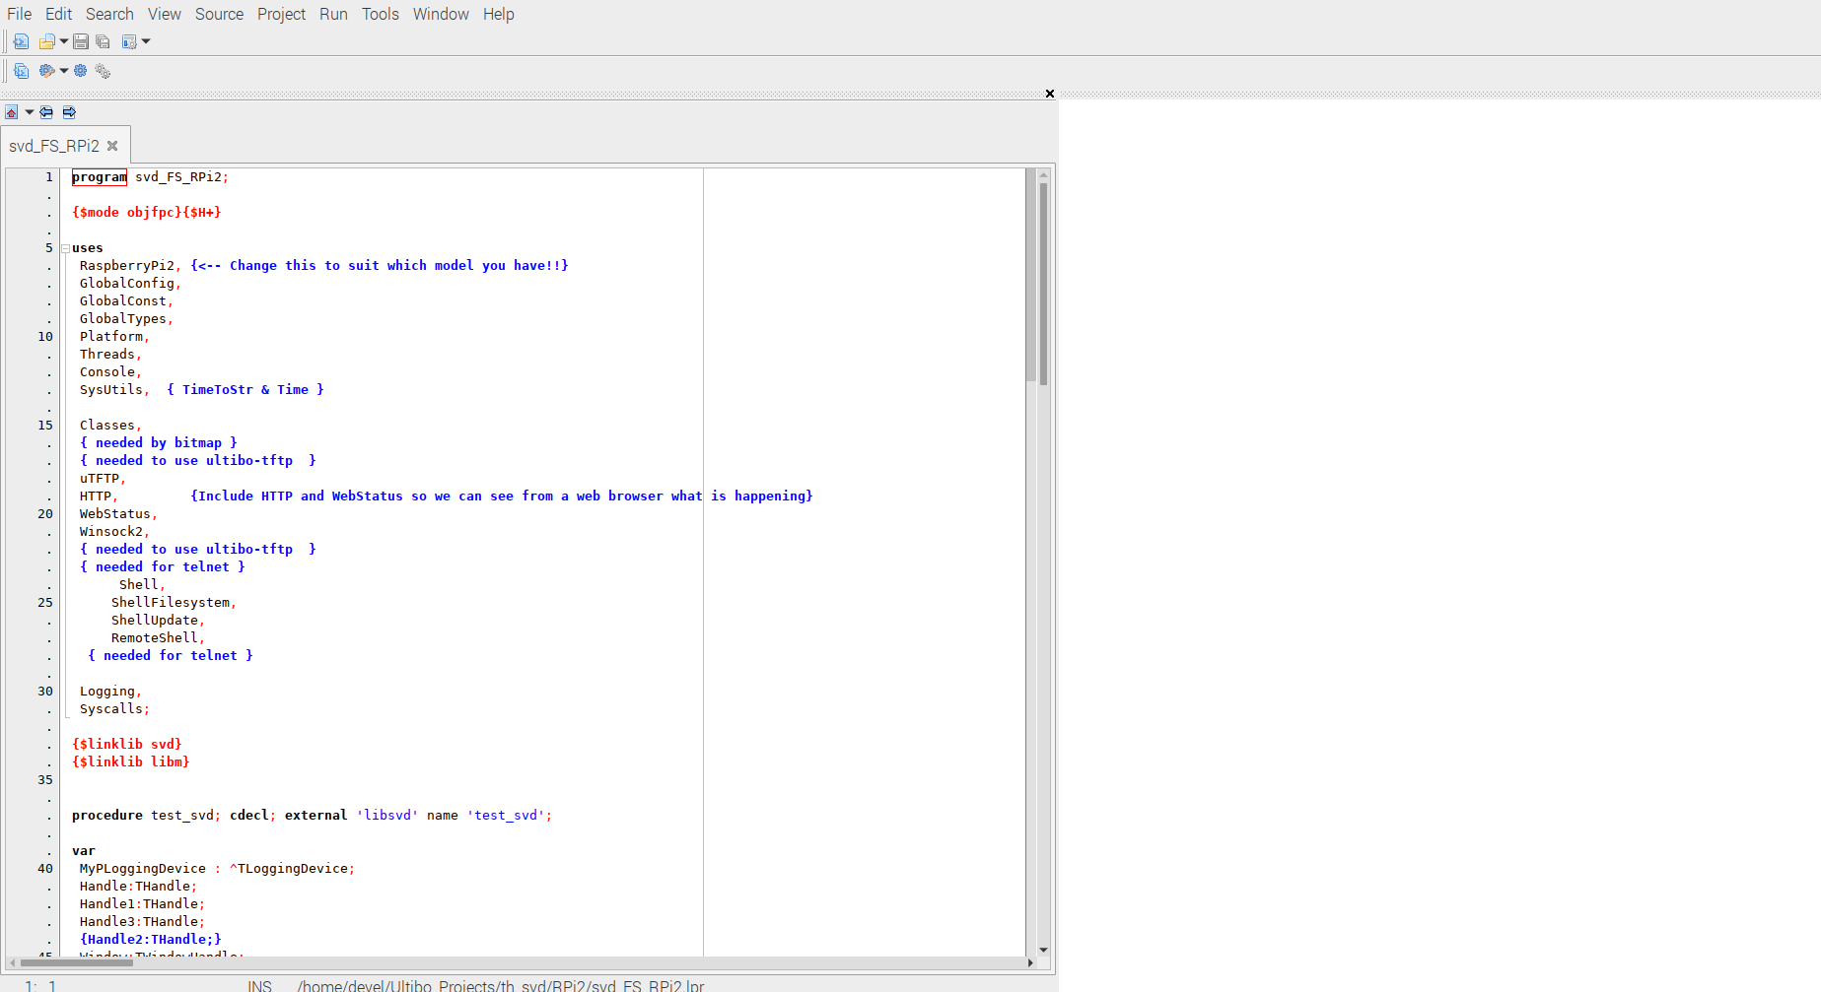

Build

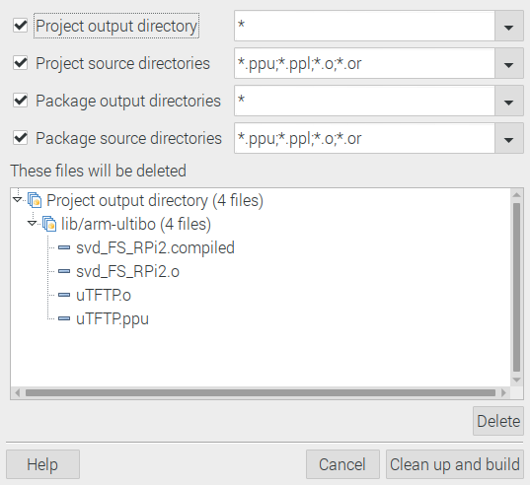
Depress Clean up and build

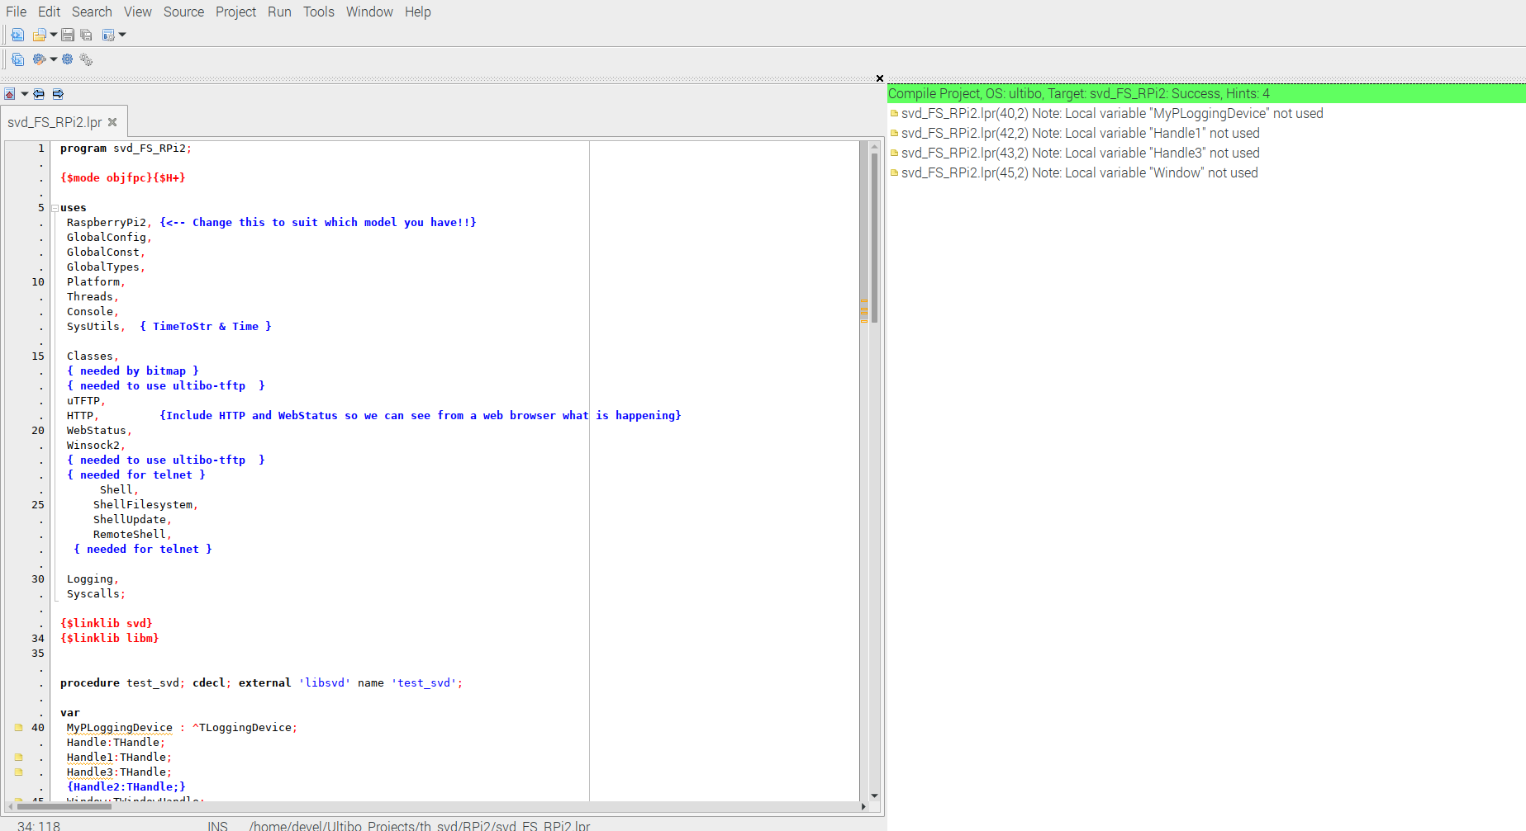

Tranfer kernel7.img to a running Ultibo System.

devel@mypi3-11:~/Ultibo_Projects/th_svd/RPi2 $ ./upker7.sh

Updating kernel7.img
tftp> tftp> Sent 2946512 bytes in 13.9 seconds
tftp> done

Inputs
q
red.pgm
grn.pgm
blu.pgm

Get the results

Sred.bin rcred.bin
Sgrn.bin rcgrn.bin
Sblu.bin rcblu.bin

devel@mypi3-11:~/Ultibo_Projects/th_svd/RPi2 $ ./getsvdresults.sh

retrieve svd results
tftp> tftp> Error code 5: 56922
Received 1024 bytes in 5.0 seconds
tftp> Error code 5: 55529
Received 1024 bytes in 5.0 seconds
tftp> Error code 5: 55412
Received 1024 bytes in 5.0 seconds
tftp> tftp> Error code 5: 41057
Received 262144 bytes in 5.8 seconds
tftp> Error code 5: 50222
Received 262144 bytes in 6.3 seconds
tftp> Error code 5: 39790
Received 262144 bytes in 6.3 seconds
tftp> tftp> done

devel@mypi3-11:~/Ultibo_Projects/th_svd/RPi2 $ octave

Require a file in home folder .octaverc
graphics_toolkit("gnuplot");

disp_S Displays original (red.pgm grn.pgm blu.pgm) and reconstructed image
The images on the top red.pgm, grn.pgm, and blue.pgm, The images on the bottom, rcred.bin, rcgrn.bin, and rcblu.bin are created by Ulitbo with the test_svd.

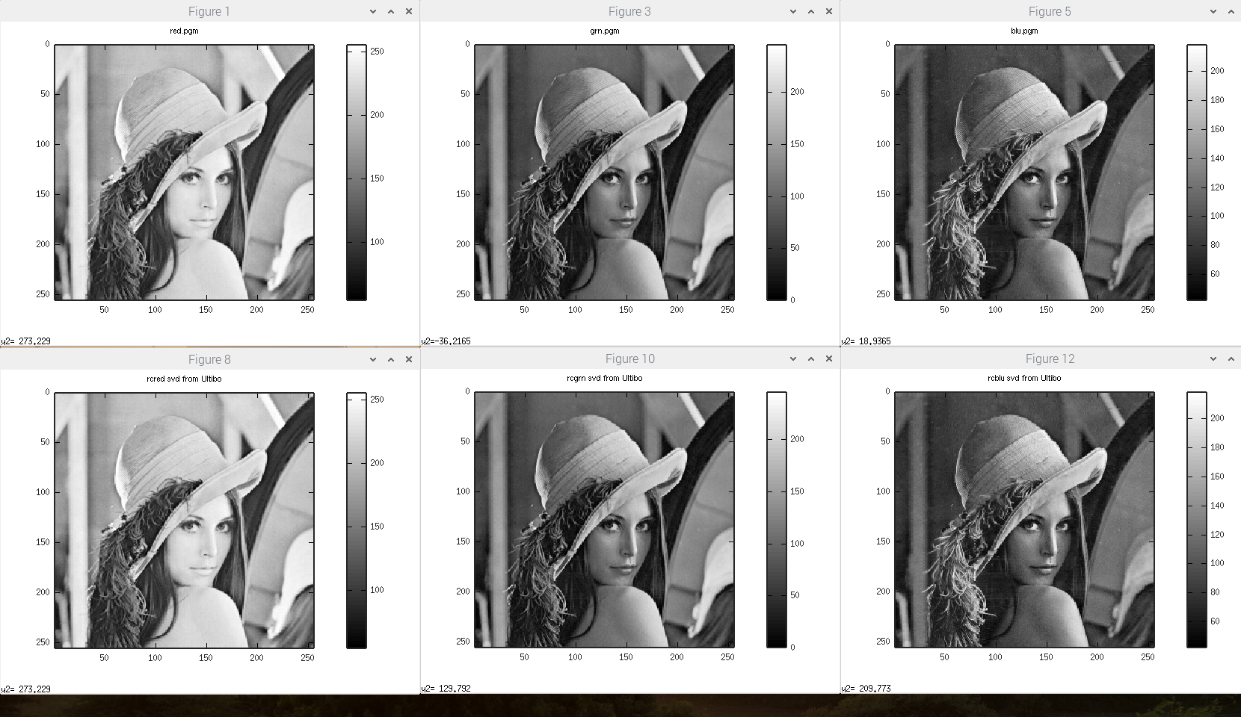

Sred.bin, Sgrn.bin and Sblu.bin are created with Ultibo test_svd. These are

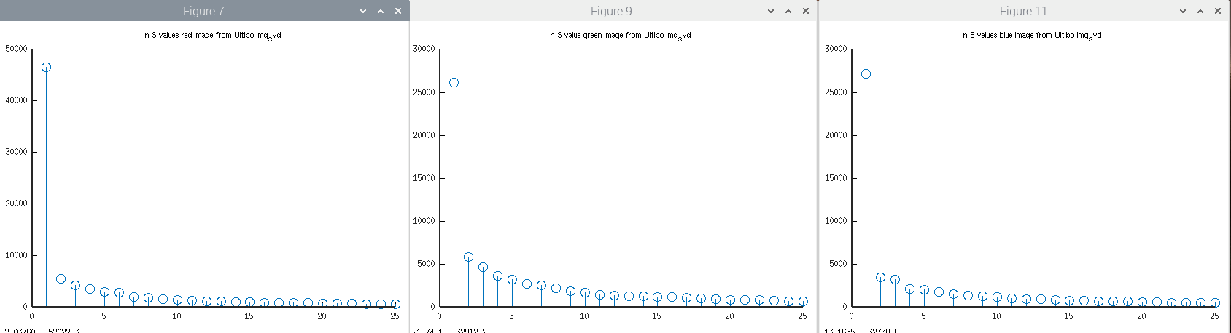

The Singular Values are found below, and the figures above are first 25 of red, grn, blu.

octave:6> red
red =

46490.7343750000
5596.3432617188
4330.5429687500
3526.7773437500
2956.7709960938
2870.0771484375
2062.8488769531
1937.9282226562
1532.7293701172
1453.5145263672
1292.3865966797
1218.7497558594
1138.0373535156
1057.3935546875
1024.6512451172
961.7035522461
944.6420898438
920.9254150391
867.0841674805
825.4244384766
796.4094848633
737.1578979492
670.1098022461
661.3618774414
620.1027221680
597.6555175781
576.4102172852
566.4093017578
540.7626342773
515.4307861328
511.3469848633
499.5811767578
478.0818786621
456.4842224121
450.5930480957
437.4675598145
432.7677917480
424.6962280273
407.8364257812
401.3485107422
389.5744018555
383.0152282715
368.9618530273
362.5980224609
356.3916931152
346.3831787109
340.6094970703
332.8945312500
329.3958435059
314.4053344727
312.7182312012
298.8931579590
295.2809143066
288.2543334961
279.0919189453
274.6800231934
266.8181762695
266.2917785645
263.5414733887
251.7684020996
248.4159088135
244.1090545654
239.5570678711
233.7316436768
229.6019439697
222.0778045654
219.4563751221
216.8686676025
211.6278533936
209.7453308105
205.6847076416
202.9426879883
200.8285369873
195.1639709473
189.1574859619
186.5259704590
183.5245361328
181.6483154297
179.3334350586
173.3685607910
170.8091735840
167.4531860352
166.3230133057
165.0324096680
164.0382537842
161.8459777832
157.3802185059
151.5467224121
150.6076812744
148.5522308350
146.7541656494
144.5440216064
143.7129058838
141.5927429199
140.5867767334
137.5796051025
134.9138336182
130.9882659912
128.7026672363
125.9705963135
125.5119705200
124.4302215576
120.5763320923
119.5853729248
118.0528335571
116.3439331055
113.4470672607
112.0395202637
110.4043121338
107.8207015991
105.3259735107
104.0724487305
102.6441955566
100.6700286865
99.6053466797
97.2046203613
95.5084686279
95.1359100342
93.3966522217
92.7792892456
91.9565505981
88.1412277222
87.7384033203
84.8822021484
83.9585113525
82.2559509277
81.4203033447
80.0033111572
78.7717819214
77.6922607422
75.9739837646
74.9790496826
73.2335586548
72.8876342773
72.5448379517
71.6504287720
70.5081939697
69.5298080444
68.5042037964
67.0900573730
65.8707046509
65.6610717773
65.0153884888
63.4507637024
62.5918846130
61.6959381104
60.0555305481
60.1186904907
58.9073867798
57.5994338989
55.4234008789
54.7148094177
53.6227607727
51.9106407166
50.5631523132
50.2768173218
49.4177474976
49.0494651794
47.8857078552
47.0076828003
46.1647453308
45.4234695435
44.5045852661
43.7742805481
42.3546867371
42.2812957764
41.5500373840
41.0262908936
40.3492050171
40.1524047852
38.8314056396
39.1207427979
37.5528755188
36.8779754639
36.0893096924
35.2399444580
35.5891036987
33.8632659912
33.4664573669
32.6618232727
31.9502182007
31.7480182648
31.6167240143
30.7730426788
29.3323802948
28.9667453766
28.0151691437
27.4720573425
27.2358341217
27.0768108368
26.1660919189
25.3492755890
25.1703758240
24.3437213898
24.0429935455
23.2838706970
22.9917678833
22.2213058472
21.8615036011
21.3245620728
20.9660472870
20.3512134552
19.9253540039
19.3956356049
19.2407855988
19.0920238495
18.2952671051
17.3460483551
17.1422195435
16.6514148712
16.4502544403
16.2072334290
16.1050434113
15.6977682114
15.2204103470
14.4829616547
14.1917057037
13.9276819229
13.1234064102
12.8743848801
12.3421821594
11.9488410950
11.6131792068
11.1958141327
11.0411224365
10.2630653381
10.0282182693
9.7196836472
9.2858333588
9.0940055847
8.3315677643
7.9746303558
7.6138062477
7.4294724464
6.7891602516
6.6679124832
6.4817247391
6.0853390694
5.7467384338
5.4393072128
5.0183682442
4.7791223526
4.6371097565
3.8515038490
3.6837930679
3.1196374893
2.8340008259
2.3310303688
2.0019757748
1.7370281219
1.3697438240
1.0989300013
0.6712408066
0.5149259567
0.0000012774
0.0945187584

octave:7> grn
grn =

26136.8515625000
5859.4916992188
4648.6933593750
3650.1845703125
3252.7487792969
2706.9963378906
2594.8276367188
2257.9294433594
1897.8415527344
1760.4191894531
1485.4122314453
1420.4635009766
1333.2521972656
1301.7596435547
1231.0753173828
1175.7124023438
1140.3868408203
1016.3177490234
947.4901123047
906.0975952148
899.5205688477
877.7921752930
791.1161499023
735.7531127930
731.7446289062
722.3657836914
681.5828857422
671.6765747070
641.5535278320
621.7358398438
599.8407592773
581.6895751953
574.3465576172
559.4675292969
550.2336425781
540.1394653320
518.5166015625
512.9561767578
507.2587585449
503.3897705078
473.4563293457
471.4446105957
456.6275024414
450.8524169922
441.5382385254
428.9694824219
420.0426940918
408.5807495117
400.6606445312
392.0009460449
388.3068847656
375.5012817383
367.5369567871
355.1669921875
352.5581359863
347.2686157227
343.1580200195
343.7996520996
339.4276733398
328.4135437012
314.8340454102
312.5771179199
303.7370605469
301.1005859375
294.1311950684
290.1683044434
286.8659973145
285.5745239258
285.0696411133
277.9939575195
272.8782653809
267.4771423340
262.7816467285
256.7182006836
254.1877288818
251.0511322021
245.0108032227
242.1088867188
240.0716094971
237.8582611084
232.4597015381
231.6824340820
221.5392303467
219.9149475098
216.7705841064
216.2714080811
215.5254669189
213.2120971680
210.0785522461
205.7899322510
202.5356597900
199.4328613281
197.0677032471
192.8977813721
189.2535095215
187.8017272949
185.4735565186
184.7980041504
181.3895874023
179.8304443359
172.8542938232
168.4182434082
167.1517181396
164.1532287598
161.8439331055
159.4327392578
156.4186706543
153.5744781494
151.8145599365
151.0813751221
148.3957672119
146.6819000244
144.6723785400
142.7863006592
140.8717041016
137.4505615234
136.7503662109
134.8432312012
133.3742828369
128.0522308350
126.8479766846
125.4322204590
124.9142532349
121.4050674438
119.7617263794
118.9789657593
117.0542831421
115.2584152222
113.1638259888
111.8580780029
110.1544418335
107.8182525635
109.2153091431
104.6459732056
102.5699386597
100.9728088379
99.7932968140
98.9827651978
97.2015151978
95.2019577026
93.6018753052
93.0297164917
91.6384429932
90.2380981445
87.9731521606
86.3405227661
84.7878570557
84.3739395142
82.6124343872
81.8116607666
81.0489501953
79.1846618652
77.4316558838
76.9565429688
75.4625015259
74.4336090088
73.6531982422
72.0237426758
70.4113235474
69.7333984375
68.7350463867
67.3141479492
64.8800277710
64.4248657227
63.7386398315
61.8538093567
61.2554054260
59.9832229614
60.5047492981
58.4760589600
56.3093223572
56.2127571106
55.1968231201
53.8621826172
52.2178802490
51.7396011353
50.9309158325
50.2690658569
48.8466453552
48.6146240234
47.4008789062
46.8353309631
46.1361236572
45.4367294312
44.9794845581
43.9881629944
43.0495147705
41.9875869751
41.0243759155
39.5749931335
39.1904830933
38.3289833069
37.2593383789
36.8873443604
36.4164543152
35.9904441833
35.4790229797
34.4642982483
33.5584716797
33.0308418274
32.1625900269
30.9487552643
29.6334533691
29.4645729065
28.9180335999
28.2978668213
27.2574386597
26.5678386688
25.7616176605
24.6165313721
23.8716011047
23.5368061066
22.3802032471
21.5464801788
20.9224567413
20.4426574707
20.2958717346
19.6748313904
19.0797195435
18.3801765442
18.1497344971
17.5928707123
17.2712764740
15.9325723648
15.6775741577
15.5049829483
14.6474113464
14.2513837814
14.0500707626
13.7360610962
13.1360960007
12.6536464691
12.4076499939
11.5416765213
10.8093757629
9.8998336792
9.5388317108
8.9729623795
8.1923179626
8.0394678116
7.0907297134
6.5049962997
5.8725857735
5.4745202065
4.7139377594
4.4690213203
4.0199046135
3.8338079453
0.8131526113
0.0000017890
0.3183091581
1.5027192831
2.0284924507
2.3767004013
3.1395895481
2.8475480080

octave:8> blu
blu =

27158.9199218750
3507.5581054688
3219.3447265625
2173.1728515625
2080.7851562500
1847.3824462891
1591.7998046875
1387.6192626953
1323.6564941406
1210.9139404297
1020.5325927734
990.1828002930
944.8300170898
890.9213256836
779.2144165039
763.0958862305
735.0294799805
694.2989501953
679.0372314453
644.9321289062
632.1785888672
579.8778686523
536.1601562500
525.2123413086
509.9426269531
500.6754150391
489.4238586426
479.7215576172
464.9911193848
456.2604675293
445.1365356445
442.8542175293
420.2432250977
399.1830444336
396.8740234375
389.8049011230
384.2715148926
375.9946289062
371.4112243652
360.3256835938
357.9037170410
351.5963134766
340.5518493652
335.2889709473
329.7984008789
320.1760559082
317.6122741699
309.5576477051
307.8468322754
303.1744689941
296.3532714844
289.7804870605
289.3063964844
280.0120544434
274.9713439941
274.0708007812
267.1106262207
263.1430053711
258.6246643066
252.0297851562
244.7610626221
242.0476684570
240.5553131104
235.0776519775
232.5705566406
228.2366027832
227.2181243896
223.9588012695
222.6473999023
218.3510437012
216.0277709961
210.5857086182
209.0536346436
205.8899841309
199.1678771973
198.6155548096
197.7225189209
194.6028747559
192.5930480957
189.2682037354
187.4035491943
185.6651000977
182.1620788574
180.5402069092
176.7960968018
173.0097351074
170.8731689453
170.2092895508
167.0576629639
166.7517089844
165.0933685303
163.5560607910
160.3636932373
157.7403717041
156.8637084961
154.6108856201
152.2603912354
150.8940277100
149.4701843262
148.2577362061
144.7669677734
141.1126861572
140.0565032959
137.9224853516
136.1683807373
133.4224395752
132.9426422119
130.7977142334
129.5326385498
127.1349945068
126.5718841553
124.4090499878
123.6354064941
122.6773605347
119.3271102905
119.2159347534
118.2924118042
115.8735198975
113.0821151733
112.7387542725
111.5073318481
110.1816101074
108.4066467285
106.2374191284
105.8417053223
104.1263198853
103.4325103760
101.7006301880
100.5811157227
99.5337448120
97.7920532227
96.0039596558
95.5127334595
93.8215103149
92.2148208618
91.0025482178
90.8578872681
88.1319503784
87.0088577271
86.1961822510
84.7979507446
85.4510803223
83.7836303711
81.7614898682
80.2505645752
78.6069259644
77.8627929688
77.1550369263
75.2658157349
73.9056777954
73.2220001221
72.4392242432
71.5293807983
70.8384704590
69.6501007080
68.9629898071
68.1144180298
65.9589843750
64.4058151245
64.2421417236
63.8155403137
62.6520156860
61.3428230286
60.5529327393
59.5502548218
58.9789619446
58.3902053833
57.5975761414
56.7027626038
56.2376670837
56.1384887695
55.2939872742
54.7654304504
52.1934471130
51.7156600952
51.2033157349
50.0882644653
49.5921516418
48.5653762817
47.4120178223
46.4429168701
45.1983299255
44.2505340576
44.1507987976
43.6816482544
42.6002655029
42.2288627625
40.2944374084
40.0313568115
39.4936599731
38.8922805786
38.1122093201
37.7679214478
37.0669136047
35.8810081482
35.0909194946
34.7775001526
33.7472991943
33.3026084900
32.3081245422
31.9021968842
31.3445301056
30.6362438202
29.4928302765
29.0002613068
28.4895000458
27.5879249573
27.1875190735
26.3514080048
26.0561370850
25.7744235992
24.8332519531
24.5494785309
23.5079269409
23.2051219940
22.9610595703
22.1021614075
21.7774410248
21.1371612549
20.8098716736
20.0694103241
19.3410263062
18.9826831818
18.6270160675
18.1711406708
17.1895198822
16.8759536743
15.8275880814
15.0579109192
13.9528169632
13.7689580917
13.2845735550
12.9880952835
12.4779443741
12.0599327087
11.5358648300
10.5687170029
9.5950202942
9.2113637924
8.6947717667
8.3593072891
7.5175709724
7.1817870140
6.6384763718
6.2457270622
5.9409780502
5.4444427490
4.8478384018
3.6946516037
2.9689142704
2.2607605457
0.0000023130
1.7866059542
1.5539444685
0.8392905593
1.2424732447

