Pico FreeRTOS part 2: Tasks and Queues tutorial

This video was used

https://www.youtube.com/watch?app=desktop&v=-fwJZzDpBIg

https://learnembeddedsystems.co.uk/freertos-part-2-tasks-and-queues-tutorial

https://github.com/develone/rp2040-freertos-project/blob/master/doc/pico-freeRtos.pdf

On a RPi O/S
pico programmed with pico-lifting.uf2
pico connected
[ 18.755415] input: Logitech USB Receiver System Control as /devices/platform/scb/fd500000.pcie/pci0000:00/0000:00:00.0/0000:01:00.0/usb1/1-1/1-1.2/1-1.2.7/1-1.2.7:1.1/0003:046D:C534.0002/input/input3
[ 18.756006] hid-generic 0003:046D:C534.0002: input,hiddev96,hidraw1: USB HID v1.11 Mouse [Logitech USB Receiver] on usb-0000:01:00.0-1.2.7/input1
[ 19.076832] logitech-djreceiver 0003:046D:C534.0001: hidraw0: USB HID v1.11 Keyboard [Logitech USB Receiver] on usb-0000:01:00.0-1.2.7/input0
[ 19.458442] logitech-djreceiver 0003:046D:C534.0002: hiddev96,hidraw1: USB HID v1.11 Mouse [Logitech USB Receiver] on usb-0000:01:00.0-1.2.7/input1
[ 19.546690] logitech-djreceiver 0003:046D:C534.0002: device of type eQUAD nano Lite (0x0a) connected on slot 1
[ 19.548294] input: Logitech Wireless Keyboard PID:4023 Keyboard as /devices/platform/scb/fd500000.pcie/pci0000:00/0000:00:00.0/0000:01:00.0/usb1/1-1/1-1.2/1-1.2.7/1-1.2.7:1.1/0003:046D:C534.0002/0003:046D:4023.0003/input/input6
[ 19.548955] input: Logitech Wireless Keyboard PID:4023 Consumer Control as /devices/platform/scb/fd500000.pcie/pci0000:00/0000:00:00.0/0000:01:00.0/usb1/1-1/1-1.2/1-1.2.7/1-1.2.7:1.1/0003:046D:C534.0002/0003:046D:4023.0003/input/input7
[ 19.549126] input: Logitech Wireless Keyboard PID:4023 System Control as /devices/platform/scb/fd500000.pcie/pci0000:00/0000:00:00.0/0000:01:00.0/usb1/1-1/1-1.2/1-1.2.7/1-1.2.7:1.1/0003:046D:C534.0002/0003:046D:4023.0003/input/input8
[ 19.549304] hid-generic 0003:046D:4023.0003: input,hidraw2: USB HID v1.11 Keyboard [Logitech Wireless Keyboard PID:4023] on usb-0000:01:00.0-1.2.7/input1:1
[ 19.562695] logitech-djreceiver 0003:046D:C534.0002: device of type eQUAD nano Lite (0x0a) connected on slot 2
[ 19.563741] input: Logitech Wireless Mouse PID:4058 Mouse as /devices/platform/scb/fd500000.pcie/pci0000:00/0000:00:00.0/0000:01:00.0/usb1/1-1/1-1.2/1-1.2.7/1-1.2.7:1.1/0003:046D:C534.0002/0003:046D:4058.0004/input/input13
[ 19.564045] hid-generic 0003:046D:4058.0004: input,hidraw3: USB HID v1.11 Mouse [Logitech Wireless Mouse PID:4058] on usb-0000:01:00.0-1.2.7/input1:2
[ 20.234831] logitech-hidpp-device 0003:046D:4023.0003: HID++ 2.0 device connected.
[ 21.643808] input: Logitech Wireless Keyboard PID:4023 as /devices/platform/scb/fd500000.pcie/pci0000:00/0000:00:00.0/0000:01:00.0/usb1/1-1/1-1.2/1-1.2.7/1-1.2.7:1.1/0003:046D:C534.0002/0003:046D:4023.0003/input/input17
[ 21.645518] logitech-hidpp-device 0003:046D:4023.0003: input,hidraw2: USB HID v1.11 Keyboard [Logitech Wireless Keyboard PID:4023] on usb-0000:01:00.0-1.2.7/input1:1
[ 21.787346] input: Logitech Wireless Mouse as /devices/platform/scb/fd500000.pcie/pci0000:00/0000:00:00.0/0000:01:00.0/usb1/1-1/1-1.2/1-1.2.7/1-1.2.7:1.1/0003:046D:C534.0002/0003:046D:4058.0004/input/input18
[ 21.787989] logitech-hidpp-device 0003:046D:4058.0004: input,hidraw3: USB HID v1.11 Mouse [Logitech Wireless Mouse] on usb-0000:01:00.0-1.2.7/input1:2
[ 25.003659] logitech-hidpp-device 0003:046D:4058.0004: HID++ 4.5 device connected.

pico disconnected
pico connected
v1.11 Mouse [Logitech Wireless Mouse] on usb-0000:01:00.0-1.2.7/input1:2
[ 25.003659] logitech-hidpp-device 0003:046D:4058.0004: HID++ 4.5 device connected.
[ 75.333264] v3d fec00000.v3d: MMU error from client L2T (0) at 0x3461000, pte invalid
[ 6083.745423] usb 1-1.2.4: new full-speed USB device number 9 using xhci_hcd
[ 6083.893652] usb 1-1.2.4: New USB device found, idVendor=2e8a, idProduct=000a, bcdDevice= 1.00
[ 6083.893675] usb 1-1.2.4: New USB device strings: Mfr=1, Product=2, SerialNumber=3
[ 6083.893693] usb 1-1.2.4: Product: Pico
[ 6083.893711] usb 1-1.2.4: Manufacturer: Raspberry Pi
[ 6083.893728] usb 1-1.2.4: SerialNumber: E66034F71F1F4F36
[ 6083.970640] cdc_acm 1-1.2.4:1.0: ttyACM0: USB ACM device
[ 6083.973358] usbcore: registered new interface driver cdc_acm
[ 6083.973372] cdc_acm: USB Abstract Control Model driver for USB modems and ISDN adapters

pico programmed with 2tasks.uf2
[ 7282.996139] logitech-hidpp-device 0003:046D:4058.0008: input,hidraw3: USB HID v1.11 Mouse [Logitech Wireless Mouse] on usb-0000:01:00.0-1.2.7/input1:2
[ 7440.213471] usb 1-1.2.4: new full-speed USB device number 12 using xhci_hcd
[ 7440.361130] usb 1-1.2.4: New USB device found, idVendor=2e8a, idProduct=000a, bcdDevice= 1.00
[ 7440.361152] usb 1-1.2.4: New USB device strings: Mfr=1, Product=2, SerialNumber=3
[ 7440.361171] usb 1-1.2.4: Product: Pico
[ 7440.361188] usb 1-1.2.4: Manufacturer: Raspberry Pi
[ 7440.361206] usb 1-1.2.4: SerialNumber: E66034F71F1F4F36
[ 7440.372750] cdc_acm 1-1.2.4:1.0: ttyACM0: USB ACM device
[ 7445.772139] logitech-hidpp-device 0003:046D:4058.0008: HID++ 4.5 device connected.
[ 7453.005026] logitech-hidpp-device 0003:046D:4023.0007: HID++ 2.0 device connected.

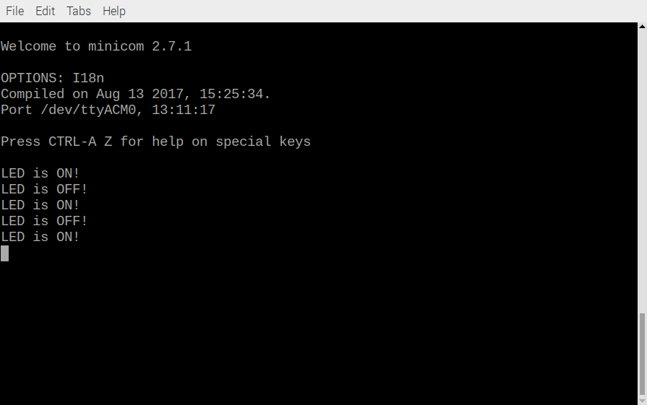

Ultibo
https://github.com/develone/Ultibo_Projects/blob/master/Pauls-pico-receive/RPi3/PicoTest1.lpr

Line 138 if ch = #13 then –> if ch = #10 then

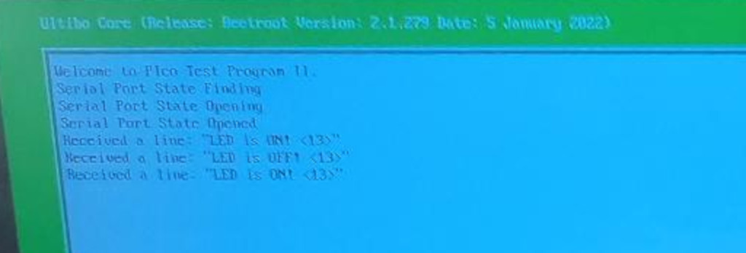
https://github.com/develone/rp2040-freertos-project/blob/master/2tasks/main.c

https://github.com/develone/rp2040-freertos-project/blob/master/2tasks/CMakeLists.txt

