******************Draft******************
Testing the high pass filter and
low pass filter on a RPi4B
05/20/21
******************Draft******************

The Lazarus IDE (Ultibo Edition) is used to link the C library “libfilter.a”. The library is created with script “compile-ultibo.sh”. Depending in which file is in “example.c” “example.c.high” or “example.c.low”

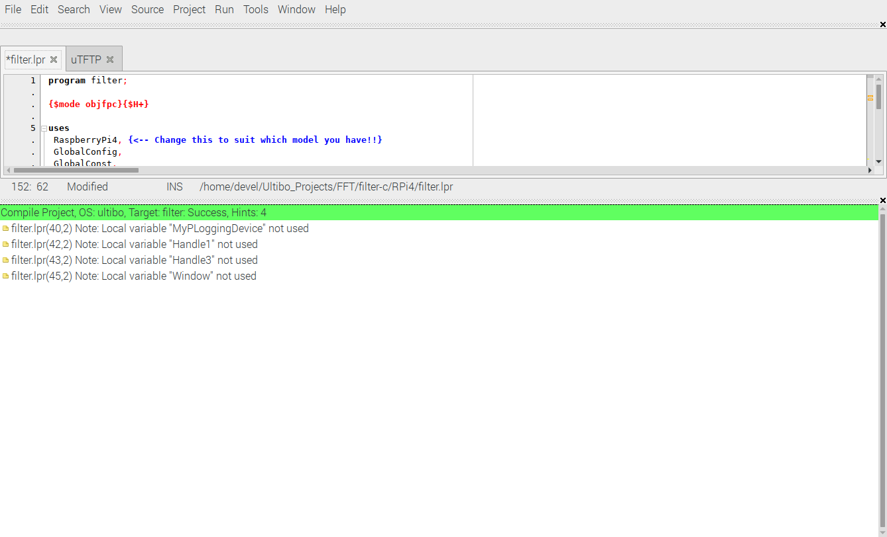
The uTFTP.pas provides the transfer of “kernel7l.img”. In addition it provides a method to send/receive files between RPi4B Ultibo System and the development system.

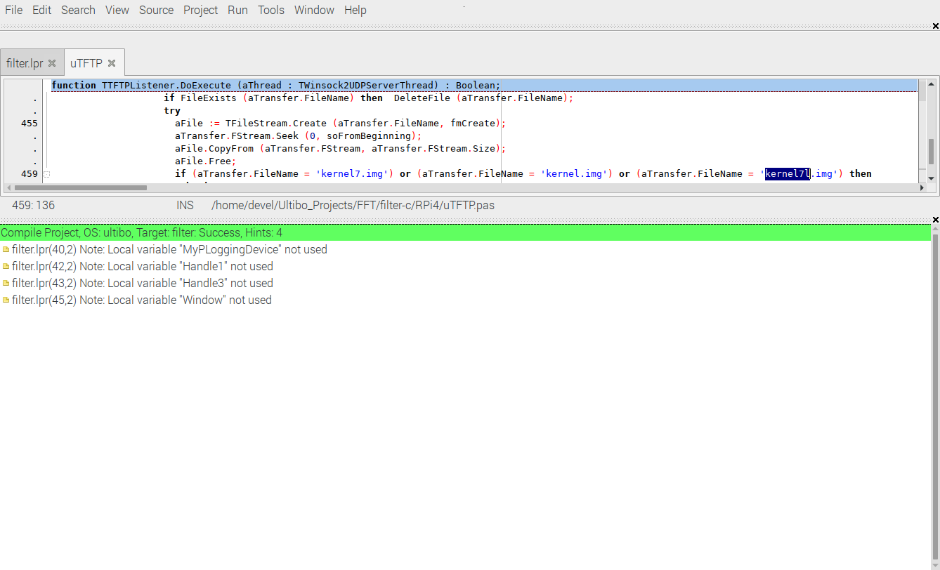
The commad to transfer a new “kernel7l.img” and reboot is “tftp 192.168.1.143 < cmdstftp”

Note: Octave program “sig.m” requires 2 packages “signal-1.4.1.tar.gz” & “control-3.2.0.tar.gz” which first need to be installed. With the commands “pkg install signal-1.4.1.tar.gz” & “pkg install control-3.2.0.tar.gz” the files are extracted in the folder “/home/devel/octave”. There are 14 directories, 487 files.

clear
close all
pkg load signal
order = 6;
fs = 1000;
T = 1/fs; % Sampling period
L = 2048; % Length of signal
t = (0:L-1)*T;
%mysig was created with gensindata(ptrsignal); in example.c
fid = fopen('mysig.bin','r'); mysig = fread(fid, 2048, 'double');
fid = fopen('myfilt.bin','r'); myfilt = fread(fid, 2048, 'double');
figure

plot(1000*t(1:50),mysig(1:50));

Ys = fft(mysig);

P2 = abs(Ys/L);
P1 = P2(1:L/2+1);
P1(2:end-1) = 2*P1(2:end-1);
f = fs*(0:(L/2))/L;
figure
plot(f,P1)

%myfilt was created with bw_low_pass(filter, signal[i])); in example.c
figure

plot(1000*t(1:50),myfilt(1:50));

Ys = fft(myfilt);
P2 = abs(Ys/L);
P1 = P2(1:L/2+1);
P1(2:end-1) = 2*P1(2:end-1);
f = fs*(0:(L/2))/L;
figure
plot(f,P1)

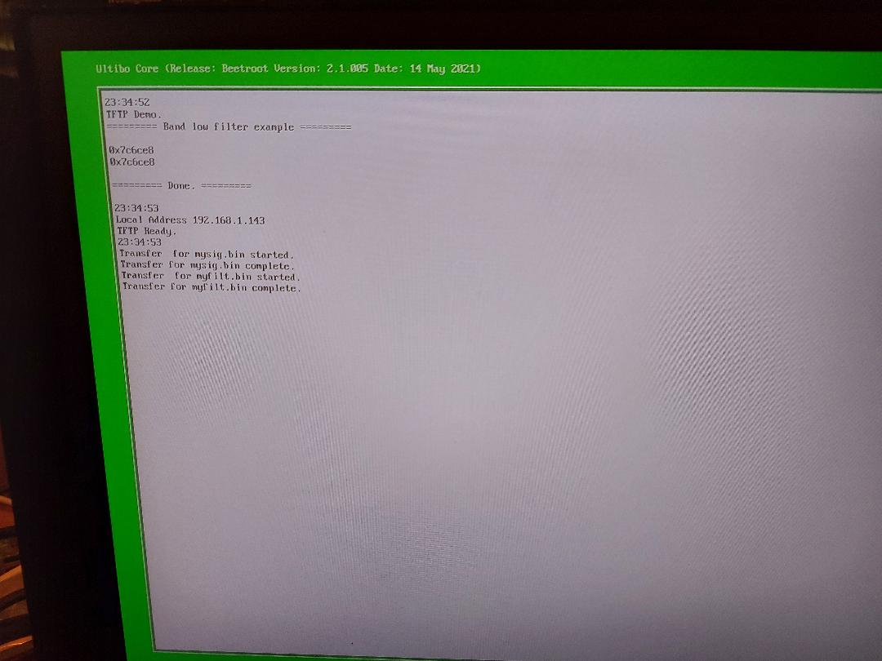
fig1

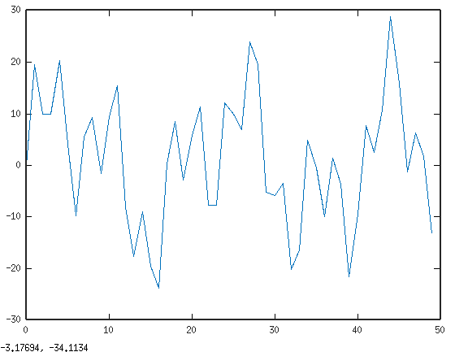

fig2

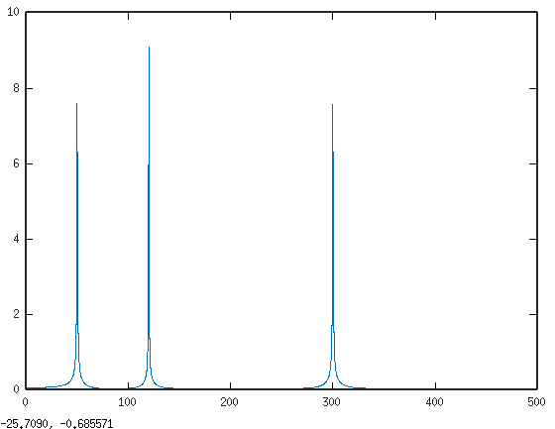
fig3

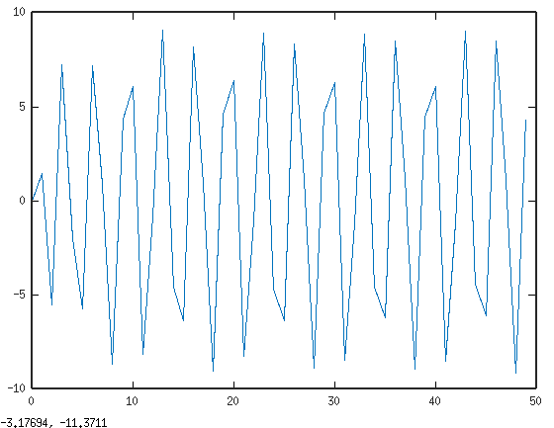

fig4 when example.c.high in example.c

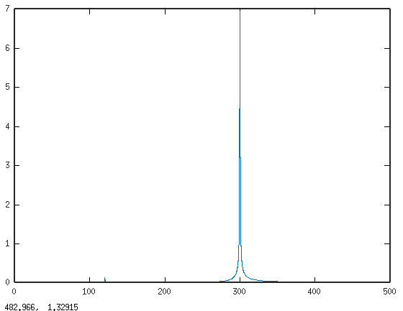

cp example.c.low example.c

./compile-ultibo.sh

cp libfilter.a RPi4

Rebuild the kernel7l.img

tftp 192.168.1.143
tftp> binary
tftp> get mysig.bin
Error code 5: 33461
Received 16384 bytes in 5.0 seconds
tftp> get myfilt.bin
Error code 5: 53947
Received 16384 bytes in 5.0 seconds
tftp> quit

fig4 when example.c.low in example.c

