*****************Draft*****************

NanoVG, NanoSVG, Nuklear
07/13/20
*****************Draft*****************

Downloaded RPi2 from ultibo forum RPi2.zip
https://ultibo.org/forum/download/file.php?id=327&sid=b0c9a16c33c16d7d63413d4b017acc96
stb_image_write.h, Testnanogl.c, and libTestnanogl.a

{$linklib Testnanogl}

procedure glSwapBuffer;export; cdecl;
procedure getMouseXY(var cx: integer; var cy: integer; var btc: integer);export; cdecl;
procedure getScreenSize(var scrWidth: LongWord ; var scrHeight: LongWord);export; cdecl;

procedure test; cdecl; external 'libTestnanogl' name 'test';

This is the initial commit
~/Ultibo_Projects/nano-vg-svg-nuk/RPi2/sdfiles $ md5sum *
9e6230038afeddd6b174d8fa8a19a371 config.txt
5fc4614096c4b753fd940b75b1fa2247 fixup.dat
fb8e67c4e54427fdca9fab410d41ce2e fixup_x.dat
9864d17fa3bcd20738ee9c0c67b2330c start.elf
6fa698231abdd267ba84c4cf3c7ab8d2 start_x.elf

md5sum ~/firmwar_for_ultibo/022720/*
156a886d5855e42a887f0dd9316fb4e3 /home/devel/firmwar_for_ultibo/022720/bootcode.bin
5fc4614096c4b753fd940b75b1fa2247 /home/devel/firmwar_for_ultibo/022720/fixup.dat
fb8e67c4e54427fdca9fab410d41ce2e /home/devel/firmwar_for_ultibo/022720/fixup_x.dat
9864d17fa3bcd20738ee9c0c67b2330c /home/devel/firmwar_for_ultibo/022720/start.elf
6fa698231abdd267ba84c4cf3c7ab8d2 /home/devel/firmwar_for_ultibo/022720/start_x.elf

~/Ultibo_Projects/nano-vg-svg-nuk/RPi2 $ md5sum sdfiles/bootcode.bin sdfiles/config.txt sdfiles/fixup* sdfiles/start*
156a886d5855e42a887f0dd9316fb4e3 sdfiles/bootcode.bin
9e6230038afeddd6b174d8fa8a19a371 sdfiles/config.txt
5fc4614096c4b753fd940b75b1fa2247 sdfiles/fixup.dat
fb8e67c4e54427fdca9fab410d41ce2e sdfiles/fixup_x.dat
9864d17fa3bcd20738ee9c0c67b2330c sdfiles/start.elf
6fa698231abdd267ba84c4cf3c7ab8d2 sdfiles/start_x.elf

home/devel/Ultibo_Projects/OpenGLES/HelloGLES/RPi2/HelloGLES.lpr

07/13/20 with these files on micro sd

diffuse HelloGLES.lpr ../../OpenGLES/HelloGLES/RPi2/HelloGLES.lpr

6-7-20 23:01:16 52304 bootcode.bin
6-7-20 23:01:18 1301 config.txt
6-7-20 23:01:18 4598 cube_constant_blue_01.cob
6-7-20 23:01:18 4694 cube_constant_green_01.cob
6-7-20 23:01:18 4709 cube_constant_red_01.cob
6-7-20 23:01:18 4584 cube_constant_white_01.cob
6-7-20 23:01:18 4694 cube_constant_yellow_01.cob
6-7-20 23:01:18 6745 fixup.dat
6-7-20 23:01:18 9817 fixup_x.dat
6-7-20 23:01:18 2678 height_grass_40_40_01.bmp
6-7-20 23:01:22 <DIR> md2
6-7-20 23:01:30 2884420 start.elf
6-7-20 23:01:30 3798568 start_x.elf
6-7-20 23:01:32 196662 stone256_256_01.bmp
6-7-20 23:01:32 1440054 sunset800_600_03.bmp
13-7-20 18:16:44 3062488 kernel7.img
13-7-20 15:47:48 20468 dump.png
1-1-80 0 MD2ERROR.TXT
1-1-80 0 ERROR.TXT
14-1-03 02:09:24 1440054 cockpit03.bmp
14-1-03 02:09:30 1440054 cockpit03b.bmp
4-7-20 23:00:40 1152054 cockpit03bW.bmp
4-7-20 22:57:52 1152054 cockpit03W.bmp
14-1-03 02:08:26 9462 crosshair01.bmp
14-1-03 02:09:48 1440054 nebblue01.bmp
14-1-03 02:08:36 1440054 nebgreen03.bmp
14-1-03 02:08:36 1440054 nebred01.bmp
14-1-03 02:09:26 230454 tech_char_set_01.bmp
13-7-20 18:13:46 60367 tie04.cob
28 file(s) 21303445 bytes
1 dir(s)

1.
~/Ultibo_Projects/nano-vg-svg-nuk/RPi2 $ tftp 192.168.1.245 < cmdstftp
tftp> tftp> Sent 3062488 bytes in 38.6 seconds

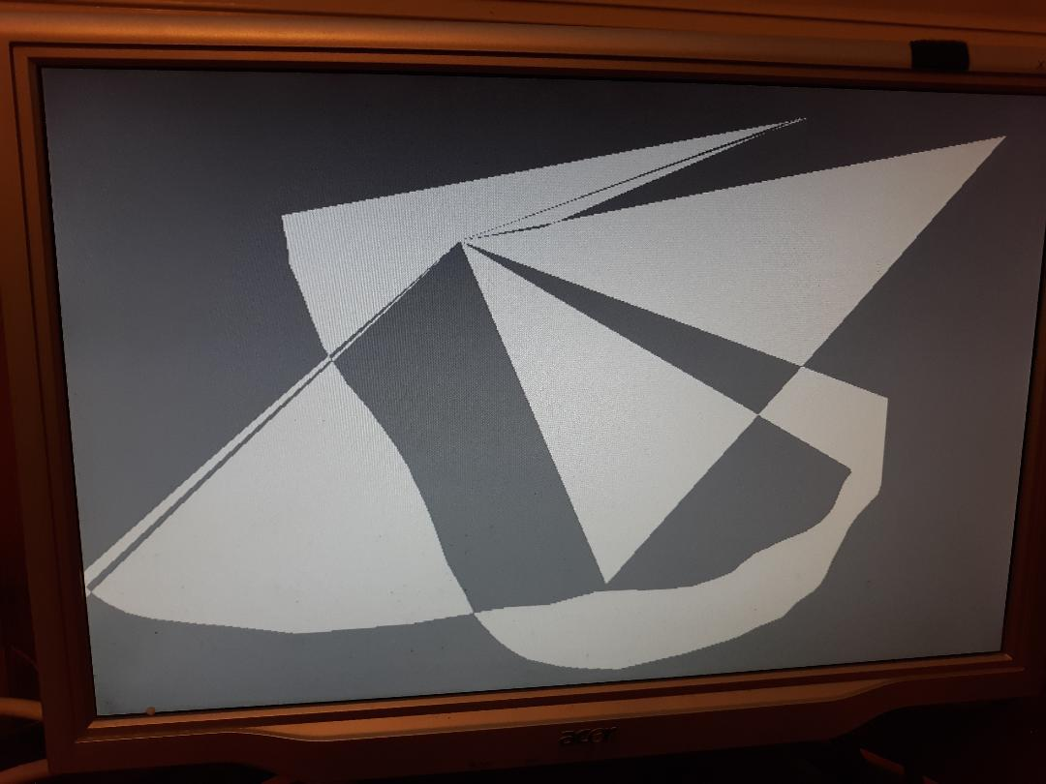

2.
~/Ultibo_Projects/soft-rast-ultibo/RPi3 $ tftp 192.168.1.245 < cmdstftp
tftp> tftp> Sent 3754920 bytes in 24.9 seconds
3.

~/Ultibo_Projects/soft-rast-ultibo/raiders3d_ultibo_source/RPI3 $ tftp 192.168.1.245 < cmdstftp
tftp> tftp> Sent 3250784 bytes in 15.9 seconds

