Testing ultiboinstaller.sh
Ultibo2.5.037
RPi4B 4Gb
05/25/22

Fetch latest (Commits on May 24, 2022) Tools repo. To https://github.com/develone/Tools
ultiboinstaller.sh
sha256sum ultiboinstaller.sh
287f345e9fce6a7473185ce4b873d0b87c535cddd67a444eecca7f8d094c3c1c ultiboinstaller.sh

8d31ff1e9616183fe9d5e7a994bda5444a50dde0
const
{Version constants}
ULTIBO_RELEASE_DATE = '25 May 2022';
ULTIBO_RELEASE_NAME = 'Beetroot';
ULTIBO_RELEASE_VERSION = '2.5.037';
ULTIBO_RELEASE_VERSION_MAJOR = 2;
ULTIBO_RELEASE_VERSION_MINOR = 5;
ULTIBO_RELEASE_VERSION_REVISION = 037;

uname -a
Linux pi4-32 5.15.32-v7l+ #1538 SMP Thu Mar 31 19:39:41 BST 2022 armv7l GNU/Linux
Testing RPi4B 4Gb with a USB hard drive
/dev/root 479626788 98099640 361454524 22% /
/dev/sda1 258095 50411 207685 20% /boot

Build took around 23 minutes.
sudo mksquashfs ultibo ultibo2.5.037-052522.img
Parallel mksquashfs: Using 4 processors
Creating 4.0 filesystem on ultibo2.5.037-052522.img, block size 131072.
[===========================================================|] 56108/56108 100%

Exportable Squashfs 4.0 filesystem, gzip compressed, data block size 131072
compressed data, compressed metadata, compressed fragments,
compressed xattrs, compressed ids
duplicates are removed
Filesystem size 373363.53 Kbytes (364.61 Mbytes)
18.35% of uncompressed filesystem size (2034221.50 Kbytes)
Inode table size 491056 bytes (479.55 Kbytes)
30.01% of uncompressed inode table size (1636320 bytes)
Directory table size 439372 bytes (429.07 Kbytes)
39.83% of uncompressed directory table size (1103248 bytes)
Number of duplicate files found 6471
Number of inodes 49534
Number of files 46468
Number of fragments 5038
Number of symbolic links 4
Number of device nodes 0
Number of fifo nodes 0
Number of socket nodes 0
Number of directories 3062
Number of ids (unique uids + gids) 1
Number of uids 1
devel (1000)
Number of gids 1
devel (1000)

First target RPi4B 4Gb
sudo unsquashfs -d ultibo ultibo2.5.037-052522.img
Parallel unsquashfs: Using 4 processors
46472 inodes (56112 blocks) to write

[===========================================================/] 56112/56112 100%

created 46468 files
created 3062 directories
created 4 symlinks
created 0 devices
created 0 fifos

Testing Lazarus IDE (Ultibo Edition) 2.2.3U

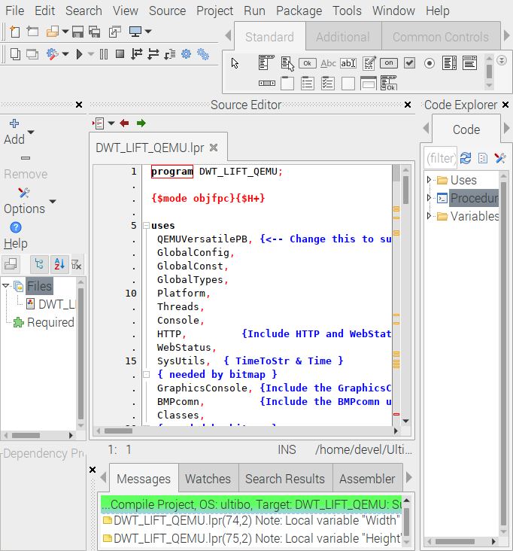
QEMU build

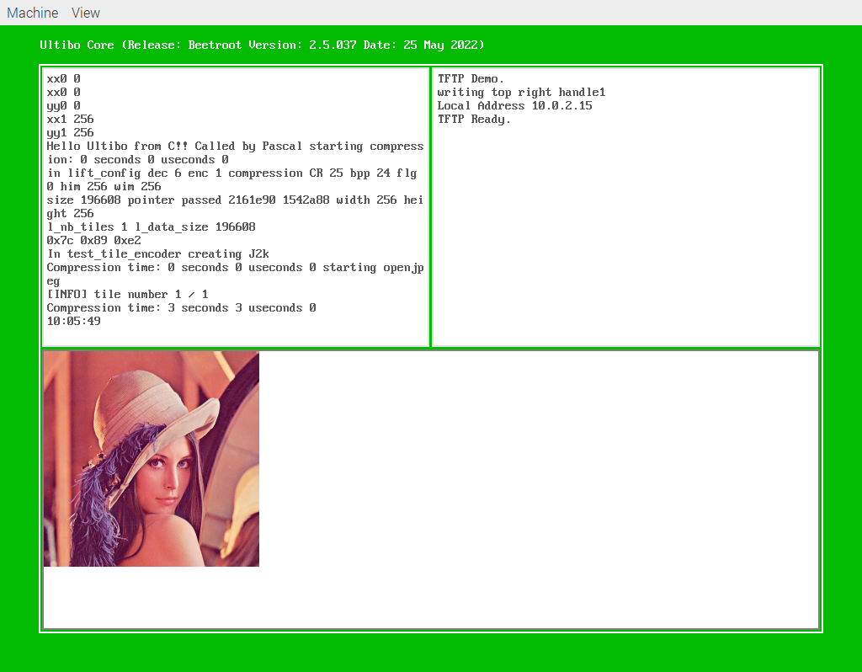

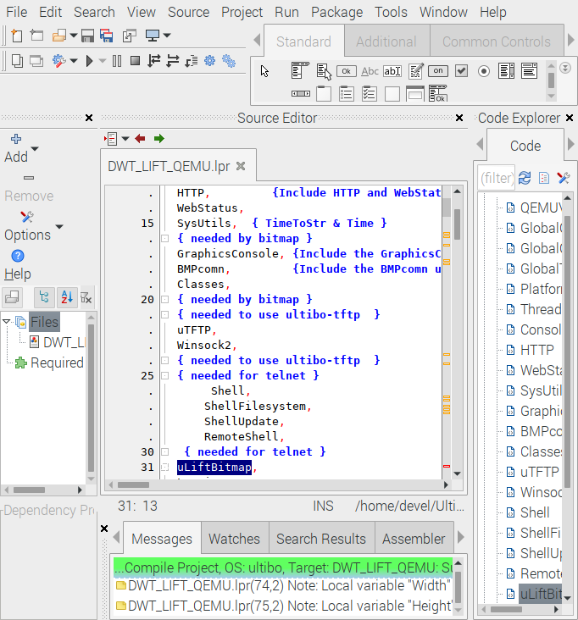
Test Find Declaration
