**********************Draft**********************
Adding Webstatus to AsyncTest
06/12/21
**********************Draft**********************

The kernel7l,img was transferred to Ulitbo System with the following command “tftp 192.168.1.143 < cmdstftp”
tftp> tftp> Sent 2959144 bytes in 8.5 seconds
This new kernel7l.img will reboot.

Contents cmdstftp
binary
put kernel7l.img
quit

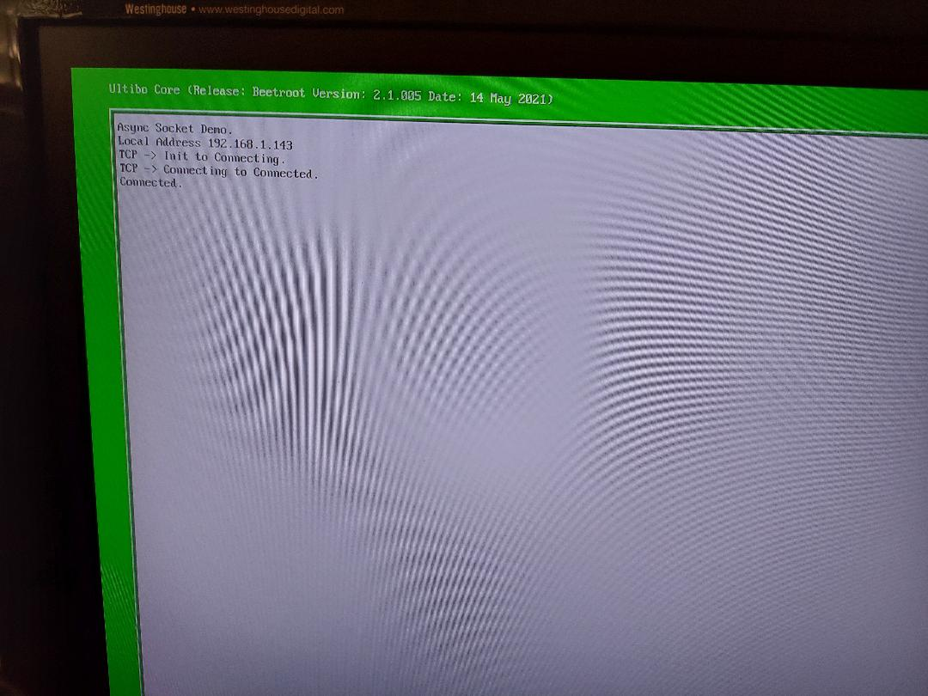
Following the Reboot of Ultibo on RPi4B, if the server was running on Raspberry Pi OS

./server
Socket created successfully
Done with binding

Listening for incoming connections.....
Client connected at IP: 192.168.1.143 and port: 49152

Changes needed to support Webstatus.

git diff AsyncTest.lpr
diff --git a/AsyncTest/RPi4/AsyncTest.lpr b/AsyncTest/RPi4/AsyncTest.lpr
index c25f488..4602862 100644
--- a/AsyncTest/RPi4/AsyncTest.lpr
+++ b/AsyncTest/RPi4/AsyncTest.lpr
@@ -33,7 +33,8 @@ uses
FileSystem, {Include the file system core and interfaces}
FATFS, {Include the FAT file system driver}
MMC, {Include the MMC/SD core to access our SD card}
- BCM2711,
+
+ //BCM2711,
HTTP, {Include HTTP and WebStatus so we can see from a web browser what is happening}
WebStatus
{ Add additional units here };
@@ -43,6 +44,7 @@ var
WindowHandle : TWindowHandle;
IPAddress : string;
ch : char;
+ HTTPListener:THTTPListener;

function display_string (s : string) : string;
var
@@ -118,7 +120,12 @@ begin
aSocket.Addr := '192.168.1.245';
aSocket.Port := 5050;
aSocket.Connect;
-
+ {Create and start the HTTP Listener for our web status page}
+ HTTPListener:=THTTPListener.Create;
+ HTTPListener.Active:=True;
+ Sleep(5000);
+ {Register the web status page, the "Thread List" page will allow us to see what is happening in the example}
+ WebStatusRegister(HTTPListener,'','',True);
while true do
begin
if ConsoleReadChar (ch, nil) then

General
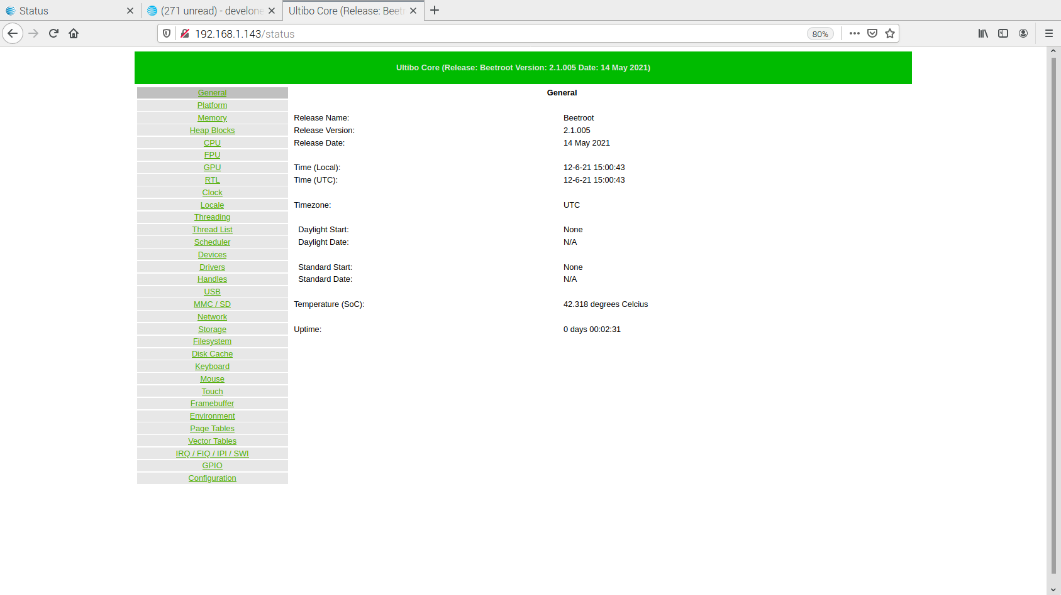

Platform

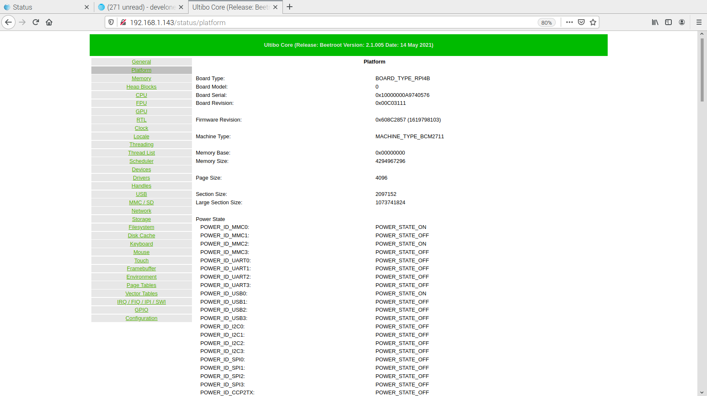

Thread List

