******************Draft******************

Ultibo Files in Examples/08-FileHandling/QEMU to Learn How to use QEMU
07/16/21

******************Draft******************

Goal: To learn how to create an img file that can mouted on RPi4 4B. The folder ~/Ultibo_Projects/Little_Interpreted_Language/img-tests/disk has the files & folder extracted from disk.img. ls disk
'Another File.txt' 'Test File.txt' www.
To use QEMU to run a Bare Metal Ulitibo. The initial Pascal Code was forked from “https://github.com/ultibohub/Examples/tree/master/08-FileHandling/QEMU”. Now I have a repo
“https://github.com/develone/Examples”.
The command to start QEMU “sudo qemu-system-arm -machine versatilepb -kernel kernel.bin -drive file=disk2.img,if=sd,format=raw”

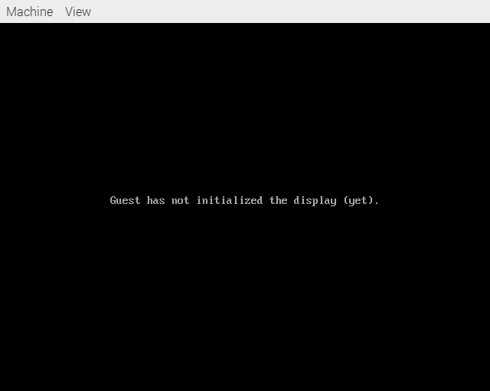

The image below is what expected in QEMU which was run on RPi3B+

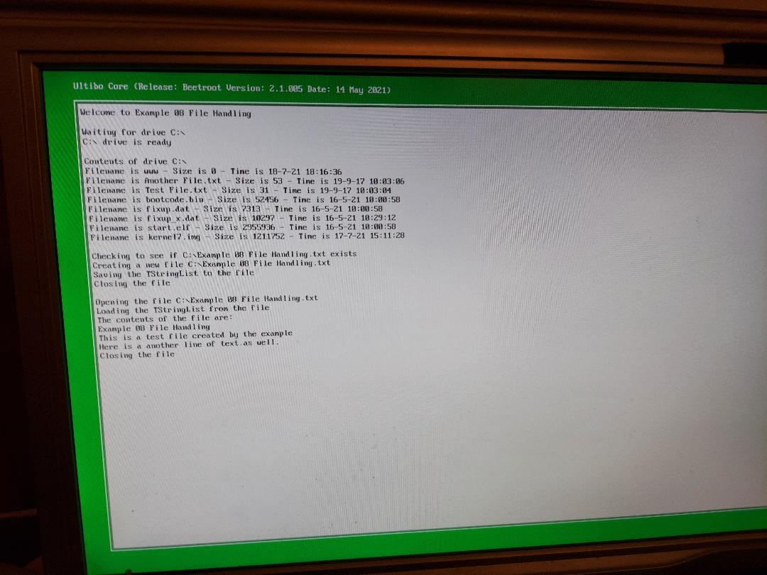
sudo apt-get install qemu-system-arm appears to install both 32 & 64 versions.

These were the programs that were installed.
/usr/bin/qemu-img /usr/bin/qemu-nbd /usr/bin/qemu-system-aarch64
/usr/bin/qemu-io /usr/bin/qemu-pr-helper /usr/bin/qemu-system-arm

qemu-img create -f raw disk1.img 1000M

fdisk disk1.img
Disk /dev/sda: 7.3 GiB, 7864320000 bytes, 15360000 sectors
Disk model: Storage Device
Units: sectors of 1 * 512 = 512 bytes
Sector size (logical/physical): 512 bytes / 512 bytes
I/O size (minimum/optimal): 512 bytes / 512 bytes
Disklabel type: dos
Disk identifier: 0xa46788b6

Device Boot Start End Sectors Size Id Type
/dev/sda1 2048 2047999 2045952 999M b W95 FAT32

