***********************Draft***********************
QEMU Ultibo Bare Metal
07/21/21
***********************Draft***********************

https://en.m.wikipedia.org/wiki/QEMU

QEMU is a hosted virtual machine monitor: it emulates the machine's processor through dynamic binary translation and provides a set of different hardware and device models for the machine, enabling it to run a variety of guest operating systems. It also can be used with Kernel-based Virtual Machine (KVM) to run virtual machines at near-native speed (by taking advantage of hardware extensions such as Intel VT-x). QEMU can also do emulation for user-level processes, allowing applications compiled for one architecture to run on another.[3]

Note : Additional software is needed to run QEMU “sudo apt-get install qemu-system-arm”.
The following programs are added.

/usr/bin/qemu-img /usr/bin/qemu-nbd /usr/bin/qemu-system-aarch64
/usr/bin/qemu-io /usr/bin/qemu-pr-helper /usr/bin/qemu-system-arm

The command line for starting ~/ultibo/core/lazarus.sh Lazarus IDE (Ultibo Edition)

Project/Project Open

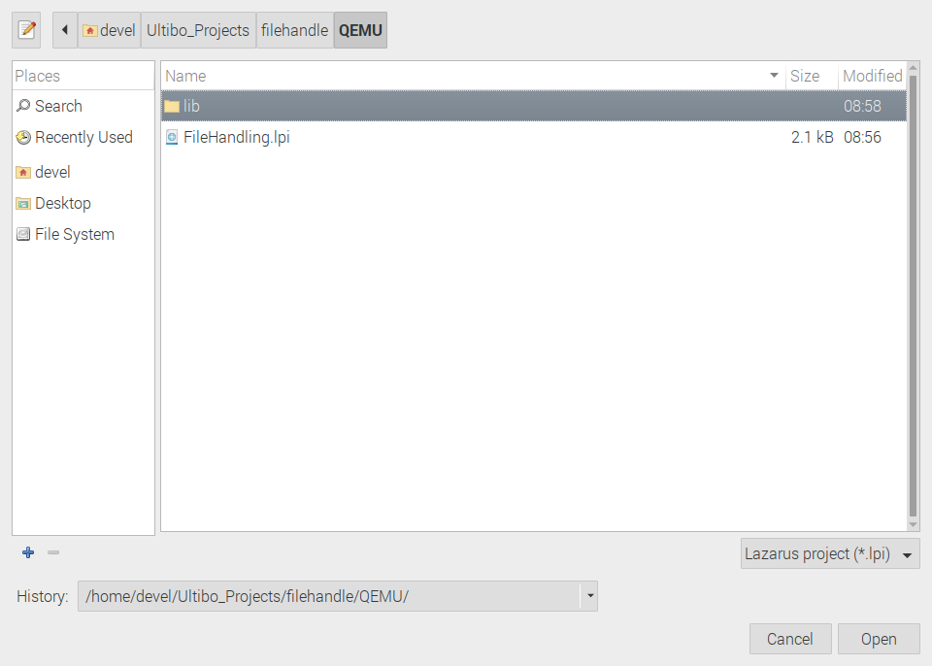
Select FileHanding.lpi

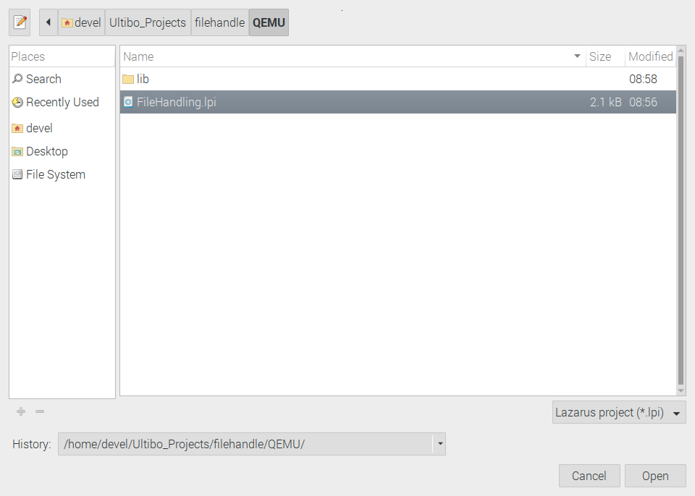

Using Lazarus IDE (Ultibo Edition)

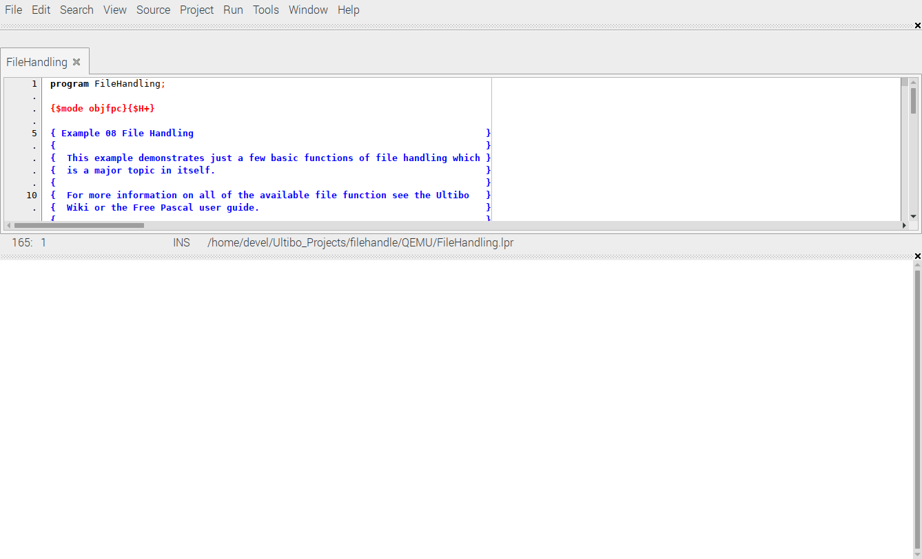
Depress Open

RUN/Compile The kernl.bin is created when the Grean bar appers.

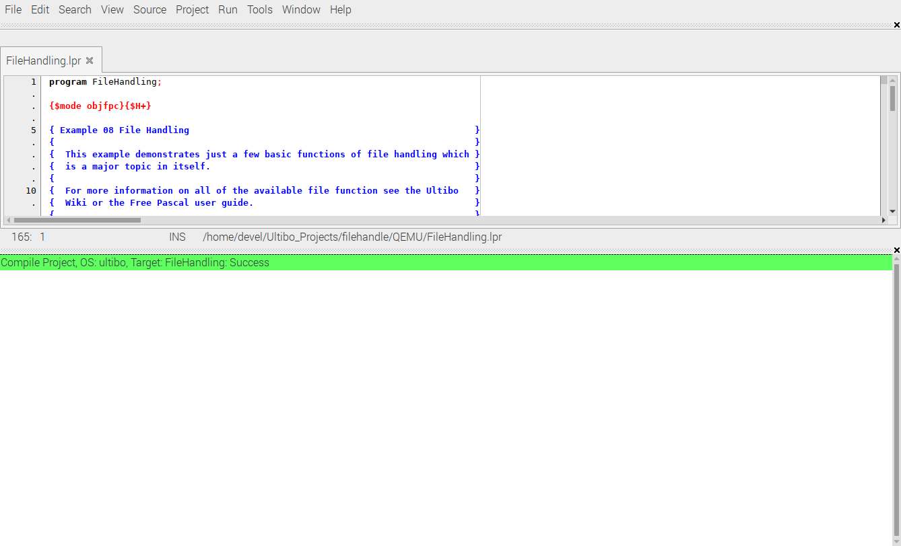
Project/Project Options/Config and Target

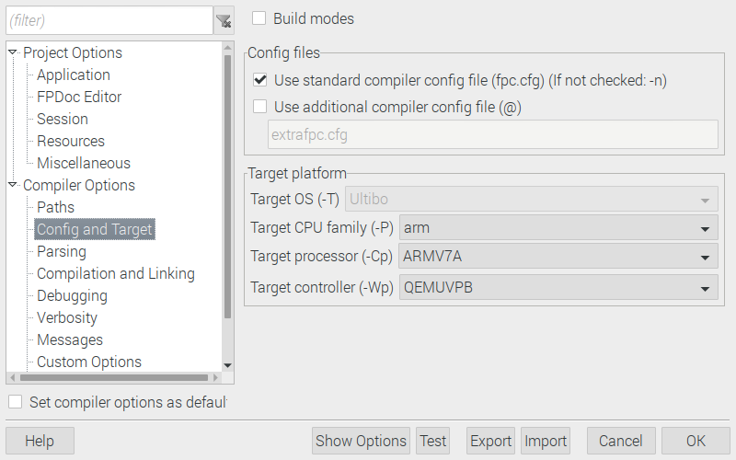

Note: Currently this is not working correctly.

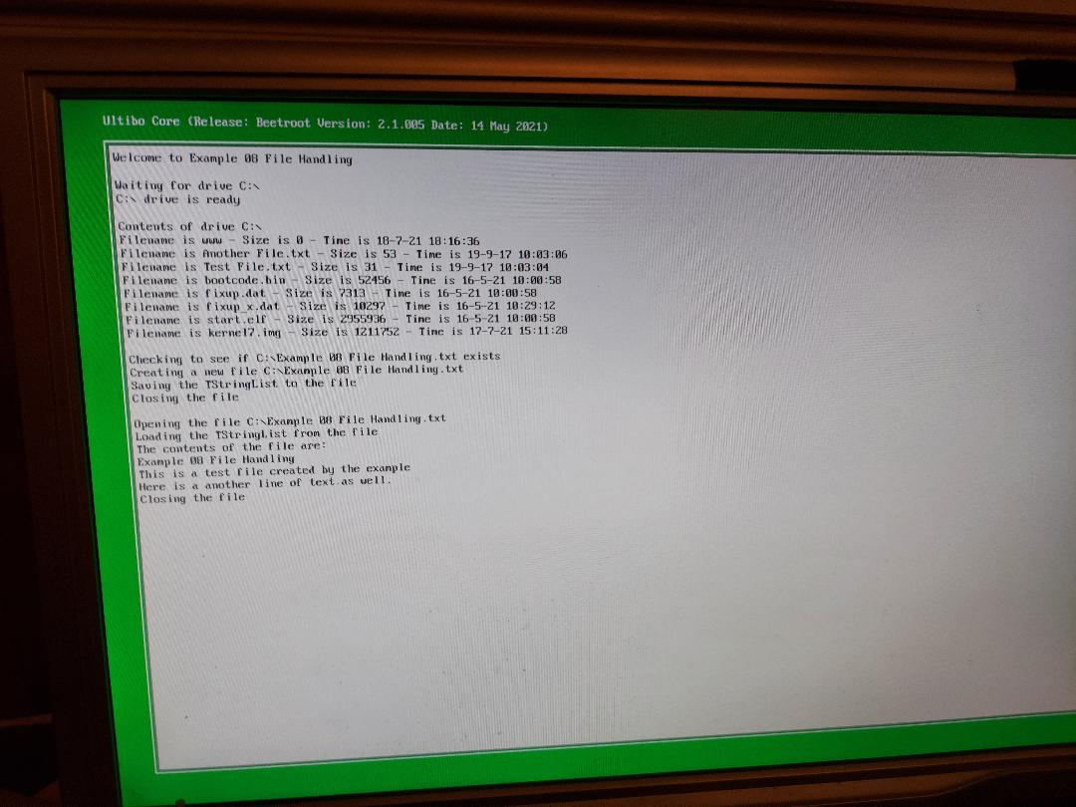
This is an 8Gb

Disk /dev/sda: 7.3 GiB, 7864320000 bytes, 15360000 sectors
Disk model: Storage Device
Units: sectors of 1 * 512 = 512 bytes
Sector size (logical/physical): 512 bytes / 512 bytes
I/O size (minimum/optimal): 512 bytes / 512 bytes
Disklabel type: dos
Disk identifier: 0xa46788b6

Device Boot Start End Sectors Size Id Type
/dev/sda1 2048 2047999 2045952 999M b W95 FAT32

These are the files needed on a micro sd.
'Another File.txt' fixup.dat start.elf
bootcode.bin fixup_x.dat 'Test File.txt'
'Example 08 File Handling.txt' kernel7.img www

devel@mypi3-20:~/Ultibo_Projects/filehandle/QEMU $ ./startqemu.sh
