***********************Draft***********************
QEMU Ultibo Bare Metal
JPEG2000 Compression/Decompression
Remote Shell & WebStatus
with
TFTP transfer between QEMU & PI400
and
Compiling OPENJPEG with cmake
OPENJPEG Decompression
08/01/21
***********************Draft***********************

TFTP was not working between QEMU & Pi400.
Ultibo provided some areas to check. This issue in now is resloved.
https://ultibo.org/forum/viewtopic.php?f=13&t=1303&start=58

The image below provides the areas to check

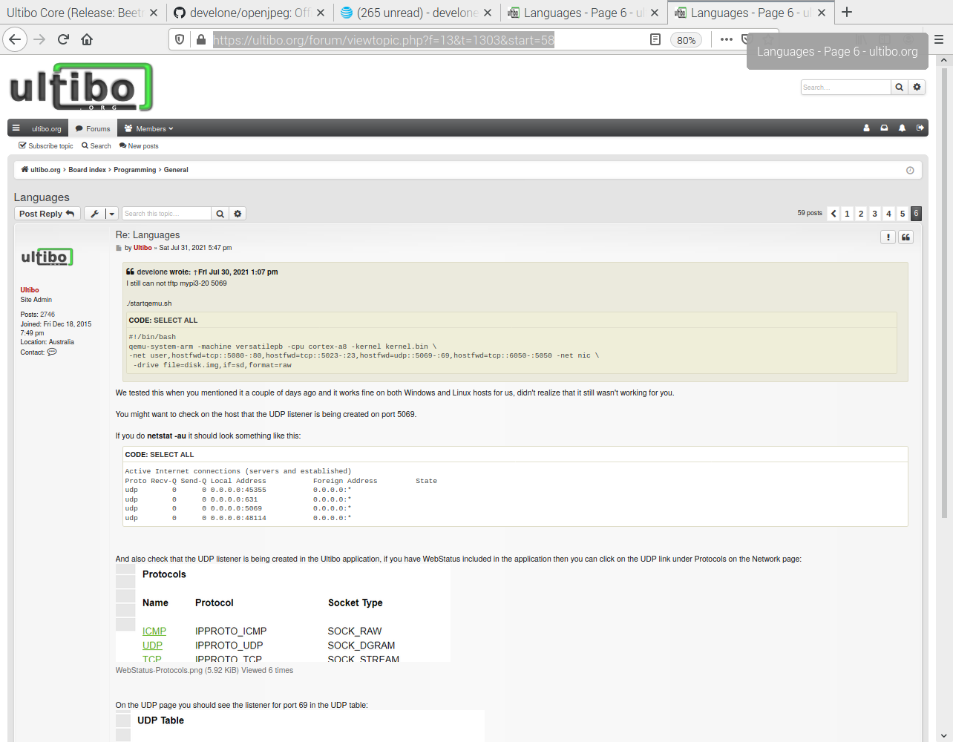

The document ~/Ultibo_Projects/jpeg2000/doc/QEMU-JPEG2000.odt povides detailed steps to create kernel.bin, libdwtlift.a, and libopenjp2.a

devel@pi400-1:~/Ultibo_Projects/jpeg2000/QEMU $ ./startqemu.sh

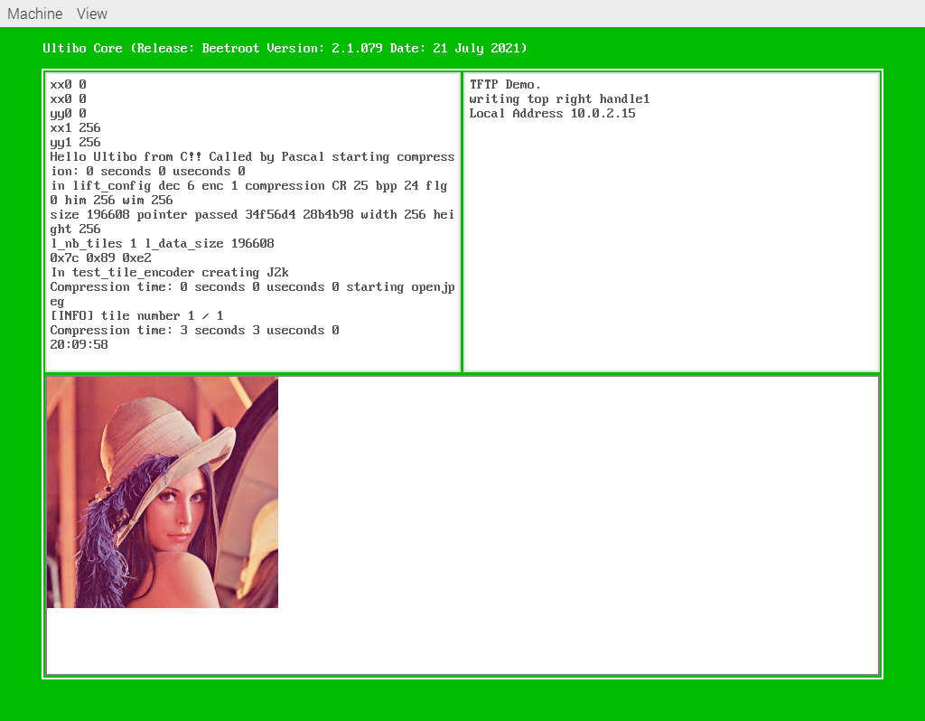
256com
00000000 19 00 00 00 01 00 00 00 00 00 00 00 00 00 00 00 ................
00000010 00 01 00 00 00 01 00 00
This used to determine the compression ratio of 25 and Encode

256decom
00000000 19 00 00 00 00 00 00 00 00 00 00 00 00 00 00 00 ................
00000010 00 01 00 00 00 01 00 00
This used in decompression of test.j2k to test_wr.bmp

The following files 256com copied to testfile lena_rgb_256.bmp copied to MyBitmap.bmp are needed on a disk.img. This will then create a 25:1 compressed test.j2k.

devel@pi400-1:~/t_ultibo/build $ bin/opj_decompress -i ~/Ultibo_Projects/jpeg2000/QEMU/xxx.j2k -o ~/Ultibo_Projects/jpeg2000/QEMU/openjpeg.bmp

[INFO] Start to read j2k main header (0).
[INFO] Main header has been correctly decoded.
[INFO] No decoded area parameters, set the decoded area to the whole image
[INFO] Header of tile 1 / 1 has been read.
[INFO] Generated Outfile /home/devel/Ultibo_Projects/jpeg2000/QEMU/openjpeg.bmp
decode time: 24 ms
devel@pi400-1:~/t_ultibo/build $ gpicview ~/Ultibo_Projects/jpeg2000/QEMU/openjpeg.bmp
^C
devel@pi400-1:~/t_ultibo/build $ bin/opj_dump ~/Ultibo_Projects/jpeg2000/QEMU/xxx.j2k
[ERROR] Required parameter is missing
Example: bin/opj_dump -i image.j2k
Help: bin/opj_dump -h

devel@pi400-1:~/Ultibo_Projects/jpeg2000/QEMU $ tftp pi400-1 5069
tftp> binary
tftp> trace
Packet tracing on.
tftp> get test.j2k xxx.j2k
sent RRQ <file=test.j2k, mode=octet>
received DATA <block=1, 512 bytes>
sent ACK <block=1>
received DATA <block=2, 512 bytes>
sent ACK <block=2>
received DATA <block=3, 512 bytes>
sent ACK <block=3>
received DATA <block=4, 512 bytes>
sent ACK <block=4>
received DATA <block=5, 512 bytes>
sent ACK <block=5>
received DATA <block=6, 512 bytes>
sent ACK <block=6>
received DATA <block=7, 512 bytes>
sent ACK <block=7>
received DATA <block=8, 512 bytes>
sent ACK <block=8>
received DATA <block=9, 512 bytes>
sent ACK <block=9>
received DATA <block=10, 512 bytes>
sent ACK <block=10>
received DATA <block=11, 512 bytes>
sent ACK <block=11>
received DATA <block=12, 512 bytes>
sent ACK <block=12>
received DATA <block=13, 512 bytes>
sent ACK <block=13>
received DATA <block=14, 512 bytes>
sent ACK <block=14>
received DATA <block=15, 512 bytes>
sent ACK <block=15>
received DATA <block=16, 168 bytes>
Received 7848 bytes in 0.2 seconds
tftp> quit

Cloning repo openjpeg into folder t_ultibo.

devel@pi400-1:~ $ git clone https://github.com/develone/openjpeg.git t_ultibo

devel@pi400-1:~ $ cd t_ultibo/

devel@pi400-1:~/t_ultibo $ mkdir build

devel@pi400-1:~/t_ultibo $ cd build/

devel@pi400-1:~/t_ultibo/build $ cmake ../
-- The C compiler identification is GNU 8.3.0
-- The CXX compiler identification is GNU 8.3.0
-- Check for working C compiler: /usr/bin/cc
-- Check for working C compiler: /usr/bin/cc -- works
-- Detecting C compiler ABI info
-- Detecting C compiler ABI info - done
-- Detecting C compile features
-- Detecting C compile features - done
-- Check for working CXX compiler: /usr/bin/c++
-- Check for working CXX compiler: /usr/bin/c++ -- works
-- Detecting CXX compiler ABI info
-- Detecting CXX compiler ABI info - done
-- Detecting CXX compile features
-- Detecting CXX compile features - done
-- Check if the system is big endian
-- Searching 16 bit integer
-- Looking for sys/types.h
-- Looking for sys/types.h - found
-- Looking for stdint.h
-- Looking for stdint.h - found
-- Looking for stddef.h
-- Looking for stddef.h - found
-- Check size of unsigned short
-- Check size of unsigned short - done
-- Using unsigned short
-- Check if the system is big endian - little endian
-- Looking for string.h
-- Looking for string.h - found
-- Looking for memory.h
-- Looking for memory.h - found
-- Looking for stdlib.h
-- Looking for stdlib.h - found
-- Looking for stdio.h
-- Looking for stdio.h - found
-- Looking for math.h
-- Looking for math.h - found
-- Looking for float.h
-- Looking for float.h - found
-- Looking for time.h
-- Looking for time.h - found
-- Looking for stdarg.h
-- Looking for stdarg.h - found
-- Looking for ctype.h
-- Looking for ctype.h - found
-- Looking for assert.h
-- Looking for assert.h - found
-- Looking for stdint.h
-- Looking for stdint.h - found
-- Looking for inttypes.h
-- Looking for inttypes.h - found
-- Looking for strings.h
-- Looking for strings.h - found
-- Looking for sys/stat.h
-- Looking for sys/stat.h - found
-- Looking for unistd.h
-- Looking for unistd.h - found
-- Checking for 64-bit off_t
-- Checking for 64-bit off_t - present with _FILE_OFFSET_BITS=64
-- Checking for fseeko/ftello
-- Checking for fseeko/ftello - present
-- Large File support - found
-- Looking for include file malloc.h
-- Looking for include file malloc.h - found
-- Looking for _aligned_malloc
-- Looking for _aligned_malloc - not found
-- Looking for posix_memalign
-- Looking for posix_memalign - found
-- Looking for memalign
-- Looking for memalign - found
-- Found ZLIB: /usr/lib/arm-linux-gnueabihf/libz.so (found version "1.2.11")
-- Your system seems to have a Z lib available, we will use it to generate PNG lib
-- Found PNG: /usr/lib/arm-linux-gnueabihf/libpng.so (found version "1.6.36")
-- Your system seems to have a PNG lib available, we will use it
-- Found TIFF: /usr/lib/arm-linux-gnueabihf/libtiff.so (found version "4.1.0")
-- Your system seems to have a TIFF lib available, we will use it
-- Could NOT find LCMS2 (missing: LCMS2_LIBRARY LCMS2_INCLUDE_DIR)
-- Could NOT find LCMS (missing: LCMS_LIBRARY LCMS_INCLUDE_DIR)
-- LCMS2 or LCMS lib not found, activate BUILD_THIRDPARTY if you want build it
-- Configuring done
-- Generating done
-- Build files have been written to: /home/devel/t_ultibo/build

devel@pi400-1:~/t_ultibo/build $ make
Scanning dependencies of target openjp2
[ 1%] Building C object src/lib/openjp2/CMakeFiles/openjp2.dir/thread.c.o
[ 2%] Building C object src/lib/openjp2/CMakeFiles/openjp2.dir/bio.c.o
[ 4%] Building C object src/lib/openjp2/CMakeFiles/openjp2.dir/cio.c.o
[ 5%] Building C object src/lib/openjp2/CMakeFiles/openjp2.dir/dwt.c.o
[ 7%] Building C object src/lib/openjp2/CMakeFiles/openjp2.dir/event.c.o
[ 8%] Building C object src/lib/openjp2/CMakeFiles/openjp2.dir/image.c.o
[ 9%] Building C object src/lib/openjp2/CMakeFiles/openjp2.dir/invert.c.o
[ 11%] Building C object src/lib/openjp2/CMakeFiles/openjp2.dir/j2k.c.o
[ 12%] Building C object src/lib/openjp2/CMakeFiles/openjp2.dir/jp2.c.o
[ 14%] Building C object src/lib/openjp2/CMakeFiles/openjp2.dir/mct.c.o
[ 15%] Building C object src/lib/openjp2/CMakeFiles/openjp2.dir/mqc.c.o
[ 16%] Building C object src/lib/openjp2/CMakeFiles/openjp2.dir/openjpeg.c.o
/home/devel/t_ultibo/src/lib/openjp2/openjpeg.c: In function ‘opj_stream_create_file_stream’:
/home/devel/t_ultibo/src/lib/openjp2/openjpeg.c:1041:30: warning: cast between incompatible function types from ‘int (*)(FILE *)’ {aka ‘int (*)(struct _IO_FILE *)’} to ‘void (*)(void *)’ [-Wcast-function-type]
(opj_stream_free_user_data_fn) fclose);
^
[ 18%] Building C object src/lib/openjp2/CMakeFiles/openjp2.dir/opj_clock.c.o
[ 19%] Building C object src/lib/openjp2/CMakeFiles/openjp2.dir/pi.c.o
/home/devel/t_ultibo/src/lib/openjp2/pi.c: In function ‘opj_pi_next_rpcl’:
/home/devel/t_ultibo/src/lib/openjp2/pi.c:373:23: warning: conversion to ‘OPJ_INT32’ {aka ‘int’} from ‘OPJ_UINT32’ {aka ‘unsigned int’} may change the sign of the result [-Wsign-conversion]
pi->poc.ty0 = pi->ty0;
^~
/home/devel/t_ultibo/src/lib/openjp2/pi.c:374:23: warning: conversion to ‘OPJ_INT32’ {aka ‘int’} from ‘OPJ_UINT32’ {aka ‘unsigned int’} may change the sign of the result [-Wsign-conversion]
pi->poc.tx0 = pi->tx0;
^~
/home/devel/t_ultibo/src/lib/openjp2/pi.c:375:23: warning: conversion to ‘OPJ_INT32’ {aka ‘int’} from ‘OPJ_UINT32’ {aka ‘unsigned int’} may change the sign of the result [-Wsign-conversion]
pi->poc.ty1 = pi->ty1;
^~
/home/devel/t_ultibo/src/lib/openjp2/pi.c:376:23: warning: conversion to ‘OPJ_INT32’ {aka ‘int’} from ‘OPJ_UINT32’ {aka ‘unsigned int’} may change the sign of the result [-Wsign-conversion]
pi->poc.tx1 = pi->tx1;
^~
/home/devel/t_ultibo/src/lib/openjp2/pi.c:407:46: warning: conversion to ‘OPJ_INT32’ {aka ‘int’} from ‘OPJ_UINT32’ {aka ‘unsigned int’} may change the sign of the result [-Wsign-conversion]
trx0 = opj_int_ceildiv(pi->tx0, (OPJ_INT32)(comp->dx << levelno));
~~^~~~~
/home/devel/t_ultibo/src/lib/openjp2/pi.c:408:46: warning: conversion to ‘OPJ_INT32’ {aka ‘int’} from ‘OPJ_UINT32’ {aka ‘unsigned int’} may change the sign of the result [-Wsign-conversion]
try0 = opj_int_ceildiv(pi->ty0, (OPJ_INT32)(comp->dy << levelno));
~~^~~~~
/home/devel/t_ultibo/src/lib/openjp2/pi.c:409:46: warning: conversion to ‘OPJ_INT32’ {aka ‘int’} from ‘OPJ_UINT32’ {aka ‘unsigned int’} may change the sign of the result [-Wsign-conversion]
trx1 = opj_int_ceildiv(pi->tx1, (OPJ_INT32)(comp->dx << levelno));
~~^~~~~
/home/devel/t_ultibo/src/lib/openjp2/pi.c:410:46: warning: conversion to ‘OPJ_INT32’ {aka ‘int’} from ‘OPJ_UINT32’ {aka ‘unsigned int’} may change the sign of the result [-Wsign-conversion]
try1 = opj_int_ceildiv(pi->ty1, (OPJ_INT32)(comp->dy << levelno));
~~^~~~~
/home/devel/t_ultibo/src/lib/openjp2/pi.c:424:34: warning: conversion to ‘OPJ_UINT32’ {aka ‘unsigned int’} from ‘int’ may change the sign of the result [-Wsign-conversion]
if (!((pi->y % (OPJ_INT32)(comp->dy << rpy) == 0) || ((pi->y == pi->ty0) &&
^
/home/devel/t_ultibo/src/lib/openjp2/pi.c:428:34: warning: conversion to ‘OPJ_UINT32’ {aka ‘unsigned int’} from ‘int’ may change the sign of the result [-Wsign-conversion]
if (!((pi->x % (OPJ_INT32)(comp->dx << rpx) == 0) || ((pi->x == pi->tx0) &&
^
/home/devel/t_ultibo/src/lib/openjp2/pi.c:441:67: warning: conversion to ‘OPJ_INT32’ {aka ‘int’} from ‘OPJ_UINT32’ {aka ‘unsigned int’} may change the sign of the result [-Wsign-conversion]
prci = opj_int_floordivpow2(opj_int_ceildiv(pi->x,
~~^~~
/home/devel/t_ultibo/src/lib/openjp2/pi.c:444:67: warning: conversion to ‘OPJ_INT32’ {aka ‘int’} from ‘OPJ_UINT32’ {aka ‘unsigned int’} may change the sign of the result [-Wsign-conversion]
prcj = opj_int_floordivpow2(opj_int_ceildiv(pi->y,
~~^~~
/home/devel/t_ultibo/src/lib/openjp2/pi.c: In function ‘opj_pi_next_pcrl’:
/home/devel/t_ultibo/src/lib/openjp2/pi.c:506:23: warning: conversion to ‘OPJ_INT32’ {aka ‘int’} from ‘OPJ_UINT32’ {aka ‘unsigned int’} may change the sign of the result [-Wsign-conversion]
pi->poc.ty0 = pi->ty0;
^~
/home/devel/t_ultibo/src/lib/openjp2/pi.c:507:23: warning: conversion to ‘OPJ_INT32’ {aka ‘int’} from ‘OPJ_UINT32’ {aka ‘unsigned int’} may change the sign of the result [-Wsign-conversion]
pi->poc.tx0 = pi->tx0;
^~
/home/devel/t_ultibo/src/lib/openjp2/pi.c:508:23: warning: conversion to ‘OPJ_INT32’ {aka ‘int’} from ‘OPJ_UINT32’ {aka ‘unsigned int’} may change the sign of the result [-Wsign-conversion]
pi->poc.ty1 = pi->ty1;
^~
/home/devel/t_ultibo/src/lib/openjp2/pi.c:509:23: warning: conversion to ‘OPJ_INT32’ {aka ‘int’} from ‘OPJ_UINT32’ {aka ‘unsigned int’} may change the sign of the result [-Wsign-conversion]
pi->poc.tx1 = pi->tx1;
^~
/home/devel/t_ultibo/src/lib/openjp2/pi.c:538:46: warning: conversion to ‘OPJ_INT32’ {aka ‘int’} from ‘OPJ_UINT32’ {aka ‘unsigned int’} may change the sign of the result [-Wsign-conversion]
trx0 = opj_int_ceildiv(pi->tx0, (OPJ_INT32)(comp->dx << levelno));
~~^~~~~
/home/devel/t_ultibo/src/lib/openjp2/pi.c:539:46: warning: conversion to ‘OPJ_INT32’ {aka ‘int’} from ‘OPJ_UINT32’ {aka ‘unsigned int’} may change the sign of the result [-Wsign-conversion]
try0 = opj_int_ceildiv(pi->ty0, (OPJ_INT32)(comp->dy << levelno));
~~^~~~~
/home/devel/t_ultibo/src/lib/openjp2/pi.c:540:46: warning: conversion to ‘OPJ_INT32’ {aka ‘int’} from ‘OPJ_UINT32’ {aka ‘unsigned int’} may change the sign of the result [-Wsign-conversion]
trx1 = opj_int_ceildiv(pi->tx1, (OPJ_INT32)(comp->dx << levelno));
~~^~~~~
/home/devel/t_ultibo/src/lib/openjp2/pi.c:541:46: warning: conversion to ‘OPJ_INT32’ {aka ‘int’} from ‘OPJ_UINT32’ {aka ‘unsigned int’} may change the sign of the result [-Wsign-conversion]
try1 = opj_int_ceildiv(pi->ty1, (OPJ_INT32)(comp->dy << levelno));
~~^~~~~
/home/devel/t_ultibo/src/lib/openjp2/pi.c:555:34: warning: conversion to ‘OPJ_UINT32’ {aka ‘unsigned int’} from ‘int’ may change the sign of the result [-Wsign-conversion]
if (!((pi->y % (OPJ_INT32)(comp->dy << rpy) == 0) || ((pi->y == pi->ty0) &&
^
/home/devel/t_ultibo/src/lib/openjp2/pi.c:559:34: warning: conversion to ‘OPJ_UINT32’ {aka ‘unsigned int’} from ‘int’ may change the sign of the result [-Wsign-conversion]
if (!((pi->x % (OPJ_INT32)(comp->dx << rpx) == 0) || ((pi->x == pi->tx0) &&
^
/home/devel/t_ultibo/src/lib/openjp2/pi.c:572:67: warning: conversion to ‘OPJ_INT32’ {aka ‘int’} from ‘OPJ_UINT32’ {aka ‘unsigned int’} may change the sign of the result [-Wsign-conversion]
prci = opj_int_floordivpow2(opj_int_ceildiv(pi->x,
~~^~~
/home/devel/t_ultibo/src/lib/openjp2/pi.c:575:67: warning: conversion to ‘OPJ_INT32’ {aka ‘int’} from ‘OPJ_UINT32’ {aka ‘unsigned int’} may change the sign of the result [-Wsign-conversion]
prcj = opj_int_floordivpow2(opj_int_ceildiv(pi->y,
~~^~~
/home/devel/t_ultibo/src/lib/openjp2/pi.c: In function ‘opj_pi_next_cprl’:
/home/devel/t_ultibo/src/lib/openjp2/pi.c:637:27: warning: conversion to ‘OPJ_INT32’ {aka ‘int’} from ‘OPJ_UINT32’ {aka ‘unsigned int’} may change the sign of the result [-Wsign-conversion]
pi->poc.ty0 = pi->ty0;
^~
/home/devel/t_ultibo/src/lib/openjp2/pi.c:638:27: warning: conversion to ‘OPJ_INT32’ {aka ‘int’} from ‘OPJ_UINT32’ {aka ‘unsigned int’} may change the sign of the result [-Wsign-conversion]
pi->poc.tx0 = pi->tx0;
^~
/home/devel/t_ultibo/src/lib/openjp2/pi.c:639:27: warning: conversion to ‘OPJ_INT32’ {aka ‘int’} from ‘OPJ_UINT32’ {aka ‘unsigned int’} may change the sign of the result [-Wsign-conversion]
pi->poc.ty1 = pi->ty1;
^~
/home/devel/t_ultibo/src/lib/openjp2/pi.c:640:27: warning: conversion to ‘OPJ_INT32’ {aka ‘int’} from ‘OPJ_UINT32’ {aka ‘unsigned int’} may change the sign of the result [-Wsign-conversion]
pi->poc.tx1 = pi->tx1;
^~
/home/devel/t_ultibo/src/lib/openjp2/pi.c:666:46: warning: conversion to ‘OPJ_INT32’ {aka ‘int’} from ‘OPJ_UINT32’ {aka ‘unsigned int’} may change the sign of the result [-Wsign-conversion]
trx0 = opj_int_ceildiv(pi->tx0, (OPJ_INT32)(comp->dx << levelno));
~~^~~~~
/home/devel/t_ultibo/src/lib/openjp2/pi.c:667:46: warning: conversion to ‘OPJ_INT32’ {aka ‘int’} from ‘OPJ_UINT32’ {aka ‘unsigned int’} may change the sign of the result [-Wsign-conversion]
try0 = opj_int_ceildiv(pi->ty0, (OPJ_INT32)(comp->dy << levelno));
~~^~~~~
/home/devel/t_ultibo/src/lib/openjp2/pi.c:668:46: warning: conversion to ‘OPJ_INT32’ {aka ‘int’} from ‘OPJ_UINT32’ {aka ‘unsigned int’} may change the sign of the result [-Wsign-conversion]
trx1 = opj_int_ceildiv(pi->tx1, (OPJ_INT32)(comp->dx << levelno));
~~^~~~~
/home/devel/t_ultibo/src/lib/openjp2/pi.c:669:46: warning: conversion to ‘OPJ_INT32’ {aka ‘int’} from ‘OPJ_UINT32’ {aka ‘unsigned int’} may change the sign of the result [-Wsign-conversion]
try1 = opj_int_ceildiv(pi->ty1, (OPJ_INT32)(comp->dy << levelno));
~~^~~~~
/home/devel/t_ultibo/src/lib/openjp2/pi.c:683:34: warning: conversion to ‘OPJ_UINT32’ {aka ‘unsigned int’} from ‘int’ may change the sign of the result [-Wsign-conversion]
if (!((pi->y % (OPJ_INT32)(comp->dy << rpy) == 0) || ((pi->y == pi->ty0) &&
^
/home/devel/t_ultibo/src/lib/openjp2/pi.c:687:34: warning: conversion to ‘OPJ_UINT32’ {aka ‘unsigned int’} from ‘int’ may change the sign of the result [-Wsign-conversion]
if (!((pi->x % (OPJ_INT32)(comp->dx << rpx) == 0) || ((pi->x == pi->tx0) &&
^
/home/devel/t_ultibo/src/lib/openjp2/pi.c:700:67: warning: conversion to ‘OPJ_INT32’ {aka ‘int’} from ‘OPJ_UINT32’ {aka ‘unsigned int’} may change the sign of the result [-Wsign-conversion]
prci = opj_int_floordivpow2(opj_int_ceildiv(pi->x,
~~^~~
/home/devel/t_ultibo/src/lib/openjp2/pi.c:703:67: warning: conversion to ‘OPJ_INT32’ {aka ‘int’} from ‘OPJ_UINT32’ {aka ‘unsigned int’} may change the sign of the result [-Wsign-conversion]
prcj = opj_int_floordivpow2(opj_int_ceildiv(pi->y,
~~^~~
/home/devel/t_ultibo/src/lib/openjp2/pi.c: In function ‘opj_pi_create_decode’:
/home/devel/t_ultibo/src/lib/openjp2/pi.c:1459:25: warning: conversion to ‘OPJ_UINT32’ {aka ‘unsigned int’} from ‘OPJ_INT32’ {aka ‘int’} may change the sign of the result [-Wsign-conversion]
l_current_pi->tx0 = l_tx0;
^~~~~
/home/devel/t_ultibo/src/lib/openjp2/pi.c:1460:25: warning: conversion to ‘OPJ_UINT32’ {aka ‘unsigned int’} from ‘OPJ_INT32’ {aka ‘int’} may change the sign of the result [-Wsign-conversion]
l_current_pi->ty0 = l_ty0;
^~~~~
/home/devel/t_ultibo/src/lib/openjp2/pi.c:1461:25: warning: conversion to ‘OPJ_UINT32’ {aka ‘unsigned int’} from ‘OPJ_INT32’ {aka ‘int’} may change the sign of the result [-Wsign-conversion]
l_current_pi->tx1 = l_tx1;
^~~~~
/home/devel/t_ultibo/src/lib/openjp2/pi.c:1462:25: warning: conversion to ‘OPJ_UINT32’ {aka ‘unsigned int’} from ‘OPJ_INT32’ {aka ‘int’} may change the sign of the result [-Wsign-conversion]
l_current_pi->ty1 = l_ty1;
^~~~~
/home/devel/t_ultibo/src/lib/openjp2/pi.c:1500:29: warning: conversion to ‘OPJ_UINT32’ {aka ‘unsigned int’} from ‘OPJ_INT32’ {aka ‘int’} may change the sign of the result [-Wsign-conversion]
l_current_pi->tx0 = l_tx0;
^~~~~
/home/devel/t_ultibo/src/lib/openjp2/pi.c:1501:29: warning: conversion to ‘OPJ_UINT32’ {aka ‘unsigned int’} from ‘OPJ_INT32’ {aka ‘int’} may change the sign of the result [-Wsign-conversion]
l_current_pi->ty0 = l_ty0;
^~~~~
/home/devel/t_ultibo/src/lib/openjp2/pi.c:1502:29: warning: conversion to ‘OPJ_UINT32’ {aka ‘unsigned int’} from ‘OPJ_INT32’ {aka ‘int’} may change the sign of the result [-Wsign-conversion]
l_current_pi->tx1 = l_tx1;
^~~~~
/home/devel/t_ultibo/src/lib/openjp2/pi.c:1503:29: warning: conversion to ‘OPJ_UINT32’ {aka ‘unsigned int’} from ‘OPJ_INT32’ {aka ‘int’} may change the sign of the result [-Wsign-conversion]
l_current_pi->ty1 = l_ty1;
^~~~~
/home/devel/t_ultibo/src/lib/openjp2/pi.c: In function ‘opj_pi_initialise_encode’:
/home/devel/t_ultibo/src/lib/openjp2/pi.c:1652:25: warning: conversion to ‘OPJ_UINT32’ {aka ‘unsigned int’} from ‘OPJ_INT32’ {aka ‘int’} may change the sign of the result [-Wsign-conversion]
l_current_pi->tx0 = l_tx0;
^~~~~
/home/devel/t_ultibo/src/lib/openjp2/pi.c:1653:25: warning: conversion to ‘OPJ_UINT32’ {aka ‘unsigned int’} from ‘OPJ_INT32’ {aka ‘int’} may change the sign of the result [-Wsign-conversion]
l_current_pi->ty0 = l_ty0;
^~~~~
/home/devel/t_ultibo/src/lib/openjp2/pi.c:1654:25: warning: conversion to ‘OPJ_UINT32’ {aka ‘unsigned int’} from ‘OPJ_INT32’ {aka ‘int’} may change the sign of the result [-Wsign-conversion]
l_current_pi->tx1 = l_tx1;
^~~~~
/home/devel/t_ultibo/src/lib/openjp2/pi.c:1655:25: warning: conversion to ‘OPJ_UINT32’ {aka ‘unsigned int’} from ‘OPJ_INT32’ {aka ‘int’} may change the sign of the result [-Wsign-conversion]
l_current_pi->ty1 = l_ty1;
^~~~~
/home/devel/t_ultibo/src/lib/openjp2/pi.c:1691:29: warning: conversion to ‘OPJ_UINT32’ {aka ‘unsigned int’} from ‘OPJ_INT32’ {aka ‘int’} may change the sign of the result [-Wsign-conversion]
l_current_pi->tx0 = l_tx0;
^~~~~
/home/devel/t_ultibo/src/lib/openjp2/pi.c:1692:29: warning: conversion to ‘OPJ_UINT32’ {aka ‘unsigned int’} from ‘OPJ_INT32’ {aka ‘int’} may change the sign of the result [-Wsign-conversion]
l_current_pi->ty0 = l_ty0;
^~~~~
/home/devel/t_ultibo/src/lib/openjp2/pi.c:1693:29: warning: conversion to ‘OPJ_UINT32’ {aka ‘unsigned int’} from ‘OPJ_INT32’ {aka ‘int’} may change the sign of the result [-Wsign-conversion]
l_current_pi->tx1 = l_tx1;
^~~~~
/home/devel/t_ultibo/src/lib/openjp2/pi.c:1694:29: warning: conversion to ‘OPJ_UINT32’ {aka ‘unsigned int’} from ‘OPJ_INT32’ {aka ‘int’} may change the sign of the result [-Wsign-conversion]
l_current_pi->ty1 = l_ty1;
^~~~~
[ 21%] Building C object src/lib/openjp2/CMakeFiles/openjp2.dir/t1.c.o
[ 22%] Building C object src/lib/openjp2/CMakeFiles/openjp2.dir/t2.c.o
[ 23%] Building C object src/lib/openjp2/CMakeFiles/openjp2.dir/tcd.c.o
[ 25%] Building C object src/lib/openjp2/CMakeFiles/openjp2.dir/tgt.c.o
[ 26%] Building C object src/lib/openjp2/CMakeFiles/openjp2.dir/function_list.c.o
[ 28%] Building C object src/lib/openjp2/CMakeFiles/openjp2.dir/opj_malloc.c.o
[ 29%] Building C object src/lib/openjp2/CMakeFiles/openjp2.dir/sparse_array.c.o
[ 30%] Linking C shared library ../../../bin/libopenjp2.so
[ 30%] Built target openjp2
Scanning dependencies of target openjp2_static
[ 32%] Building C object src/lib/openjp2/CMakeFiles/openjp2_static.dir/thread.c.o
[ 33%] Building C object src/lib/openjp2/CMakeFiles/openjp2_static.dir/bio.c.o
[ 35%] Building C object src/lib/openjp2/CMakeFiles/openjp2_static.dir/cio.c.o
[ 36%] Building C object src/lib/openjp2/CMakeFiles/openjp2_static.dir/dwt.c.o
[ 38%] Building C object src/lib/openjp2/CMakeFiles/openjp2_static.dir/event.c.o
[ 39%] Building C object src/lib/openjp2/CMakeFiles/openjp2_static.dir/image.c.o
[ 40%] Building C object src/lib/openjp2/CMakeFiles/openjp2_static.dir/invert.c.o
[ 42%] Building C object src/lib/openjp2/CMakeFiles/openjp2_static.dir/j2k.c.o
[ 43%] Building C object src/lib/openjp2/CMakeFiles/openjp2_static.dir/jp2.c.o
[ 45%] Building C object src/lib/openjp2/CMakeFiles/openjp2_static.dir/mct.c.o
[ 46%] Building C object src/lib/openjp2/CMakeFiles/openjp2_static.dir/mqc.c.o
[ 47%] Building C object src/lib/openjp2/CMakeFiles/openjp2_static.dir/openjpeg.c.o
[ 49%] Building C object src/lib/openjp2/CMakeFiles/openjp2_static.dir/opj_clock.c.o
[ 50%] Building C object src/lib/openjp2/CMakeFiles/openjp2_static.dir/pi.c.o
[ 52%] Building C object src/lib/openjp2/CMakeFiles/openjp2_static.dir/t1.c.o
[ 53%] Building C object src/lib/openjp2/CMakeFiles/openjp2_static.dir/t2.c.o
[ 54%] Building C object src/lib/openjp2/CMakeFiles/openjp2_static.dir/tcd.c.o
[ 56%] Building C object src/lib/openjp2/CMakeFiles/openjp2_static.dir/tgt.c.o
[ 57%] Building C object src/lib/openjp2/CMakeFiles/openjp2_static.dir/function_list.c.o
[ 59%] Building C object src/lib/openjp2/CMakeFiles/openjp2_static.dir/opj_malloc.c.o
[ 60%] Building C object src/lib/openjp2/CMakeFiles/openjp2_static.dir/sparse_array.c.o
[ 61%] Linking C static library ../../../bin/libopenjp2.a
[ 61%] Built target openjp2_static
Scanning dependencies of target opj_compress
[ 63%] Building C object src/bin/jp2/CMakeFiles/opj_compress.dir/opj_compress.c.o
/home/devel/t_ultibo/src/bin/jp2/opj_compress.c: In function ‘get_next_file’:
/home/devel/t_ultibo/src/bin/jp2/opj_compress.c:550:31: warning: ‘sprintf’ may write a terminating nul past the end of the destination [-Wformat-overflow=]
sprintf(infilename, "%s/%s", img_fol->imgdirpath, image_filename);
^
/home/devel/t_ultibo/src/bin/jp2/opj_compress.c:550:5: note: ‘sprintf’ output 2 or more bytes (assuming 4097) into a destination of size 4096
sprintf(infilename, "%s/%s", img_fol->imgdirpath, image_filename);
^~~~~~~~~~~~~~~~~~~~~~~~~~~~~~~~~~~~~~~~~~~~~~~~~~~~~~~~~~~~~~~~~
/home/devel/t_ultibo/src/bin/jp2/opj_compress.c:563:36: warning: ‘.’ directive writing 1 byte into a region of size between 0 and 4095 [-Wformat-overflow=]
sprintf(outfilename, "%s/%s.%s", img_fol->imgdirpath, temp_ofname,
^
/home/devel/t_ultibo/src/bin/jp2/opj_compress.c:563:9: note: ‘sprintf’ output 3 or more bytes (assuming 4098) into a destination of size 4096
sprintf(outfilename, "%s/%s.%s", img_fol->imgdirpath, temp_ofname,
^~~~~~~~~~~~~~~~~~~~~~~~~~~~~~~~~~~~~~~~~~~~~~~~~~~~~~~~~~~~~~~~~~
img_fol->out_format);
~~~~~~~~~~~~~~~~~~~~
[ 64%] Building C object src/bin/jp2/CMakeFiles/opj_compress.dir/convert.c.o
[ 66%] Building C object src/bin/jp2/CMakeFiles/opj_compress.dir/convertbmp.c.o
[ 67%] Building C object src/bin/jp2/CMakeFiles/opj_compress.dir/index.c.o
[ 69%] Building C object src/bin/jp2/CMakeFiles/opj_compress.dir/__/common/color.c.o
[ 70%] Building C object src/bin/jp2/CMakeFiles/opj_compress.dir/__/common/opj_getopt.c.o
[ 71%] Building C object src/bin/jp2/CMakeFiles/opj_compress.dir/converttif.c.o
[ 73%] Building C object src/bin/jp2/CMakeFiles/opj_compress.dir/convertpng.c.o
[ 74%] Linking C executable ../../../bin/opj_compress
[ 74%] Built target opj_compress
Scanning dependencies of target opj_decompress
[ 76%] Building C object src/bin/jp2/CMakeFiles/opj_decompress.dir/opj_decompress.c.o
/home/devel/t_ultibo/src/bin/jp2/opj_decompress.c: In function ‘get_next_file’:
/home/devel/t_ultibo/src/bin/jp2/opj_decompress.c:482:36: warning: ‘.’ directive writing 1 byte into a region of size between 0 and 4095 [-Wformat-overflow=]
sprintf(outfilename, "%s/%s.%s", img_fol->imgdirpath, temp_ofname,
^
/home/devel/t_ultibo/src/bin/jp2/opj_decompress.c:482:9: note: ‘sprintf’ output 3 or more bytes (assuming 4098) into a destination of size 4096
sprintf(outfilename, "%s/%s.%s", img_fol->imgdirpath, temp_ofname,
^~~~~~~~~~~~~~~~~~~~~~~~~~~~~~~~~~~~~~~~~~~~~~~~~~~~~~~~~~~~~~~~~~
img_fol->out_format);
~~~~~~~~~~~~~~~~~~~~
[ 77%] Building C object src/bin/jp2/CMakeFiles/opj_decompress.dir/convert.c.o
[ 78%] Building C object src/bin/jp2/CMakeFiles/opj_decompress.dir/convertbmp.c.o
[ 80%] Building C object src/bin/jp2/CMakeFiles/opj_decompress.dir/index.c.o
[ 81%] Building C object src/bin/jp2/CMakeFiles/opj_decompress.dir/__/common/color.c.o
[ 83%] Building C object src/bin/jp2/CMakeFiles/opj_decompress.dir/__/common/opj_getopt.c.o
[ 84%] Building C object src/bin/jp2/CMakeFiles/opj_decompress.dir/converttif.c.o
[ 85%] Building C object src/bin/jp2/CMakeFiles/opj_decompress.dir/convertpng.c.o
[ 87%] Linking C executable ../../../bin/opj_decompress
[ 87%] Built target opj_decompress
Scanning dependencies of target opj_dump
[ 88%] Building C object src/bin/jp2/CMakeFiles/opj_dump.dir/opj_dump.c.o
/home/devel/t_ultibo/src/bin/jp2/opj_dump.c: In function ‘get_next_file’:
/home/devel/t_ultibo/src/bin/jp2/opj_dump.c:214:31: warning: ‘sprintf’ may write a terminating nul past the end of the destination [-Wformat-overflow=]
sprintf(infilename, "%s/%s", img_fol->imgdirpath, image_filename);
^
/home/devel/t_ultibo/src/bin/jp2/opj_dump.c:214:5: note: ‘sprintf’ output 2 or more bytes (assuming 4097) into a destination of size 4096
sprintf(infilename, "%s/%s", img_fol->imgdirpath, image_filename);
^~~~~~~~~~~~~~~~~~~~~~~~~~~~~~~~~~~~~~~~~~~~~~~~~~~~~~~~~~~~~~~~~
/home/devel/t_ultibo/src/bin/jp2/opj_dump.c:227:36: warning: ‘.’ directive writing 1 byte into a region of size between 0 and 4095 [-Wformat-overflow=]
sprintf(outfilename, "%s/%s.%s", img_fol->imgdirpath, temp_ofname,
^
/home/devel/t_ultibo/src/bin/jp2/opj_dump.c:227:9: note: ‘sprintf’ output 3 or more bytes (assuming 4098) into a destination of size 4096
sprintf(outfilename, "%s/%s.%s", img_fol->imgdirpath, temp_ofname,
^~~~~~~~~~~~~~~~~~~~~~~~~~~~~~~~~~~~~~~~~~~~~~~~~~~~~~~~~~~~~~~~~~
img_fol->out_format);
~~~~~~~~~~~~~~~~~~~~
[ 90%] Building C object src/bin/jp2/CMakeFiles/opj_dump.dir/convert.c.o
[ 91%] Building C object src/bin/jp2/CMakeFiles/opj_dump.dir/convertbmp.c.o
[ 92%] Building C object src/bin/jp2/CMakeFiles/opj_dump.dir/index.c.o
[ 94%] Building C object src/bin/jp2/CMakeFiles/opj_dump.dir/__/common/color.c.o
[ 95%] Building C object src/bin/jp2/CMakeFiles/opj_dump.dir/__/common/opj_getopt.c.o
[ 97%] Building C object src/bin/jp2/CMakeFiles/opj_dump.dir/converttif.c.o
[ 98%] Building C object src/bin/jp2/CMakeFiles/opj_dump.dir/convertpng.c.o
[100%] Linking C executable ../../../bin/opj_dump
[100%] Built target opj_dump

devel@pi400-1:~/t_ultibo/build $ ls bin
libopenjp2.a libopenjp2.so.2.3.1 opj_compress opj_dump
libopenjp2.so libopenjp2.so.7 opj_decompress

devel@pi400-1:~/t_ultibo/build $ bin/opj_decompress -i ~/Ultibo_Projects/jpeg2000/QEMU/xxx.j2k -o ~/Ultibo_Projects/jpeg2000/QEMU/openjpeg.bmp

[INFO] Start to read j2k main header (0).
[INFO] Main header has been correctly decoded.
[INFO] No decoded area parameters, set the decoded area to the whole image
[INFO] Header of tile 1 / 1 has been read.
[INFO] Generated Outfile /home/devel/Ultibo_Projects/jpeg2000/QEMU/openjpeg.bmp
decode time: 24 ms

Below Is a 25:1 compression of a 256x256 RGB that was done on QEMU Ultibo and transferred to pi400-1 using tftp.

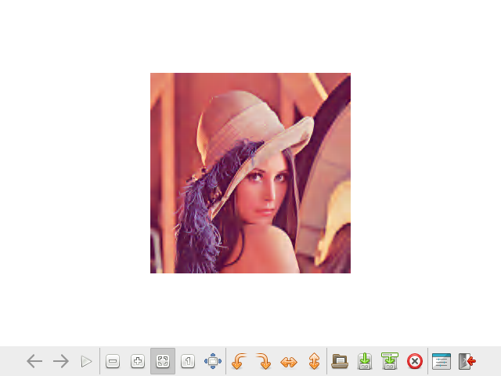
This demonstrates how a file -rw-r--r-- 1 devel devel 196730 Jul 28 11:54 lena_rgb_256.bmp
can be sent using a file -rw-r--r-- 1 devel devel 7848 Aug 1 06:13 /home/devel/Ultibo_Projects/jpeg2000/QEMU/xxx.j2k with compression at 25:1 and still get a good represntation of image.

devel@pi400-1:~/t_ultibo/build $ bin/opj_dump -i ~/Ultibo_Projects/jpeg2000/QEMU/xxx.j2k

[INFO] Start to read j2k main header (0).
[INFO] Main header has been correctly decoded.
Image info {
x0=0, y0=0
x1=256, y1=256
numcomps=3
component 0 {
dx=1, dy=1
prec=8
sgnd=0
}
component 1 {
dx=1, dy=1
prec=8
sgnd=0
}
component 2 {
dx=1, dy=1
prec=8
sgnd=0
}
}
Codestream info from main header: {
tx0=0, ty0=0
tdx=256, tdy=256
tw=1, th=1
default tile {
csty=0
prg=0
numlayers=1
mct=0
comp 0 {
csty=0
numresolutions=6
cblkw=2^6
cblkh=2^6
cblksty=0
qmfbid=1
preccintsize (w,h)=(15,15) (15,15) (15,15) (15,15) (15,15) (15,15)
qntsty=0
numgbits=2
stepsizes (m,e)=(0,8) (0,9) (0,9) (0,10) (0,9) (0,9) (0,10) (0,9) (0,9) (0,10) (0,9) (0,9) (0,10) (0,9) (0,9) (0,10)
roishift=0
}
comp 1 {
csty=0
numresolutions=6
cblkw=2^6
cblkh=2^6
cblksty=0
qmfbid=1
preccintsize (w,h)=(15,15) (15,15) (15,15) (15,15) (15,15) (15,15)
qntsty=0
numgbits=2
stepsizes (m,e)=(0,8) (0,9) (0,9) (0,10) (0,9) (0,9) (0,10) (0,9) (0,9) (0,10) (0,9) (0,9) (0,10) (0,9) (0,9) (0,10)
roishift=0
}
comp 2 {
csty=0
numresolutions=6
cblkw=2^6
cblkh=2^6
cblksty=0
qmfbid=1
preccintsize (w,h)=(15,15) (15,15) (15,15) (15,15) (15,15) (15,15)
qntsty=0
numgbits=2
stepsizes (m,e)=(0,8) (0,9) (0,9) (0,10) (0,9) (0,9) (0,10) (0,9) (0,9) (0,10) (0,9) (0,9) (0,10) (0,9) (0,9) (0,10)
roishift=0
}
}
}
Codestream index from main header: {
Main header start position=0
Main header end position=125
Marker list: {
type=0xff4f, pos=0, len=2
type=0xff51, pos=2, len=49
type=0xff52, pos=51, len=14
type=0xff5c, pos=65, len=21
type=0xff64, pos=86, len=39
}
}

