***********************Draft***********************
QEMU Ultibo Bare Metal
TextEditor
07/23/21
***********************Draft***********************

https://en.m.wikipedia.org/wiki/QEMU

QEMU is a hosted virtual machine monitor: it emulates the machine's processor through dynamic binary translation and provides a set of different hardware and device models for the machine, enabling it to run a variety of guest operating systems. It also can be used with Kernel-based Virtual Machine (KVM) to run virtual machines at near-native speed (by taking advantage of hardware extensions such as Intel VT-x). QEMU can also do emulation for user-level processes, allowing applications compiled for one architecture to run on another.[3]

Note : Additional software is needed to run QEMU “sudo apt-get install qemu-system-arm”.
The following programs are added.

/usr/bin/qemu-img /usr/bin/qemu-nbd /usr/bin/qemu-system-aarch64
/usr/bin/qemu-io /usr/bin/qemu-pr-helper /usr/bin/qemu-system-arm

The command line for starting Lazarus IDE (Ultibo Edition) “~/ultibo/core/lazarus.sh”

Requires Ultibo RTL installed with ultiboinstaller.sh

ultibo/core/fpc/source/rtl/ultibo/core/globalconst.pas

{Global constants}
const
{Version constants}
ULTIBO_RELEASE_DATE = '21 July 2021';
ULTIBO_RELEASE_NAME = 'Beetroot';
ULTIBO_RELEASE_VERSION = '2.1.079';
ULTIBO_RELEASE_VERSION_MAJOR = 2;
ULTIBO_RELEASE_VERSION_MINOR = 1;
ULTIBO_RELEASE_VERSION_REVISION = 079;

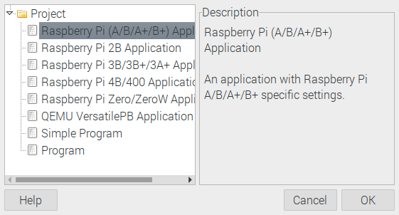
Select QEMU VersatilePB Application.

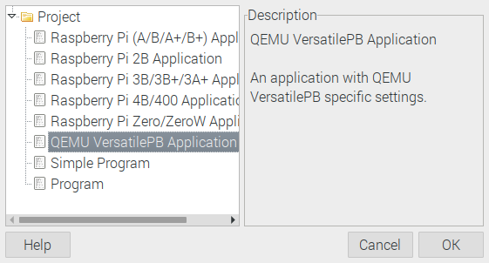
Depress OK

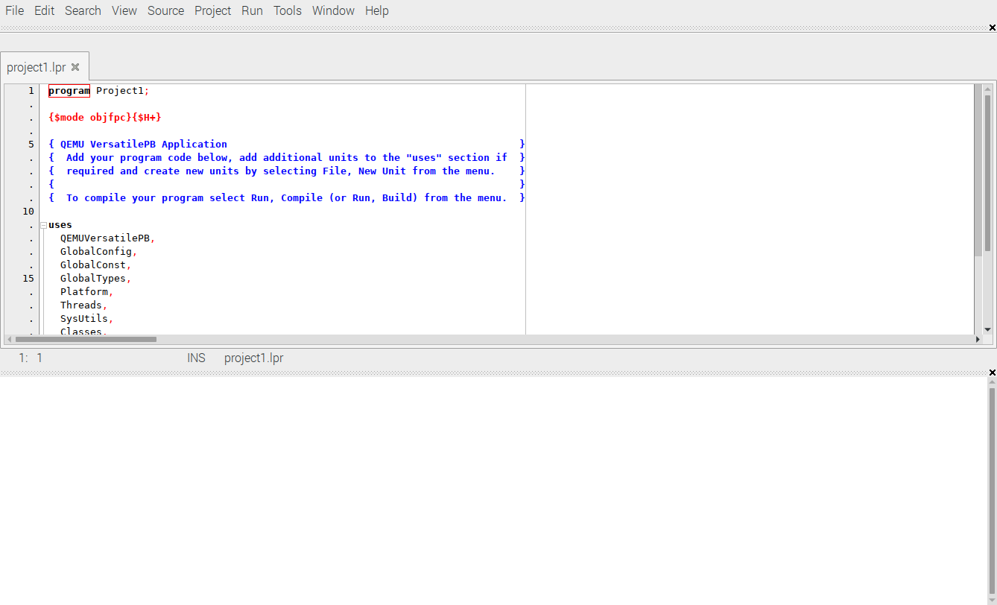
Paste The contents of Examples/17-TextEditor/QEMU/TextEditor.lpr

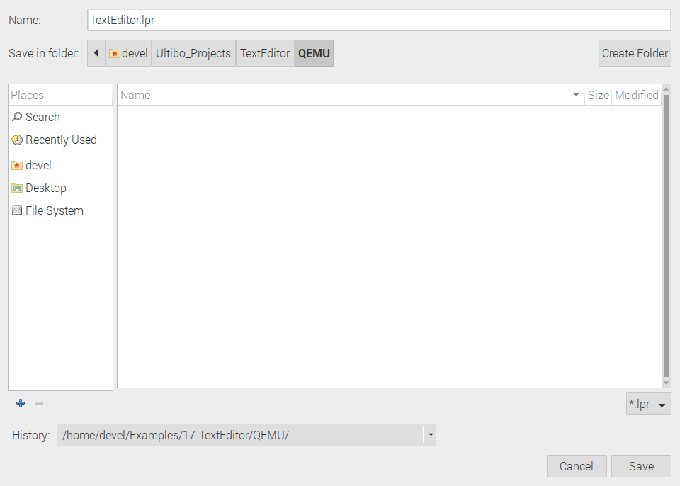

File/Save As Depress Save

Run/Compile The kernel.bin is created when the Grean bar appers.

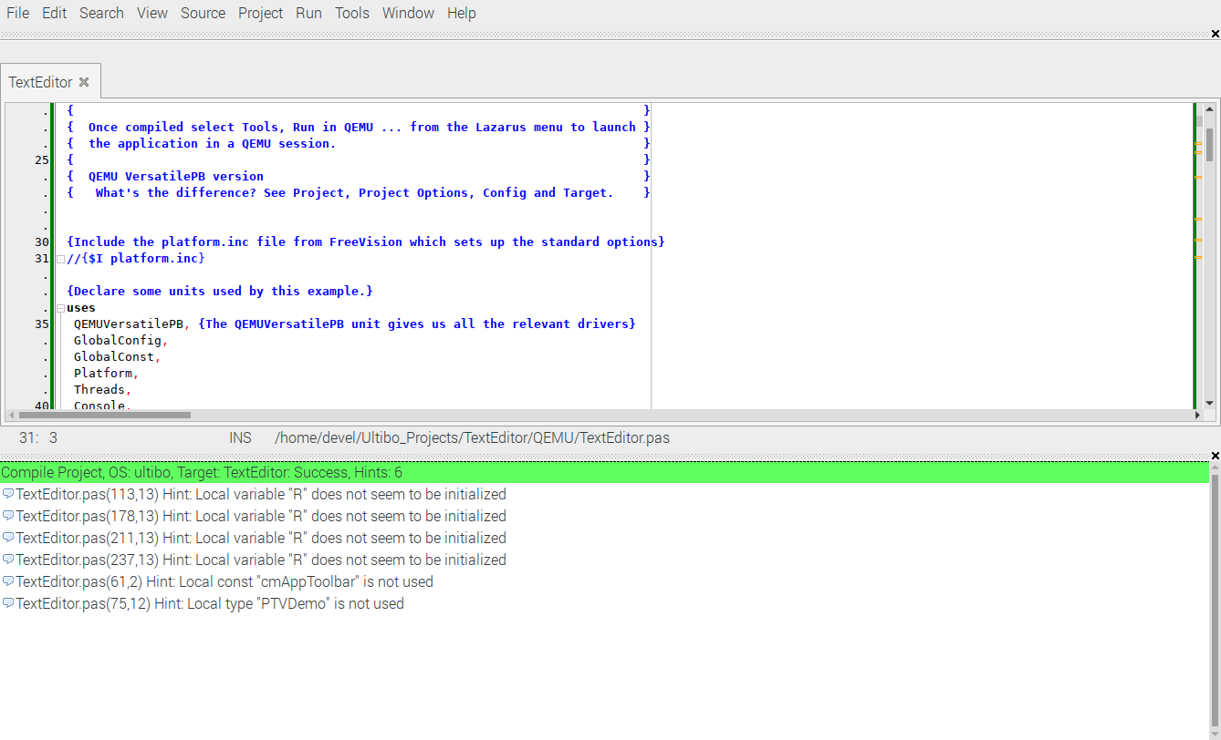
qemu-system-arm -machine versatilepb -cpu cortex-a8 -kernel kernel.bin -drive file=disk.img,if=sd,format=raw

