******************************Draft******************************
The first boot running Demo Rpi4B $Gb
05/16/21
******************************Draft******************************

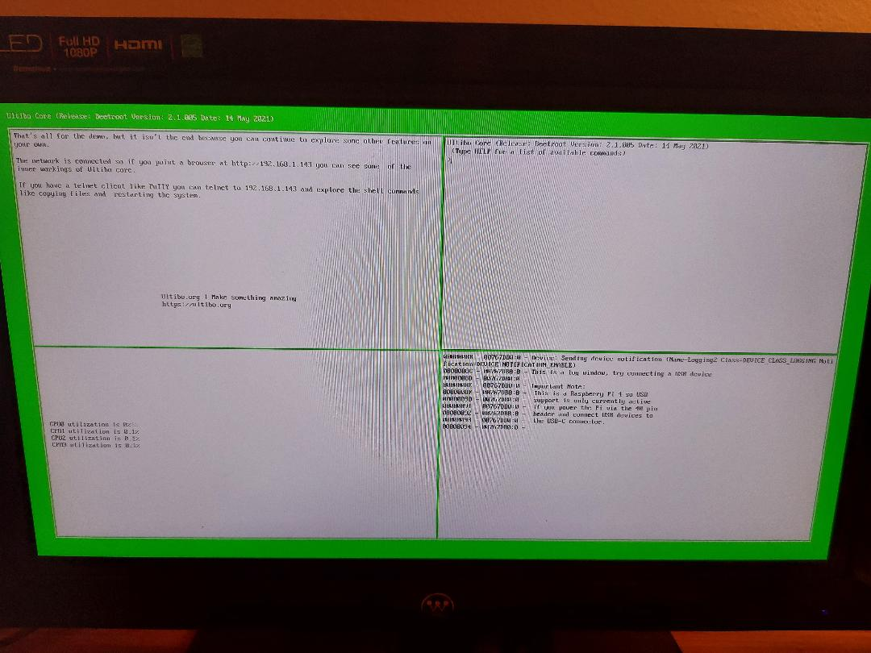
This using telnet to see the files on the SD of Rpi4 running the latest Ultibo Version

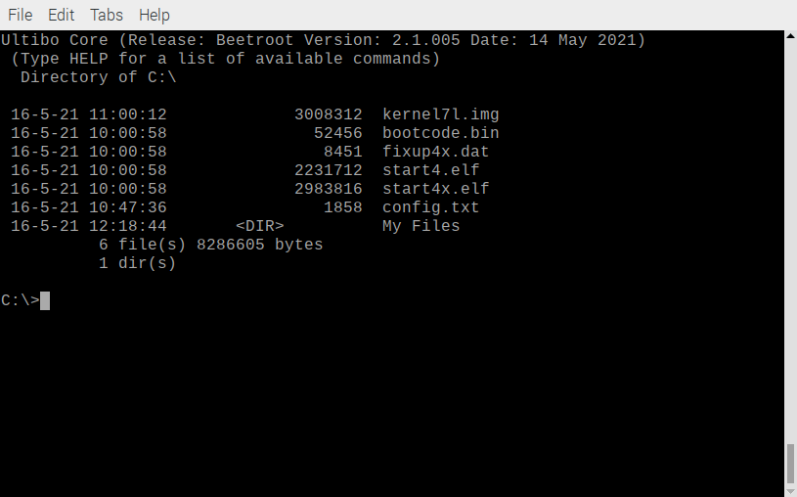

General

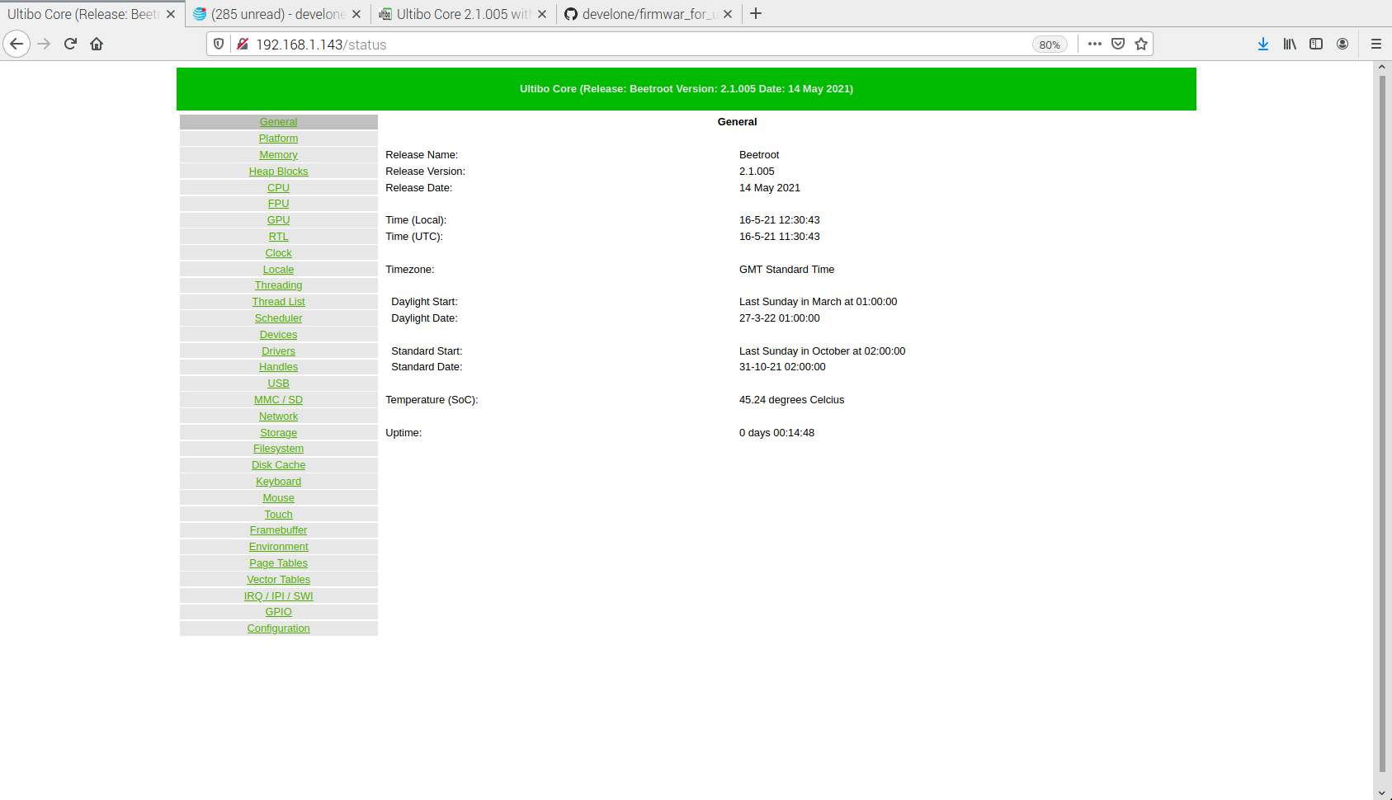
Platform

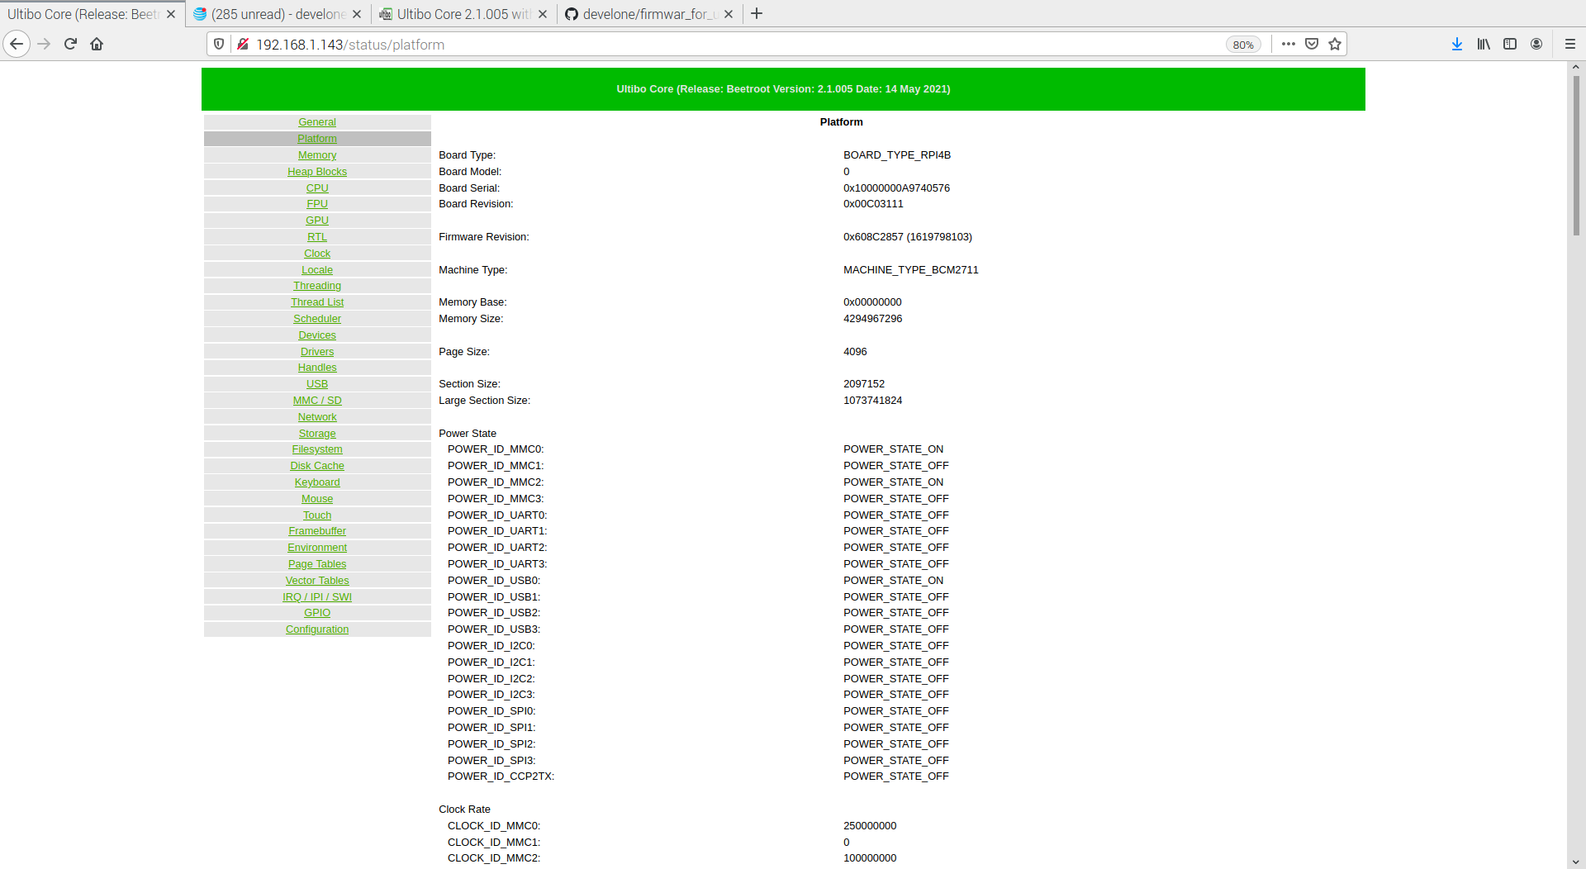

Environment

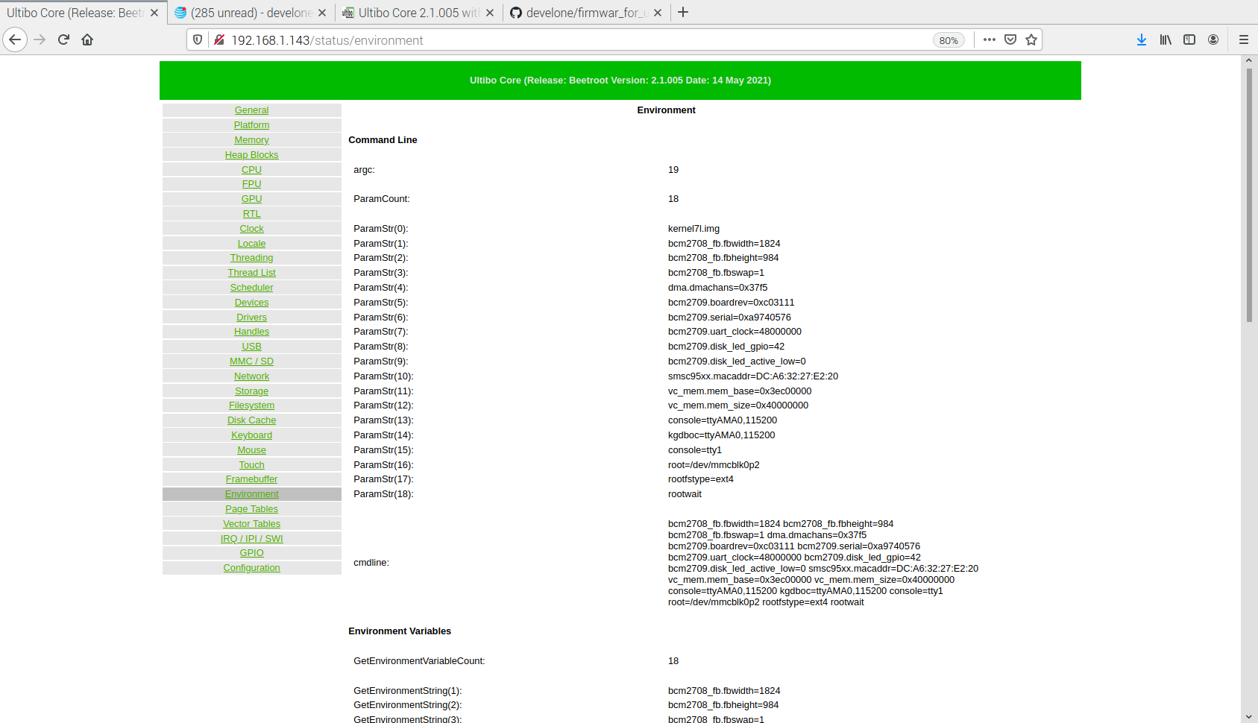

Memory

