JRsamayoa wrote
rendering code to nuklear_ultibo_gles2.h removed everything else (hopefully)

https://github.com/cejasmasmas/ultibo_nuklear ultiboCgeneric.c uses nuklear_ultibo_gles2.h

https://github.com/cejasmasmas/ultiboTessellator svgTessellator.c would be cleaned up using
nuklear_ultibo_gles2.h. This would require changes to svgTessellator.c. In addition, this would
make svgTessellator.c, more in line with both projects.

I had indicated that #include "nuklear_ultibo_gles2.h"
be used svgTessellator.c
https://gist.githubusercontent.com/deve ... ator.c.tmp
This file tries to provide the changes needed. Can someone explain how this could be
done in github so user JRsamayoa could test the changes in https://github.com/cejasmasmas/ultiboTessellator.git
and if acceptable he could merge into his repo.
This would help in support to other users. I believe this would be a pull request.
I don't know if this is all the changes required.

Any help in this area is appreciated.

I think this is the correct link
https://gist.githubusercontent.com/deve ... ator.c.tmp

I've seen this in a lot of places, this is really interesting
I don't know how to do it, what I can tell you is that by
reading your file edit is everything should work, I can
download and compile but its not part of the exercise,
I'm really curious as how this is done, by the way
you can also remove:

struct nk_gen_device {
struct nk_buffer cmds;
struct nk_draw_null_texture null;
GLuint vbo, ebo;
GLuint prog;
GLuint vert_shdr;
GLuint frag_shdr;
GLint attrib_pos;
GLint attrib_uv;
GLint attrib_col;
GLint uniform_tex;
GLint uniform_proj;
GLuint font_tex;
GLsizei vs;
size_t vp, vt, vc;
};

struct nk_gen_vertex {
GLfloat position[2];
GLfloat uv[2];
nk_byte col[4];
};

static struct nk_gen {
//SDL_Window *win;
struct nk_gen_device ogl;
struct nk_context ctx;
struct nk_font_atlas atlas;
} gen;

NK_API void
nk_gen_device_create(void);

NK_API void
nk_gen_device_destroy(void);

NK_INTERN void
nk_gen_device_upload_atlas(const void *image, int width, int height);

NK_API void
nk_gen_render(enum nk_anti_aliasing AA, int max_vertex_buffer, int max_element_buffer, int rwidth, int rheight);

NK_API struct nk_context*
nk_gen_init();

NK_API void
nk_gen_font_stash_begin(struct nk_font_atlas **atlas);

NK_API void
nk_gen_font_stash_end(void);

NK_API
void nk_gen_shutdown(void);

they are implemented in "nuklear_ultibo_gles2.h"

develone wrote: ↑
Wed Aug 19, 2020 2:09 pm
Can someone explain how this could be done in github so user JRsamayoa could test the changes in https://github.com/cejasmasmas/ultiboTessellator.git
and if acceptable he could merge into his repo.

GitHub have a guide that outlines the process of forking a repository and making a pull request to submit changes.

https://guides.github.com/activities/forking/

This might be a good starting point to learn about the process.

I read the guide that Ultibo provided. Now I hope this goes a bit smoother.

steps to create a pull request.

git clone https://github.com/develone/ultiboTessellator.git

cd ultiboTessellator

I don't know if this needed.

git checkout -b testpullreq

removed additional items
commented line 456 static void
needed / in lines 10 & 11 since working on a Linux system.

git push --set-upstream origin testpullreq

There are other chgs still required.

What are the steps for Ultibo member JRsamayoa?

Is he notified of the pull request. I do think this will help in shareing

projects between Ultibo members.

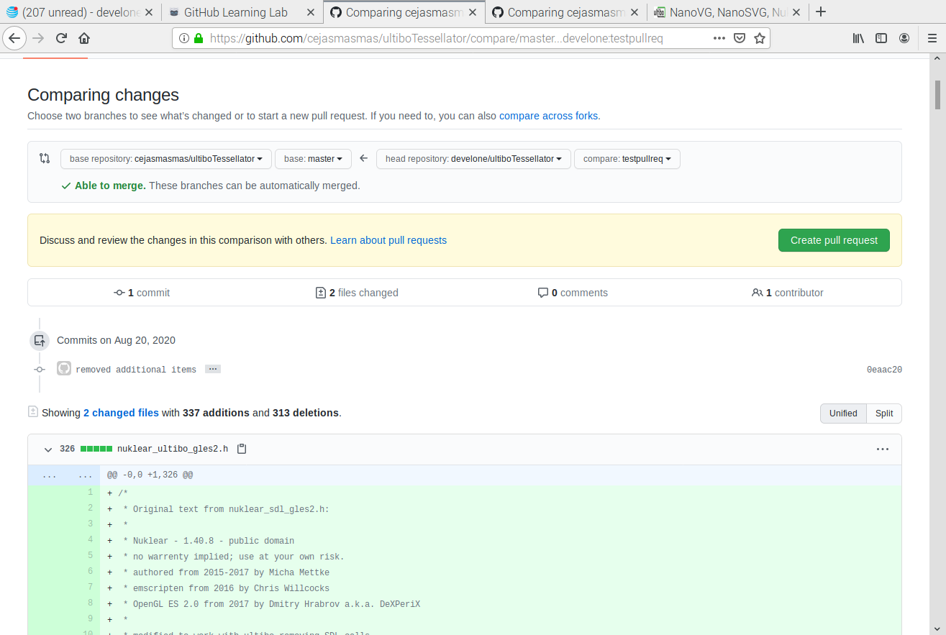
*******************************************5, 5a, 6

[b]All help is appreciated. Should some of these post be put in a new thread?[/b]
[b]Starting with a clean repo following the initial pull request being applied JRsamayoa.[/b]

[quote]When doing the compile.sh in line 197
svgTessellator.c:197:11: warning: implicit declaration of function 'nk_gen_init'; did you mean 'nk_font_init'? [-Wimplicit-function-declaration]
ctx = nk_gen_init();
With my testpullreq
svgTessellator.c:197:11: warning: implicit declaration of function 'nk_ultibo_init'; did you mean 'nk_ultb_init'? [-Wimplicit-function-declaration]
ctx = nk_ultibo_init();[/quote]

[url]git clone https://github.com/cejasmasmas/ultiboTessellator.git[/url]

[b]I see the cejasmasmas applied the pull request see the attached gitk.png.
[/b]
cd ultiboTessellator/

[code]This is what I used to compile libultiboCgeneric.a

#!/bin/bash
#rm -f *.o libsvgTessellator.a
arm-none-eabi-gcc -O2 -mabi=aapcs -marm -march=armv7-a -mfpu=vfpv3-d16 \
-mfloat-abi=hard -D__DYNAMIC_REENT__ -I libtess2/Include/ -c svgTessellator.c \
libtess2/Source/bucketalloc.c libtess2/Source/dict.c libtess2/Source/geom.c \
libtess2/Source/mesh.c libtess2/Source/priorityq.c libtess2/Source/sweep.c \
libtess2/Source/tess.c
arm-none-eabi-ar rcs libultiboCgeneric.a svgTessellator.o bucketalloc.o \
dict.o geom.o mesh.o priorityq.o sweep.o tess.o
[/code]
[code]./compile.sh
svgTessellator.c: In function 'ultibo_C_main':
svgTessellator.c:197:11: warning: implicit declaration of function 'nk_gen_init'; did you mean 'nk_font_init'? [-Wimplicit-function-declaration]
ctx = nk_gen_init();
^~~~~~~~~~~
nk_font_init
svgTessellator.c:197:9: warning: assignment makes pointer from integer without a cast [-Wint-conversion]
ctx = nk_gen_init();
^
svgTessellator.c:201:5: warning: implicit declaration of function 'nk_ultibo_font_stash_begin'; did you mean 'nk_ultb_font_stash_begin'? [-Wimplicit-function-declaration]
nk_ultibo_font_stash_begin(&atlas); //left here you can test more fonts
^~~~~~~~~~~~~~~~~~~~~~~~~~
nk_ultb_font_stash_begin
svgTessellator.c:208:5: warning: implicit declaration of function 'nk_ultibo_font_stash_end'; did you mean 'nk_ultb_font_stash_end'? [-Wimplicit-function-declaration]
nk_ultibo_font_stash_end();
^~~~~~~~~~~~~~~~~~~~~~~~
nk_ultb_font_stash_end
svgTessellator.c:236:7: warning: implicit declaration of function 'nuklear_MainLoop'; did you mean 'MainLoop'? [-Wimplicit-function-declaration]
nuklear_MainLoop((void*)ctx); // here is the gui code
^~~~~~~~~~~~~~~~
MainLoop
svgTessellator.c:288:5: warning: implicit declaration of function 'nk_ultibo_shutdown'; did you mean 'nk_ultb_shutdown'? [-Wimplicit-function-declaration]
nk_ultibo_shutdown(); // not needed but to show where it goes
^~~~~~~~~~~~~~~~~~
nk_ultb_shutdown
svgTessellator.c: At top level:
svgTessellator.c:457:1: warning: return type defaults to 'int' [-Wimplicit-int]
nuklear_MainLoop(void* loopArg){
^~~~~~~~~~~~~~~~
svgTessellator.c: In function 'nuklear_MainLoop':
svgTessellator.c:572:5: warning: implicit declaration of function 'nk_ultibo_render'; did you mean 'nk_ultb_render'? [-Wimplicit-function-declaration]
nk_ultibo_render(NK_ANTI_ALIASING_ON, MAX_VERTEX_MEMORY, MAX_ELEMENT_MEMORY, ScreenWidth, ScreenHeight);
^~~~~~~~~~~~~~~~
nk_ultb_render
[/code]

[code]When compiling with Lazarus IDE (Ultibo Edition) these are the errors I am getting.

Compile Project, OS: ultibo, Target: svgTessellator: Exit code 256, Errors: 1, Hints: 3
ultiboGLES2C.pas(72,24) Hint: Local variable "Key" does not seem to be initialized
ultiboGLES2C.pas(112,51) Hint: Local variable "count" does not seem to be initialized{$linklib libultiboCgeneric}
ultiboGLES2C.pas(12,109) Hint: Unit "math" not used in ultiboGLES2C
/usr/bin/arm-none-eabi-ld: libultiboCgeneric.a(svgTessellator.o): in function `nuklear_MainLoop':procedure ultibo_C_main; cdecl; external 'libultiboCgeneric' name 'ultibo_C_main';
svgTessellator.c:(.text+0x369fc): undefined reference to `nk_ultibo_render'
/usr/bin/arm-none-eabi-ld: libultiboCgeneric.a(svgTessellator.o): in function `ultibo_C_main':arm-none-eabi-objdump -d libultiboCgeneric.a | less
svgTessellator.c:(.text+0x37030): undefined reference to `nk_gen_init'
/usr/bin/arm-none-eabi-ld: svgTessellator.c:(.text+0x37050): undefined reference to `nk_ultibo_font_stash_begin' 369fc: ebfffffe bl 0 <nk_ultibo_render>
/usr/bin/arm-none-eabi-ld: svgTessellator.c:(.text+0x37070): undefined reference to `nk_ultibo_font_stash_end' 36a00: e28dd03c add sp, sp, #60 ; 0x3c
[/code]svgTessellator.lpr(57,59) Error: Error while linking 36a04: ecbd8b02 vpop {d8}

[code]arm-none-eabi-objdump -d svgTessellator.o | less

3684c: 0a000112 beq 36c9c <nuklear_MainLoop+0x470>
36850: e3530004 cmp r3, #4
36854: 0a00010d beq 36c90 <nuklear_MainLoop+0x464>
36858: e3530001 cmp r3, #1

37030: ebfffffe bl 0 <nk_gen_init>
37034: e58da010 str sl, [sp, #16]
37038: e3006000 movw r6, #0

37050: ebfffffe bl 0 <nk_ultibo_font_stash_begin>
37054: eeb30a00 vmov.f32 s0, #48 ; 0x41800000 16.0
37058: ee192a10 vmov r2, s18

37070: ebfffffe bl 0 <nk_ultibo_font_stash_end>
37074: e28a1004 add r1, sl, #4
37078: e59da010 ldr sl, [sp, #16]
3707c: e59a0000 ldr r0, [sl]
[/code]
git clone https://github.com/develone/ultiboTessellator.git

cd ultiboTessellator/

git checkout testpullreq

[code]./compile.sh
svgTessellator.c: In function 'ultibo_C_main':
svgTessellator.c:197:11: warning: implicit declaration of function 'nk_ultibo_init'; did you mean 'nk_ultb_init'? [-Wimplicit-function-declaration]
ctx = nk_ultibo_init();
^~~~~~~~~~~~~~
nk_ultb_init
svgTessellator.c:197:9: warning: assignment makes pointer from integer without a cast [-Wint-conversion]
ctx = nk_ultibo_init();
^
svgTessellator.c:201:5: warning: implicit declaration of function 'nk_ultibo_font_stash_begin'; did you mean 'nk_ultb_font_stash_begin'? [-Wimplicit-function-declaration]
nk_ultibo_font_stash_begin(&atlas); //left here you can test more fonts
^~~~~~~~~~~~~~~~~~~~~~~~~~
nk_ultb_font_stash_begin
svgTessellator.c:208:5: warning: implicit declaration of function 'nk_ultibo_font_stash_end'; did you mean 'nk_ultb_font_stash_end'? [-Wimplicit-function-declaration]
nk_ultibo_font_stash_end();
^~~~~~~~~~~~~~~~~~~~~~~~
nk_ultb_font_stash_end
svgTessellator.c:236:7: warning: implicit declaration of function 'nuklear_Main' [-Wimplicit-function-declaration]
nuklear_Main((void*)ctx); // here is the gui code
^~~~~~~~~~~~
svgTessellator.c:288:5: warning: implicit declaration of function 'nk_ultibo_shutdown'; did you mean 'nk_ultb_shutdown'? [-Wimplicit-function-declaration]
nk_ultibo_shutdown(); // not needed but to show where it goes
^~~~~~~~~~~~~~~~~~
nk_ultb_shutdown
svgTessellator.c: At top level:
svgTessellator.c:457:1: warning: return type defaults to 'int' [-Wimplicit-int]
nuklear_Main(void* loopArg){
^~~~~~~~~~~~
svgTessellator.c: In function 'nuklear_Main':
svgTessellator.c:572:5: warning: implicit declaration of function 'nk_ultibo_render'; did you mean 'nk_ultb_render'? [-Wimplicit-function-declaration]
nk_ultibo_render(NK_ANTI_ALIASING_ON, MAX_VERTEX_MEMORY, MAX_ELEMENT_MEMORY, ScreenWidth, ScreenHeight);
^~~~~~~~~~~~~~~~
nk_ultb_render
[/code]

[code]When compiling with Lazarus IDE (Ultibo Edition) these are the errors I am getting.

Compile Project, OS: ultibo, Target: svgTessellator: Exit code 256, Errors: 1, Hints: 3
ultiboGLES2C.pas(72,24) Hint: Local variable "Key" does not seem to be initialized
ultiboGLES2C.pas(112,51) Hint: Local variable "count" does not seem to be initialized
ultiboGLES2C.pas(12,109) Hint: Unit "math" not used in ultiboGLES2C
/usr/bin/arm-none-eabi-ld: libultiboCgeneric.a(svgTessellator.o): in function `nuklear_Main':
svgTessellator.c:(.text+0x369fc): undefined reference to `nk_ultibo_render'
/usr/bin/arm-none-eabi-ld: libultiboCgeneric.a(svgTessellator.o): in function ` ':
svgTessellator.c:(.text+0x37030): undefined reference to `nk_ultibo_init'
/usr/bin/arm-none-eabi-ld: svgTessellator.c:(.text+0x37050): undefined reference to `nk_ultibo_font_stash_begin'
/usr/bin/arm-none-eabi-ld: svgTessellator.c:(.text+0x37070): undefined reference to `nk_ultibo_font_stash_end'
svgTessellator.lpr(57,59) Error: Error while linking

arm-none-eabi-objdump -d svgTessellator.o | less

nuklear_Main nk_ultibo_render ultibo_C_main nk_ultibo_init nk_ultibo_font_stash_begin nk_ultibo_font_stash_end

3684c: 0a000112 beq 36c9c <nuklear_Main+0x470>
36850: e3530004 cmp r3, #4
36854: 0a00010d beq 36c90 <nuklear_Main+0x464>
36858: e3530001 cmp r3, #1

369fc: ebfffffe bl 0 <nk_ultibo_render>
36a00: e28dd03c add sp, sp, #60 ; 0x3c
36a04: ecbd8b02 vpop {d8}

36dc4: e59f1564 ldr r1, [pc, #1380] ; 37330 <ultibo_C_main+0x57c>
36dc8: e2810004 add r0, r1, #4
36dcc: e24ddfab sub sp, sp, #684 ; 0x2ac
36dd0: ebfffffe bl 0 <getScreenSize>
36dd4: e59fe558 ldr lr, [pc, #1368] ; 37334 <ultibo_C_main+0x580>

37030: ebfffffe bl 0 <nk_ultibo_init>
37034: e58da010 str sl, [sp, #16]
37038: e3006000 movw r6, #0
[/code]
37050: ebfffffe bl 0 <nk_ultibo_font_stash_begin>
37054: eeb30a00 vmov.f32 s0, #48 ; 0x41800000 16.0
37058: ee192a10 vmov r2, s18

37070: ebfffffe bl 0 <nk_ultibo_font_stash_end>
37074: e28a1004 add r1, sl, #4

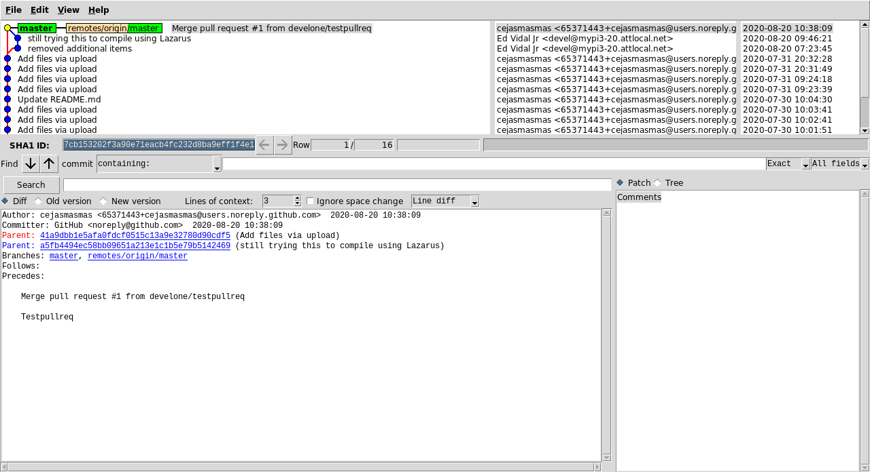
**********7

[b]This demonstrates that a pull request works. I do think this will help in sharing work with other members. This provided a good understanding on the benefit of git.[/b]

[url]git clone https://github.com/cejasmasmas/ultiboTessellator.git
[/url]
cd ultiboTessellator/

[b]I see the cejasmasmas applied the pull request see the attached gitk1.png.
[/b]

[code]Since I am working on a RPi4 4gB needed to modify svgTessellator.c

git diff svgTessellator.c
diff --git a/svgTessellator.c b/svgTessellator.c
index 21aa916..97bcb30 100644
--- a/svgTessellator.c
+++ b/svgTessellator.c
@@ -7,8 +7,8 @@

#include <stdio.h>

-#include "opt/vc/include/GLES/gl.h"
-#include "opt/vc/include/GLES2/gl2.h"
+#include "/opt/vc/include/GLES/gl.h"
+#include "/opt/vc/include/GLES2/gl2.h"

#define NK_INCLUDE_FIXED_TYPES
[/code]
[code]Created compile.sh from compile.bat.

#!/bin/bash
arm-none-eabi-gcc -O2 -mabi=aapcs -marm -march=armv7-a -mfpu=vfpv3-d16 -mfloat-abi=hard -D__DYNAMIC_REENT__ \
-I libtess2/Include/ -c svgTessellator.c libtess2/Source/bucketalloc.c libtess2/Source/dict.c \
libtess2/Source/geom.c libtess2/Source/mesh.c libtess2/Source/priorityq.c libtess2/Source/sweep.c libtess2/Source/tess.c
arm-none-eabi-ar rcs libultiboCgeneric.a svgTessellator.o bucketalloc.o dict.o geom.o mesh.o priorityq.o sweep.o tess.o

[/code]

[b]./compile.sh
[/b]

[b]This is what I get when compiling with Lazarus IDE (Ultibo Edition) see the attached laz.png.
[/b]

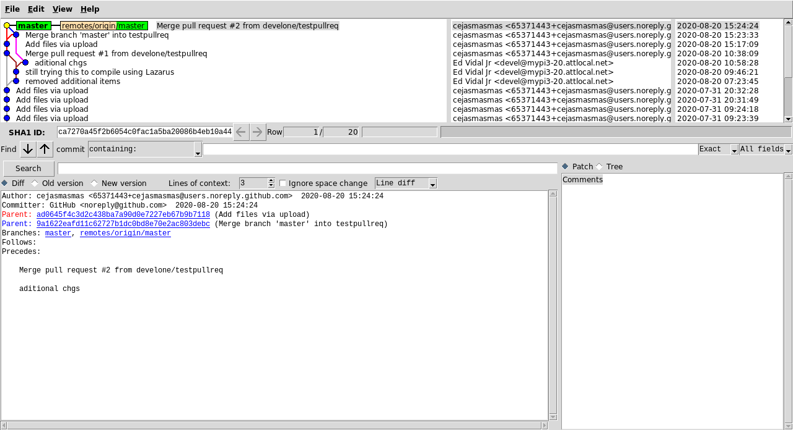
laz

