Goal: To determine the time domain response of the transfer function

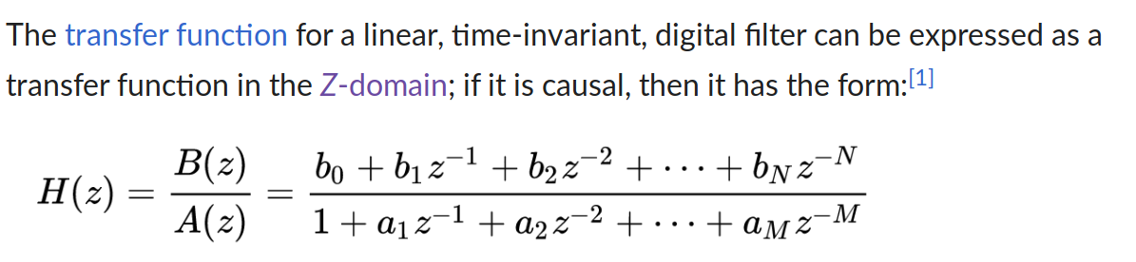

Octave filter
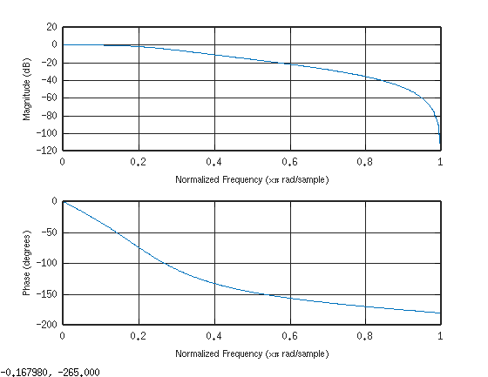
Testcase
The first signal x is 3 sine waves 50, 120, and 300 Hz

The 2nd is the FFT of the signal x.

The 3rd is the filterd with the Butterworth filter.

The 4th show that only the 50 & 120 Hz are present.
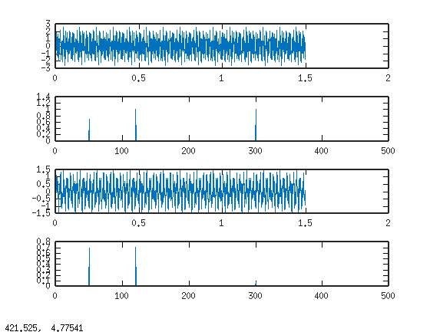
Starting first with order 2
a = 1.00000 -0.98241 0.34767

b = 0.091315 0.182630 0.091315

[A,B,C,D] = tf2ss(b,a);

A =

5.5511e-17 3.4767e-01
-1.0000e+00 9.8241e-01

B =

-0.059568
0.272338

C =

0 1

D = 0.091315

