This video covers how to use USB serial input on the Raspberry Pi Pico in your projects.
We use a Visual Studio Code project to program the brand-new Raspberry Pi Pico microcontroller board in C.
We create a basic blink LED program which accepts the inputs from the serial monitor over USB and changes
the state of the LED. We also explain how to configure the CMake configuration file to
enable the USB serial input on the Pico.

This video provides the fundamental background of the serial USB process and explains how to correctly configure your Pico microcontroller. It explains which functions in the Pico SDK to use in order to communicate to and from the Pico.

youtube https://www.youtube.com/watch?v=NHwMJZwRo7k
https://learnembeddedsystems.co.uk/usb-serial-input-on-the-pico

Adding blink_led project to my pico-examples

git diff CMakeLists.txt
diff --git a/CMakeLists.txt b/CMakeLists.txt
index 66add69..7641f33 100644
--- a/CMakeLists.txt
+++ b/CMakeLists.txt
@@ -15,6 +15,7 @@ pico_sdk_init()
include(example_auto_set_url.cmake)
# Add blink example
add_subdirectory(blink)
+add_subdirectory(blink_led)

# Add hello world example
add_subdirectory(hello_world)

Need make chgs to CmakeLists.txt
Also the CmakeLists.txt needs to be CMakeLists.txt

diff CmakeLists.txt /opt/pico-examples/blink_led/CMakeLists.txt
1,7c1
< cmake_minimum_required(VERSION 3.12)
<
< include(pico_sdk_import.cmake)
<
< project(pico-projects)
<
< pico_sdk_init()
---
>
devel@pi4-23:/opt/pico-examples $ cd build
cmake ..
PICO_SDK_PATH is /opt/pico-sdk
PICO platform is rp2040.
Using regular optimized debug build (set PICO_DEOPTIMIZED_DEBUG=1 to de-optimize)
PICO target board is pico.
Using board configuration from /opt/pico-sdk/src/boards/include/boards/pico.h
TinyUSB available at /opt/pico-sdk/lib/tinyusb/src/portable/raspberrypi/rp2040; adding USB support.
Compiling TinyUSB with CFG_TUSB_DEBUG=1
-- Configuring done
-- Generating done
-- Build files have been written to: /opt/pico-examples/build

cd blink_led
devel@mypi3-20:/opt/pico-examples/build/blink_led $ ls
CMakeFiles cmake_install.cmake Makefile

make
[ 0%] Performing build step for 'ELF2UF2Build'
[100%] Built target elf2uf2
[ 0%] No install step for 'ELF2UF2Build'
[ 0%] Completed 'ELF2UF2Build'
[ 0%] Built target ELF2UF2Build
[ 0%] Built target bs2_default
[ 0%] Built target bs2_default_padded_checksummed_asm
Scanning dependencies of target blink_led
[ 0%] Building C object blink_led/CMakeFiles/blink_led.dir/blink_led.c.obj
[ 0%] Building C object blink_led/CMakeFiles/blink_led.dir/opt/pico-sdk/src/rp2_common/pico_stdlib/stdlib.c.obj
[ 0%] Building C object blink_led/CMakeFiles/blink_led.dir/opt/pico-sdk/src/rp2_common/hardware_gpio/gpio.c.obj
[ 0%] Building C object blink_led/CMakeFiles/blink_led.dir/opt/pico-sdk/src/rp2_common/hardware_claim/claim.c.obj
[ 0%] Building C object blink_led/CMakeFiles/blink_led.dir/opt/pico-sdk/src/rp2_common/pico_platform/platform.c.obj
[ 0%] Building C object blink_led/CMakeFiles/blink_led.dir/opt/pico-sdk/src/rp2_common/hardware_sync/sync.c.obj
[ 0%] Building C object blink_led/CMakeFiles/blink_led.dir/opt/pico-sdk/src/rp2_common/hardware_uart/uart.c.obj
[ 0%] Building ASM object blink_led/CMakeFiles/blink_led.dir/opt/pico-sdk/src/rp2_common/hardware_divider/divider.S.obj
[ 0%] Building C object blink_led/CMakeFiles/blink_led.dir/opt/pico-sdk/src/common/pico_time/time.c.obj
[ 0%] Building C object blink_led/CMakeFiles/blink_led.dir/opt/pico-sdk/src/common/pico_time/timeout_helper.c.obj
[ 0%] Building C object blink_led/CMakeFiles/blink_led.dir/opt/pico-sdk/src/rp2_common/hardware_timer/timer.c.obj
[ 0%] Building C object blink_led/CMakeFiles/blink_led.dir/opt/pico-sdk/src/common/pico_sync/sem.c.obj
[ 0%] Building C object blink_led/CMakeFiles/blink_led.dir/opt/pico-sdk/src/common/pico_sync/lock_core.c.obj
[ 0%] Building C object blink_led/CMakeFiles/blink_led.dir/opt/pico-sdk/src/common/pico_sync/mutex.c.obj
[ 0%] Building C object blink_led/CMakeFiles/blink_led.dir/opt/pico-sdk/src/common/pico_sync/critical_section.c.obj
[ 0%] Building C object blink_led/CMakeFiles/blink_led.dir/opt/pico-sdk/src/common/pico_util/datetime.c.obj
[ 0%] Building C object blink_led/CMakeFiles/blink_led.dir/opt/pico-sdk/src/common/pico_util/pheap.c.obj
[ 0%] Building C object blink_led/CMakeFiles/blink_led.dir/opt/pico-sdk/src/common/pico_util/queue.c.obj
[ 0%] Building C object blink_led/CMakeFiles/blink_led.dir/opt/pico-sdk/src/rp2_common/pico_runtime/runtime.c.obj
[ 0%] Building C object blink_led/CMakeFiles/blink_led.dir/opt/pico-sdk/src/rp2_common/hardware_clocks/clocks.c.obj
[ 0%] Building C object blink_led/CMakeFiles/blink_led.dir/opt/pico-sdk/src/rp2_common/hardware_irq/irq.c.obj
[ 0%] Building ASM object blink_led/CMakeFiles/blink_led.dir/opt/pico-sdk/src/rp2_common/hardware_irq/irq_handler_chain.S.obj
[ 0%] Building C object blink_led/CMakeFiles/blink_led.dir/opt/pico-sdk/src/rp2_common/hardware_pll/pll.c.obj
[ 0%] Building C object blink_led/CMakeFiles/blink_led.dir/opt/pico-sdk/src/rp2_common/hardware_vreg/vreg.c.obj
[ 0%] Building C object blink_led/CMakeFiles/blink_led.dir/opt/pico-sdk/src/rp2_common/hardware_watchdog/watchdog.c.obj
[ 0%] Building C object blink_led/CMakeFiles/blink_led.dir/opt/pico-sdk/src/rp2_common/hardware_xosc/xosc.c.obj
[ 0%] Building C object blink_led/CMakeFiles/blink_led.dir/opt/pico-sdk/src/rp2_common/pico_printf/printf.c.obj
[ 0%] Building ASM object blink_led/CMakeFiles/blink_led.dir/opt/pico-sdk/src/rp2_common/pico_bit_ops/bit_ops_aeabi.S.obj
[ 0%] Building C object blink_led/CMakeFiles/blink_led.dir/opt/pico-sdk/src/rp2_common/pico_bootrom/bootrom.c.obj
[100%] Building ASM object blink_led/CMakeFiles/blink_led.dir/opt/pico-sdk/src/rp2_common/pico_divider/divider.S.obj
[100%] Building ASM object blink_led/CMakeFiles/blink_led.dir/opt/pico-sdk/src/rp2_common/pico_double/double_aeabi.S.obj
[100%] Building C object blink_led/CMakeFiles/blink_led.dir/opt/pico-sdk/src/rp2_common/pico_double/double_init_rom.c.obj
[100%] Building C object blink_led/CMakeFiles/blink_led.dir/opt/pico-sdk/src/rp2_common/pico_double/double_math.c.obj
[100%] Building ASM object blink_led/CMakeFiles/blink_led.dir/opt/pico-sdk/src/rp2_common/pico_double/double_v1_rom_shim.S.obj
[100%] Building ASM object blink_led/CMakeFiles/blink_led.dir/opt/pico-sdk/src/rp2_common/pico_int64_ops/pico_int64_ops_aeabi.S.obj
[100%] Building ASM object blink_led/CMakeFiles/blink_led.dir/opt/pico-sdk/src/rp2_common/pico_float/float_aeabi.S.obj
[100%] Building C object blink_led/CMakeFiles/blink_led.dir/opt/pico-sdk/src/rp2_common/pico_float/float_init_rom.c.obj
[100%] Building C object blink_led/CMakeFiles/blink_led.dir/opt/pico-sdk/src/rp2_common/pico_float/float_math.c.obj
[100%] Building ASM object blink_led/CMakeFiles/blink_led.dir/opt/pico-sdk/src/rp2_common/pico_float/float_v1_rom_shim.S.obj
[100%] Building C object blink_led/CMakeFiles/blink_led.dir/opt/pico-sdk/src/rp2_common/pico_malloc/pico_malloc.c.obj
[100%] Building ASM object blink_led/CMakeFiles/blink_led.dir/opt/pico-sdk/src/rp2_common/pico_mem_ops/mem_ops_aeabi.S.obj
[100%] Building ASM object blink_led/CMakeFiles/blink_led.dir/opt/pico-sdk/src/rp2_common/pico_standard_link/crt0.S.obj
[100%] Building CXX object blink_led/CMakeFiles/blink_led.dir/opt/pico-sdk/src/rp2_common/pico_standard_link/new_delete.cpp.obj
[100%] Building C object blink_led/CMakeFiles/blink_led.dir/opt/pico-sdk/src/rp2_common/pico_standard_link/binary_info.c.obj
[100%] Building C object blink_led/CMakeFiles/blink_led.dir/opt/pico-sdk/src/rp2_common/pico_stdio/stdio.c.obj
[100%] Building C object blink_led/CMakeFiles/blink_led.dir/opt/pico-sdk/src/rp2_common/pico_stdio_usb/reset_interface.c.obj
[100%] Building C object blink_led/CMakeFiles/blink_led.dir/opt/pico-sdk/src/rp2_common/pico_stdio_usb/stdio_usb.c.obj
[100%] Building C object blink_led/CMakeFiles/blink_led.dir/opt/pico-sdk/src/rp2_common/pico_stdio_usb/stdio_usb_descriptors.c.obj
[100%] Building C object blink_led/CMakeFiles/blink_led.dir/opt/pico-sdk/lib/tinyusb/src/portable/raspberrypi/rp2040/dcd_rp2040.c.obj
[100%] Building C object blink_led/CMakeFiles/blink_led.dir/opt/pico-sdk/lib/tinyusb/src/portable/raspberrypi/rp2040/rp2040_usb.c.obj
[100%] Building C object blink_led/CMakeFiles/blink_led.dir/opt/pico-sdk/lib/tinyusb/src/device/usbd.c.obj
[100%] Building C object blink_led/CMakeFiles/blink_led.dir/opt/pico-sdk/lib/tinyusb/src/device/usbd_control.c.obj
[100%] Building C object blink_led/CMakeFiles/blink_led.dir/opt/pico-sdk/lib/tinyusb/src/class/audio/audio_device.c.obj
[100%] Building C object blink_led/CMakeFiles/blink_led.dir/opt/pico-sdk/lib/tinyusb/src/class/cdc/cdc_device.c.obj
[100%] Building C object blink_led/CMakeFiles/blink_led.dir/opt/pico-sdk/lib/tinyusb/src/class/dfu/dfu_device.c.obj
[100%] Building C object blink_led/CMakeFiles/blink_led.dir/opt/pico-sdk/lib/tinyusb/src/class/dfu/dfu_rt_device.c.obj
[100%] Building C object blink_led/CMakeFiles/blink_led.dir/opt/pico-sdk/lib/tinyusb/src/class/hid/hid_device.c.obj
[100%] Building C object blink_led/CMakeFiles/blink_led.dir/opt/pico-sdk/lib/tinyusb/src/class/midi/midi_device.c.obj
[100%] Building C object blink_led/CMakeFiles/blink_led.dir/opt/pico-sdk/lib/tinyusb/src/class/msc/msc_device.c.obj
[100%] Building C object blink_led/CMakeFiles/blink_led.dir/opt/pico-sdk/lib/tinyusb/src/class/net/net_device.c.obj
[100%] Building C object blink_led/CMakeFiles/blink_led.dir/opt/pico-sdk/lib/tinyusb/src/class/usbtmc/usbtmc_device.c.obj
[100%] Building C object blink_led/CMakeFiles/blink_led.dir/opt/pico-sdk/lib/tinyusb/src/class/vendor/vendor_device.c.obj
[100%] Building C object blink_led/CMakeFiles/blink_led.dir/opt/pico-sdk/lib/tinyusb/src/tusb.c.obj
[100%] Building C object blink_led/CMakeFiles/blink_led.dir/opt/pico-sdk/lib/tinyusb/src/common/tusb_fifo.c.obj
[100%] Building C object blink_led/CMakeFiles/blink_led.dir/opt/pico-sdk/src/rp2_common/pico_fix/rp2040_usb_device_enumeration/rp2040_usb_device_enumeration.c.obj
[100%] Building C object blink_led/CMakeFiles/blink_led.dir/opt/pico-sdk/src/rp2_common/pico_unique_id/unique_id.c.obj
[100%] Building C object blink_led/CMakeFiles/blink_led.dir/opt/pico-sdk/src/rp2_common/hardware_flash/flash.c.obj
[100%] Linking CXX executable blink_led.elf
[100%] Built target blink_led

devel@pi4-23:/opt/pico-examples/build/blink_led $ ls
blink_led.bin blink_led.elf blink_led.hex CMakeFiles Makefile
blink_led.dis blink_led.elf.map blink_led.uf2 cmake_install.cmake pico-sdk

program the pico with blink_led.uf2

sudo minicom -s
Welcome to minicom 2.7.1

OPTIONS: I18n
Compiled on Aug 13 2017, 15:25:34.
Port /dev/ttyACM0, 13:06:57

Press CTRL-A Z for help on special keys

LED switched on!
Command (1 = on or 0 = off):
LED switched off!
Command (1 = on or 0 = off):

sudo dmesg to see what com port is used for the pico. The pico is in the lower right.

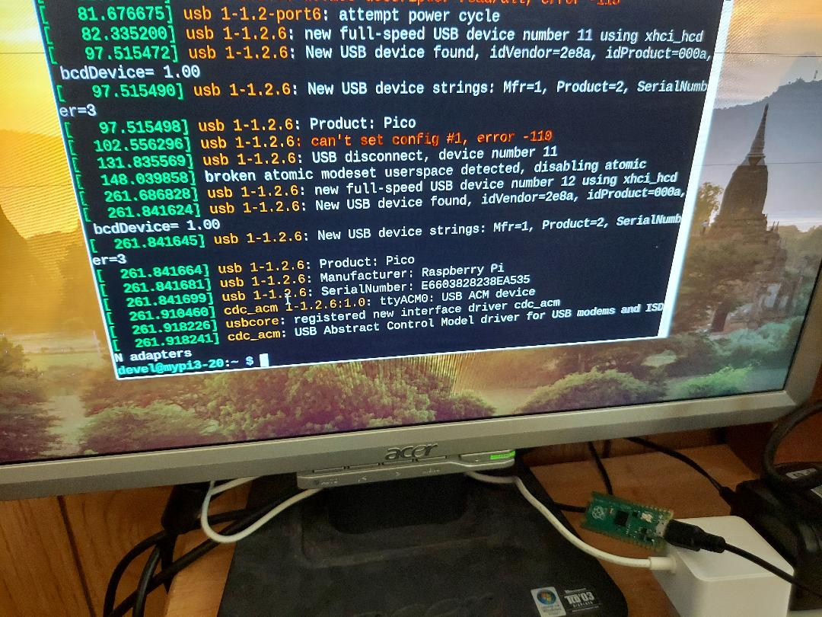
Xx
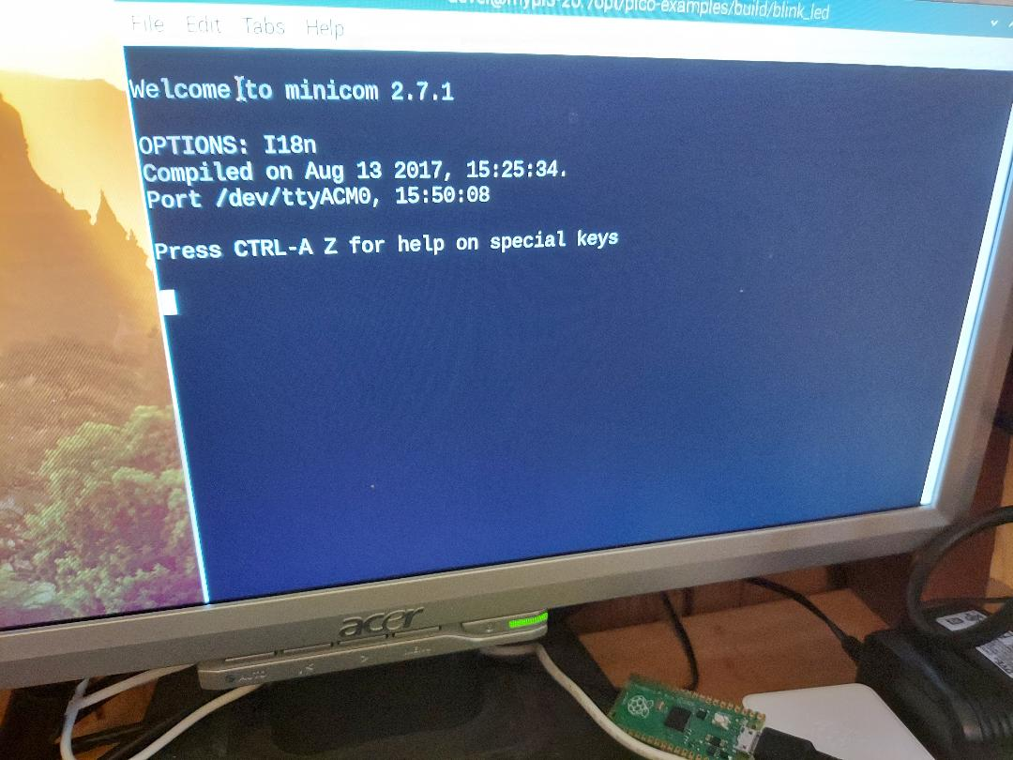
Turning led on
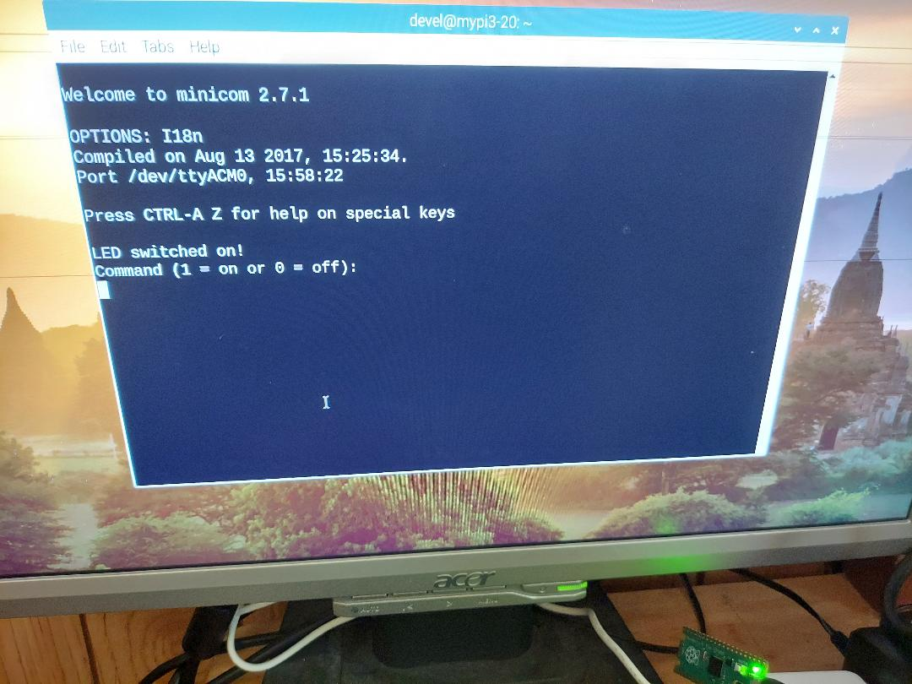
Turning led off.
