*************************Default*************************
Passing a test.j2k to Ultibo to be displayed by Ultibo.
08/18/21
*************************Default*************************

This was the output of compressing lena_rgb_256.bmp

-rw-r--r-- 1 devel devel 196730 Aug 18 16:40 MyBitmap.bmp

resulting in test.j2k

-rw-r--r-- 1 devel devel 7848 Aug 18 16:14 test.j2k

00000000 FF 4F FF 51 00 2F 00 00 00 00 01 00 00 00 01 00 .O.Q./..........
00000010 00 00 00 00 00 00 00 00 00 00 01 00 00 00 01 00 ................
00000020 00 00 00 00 00 00 00 00 00 03 07 01 01 07 01 01 ................
00000030 07 01 01 FF 52 00 0C 00 00 00 01 00 05 04 04 00 ....R...........
00000040 01 FF 5C 00 13 40 40 48 48 50 48 48 50 48 48 50 ..\..@@HHPHHPHHP
00000050 48 48 50 48 48 50 FF 64 00 25 00 01 43 72 65 61 HHPHHP.d.%..Crea
00000060 74 65 64 20 62 79 20 4F 70 65 6E 4A 50 45 47 20 ted by OpenJPEG
00000070 76 65 72 73 69 6F 6E 20 32 2E 32 2E 30 FF 90 00 version 2.2.0...

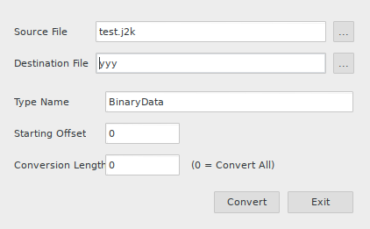

yyy

type.. TBinaryDa
ta = array[0..78
47] of Byte;....
var.. BinaryData
:TBinaryData = (
.. $FF,$4F,$FF,
$51,$00,$2F,$00,

00000000 74 79 70 65 0D 0A 20 54 42 69 6E 61 72 79 44 61 type.. TBinaryDa
00000010 74 61 20 3D 20 61 72 72 61 79 5B 30 2E 2E 37 38 ta = array[0..78
00000020 34 37 5D 20 6F 66 20 42 79 74 65 3B 0D 0A 0D 0A 47] of Byte;....
00000030 76 61 72 0D 0A 20 42 69 6E 61 72 79 44 61 74 61 var.. BinaryData
00000040 3A 54 42 69 6E 61 72 79 44 61 74 61 20 3D 20 28 :TBinaryData = (
00000050 0D 0A 20 20 24 46 46 2C 24 34 46 2C 24 46 46 2C .. $FF,$4F,$FF,
00000060 24 35 31 2C 24 30 30 2C 24 32 46 2C 24 30 30 2C $51,$00,$2F,$00,

497 lines in yyy

type
TBinaryData = array[0..7847] of Byte;

var
BinaryData:TBinaryData = (
$FF,$4F,$FF,$51,$00,$2F,$00,$00,$00,$00,$01,$00,$00,$00,$01,$00,
.
.
.
$A4,$4F,$B7,$4E,$98,$F3,$08,$74,$E4,$A2,$EF,$88,$C1,$D0,$CE,$F8,
$D8,$49,$4E,$93,$EF,$A8,$0F,$57,$61,$77,$BE,$24,$8D,$61,$1C,$AA,
$14,$CF,$B8,$91,$4D,$B0,$05,$0B,$E4,$AA,$EB,$19,$75,$9B,$88,$02,
$EE,$B6,$7B,$70,$87,$17,$B3,$41,$0D,$DB,$90,$34,$12,$6C,$1C,$A9,
$FC,$62,$BB,$0B,$67,$89,$FF,$D9
);

Next step to add the openjpeg to a program fclimge.lpr.

