***********************Draft***********************
QEMU Ultibo Bare Metal
SerialConnection
07/21/21
***********************Draft***********************

https://en.m.wikipedia.org/wiki/QEMU

QEMU is a hosted virtual machine monitor: it emulates the machine's processor through dynamic binary translation and provides a set of different hardware and device models for the machine, enabling it to run a variety of guest operating systems. It also can be used with Kernel-based Virtual Machine (KVM) to run virtual machines at near-native speed (by taking advantage of hardware extensions such as Intel VT-x). QEMU can also do emulation for user-level processes, allowing applications compiled for one architecture to run on another.[3]

Note : Additional software is needed to run QEMU “sudo apt-get install qemu-system-arm”.
The following programs are added.

/usr/bin/qemu-img /usr/bin/qemu-nbd /usr/bin/qemu-system-aarch64
/usr/bin/qemu-io /usr/bin/qemu-pr-helper /usr/bin/qemu-system-arm

The command line for starting Lazarus IDE (Ultibo Edition) “~/ultibo/core/lazarus.sh”

Project/Project Open

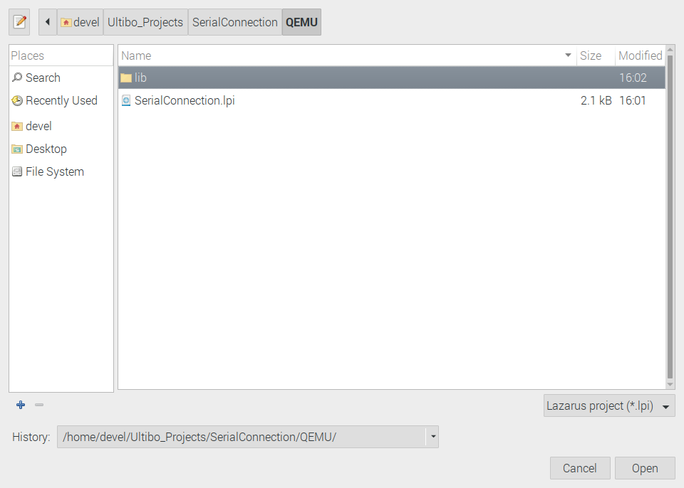

Laz0

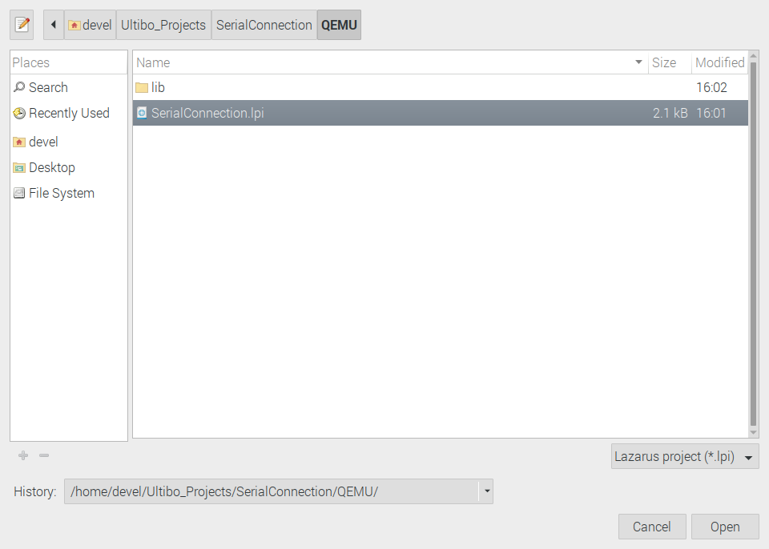

Depress Open

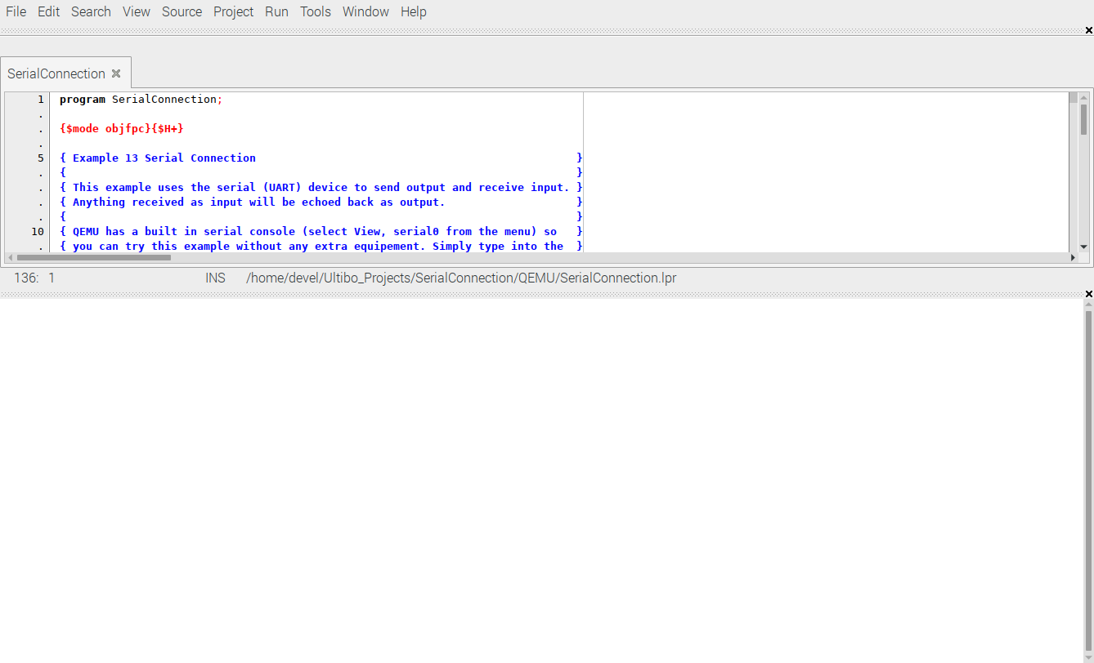

Laz0

Run/Compile The kernel.bin is created when the Grean bar appers.

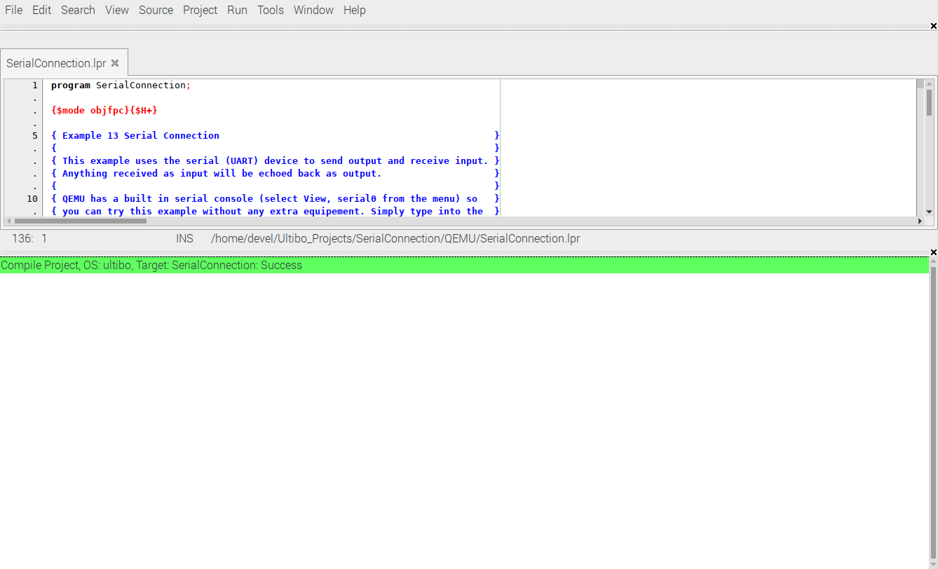

qemu

~/Ultibo_Projects/SerialConnection/QEMU

qemu-system-arm -machine versatilepb -cpu cortex-a8 -kernel kernel.bin

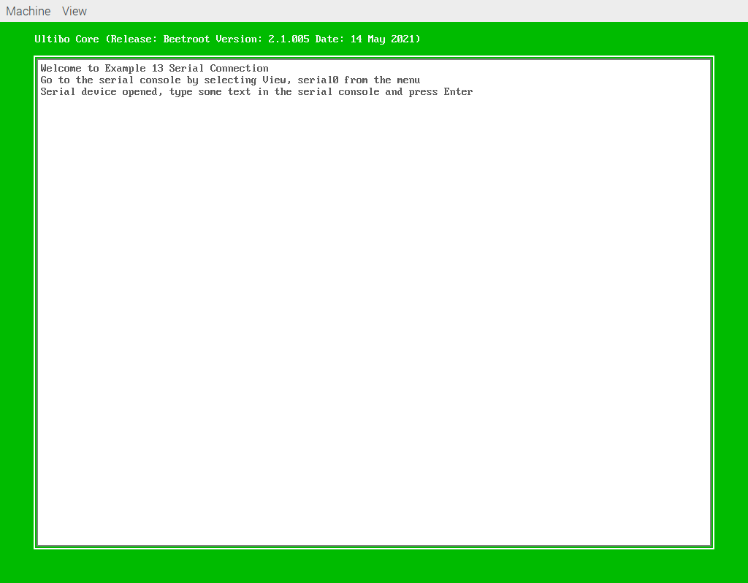

View

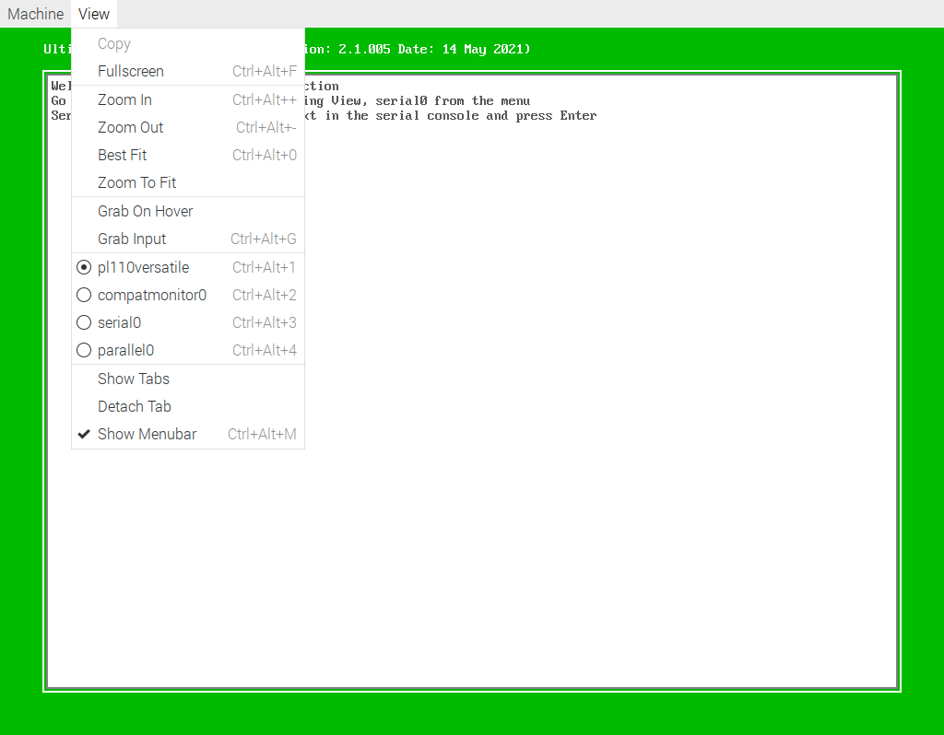
Check serial0

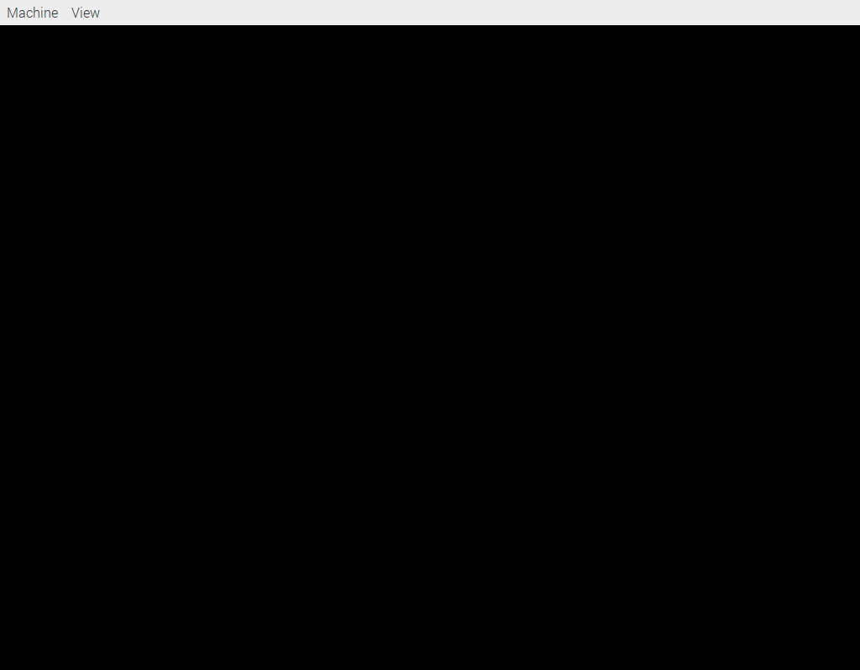

Notr: Type in the serial0 This might need additional options qemu-system-arm for it to be sent out the serial port.

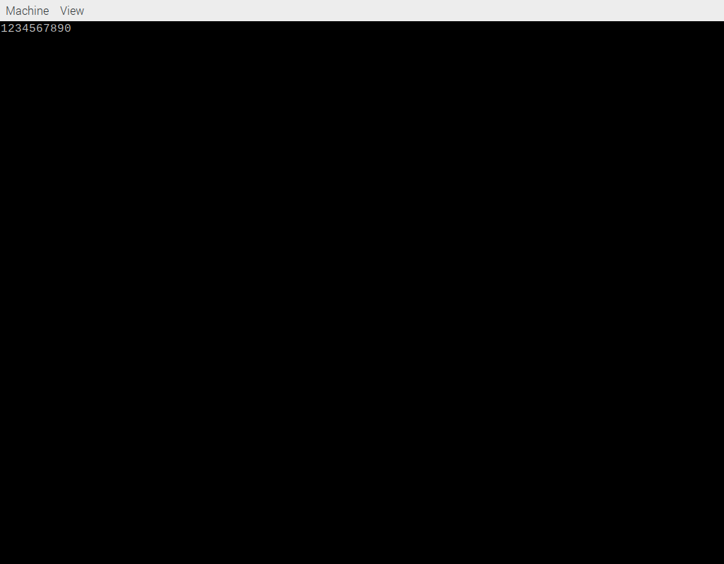

sudo minicom -s

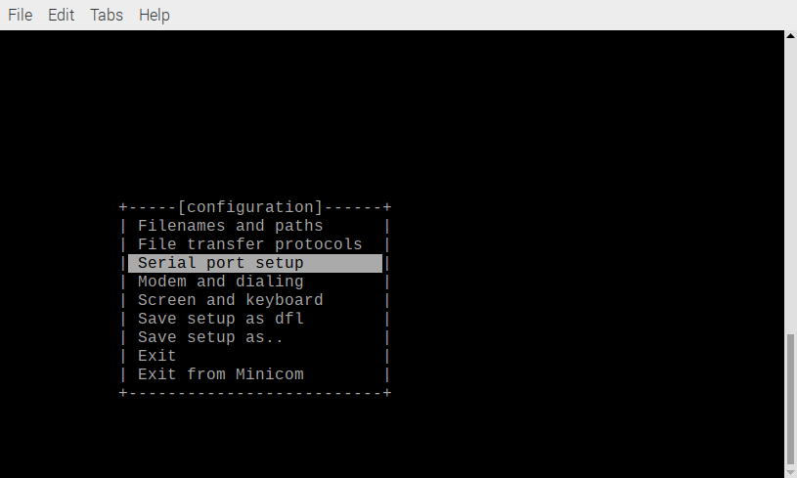
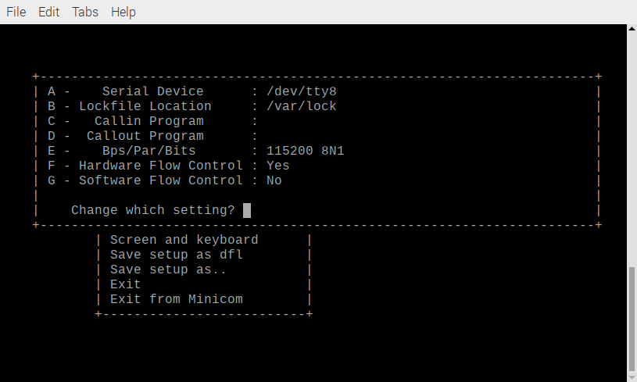

Change “/dev/tty8” to “/dev/serial0”.

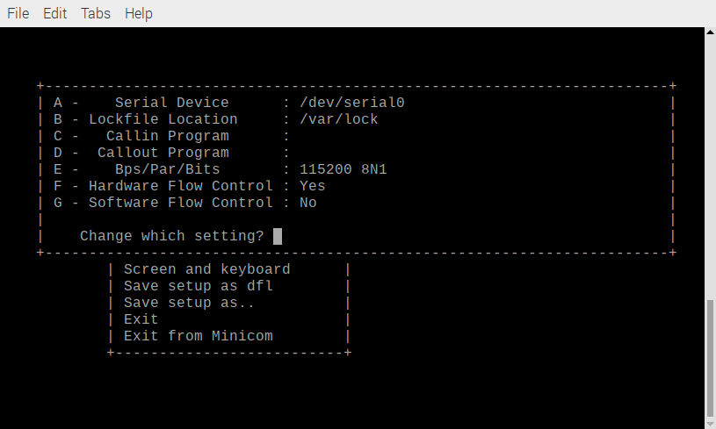

Change “115200 8N1” to “9600 8N1”.

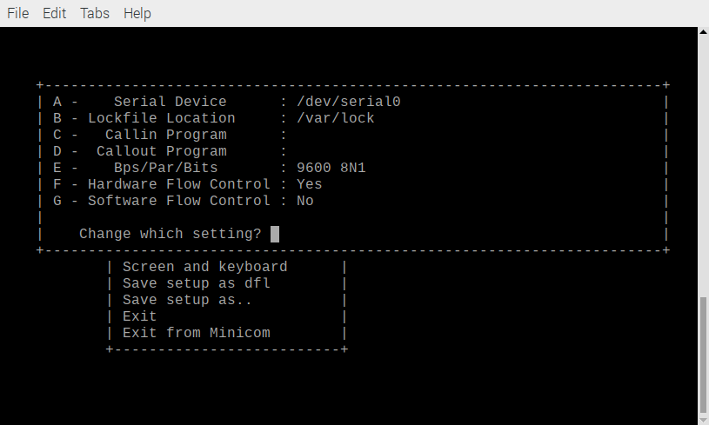

Change Hardware Flow Contral “Yes” to “No”

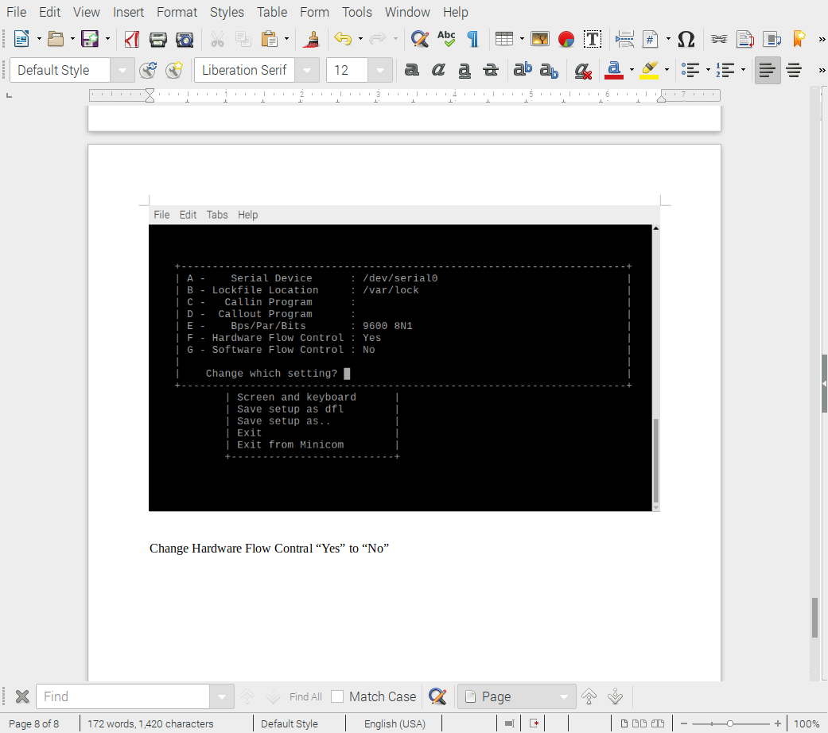
Enter

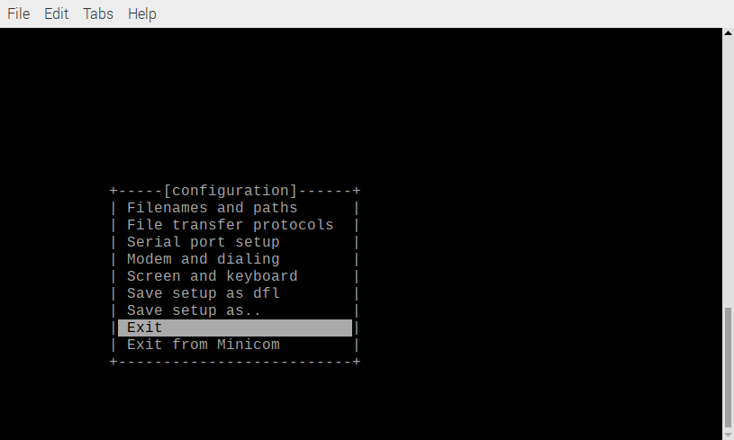
Select Exit

