******************Draft******************
09/18/20
lvgl
******************Draft******************

Forked https://github.com/cejasmasmas/ultibo_lvgl

git clone https://github.com/develone/ultibo_lvgl.git

unzipped these 2 files lv_examples.zip lvgl.zip which provides the C sources.

I created a script compile.sh based on compile.bat

Rather than compiling everything when a chanage is made in ultiboClvg.c.
I split the compile into 2 files. The first compiles most of the function
/home/devel/Ultibo_Projects/ultibo_lvgl is done with "./compile.sh". This creates
liblvgl.a. The liblvgl.a is copied to the RPi3 folder. The 2nd is done in
/home/devel/Ultibo_Projects/ultibo_lvgl/RPi3 with "./compilelib.sh". The
script copies liblvgl.a to libultiboClvg.a compiles and adds ultiboClvgl.o

compile.sh

#!/bin/bash
rm -f *.o libultiboCgeneric.a
arm-none-eabi-gcc -O2 -mabi=aapcs -marm -march=armv7-a -mfpu=vfpv3-d16 \
-mfloat-abi=hard -D__DYNAMIC_REENT__ -I libtess2/Include/ -c ultiboClvgl.c lvgl/src/lv_core/*.c \
lvgl/src/lv_draw/*.c lvgl/src/lv_font/*.c lvgl/src/lv_gpu/*.c lvgl/src/lv_hal/*.c \
lvgl/src/lv_misc/*.c lvgl/src/lv_themes/*.c lvgl/src/lv_widgets/*.c \
lv_examples/src/lv_demo_printer/*.c lv_examples/src/lv_demo_printer/images/*.c \
lv_examples/src/lv_demo_benchmark/*.c lv_examples/assets/*.c
arm-none-eabi-ar rcs libultiboClvgl.a *.o
arm-none-eabi-objdump -d libultiboClvgl.a > libultiboClvgl.txt

#!/bin/bash
rm -f *.o liblvgl.a RPi3/liblvgl.a
arm-none-eabi-gcc -O2 -mabi=aapcs -marm -march=armv7-a -mfpu=vfpv3-d16 \
-mfloat-abi=hard -D__DYNAMIC_REENT__ -I libtess2/Include/ -c lvgl/src/lv_core/*.c \
lvgl/src/lv_draw/*.c lvgl/src/lv_font/*.c lvgl/src/lv_gpu/*.c lvgl/src/lv_hal/*.c \
lvgl/src/lv_misc/*.c lvgl/src/lv_themes/*.c lvgl/src/lv_widgets/*.c \
lv_examples/src/lv_demo_printer/*.c lv_examples/src/lv_demo_printer/images/*.c \
lv_examples/src/lv_demo_benchmark/*.c lv_examples/assets/*.c \
lv_examples/src/lv_demo_widgets/*.c lv_examples/src/lv_ex_widgets/*.c \
lv_examples/src/lv_ex_get_started/*.c
arm-none-eabi-ar rcs liblvgl.a *.o
arm-none-eabi-ar t liblvgl.a > liblvgl_obj.txt
arm-none-eabi-objdump -d liblvgl.a > liblvgl_disasm.txt
cp liblvgl.a RPi3/
rm -f *.o

compilelib.sh
#!/bin/bash
rm -f *.o libultiboClvgl.a
arm-none-eabi-gcc -O2 -mabi=aapcs -marm -march=armv7-a -mfpu=vfpv3-d16 \
-mfloat-abi=hard -D__DYNAMIC_REENT__ -I libtess2/Include/ -I../ -c ultiboClvgl.c
cp liblvgl.a libultiboClvgl.a
arm-none-eabi-ar rcs libultiboClvgl.a ultiboClvgl.o
arm-none-eabi-ar t libultiboClvgl.a > libultiboClvgl_obj.txt
arm-none-eabi-objdump -d libultiboClvgl.a > libultiboClvgl_disasm.txt

Project needed a fix.

git remote add upstream https://github.com/cejasmasmas/ultibo_lvgl

git fetch upstream

git merge upstream/master

git push origin master

https://github.com/develone/Ultibo_Projects/tree/master/ultibo_lvgl

git clone https://github.com/develone/Ultibo_Projects.git

cd Ultibo_Projects/ultibo_lvgl

unzip lv_examples.zip

unzip lv_examples.zip

~/Ultibo_Projects/ultibo_lvgl/
./compile.sh

~/Ultibo_Projects/ultibo_lvgl/RPi3
libultiboClvgl.a

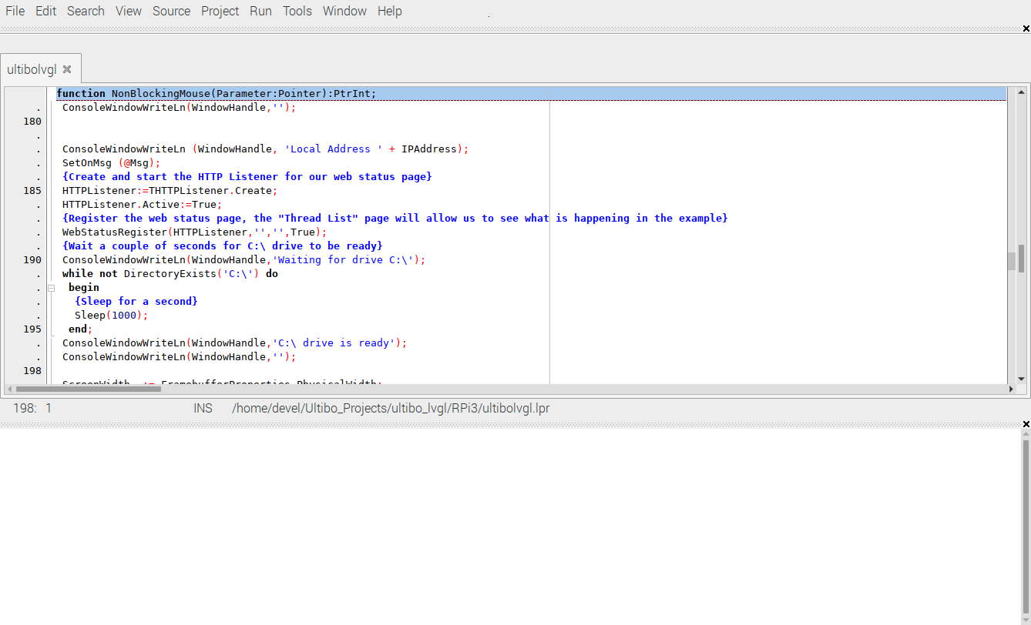
Run/Compile

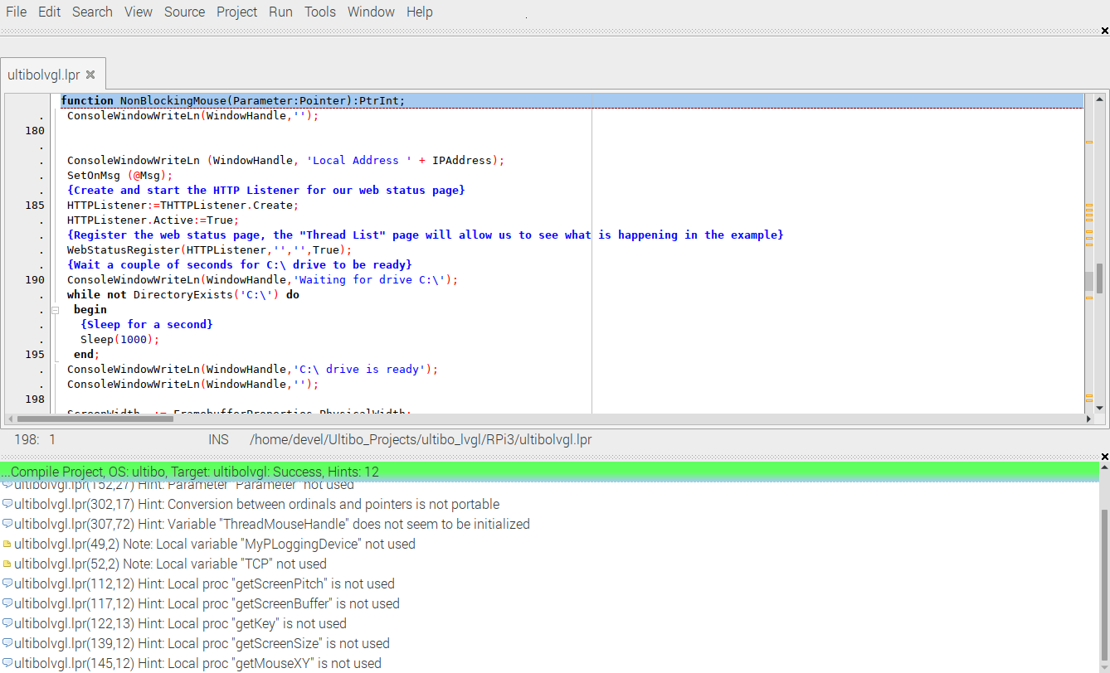

Green bar compile & link successful.

tftp 192.168.1.245 < cmdstftp
tftp> tftp> Sent 5044228 bytes in 27.4 seconds
After the reboot.

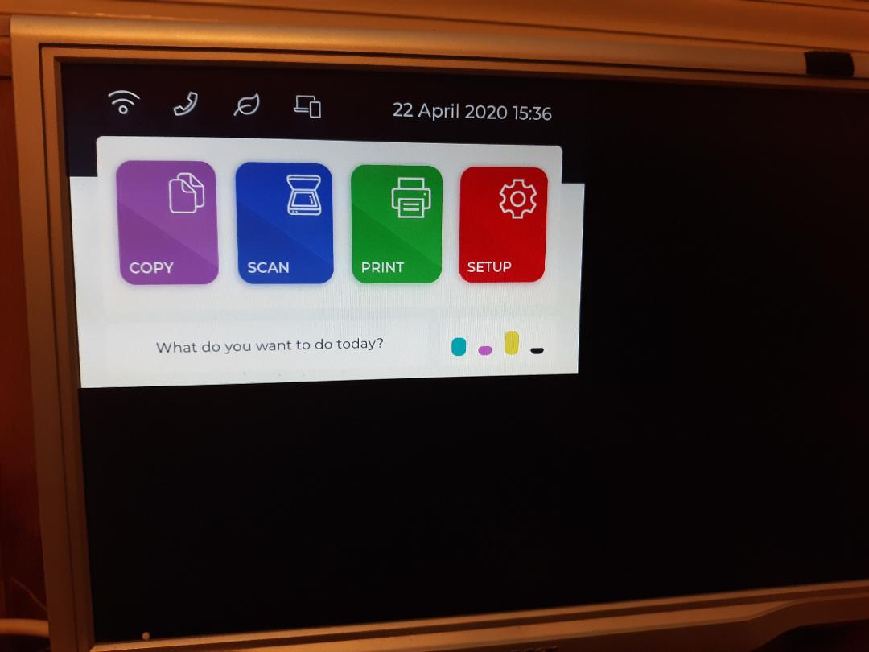
Remote shell

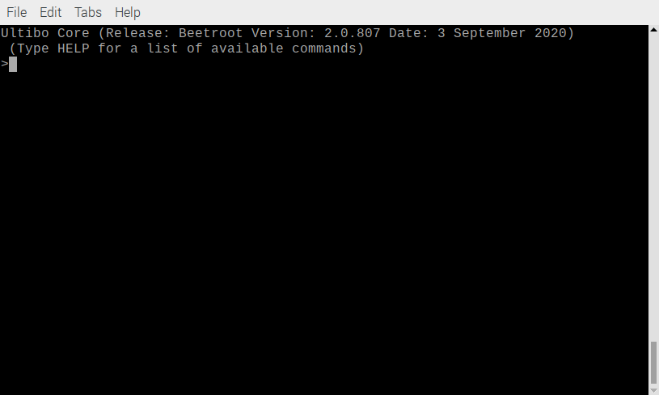
Remote shell help
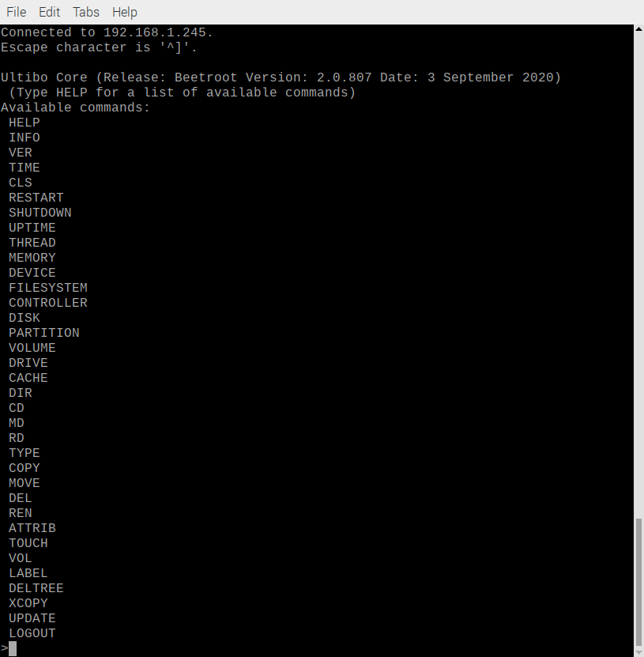
Depress Settings
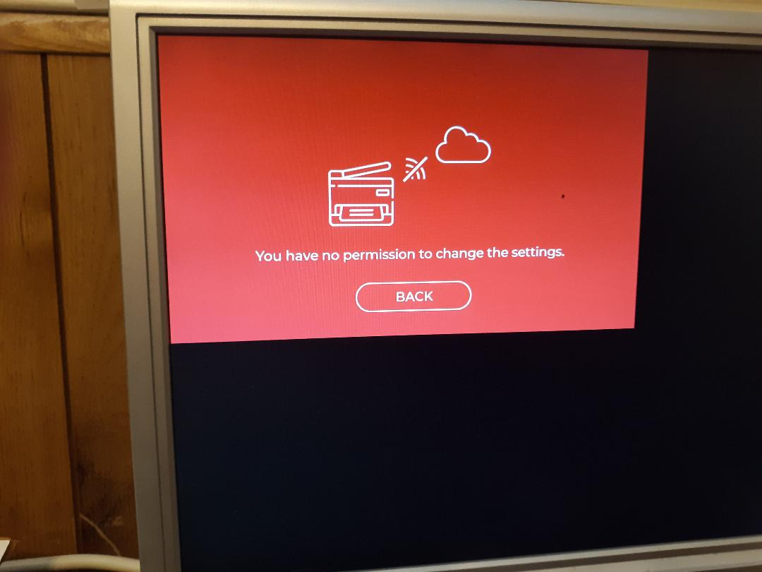

Depress Copy
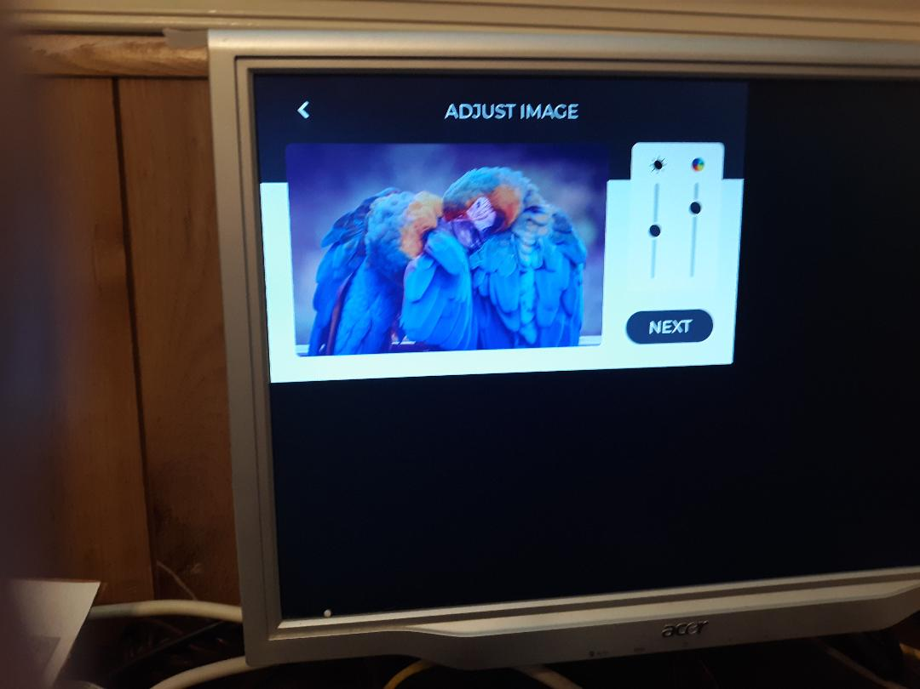
Depress Next
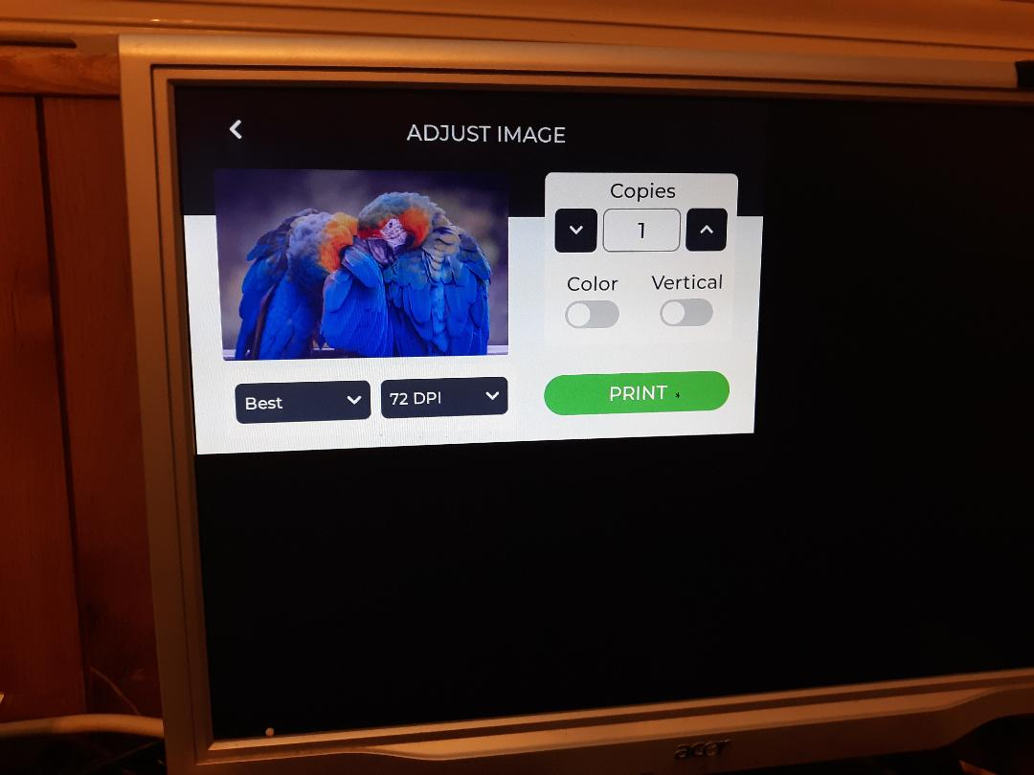
Modifying ultiboClvgl.c commenting lv_demo_printer(); and adding lv_ex_get_started_1();.
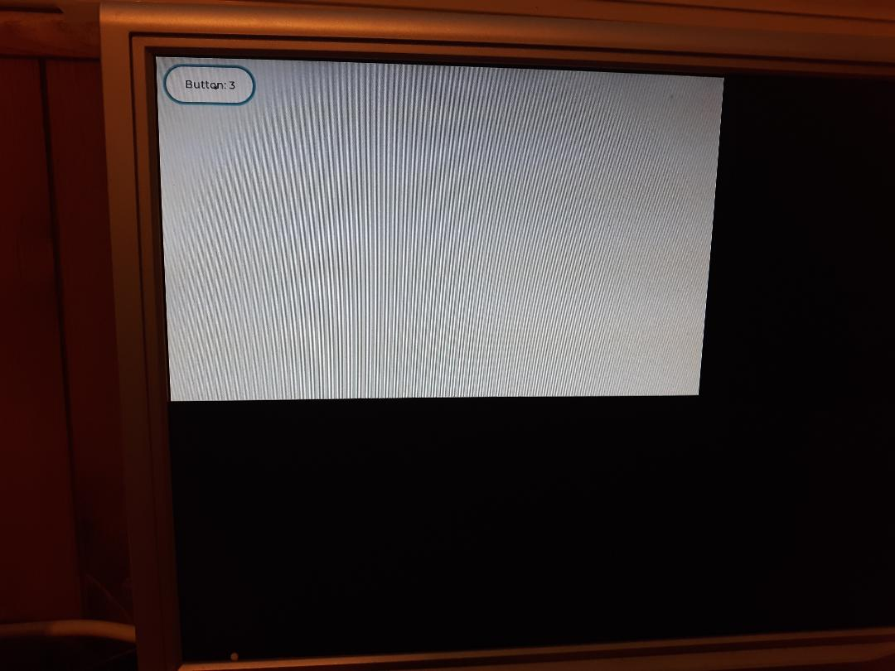
When the Button is depressed with left mouse button the number increaes.
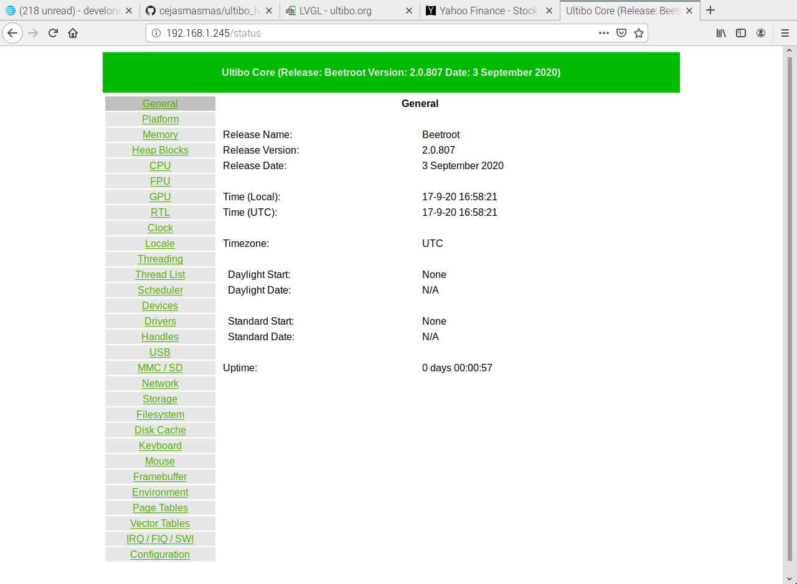
web cpu
