******************Draft******************
picokltdwt-ultibo
03/31/21
******************Draft******************

The RPi3B Running Ultibo provides the capability to update the kernel7.img
tftp xx.xx.xx.xx < cmdstftp
tftp> tftp> Sent 3223812 bytes in 12.6 second

In addition it provides a WebStatus and remote shell
The remote shell can be use to examine files and restart the RPi3B+ Ultibo.

Ultibo Core (Release: Beetroot Version: 2.1.341 Date: 21 March 2022)
telnet xx.xx.xx.xx
Ultibo Core (Release: Beetroot Version: 2.1.341 Date: 21 March 2022)
(Type HELP for a list of available commands)
Available commands:
HELP
INFO
VER
TIME
CLS
RESTART
SHUTDOWN
UPTIME
THREAD
MEMORY
DEVICE
FILESYSTEM
CONTROLLER
DISK
PARTITION
VOLUME
DRIVE
CACHE
DIR
CD
MD
RD
TYPE
COPY
MOVE
DEL
REN
ATTRIB
TOUCH
VOL
LABEL
DELTREE
XCOPY
UPDATE
LOGOUT

type pico.log
LASS_SERIAL Name=Serial1)
0000007E - 01617F54:2 - USB: Bound USB CDC ACM Serial Driver to full-speed USB 2.0 device (Pico) (idVendor=2E8A idProduct=000A) (Interface=0)
0000007F - 01617F54:2 - Device: Sending device notification (Name=USB3 Class=DEVICE_CLASS_USB Notification=DEVICE_NOTIFICATION_BIND)
00000080 - 01617F54:2 - Device: Sending device notification (Name=USB4 Class=DEVICE_CLASS_USB Notification=DEVICE_NOTIFICATION_REGISTER)
00000081 - 01617F54:2 - Device: Registered device (Handle=029AA214 Class=DEVICE_CLASS_USB Name=USB4)
00000082 - 01617F54:2 - USB: Device3: Hub: New high-speed device connected to port 1
00000083 - 01617F54:2 - Device: Sending device notification (Name=USB4 Class=DEVICE_CLASS_USB Notification=DEVICE_NOTIFICATION_ATTACHING)
(Type HELP for a list of available commands)
>restart
Restarting in 1000 milliseconds
The RPi3B+ is programmed using repo

https://github.com/develone/Ultibo_Projects

https://github.com/develone/Ultibo_Projects/blob/master/picotransfer/RPi3/picokltdwtultibo.lpr

The pico is programmed using repo

https://github.com/develone/rp2040-freertos-project

https://github.com/develone/rp2040-freertos-project/blob/master/kltdwt-ultibo/main.c

https://github.com/develone/rp2040-freertos-project/blob/master/kltdwt-ultibo/CMakeLists.txt

cmake ../
PICO_SDK_PATH is /home/devel/rp2040-freertos-project/pico-sdk
PICO platform is rp2040.
PICO target board is pico.
Using board configuration from /home/devel/rp2040-freertos-project/pico-sdk/src/boards/include/boards/pico.h
TinyUSB available at /home/devel/rp2040-freertos-project/pico-sdk/lib/tinyusb/src/portable/raspberrypi/rp2040; enabling build support for USB.
-- Configuring done
-- Generating done
-- Build files have been written to: /home/devel/rp2040-freertos-project/build
devel@pi4-27:~/rp2040-freertos-project/build $ make
[ 1%] Built target bs2_default
[ 2%] Performing build step for 'ELF2UF2Build'
[100%] Built target elf2uf2
[ 2%] No install step for 'ELF2UF2Build'
[ 2%] Completed 'ELF2UF2Build'
[ 2%] Built target ELF2UF2Build
[ 2%] Built target lifting
[ 2%] Built target bs2_default_padded_checksummed_asm
[ 3%] Built target klt
[ 3%] Built target crc
[ 12%] Built target kltdwt-ultibo
[ 21%] Built target multicore
[ 29%] Built target klt-test
[ 31%] Built target freertos
[ 40%] Built target Semaphore
[ 48%] Built target Mutex
[ 56%] Built target Scheduling
[ 62%] Built target 50_pwm
[ 70%] Built target 2tasks
[ 79%] Built target ultibo_blink
[ 87%] Built target hello_usb
[ 95%] Built target pico-lifting
[100%] Built target blink

Rpi3B+
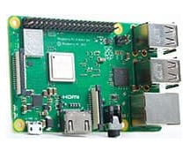

Pico

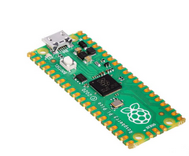

sudo minicom -s

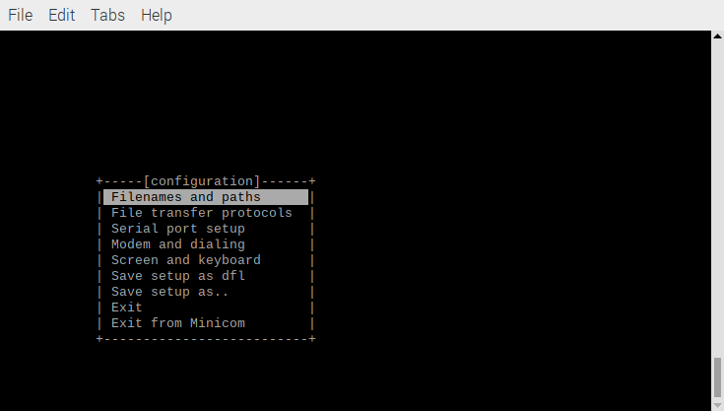
Scroll Down to Serial port setup. Depress Enter

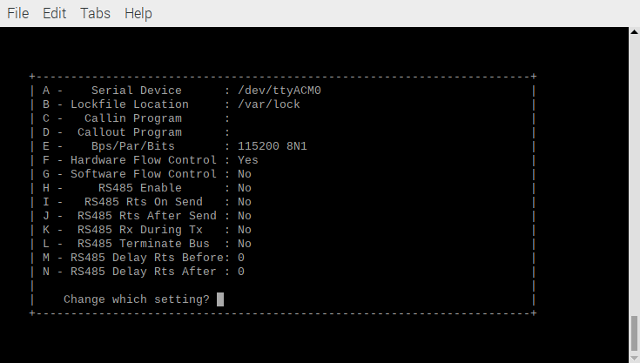

Depress Enter

Scroll Down to Exit

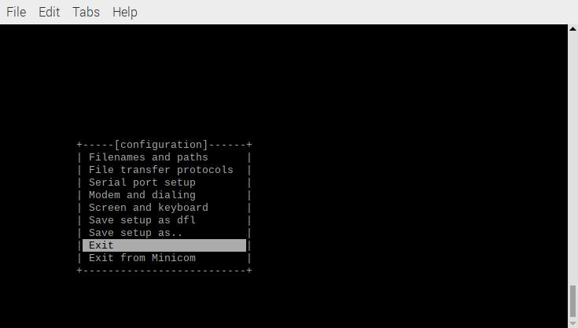

Depress Enter

New minicom

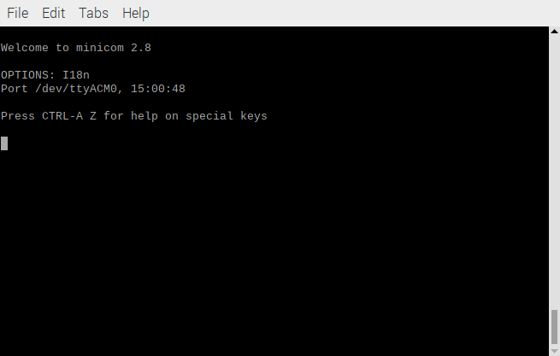

openocd -f interface/raspberrypi-swd.cfg -f target/rp2040.cfg -c "program kltdwt-ultibo/kltdwt-ultibo.elf verify reset exit"
Open On-Chip Debugger 0.10.0+dev-g71510a7-dirty (2021-08-15-17:08)
Licensed under GNU GPL v2
For bug reports, read
http://openocd.org/doc/doxygen/bugs.html
adapter speed: 1000 kHz

Info : Hardware thread awareness created
Info : Hardware thread awareness created
Info : RP2040 Flash Bank Command
Info : BCM2835 GPIO JTAG/SWD bitbang driver
Info : clock speed 1001 kHz
Info : SWD DPIDR 0x0bc12477
Info : SWD DLPIDR 0x00000001
Info : SWD DPIDR 0x0bc12477
Info : SWD DLPIDR 0x10000001
Info : rp2040.core0: hardware has 4 breakpoints, 2 watchpoints
Info : rp2040.core1: hardware has 4 breakpoints, 2 watchpoints
Info : starting gdb server for rp2040.core0 on 3333
Info : Listening on port 3333 for gdb connections
target halted due to debug-request, current mode: Thread
xPSR: 0xf1000000 pc: 0x000000ee msp: 0x20041f00
target halted due to debug-request, current mode: Thread
xPSR: 0xf1000000 pc: 0x000000ee msp: 0x20041f00
** Programming Started **
Info : RP2040 B0 Flash Probe: 2097152 bytes @10000000, in 512 sectors

target halted due to debug-request, current mode: Thread
xPSR: 0x01000000 pc: 0x0000012a msp: 0x20041f00
target halted due to debug-request, current mode: Thread
xPSR: 0x01000000 pc: 0x0000012a msp: 0x20041f00
target halted due to debug-request, current mode: Thread
xPSR: 0x01000000 pc: 0x0000012a msp: 0x20041f00
target halted due to debug-request, current mode: Thread
xPSR: 0x01000000 pc: 0x0000012a msp: 0x20041f00
Info : Writing 73728 bytes starting at 0x0
target halted due to debug-request, current mode: Thread
xPSR: 0x01000000 pc: 0x0000012a msp: 0x20041f00
target halted due to debug-request, current mode: Thread
xPSR: 0x01000000 pc: 0x0000012a msp: 0x20041f00
target halted due to debug-request, current mode: Thread
xPSR: 0x01000000 pc: 0x0000012a msp: 0x20041f00
target halted due to debug-request, current mode: Thread
xPSR: 0x01000000 pc: 0x0000012a msp: 0x20041f00
target halted due to debug-request, current mode: Thread
xPSR: 0x01000000 pc: 0x0000012a msp: 0x20041f00
target halted due to debug-request, current mode: Thread
xPSR: 0x01000000 pc: 0x0000012a msp: 0x20041f00
target halted due to debug-request, current mode: Thread
xPSR: 0x01000000 pc: 0x0000012a msp: 0x20041f00
target halted due to debug-request, current mode: Thread
xPSR: 0x01000000 pc: 0x0000012a msp: 0x20041f00
target halted due to debug-request, current mode: Thread
xPSR: 0x01000000 pc: 0x0000012a msp: 0x20041f00
** Programming Finished **
** Verify Started **
target halted due to debug-request, current mode: Thread
xPSR: 0x01000000 pc: 0x0000012a msp: 0x20041f00
target halted due to debug-request, current mode: Thread
xPSR: 0x01000000 pc: 0x0000012a msp: 0x20041f00
** Verified OK **
** Resetting Target **
shutdown command invoked

10 Sysc and 10 Ready

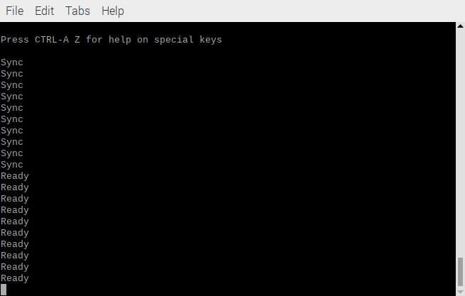
Selecting upload mode.

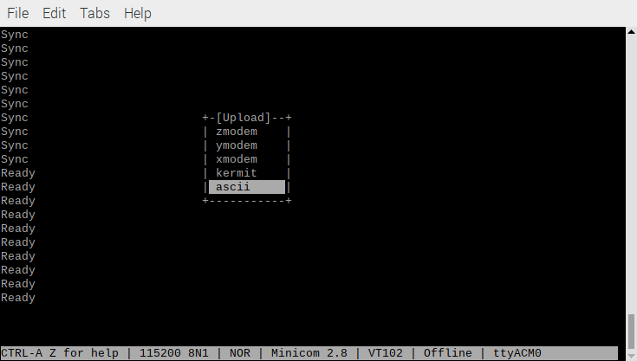
Selecting a64.bin

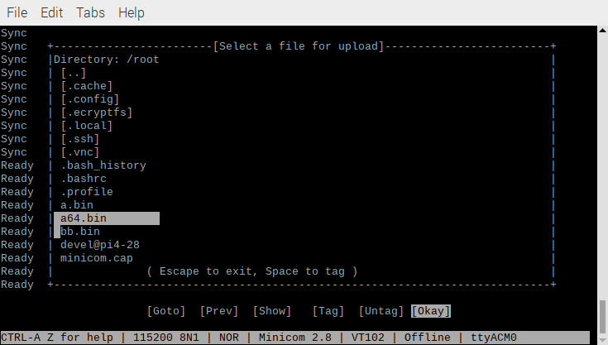
After selecting the file a64.bin

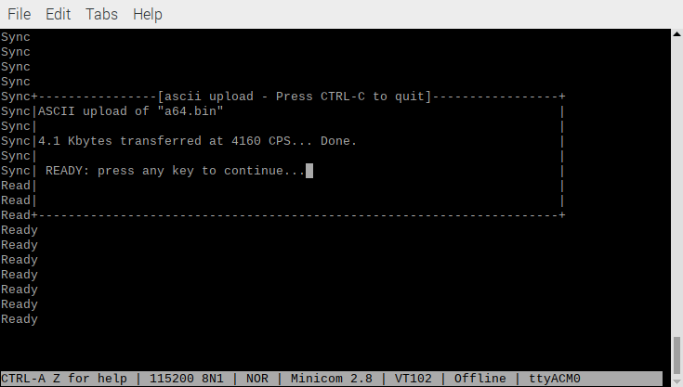

4160 data values sent. Depress Enter

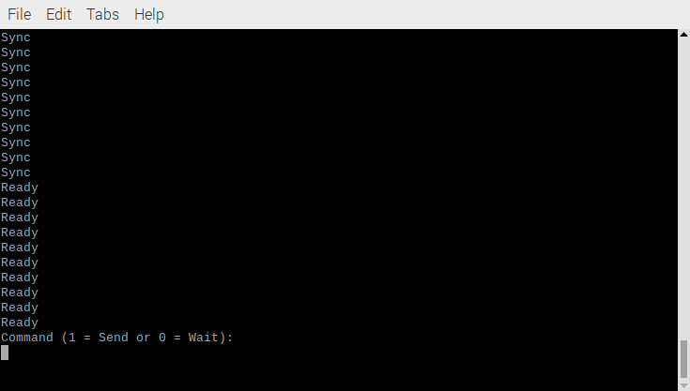
Depress 1

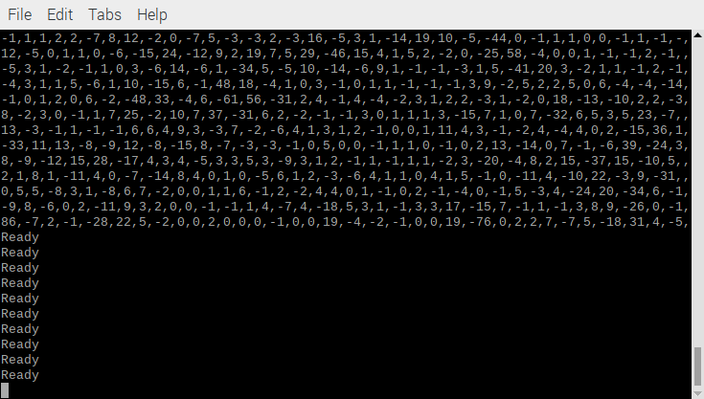

4160 data values sent.

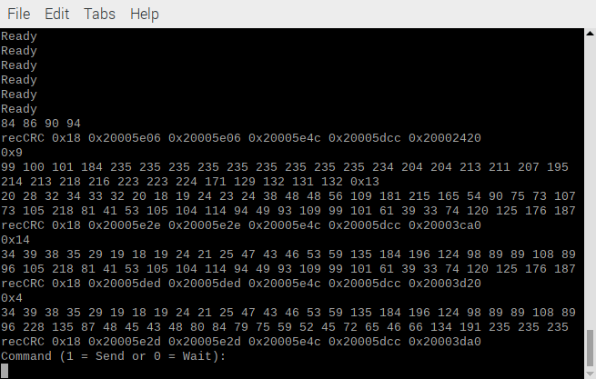

Ultibo Now can detect Sync

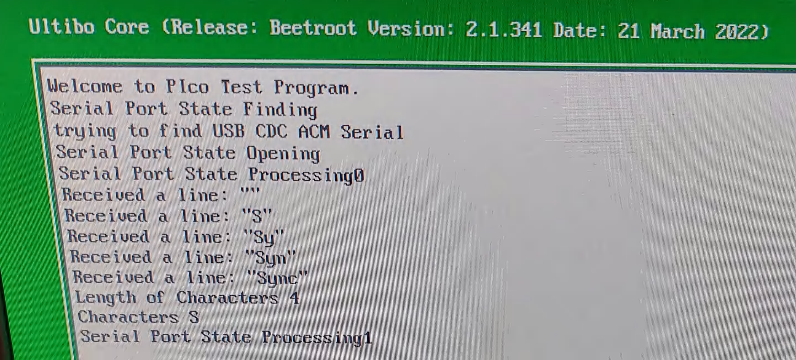

Ultibo Now can detect Ready

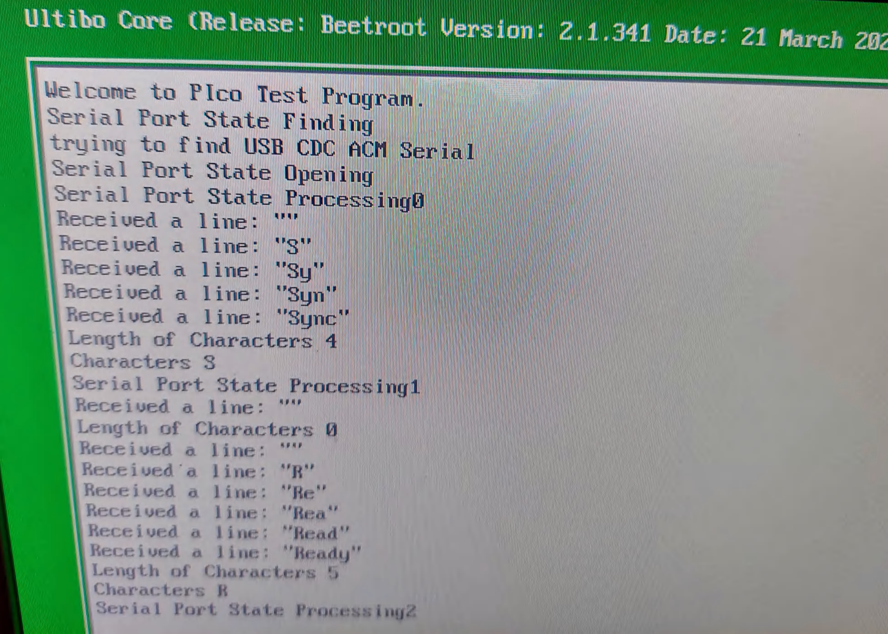
This version receive 10 Sync followed by 10 Ready.
Then sends either a64.bin or bb.bin which and image 64 X 64 with an
8 bit CRC 4160 char
Command (1 = Send or 0 = Wait):
a64.bin
Feature #0: (24.000000,32.000000) with value of 4472
Feature #1: (34.000000,39.000000) with value of 3461
Feature #2: (36.000000,29.000000) with value of 3100
bb.bin
Feature #0: (37.000000,29.000000) with value of 19844
Feature #1: (28.000000,39.000000) with value of 9270
Feature #2: (24.000000,29.000000) with value of 4393
Feature #3: (38.000000,39.000000) with value of 465

The 64 X 64 image is sent to the pico in 64 lines of 65 characters. The value at position 65 is the CRC of the image. The data is in the file a64.bin



The data is in the file bb.bin



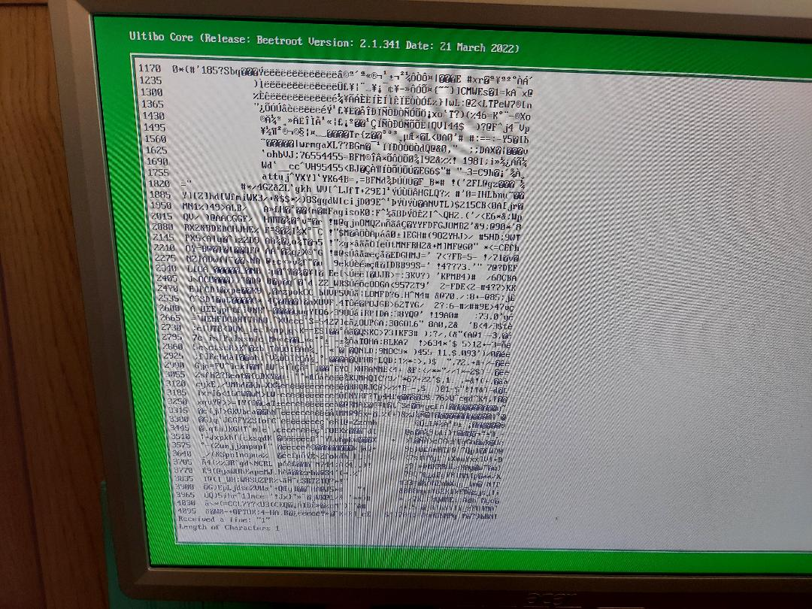
xx
The pico sends Command (1 = Send or 0 = Wait):

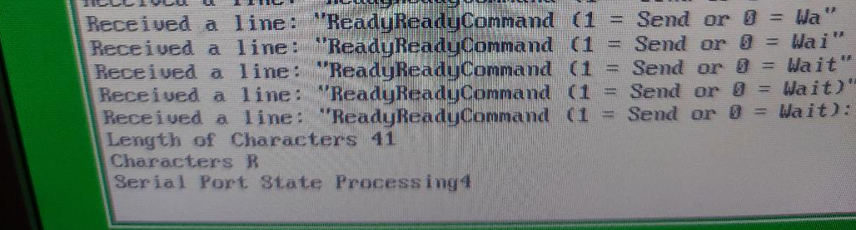

xx
need to copy the data received from host to img1
img1 = 0x2003ffd8 img2 = 0x20040fd8
0 img1 161 ptrs.buf 161
1 img1 157 ptrs.buf 157
2 img1 156 ptrs.buf 156
3 img1 157 ptrs.buf 157
4 img1 159 ptrs.buf 159
4091 img1 62 ptrs.buf 62
4092 img1 67 ptrs.buf 67
4093 img1 63 ptrs.buf 63
4094 img1 59 ptrs.buf 59
4095 img1 91 ptrs.buf 91
need to copy the data from img1 to img2
0 img2 161 img1 161
1 img2 157 img1 157
2 img2 156 img1 156
3 img2 157 img1 157
4 img2 159 img1 159
4091 img2 62 img1 62
4092 img2 67 img1 67
4093 img2 63 img1 63
4094 img2 59 img1 59
4095 img2 91 img1 91
Feature #0: (24.000000,32.000000) with value of 4472
Feature #1: (34.000000,39.000000) with value of 3461
Feature #2: (36.000000,29.000000) with value of 3100
Feature #3: (-1.000000,-1.000000) with value of -1
Feature #4: (-1.000000,-1.000000) with value of -1
Feature #5: (-1.000000,-1.000000) with value of -1
Feature #6: (-1.000000,-1.000000) with value of -1
Feature #7: (-1.000000,-1.000000) with value of -1
Feature #8: (-1.000000,-1.000000) with value of -1
Feature #9: (-1.000000,-1.000000) with value of -1
Feature #10: (-1.000000,-1.000000) with value of -1
Feature #11: (-1.000000,-1.000000) with value of -1
Feature #12: (-1.000000,-1.000000) with value of -1
Feature #13: (-1.000000,-1.000000) with value of -1
Feature #14: (-1.000000,-1.000000) with value of -1
Feature #15: (-1.000000,-1.000000) with value of -1
Feature #16: (-1.000000,-1.000000) with value of -1
Feature #17: (-1.000000,-1.000000) with value of -1
Feature #18: (-1.000000,-1.000000) with value of -1
Feature #19: (-1.000000,-1.000000) with value of -1
Feature #20: (-1.000000,-1.000000) with value of -1
Feature #21: (-1.000000,-1.000000) with value of -1
Feature #22: (-1.000000,-1.000000) with value of -1
Feature #23: (-1.000000,-1.000000) with value of -1
Feature #24: (-1.000000,-1.000000) with value of -1
Feature #25: (-1.000000,-1.000000) with value of -1
Feature #26: (-1.000000,-1.000000) with value of -1
Feature #27: (-1.000000,-1.000000) with value of -1
Feature #28: (-1.000000,-1.000000) with value of -1
Feature #29: (-1.000000,-1.000000) with value of -1
Feature #30: (-1.000000,-1.000000) with value of -1
Feature #31: (-1.000000,-1.000000) with value of -1
Feature #32: (-1.000000,-1.000000) with value of -1
Feature #33: (-1.000000,-1.000000) with value of -1
Feature #34: (-1.000000,-1.000000) with value of -1
Feature #35: (-1.000000,-1.000000) with value of -1
Feature #36: (-1.000000,-1.000000) with value of -1
Feature #37: (-1.000000,-1.000000) with value of -1
Feature #38: (-1.000000,-1.000000) with value of -1
Feature #39: (-1.000000,-1.000000) with value of -1
Feature #40: (-1.000000,-1.000000) with value of -1
Feature #41: (-1.000000,-1.000000) with value of -1
Feature #42: (-1.000000,-1.000000) with value of -1
Feature #43: (-1.000000,-1.000000) with value of -1
Feature #44: (-1.000000,-1.000000) with value of -1
Feature #45: (-1.000000,-1.000000) with value of -1
Feature #46: (-1.000000,-1.000000) with value of -1
Feature #47: (-1.000000,-1.000000) with value of -1
Feature #48: (-1.000000,-1.000000) with value of -1
Feature #49: (-1.000000,-1.000000) with value of -1
Feature #50: (-1.000000,-1.000000) with value of -1
Feature #51: (-1.000000,-1.000000) with value of -1
Feature #52: (-1.000000,-1.000000) with value of -1
Feature #53: (-1.000000,-1.000000) with value of -1
Feature #54: (-1.000000,-1.000000) with value of -1
Feature #55: (-1.000000,-1.000000) with value of -1
Feature #56: (-1.000000,-1.000000) with value of -1
Feature #57: (-1.000000,-1.000000) with value of -1
Feature #58: (-1.000000,-1.000000) with value of -1
Feature #59: (-1.000000,-1.000000) with value of -1
Feature #60: (-1.000000,-1.000000) with value of -1
Feature #61: (-1.000000,-1.000000) with value of -1
Feature #62: (-1.000000,-1.000000) with value of -1
Feature #63: (-1.000000,-1.000000) with value of -1
Feature #64: (-1.000000,-1.000000) with value of -1
Feature #65: (-1.000000,-1.000000) with value of -1
Feature #66: (-1.000000,-1.000000) with value of -1
Feature #67: (-1.000000,-1.000000) with value of -1
Feature #68: (-1.000000,-1.000000) with value of -1
Feature #69: (-1.000000,-1.000000) with value of -1
Feature #70: (-1.000000,-1.000000) with value of -1
Feature #71: (-1.000000,-1.000000) with value of -1
Feature #72: (-1.000000,-1.000000) with value of -1
Feature #73: (-1.000000,-1.000000) with value of -1
Feature #74: (-1.000000,-1.000000) with value of -1
Feature #75: (-1.000000,-1.000000) with value of -1
Feature #76: (-1.000000,-1.000000) with value of -1
Feature #77: (-1.000000,-1.000000) with value of -1
Feature #78: (-1.000000,-1.000000) with value of -1
Feature #79: (-1.000000,-1.000000) with value of -1
Feature #80: (-1.000000,-1.000000) with value of -1
Feature #81: (-1.000000,-1.000000) with value of -1
Feature #82: (-1.000000,-1.000000) with value of -1
Feature #83: (-1.000000,-1.000000) with value of -1
Feature #84: (-1.000000,-1.000000) with value of -1
Feature #85: (-1.000000,-1.000000) with value of -1
Feature #86: (-1.000000,-1.000000) with value of -1
Feature #87: (-1.000000,-1.000000) with value of -1
Feature #88: (-1.000000,-1.000000) with value of -1
Feature #89: (-1.000000,-1.000000) with value of -1
Feature #90: (-1.000000,-1.000000) with value of -1
Feature #91: (-1.000000,-1.000000) with value of -1
Feature #92: (-1.000000,-1.000000) with value of -1
Feature #93: (-1.000000,-1.000000) with value of -1
Feature #94: (-1.000000,-1.000000) with value of -1
Feature #95: (-1.000000,-1.000000) with value of -1
Feature #96: (-1.000000,-1.000000) with value of -1
Feature #97: (-1.000000,-1.000000) with value of -1
Feature #98: (-1.000000,-1.000000) with value of -1
Feature #99: (-1.000000,-1.000000) with value of -1
2,-1,0,-5,2,19,-14,3,-2,0,-1,-2,0,1,-2,1,0,-1,2,-2,1,3,-3,0,-9,20,-12,-2,2,-15,,
0,2,0,6,-9,7,0,-2,1,3,-3,-1,1,1,0,1,2,0,0,0,2,-2,-2,11,-1,-9,6,2,3,5,-8,1,1,-2,,
-3,3,-1,-1,1,0,1,2,1,0,1,-1,-1,1,1,-2,-1,-1,0,1,0,0,1,-2,0,3,0,2,2,1,-1,-3,1,5,,
3,-3,0,1,-1,-1,0,1,1,2,2,0,0,3,2,0,-1,0,2,0,0,0,0,-1,6,4,1,3,0,-2,3,3,13,14,14,,
0,1,0,0,-1,1,0,0,2,0,1,0,1,1,1,1,1,2,-1,-7,9,-3,32,1,24,-5,-11,-10,-2,-12,15,-3,
0,3,1,1,1,-1,1,0,-1,0,1,1,0,1,1,2,2,13,5,9,-9,-2,16,8,1,-25,7,-4,-6,-15,-3,-4,3,
0,-1,1,1,1,0,3,2,0,0,1,0,0,2,-2,0,-3,-7,-2,15,2,14,-14,11,9,-14,-20,34,-9,-1,-4,
0,-1,0,1,0,-1,0,5,-1,-7,4,2,-8,8,2,1,-2,36,-5,3,-12,-4,8,-5,31,-33,-16,5,-3,4,7,
1,1,0,1,0,1,-10,20,-6,-2,3,3,-6,-6,-5,8,26,4,13,6,33,-11,30,-6,-16,13,19,-1,-2,,
-1,0,-1,2,-6,8,1,0,-3,4,-1,-2,-6,5,-8,11,-22,8,8,-9,7,-12,23,-31,12,8,4,19,9,34,
1,0,1,1,-7,4,-1,-3,-3,6,17,-16,-4,4,24,-6,1,6,15,-31,31,3,-56,-37,-21,-23,25,2,,
2,2,1,3,-1,0,1,5,13,12,-17,-5,0,17,1,-8,35,-3,-15,18,22,10,-44,1,11,-18,17,-17,,
2,0,1,4,-2,1,1,19,20,-13,-4,-3,8,-1,7,-16,33,14,-2,-10,26,18,5,0,-1,-2,2,-7,8,-,
0,1,0,2,-1,-1,0,-6,-9,0,-4,-13,-12,-15,-7,10,-44,20,49,-69,16,-6,5,5,-5,2,6,-5,,
0,0,-2,5,5,0,-10,-10,5,4,0,1,-9,-5,11,0,-7,45,11,1,0,2,3,-1,-5,-2,9,3,12,-38,19,
0,2,4,11,-1,8,14,-9,3,7,-3,23,-22,10,22,2,40,13,-1,1,0,1,1,8,-6,0,-8,-4,6,-4,1,,
2,0,1,-9,-8,-6,-1,0,-2,-3,-6,-15,-24,-10,-5,42,-1,-17,2,-1,1,-7,4,0,2,-2,-3,0,-,
0,1,0,13,34,6,4,0,0,2,0,11,18,-2,4,-8,-40,-28,2,1,2,1,-6,2,2,1,-1,0,0,2,1,-2,0,,
-1,2,-1,0,-29,11,1,-2,9,3,-1,17,3,-4,-14,9,17,-7,1,-2,7,-9,5,8,7,-1,0,-1,0,-1,1,
0,0,1,1,1,-46,31,-2,0,-3,-14,4,0,-6,-1,-1,-8,14,0,-1,-10,-1,-6,8,10,-1,-1,-2,1,,
11,0,1,1,0,-1,-37,47,-22,6,0,-1,-4,-1,0,-9,19,13,6,-2,4,-11,0,-1,-25,-7,1,0,-2,,
0,1,-1,1,0,0,0,17,-23,-2,2,0,38,5,4,26,-21,-29,2,6,1,-3,-3,2,14,27,-13,1,-1,-1,,
-1,-1,0,0,-4,5,1,0,-2,-3,-1,-5,-18,9,-8,-7,8,3,0,3,-2,0,2,1,0,35,-13,10,-2,1,1,,
1,1,-1,-1,6,-5,1,30,60,0,-6,14,-15,-15,-5,2,3,-2,7,0,4,-1,-11,-3,-2,1,0,-3,-8,-,
0,0,0,1,-1,-2,10,-6,5,2,-7,-55,2,18,-1,4,0,-2,-1,-13,2,3,-1,-2,-13,3,0,0,1,-5,1,
18,0,1,0,1,1,-5,5,-5,-2,-20,-17,20,-1,5,-6,-7,6,-5,0,-1,0,1,0,2,2,-1,1,1,-7,3,4,
-7,0,-15,7,0,-6,27,-71,23,-29,-2,-1,4,-13,13,-9,4,0,-1,2,2,0,-1,0,3,0,1,-3,-2,-,
26,-35,28,10,-42,18,-2,-1,-1,0,2,-5,15,-3,4,-1,0,-2,1,0,-1,1,2,1,1,15,-18,16,7,,
0,0,11,-18,-36,11,-4,2,15,-16,12,-2,0,-2,-4,3,1,-1,0,7,-4,1,2,-6,7,6,1,3,3,1,20,
1,0,12,-33,2,-8,-3,-29,35,-11,1,2,-1,-1,0,2,2,0,-13,16,-2,-1,-1,3,0,2,3,-10,1,0,
2,15,-33,4,-4,-3,-28,-9,6,-1,2,0,-1,1,1,-1,1,-9,13,-5,1,1,-1,-3,5,-54,-7,7,-12,,
-24,-30,2,0,14,-20,-15,1,0,0,-1,0,1,-1,-2,-3,4,9,-3,5,2,2,1,-6,-21,6,-10,7,-10,,
3,0,0,3,3,-5,-1,-3,3,1,-2,0,1,1,2,0,0,5,1,-1,2,0,1,2,-9,9,4,-1,0,-6,15,-5,9,-11,
-1,-1,7,0,-4,3,-1,-1,0,0,0,3,2,0,1,1,0,1,0,0,-1,2,4,3,6,-9,6,-2,-1,0,3,5,14,-10,
0,0,-1,0,0,1,0,-1,1,4,-1,1,-1,1,1,1,1,1,2,-2,1,-1,1,-1,2,0,1,2,2,-1,1,1,1,3,0,1,
4,1,1,1,0,0,0,2,1,1,1,1,0,1,1,-1,0,2,0,-3,2,0,7,0,-2,-8,-3,-1,3,2,1,-2,1,1,0,12,
2,1,0,1,-2,0,1,0,2,0,2,-2,0,-1,1,0,-3,7,2,10,-4,0,4,5,28,3,-6,4,-2,0,2,-2,0,0,1,
1,0,0,2,0,1,0,-2,2,-1,0,1,0,0,1,1,-1,-18,11,6,3,11,-4,-8,-5,16,-4,1,5,3,-1,-1,1,
1,1,0,3,-1,0,1,2,2,-3,0,2,-1,3,4,1,8,43,0,4,10,-5,7,-5,-4,12,0,5,-8,-2,-3,-6,1,,
1,1,-1,2,-1,1,0,-8,4,5,-5,5,10,-11,2,2,19,-15,15,6,0,-14,-2,23,-2,-1,-3,-4,3,-3,
1,1,1,3,0,2,1,7,-3,-4,0,-2,-3,13,1,5,0,1,-9,3,-5,14,-12,-21,-3,0,3,-3,3,19,2,2,,
0,1,-1,1,5,-5,1,-1,4,4,-3,-4,8,-5,7,3,13,8,17,-4,-10,-29,2,22,23,2,-1,0,17,-2,-,
1,1,0,-3,-9,5,0,6,3,-2,2,4,-5,5,-17,-1,-2,6,3,41,-42,34,17,-14,-14,-5,6,32,-16,,
0,0,1,3,0,-3,1,5,-8,5,3,-5,4,0,4,1,-1,-3,-2,-14,50,-23,-17,-1,1,-3,1,-20,-8,2,1,
3,2,-1,9,-5,-2,2,-23,11,1,-2,3,9,3,-9,3,1,-9,10,27,-19,4,2,1,0,0,-1,-1,0,-3,10,,
1,3,-5,19,1,-2,-2,24,1,1,8,5,-27,0,16,-15,2,23,-7,-19,5,3,0,-5,1,-3,1,1,6,6,-17,
1,2,-7,22,2,8,-8,-7,4,-3,11,0,9,-7,-18,5,20,-16,4,1,0,1,4,3,4,-2,2,5,-5,-4,6,0,,
2,3,3,14,-2,-9,12,4,-3,2,7,-3,3,-19,24,11,-30,18,8,1,1,-1,1,10,-14,-1,2,0,3,1,1,
1,1,1,-27,19,3,-5,1,5,6,2,-22,-8,1,-3,-15,-62,11,10,1,0,8,5,2,-8,0,0,-1,0,0,0,0,
2,1,0,7,-21,9,0,-1,4,-2,6,-70,18,0,1,30,-20,5,3,2,-2,4,-1,5,2,-3,1,1,0,-1,2,2,4,
0,2,0,1,-7,9,5,2,-3,6,-6,8,0,-1,1,6,-3,2,0,-5,-30,40,22,12,-4,6,0,0,0,2,-1,1,1,,
-1,1,1,2,2,-7,8,12,-2,0,-7,5,-3,-3,2,-3,16,-5,3,1,-14,19,10,-5,-44,0,-1,1,1,0,0,
12,-5,0,1,1,0,-6,-15,24,-12,9,2,19,7,5,29,-46,15,4,1,5,2,-2,0,-25,58,-4,0,0,1,-,
-5,3,1,-2,-1,1,0,3,-6,14,-6,1,-34,5,-5,10,-14,-6,9,1,-1,-1,-3,1,5,-41,20,3,-2,1,
-4,3,1,1,5,-6,1,10,-15,6,-1,48,18,-4,1,0,3,-1,0,1,1,-1,-1,-1,3,9,-2,5,2,2,5,0,6,
-1,0,1,2,0,6,-2,-48,33,-4,6,-61,56,-31,2,4,-1,4,-4,-2,3,1,2,2,-3,1,-2,0,18,-13,,
8,-2,3,0,-1,1,7,25,-2,10,7,37,-31,6,2,-2,-1,-1,3,0,1,1,1,3,-15,7,1,0,7,-32,6,5,,
13,-3,-1,1,-1,-1,6,6,4,9,3,-3,7,-2,-6,4,1,3,1,2,-1,0,0,1,11,4,3,-1,-2,4,-4,4,0,,
-33,11,13,-8,-9,12,-8,-15,8,-7,-3,-3,-1,0,5,0,0,-1,1,1,0,-1,0,2,13,-14,0,7,-1,-,
8,-9,-12,15,28,-17,4,3,4,-5,3,3,5,3,-9,3,1,2,-1,1,-1,1,1,-2,3,-20,-4,8,2,15,-37,
2,1,8,1,-11,4,0,-7,-14,8,4,0,1,0,-5,6,1,2,-3,-6,4,1,1,0,4,1,5,-1,0,-11,4,-10,22,
0,5,5,-8,3,1,-8,6,7,-2,0,0,1,1,6,-1,2,-2,4,4,0,1,-1,0,2,-1,-4,0,-1,5,-3,4,-24,2,
-9,8,-6,0,2,-11,9,3,2,0,0,-1,-1,1,4,-7,4,-18,5,3,1,-1,3,3,17,-15,7,-1,1,-1,3,8,,
86,-7,2,-1,-28,22,5,-2,0,0,2,0,0,0,-1,0,0,19,-4,-2,-1,0,0,19,-76,0,2,2,7,-7,5,-,
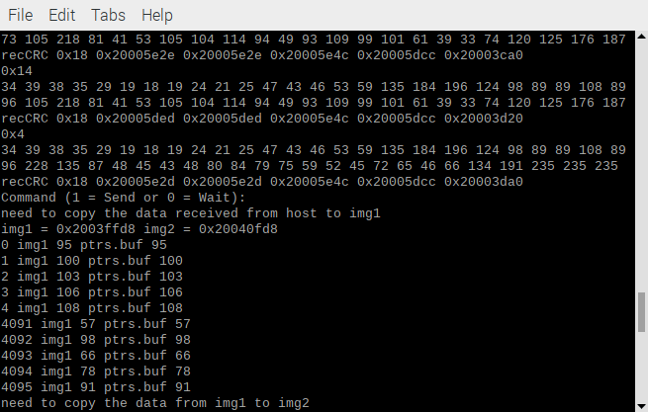
xx

xx
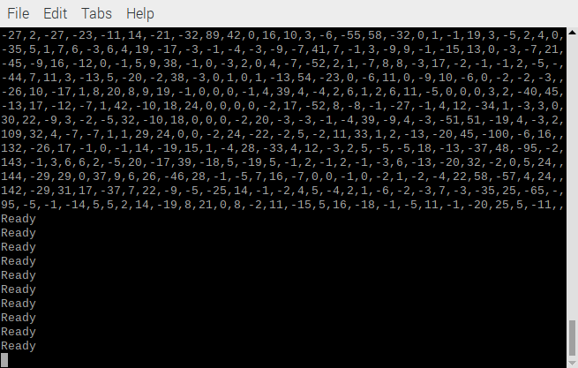
http://xx.xx.xx.xx/status//usb?action=usbdevice&id=3

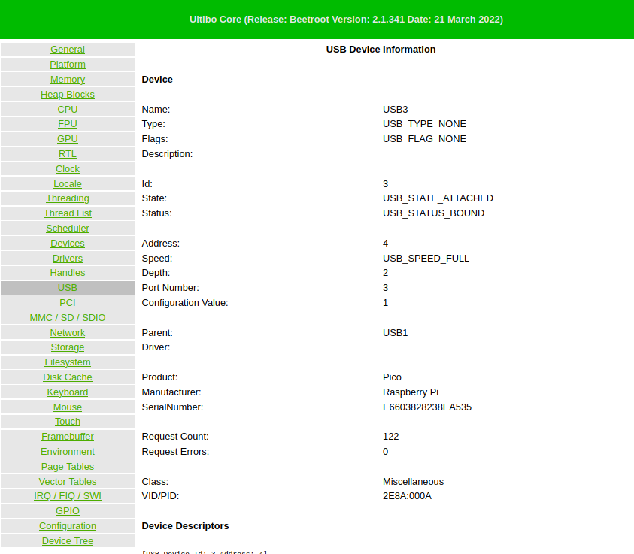
http://xx.xx.xx.xx/status//platform



