*********************Draft*********************
Testing Openjpeg Compression/Decompression
on a RPi4B running Bare Metal Ultibo
05/18/21
*********************Draft*********************

{==============================================================================}
{Global constants}
const
{Version constants}
ULTIBO_RELEASE_DATE = '14 May 2021';
ULTIBO_RELEASE_NAME = 'Beetroot';
ULTIBO_RELEASE_VERSION = '2.1.005';
ULTIBO_RELEASE_VERSION_MAJOR = 2;
ULTIBO_RELEASE_VERSION_MINOR = 1;
ULTIBO_RELEASE_VERSION_REVISION = 003;

{==============================================================================}
The file test.j2k was created on RPi4B 4Gb.
Input MyBitmap.bmp a copy lena_512_rgb.bmp testfile a copy 512com

00000000 19 00 00 00 01 00 00 00 00 00 00 00 00 00 00 00 ................
00000010 00 02 00 00 00 02 00 00

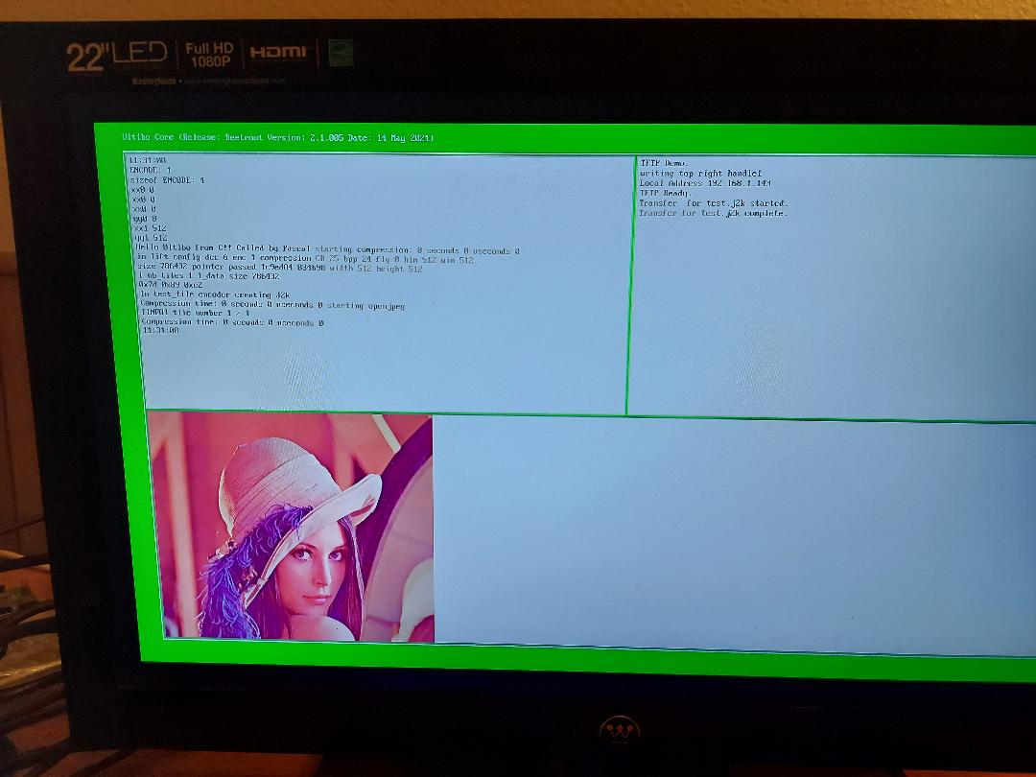
devel@mypi3-20:~/tmp $ tftp 192.168.1.143
tftp> binary
tftp> get test.j2k
Received 31411 bytes in 0.1 seconds
tftp> quit

devel@mypi3-20:~/tmp $ ~/openjpeg/build/bin/opj_decompress -i test.j2k -o lena512.bmp

[INFO] Start to read j2k main header (0).
[INFO] Main header has been correctly decoded.
[INFO] No decoded area parameters, set the decoded area to the whole image
[INFO] Header of tile 1 / 1 has been read.
[INFO] Generated Outfile lena512.bmp
decode time: 135 ms



Perform the decompression on Bare Metal Ultibo.
devel@mypi3-20:~/Ultibo_Projects/jpeg2000/RPi4/512-options $ cp 512decom testfile

devel@mypi3-20:~/Ultibo_Projects/jpeg2000/RPi4/512-options $ tftp 192.168.1.143
tftp> binary
tftp> put testfile
Sent 24 bytes in 0.0 seconds
tftp> quit

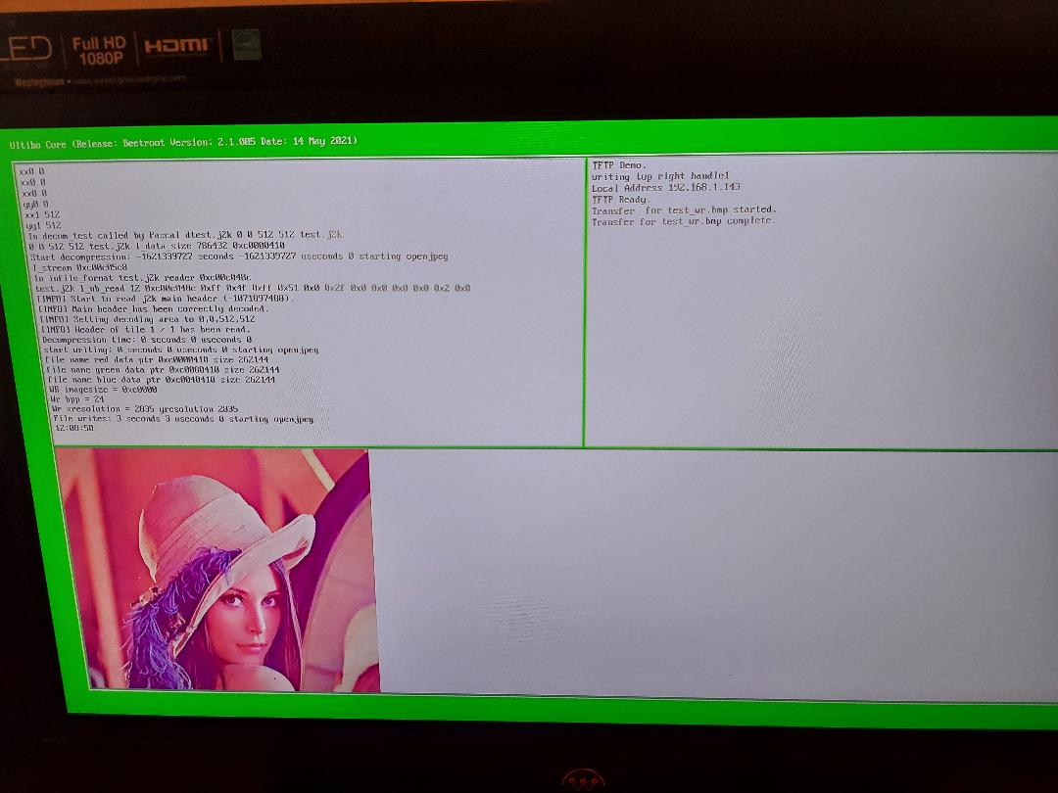

devel@mypi3-20:~/tmp $ tftp 192.168.1.143
tftp> binary
tftp> get test_wr.bmp
Received 786554 bytes in 1.9 seconds
tftp> quit

