*****************Draft*****************
These the first steps to upgrading a RPi3 to a RPi4 project for Ultibo
05/17/20
*****************Draft*****************

On a RPi4 4Gb it took 59.86 secs to perform from power-up.

This project uses a C library which is used to preform the SVD.
The script “buildlib.sh” below is used to compile
disp_mat.c master.c mythread.c svd.c
error.c mul_mat.c pnmio.c trans_mat.c
to “libsvd.a”
#!/bin/bash
#export PATH=/home/devel/ultibo/core/fpc/bin:$PATH
rm -f *.o
rm -f libsvd.a

arm-none-eabi-gcc -I../include -O3 -mabi=aapcs -marm -march=armv7-a -mfpu=vfpv3-d16 -mfloat-abi=hard -c svd.c -o svd.o
arm-none-eabi-gcc -I../include -O3 -mabi=aapcs -marm -march=armv7-a -mfpu=vfpv3-d16 -mfloat-abi=hard -c disp_mat.c -o disp_mat.o
arm-none-eabi-gcc -I../include -O3 -mabi=aapcs -marm -march=armv7-a -mfpu=vfpv3-d16 -mfloat-abi=hard -c trans_mat.c -o trans_mat.o
arm-none-eabi-gcc -I../include -O3 -mabi=aapcs -marm -march=armv7-a -mfpu=vfpv3-d16 -mfloat-abi=hard -c mul_mat.c -o mul_mat.o
arm-none-eabi-gcc -D_POSIX_THREADS -lpthread -I../include -O3 -mabi=aapcs -marm -march=armv7-a -mfpu=vfpv3-d16 -mfloat-abi=hard -c mythread.c -o mythread.o
arm-none-eabi-gcc -I../include -O3 -mabi=aapcs -marm -march=armv7-a -mfpu=vfpv3-d16 -mfloat-abi=hard -c pnmio.c -o pnmio.o
arm-none-eabi-gcc -I../include -O3 -mabi=aapcs -marm -march=armv7-a -mfpu=vfpv3-d16 -mfloat-abi=hard -c error.c -o error.o

echo "Compiling example ultibo_th_svd "
arm-none-eabi-gcc -DUltibo -D_POSIX_THREADS -lpthread -I../include -O3 -mabi=aapcs -marm -march=armv7-a -mfpu=vfpv3-d16 -mfloat-abi=hard -c master.c -o ultibo_th_svd.o

#gcc test_svd.c svd.o disp_mat.o -lm -o test_svd
arm-none-eabi-ar rcs libsvd.a *.o
arm-none-eabi-ar -t libsvd.a > libsvd_obj.txt
#fpc -vi -B -Tultibo -Parm -CpARMV7A -WpRPI3B @/home/devel/ultibo/core/fpc/bin/RPI3.CFG -O4 svd_FS_RPi3.lpr

Create a new folder RPi4 in the Ultibo_Projects ie. ~/Ultibo_Projects/th_svd/RPi4.

From the main menu Project/New scroll to Raspberry Pi4B/400/Application.

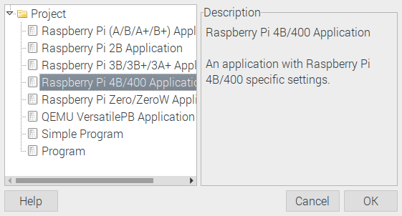

Depress OK.

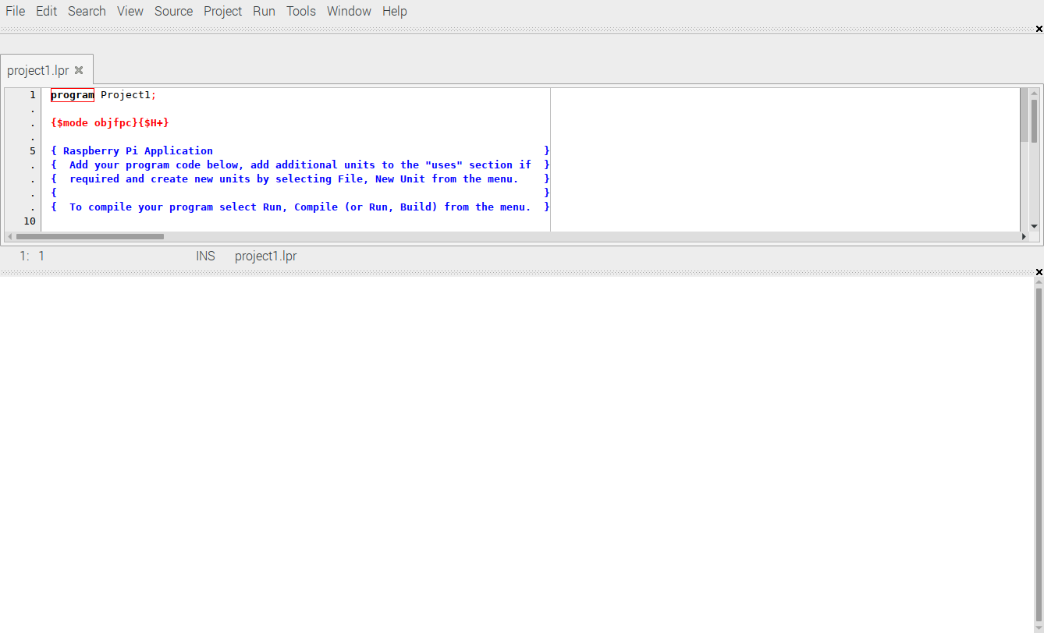
Replace the code above

Need to change program Project1; to ie. program svd_FS_RPi4;

Need to save as svd_FS_Rpi4.lpi.

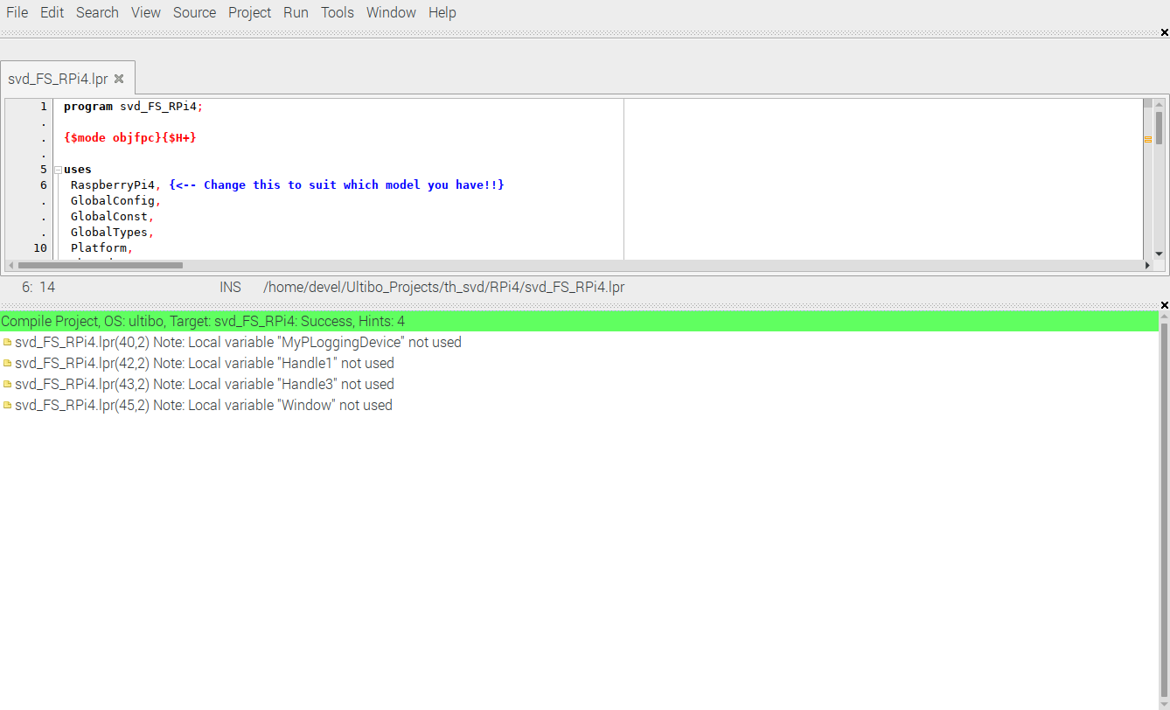

When the green bar appears the “kernel7l.img” is created.

Start Zoom in to see the image below
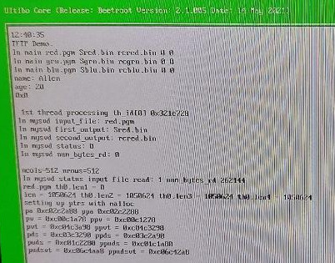

Done Zoom in to see the image below

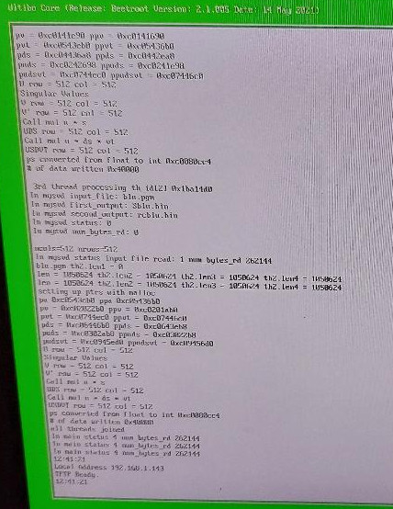

Files

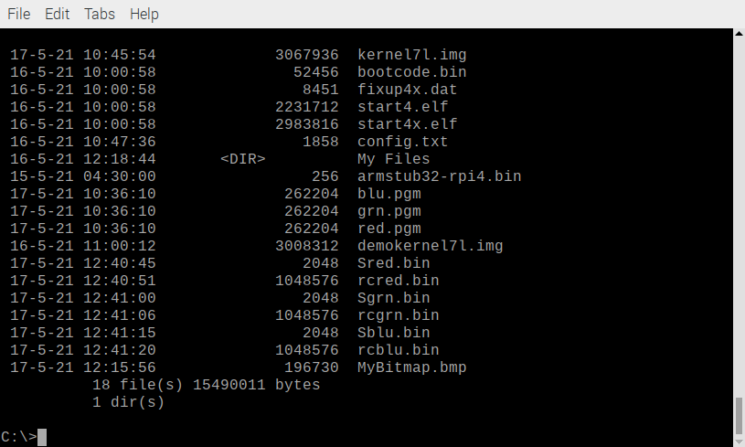
Transferring the results to the RPi4 using TFTP

devel@mypi3-20:~/Ultibo_Projects/th_svd/RPi4 $ ./getsvdresults.sh
retrieve svd results
tftp> tftp> Error code 5: 53132
Received 2048 bytes in 5.1 seconds
tftp> Error code 5: 47304
Received 2048 bytes in 5.0 seconds
tftp> Error code 5: 36435
Received 2048 bytes in 5.0 seconds
tftp> tftp> Error code 5: 45174
Received 1048576 bytes in 8.1 seconds
tftp> Error code 5: 55656
Received 1048576 bytes in 8.5 seconds
tftp> Error code 5: 51471
Received 1048576 bytes in 8.5 seconds
tftp> tftp> done

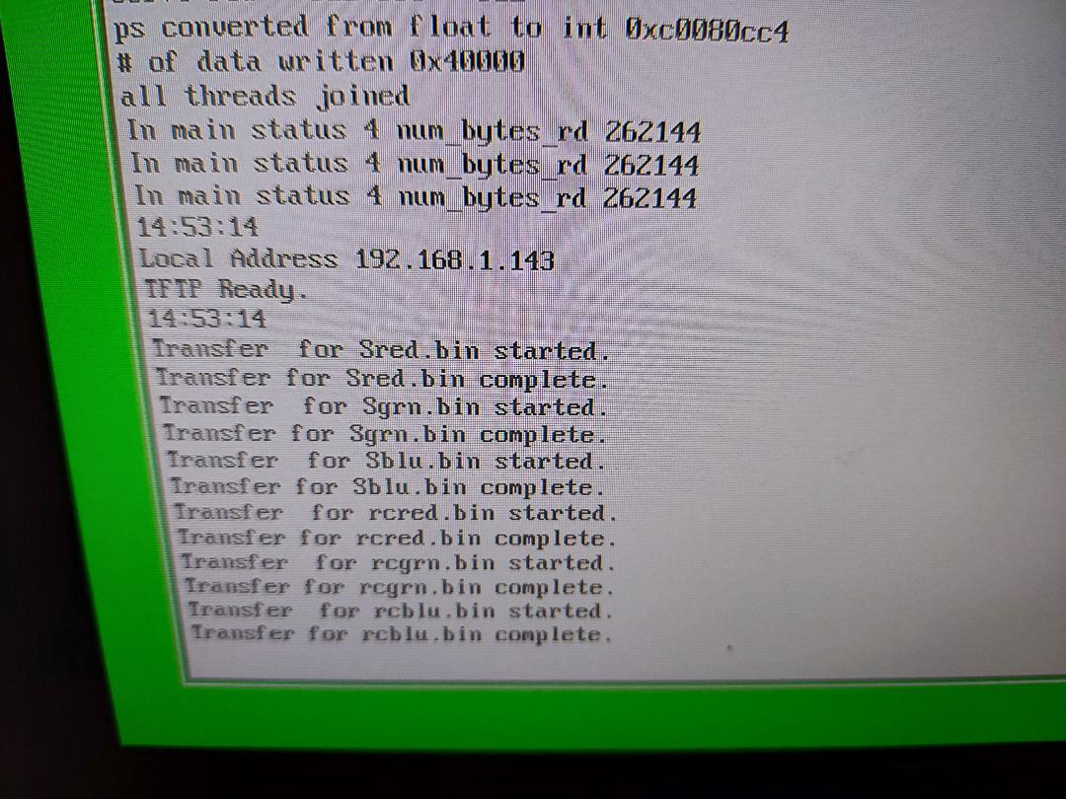

devel@mypi3-20:~/Ultibo_Projects/th_svd/RPi4 $ octave
GNU Octave, version 4.4.1
Copyright (C) 2018 John W. Eaton and others.
This is free software; see the source code for copying conditions.
There is ABSOLUTELY NO WARRANTY; not even for MERCHANTABILITY or
FITNESS FOR A PARTICULAR PURPOSE. For details, type 'warranty'.

Octave was configured for "arm-unknown-linux-gnueabihf".

Additional information about Octave is available at https://www.octave.org.

Please contribute if you find this software useful.
For more information, visit https://www.octave.org/get-involved.html

Read https://www.octave.org/bugs.html to learn how to submit bug reports.
For information about changes from previous versions, type 'news'.

octave:1> disp_S
octave:2> close all
octave:3> disp_S

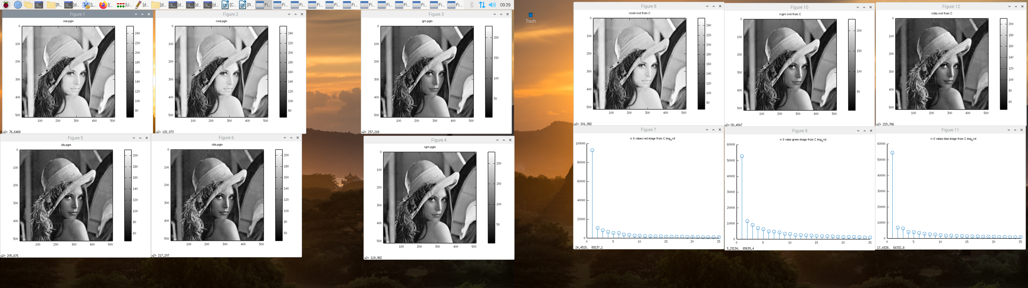

The first 4 images on the left on the top row red.pgm Figure1. The 2nd image on left 1st row is the reconstructed red in Figure 2. The 5th image on top row Figure 3 is grn.pgm and the
6th image left bottom row Figure 4 is the reconstructed grn.

On the right the top row are the C reconstruted red Figure 8, grn Figure 9 & grn Figure 10 is blu.

On the right the bottom row are the Svalues red Figure 7, Svalues grn Figure 9 and Svalues blu Figure 11

diff --git a/th_svd/RPi4/config.txt b/th_svd/RPi4/config.txt
index 2064759..b044adb 100755
--- a/th_svd/RPi4/config.txt
+++ b/th_svd/RPi4/config.txt
@@ -60,6 +60,8 @@ dtparam=audio=on
# Enable DRM VC4 V3D driver on top of the dispmanx display stack
dtoverlay=vc4-fkms-v3d
max_framebuffers=2
+enable_gic=1
+armstub=armstub32-rpi4.bin

This is the sha256 sum of the armstub32-rpi4.bin. a5f806af388b952f768ccb5e01130eb66536f5f2de288335f4c5703de8375b6a armstub32-rpi4.bin

These are firmwire being tested for Rpi4.

d239f344f610ecc005a97110b98f620e9bfe1d6a4923af488e025d2083f95e77 bootcode.bin
7716af32619f0771ee91196f367eea307ba33ce61df5f4675ed3ea0b16d16949 fixup4x.dat
215d6ccdea1e8b62643c626039bfccd751753b1bfe79be269b171ea66134eb2b start4.elf
210478ae179a91d02a3c15232a899215b8bda2e7fe1bb3461b15264f549d391f start4x.elf

Ultibo Wrote
“We just did a test of taking a brand new SanDisk card from the packet, it had a FAT32 partition on it already from the factory, we copied the Ultibo demo image (kernel7l.img) and the Pi 4 firmware files (start4.elf and fixup4.dat) to the card and booted the Pi from it”

With great power comes great responsibility, so there are a few things you need to remember.
- All Pi 4 models include two different interrupt controllers, which one is enabled by default is slightly dependant on the firmware version, the presence of device tree and the config.txt settings.
In order to ensure that Ultibo kernels always boot we have gone to great lengths to detect which interrupt controller is active and adjust accordingly, however the two are not completely equal so when reverting to the so called legacy controller some features are unavailable.
To be sure you are always using the new GIC controller your config.txt file must contain the line enable_gic=1
- Some changes to the Pi firmware late last year made it impossible to switch back to secure mode during boot, while that doesn't cause much problem on earlier models on the Pi 4 the inability to access secure mode means fast interrupts (FIQ) are unavailable.
We've provided a solution in the form of a custom boot stub that the Ultibo boot code looks for in order to determine if it can return to secure mode, to make this work you need to ensure that your SD card includes the relevant armstub32-rpi?.bin file plus the appropriate armstub= value in the config.txt file.
To make this as easy as possible we've included the new boot stubs and an example config.txt in the firmware folder of the Ultibo installation (C:\Ultibo\Core\firmware on Windows) along with copies of the latest available firmware for all models.
- The Pi 4 increased the rate of the core oscillator from 19.2MHz to 54MHz, in the past we've always set the dividers so that the system clock ticks at a rate of 1MHz which has the side benefit that it represents 1 microsecond per tick.
For the Pi 4 we've chosen to allow the clock to run at the full 54MHz rate, this means if you have used the ClockGetTotal function to provide a counter in your application and rely on the count being in microseconds that will no longer be true for the Pi 4.
The solution is very simple, either use GetTickCount64 from the RTL instead which will provide a millisecond counter or divide the value returned from ClockGetTotal by the value of the system variable CLOCK_CYCLES_PER_MICROSECOND to obtain microseconds.
We're sure you'll have a bunch of questions once you start to explore the new release, as always feel free to ask.

This project as Rpi3 used uTFTP.pas to transfer the kernel7.img to Ultibo system.

a5f806af388b952f768ccb5e01130eb66536f5f2de288335f4c5703de8375b6a armstub32-rpi4.bin
f1f5f6a47af524c947c40bbbf9d6d292663e1d5c27bd2f38b2ebce629cf6d476 blu.pgm
d239f344f610ecc005a97110b98f620e9bfe1d6a4923af488e025d2083f95e77 bootcode.bin
4fe93f768a53a54ac1d54561ffaa954f24c9140b3b1eca35e2fd2b620b81f746 config.txt
7716af32619f0771ee91196f367eea307ba33ce61df5f4675ed3ea0b16d16949 fixup4x.dat
acfce694ade49c8ec20267f30f5015b0ef747ab16f1517c15c00af92fa242f51 fixup.dat
c1cb4703861b7b2bcf9d45947143a6e06da8c40e7f01cf1dc2ed122752658abc fixup_x.dat
c2a63ec4076ffe9ed81f5d0ab6f9bda85970506c7a975e4d8af2845139a4bf8c grn.pgm
3f9a20cbd723fcf1006da0800f376bd308f76569e20efd2b8885592200ba3b64 kernel7l.img
6a180d44ce2d6b8d1e95781a10b3490f6205cdc3c4a85d816346237b34f669b9 red.pgm
215d6ccdea1e8b62643c626039bfccd751753b1bfe79be269b171ea66134eb2b start4.elf
210478ae179a91d02a3c15232a899215b8bda2e7fe1bb3461b15264f549d391f start4x.elf
8ca471067f496452b24cb492919b5d789681bf77e5ea97c04033f7d29c7e8ac7 start.elf
ec57fb988543b951413e8f4262cab2aeb1475c533716cf8878f88375fdcccbe7 start_x.elf

The installer script is found at “https://raw.githubusercontent.com/ultibohub/Tools/master/Installer/Core/Linux/ultiboinstaller.sh”.

Note: Be sure and copy the raw from GitHub into a file ultiboinstaller.sh.

-rwxr-xr-x 1 devel devel 26813 May 15 06:48 ultiboinstaller.sh
md5sum ultiboinstaller.sh
85dc58dff3bdcd0de510d69b0456ea60 ultiboinstaller.sh

./
Linux installer for Free Pascal and Lazarus (Ultibo edition)
------------------------------------------------------------
This installation will download the sources for:
Ultibo core
Ultibo examples
Free Pascal (Ultibo edition)
Lazarus IDE (Ultibo edition)

Then it will build all of the above, this will take several
minutes to complete depending on the speed of your system.

The installation will not interfere with any existing
development environments including other installations
of Free Pascal and Lazarus.

Continue (y/n)?

Do you want to build and install the Lazarus IDE (y/n)?

Free Pascal and Lazarus (Ultibo edition) prerequisites
------------------------------------------------------
Installing and building Free Pascal requires several tools
from the build essentials package including make, ld and as
as well as the unzip utility.

These can be installed on Debian based distributions using:

sudo apt-get install build-essential unzip

Lazarus IDE requires the GTK2 and X11 dev packages which
can be installed on Debian based distributions by using:

sudo apt-get install libgtk2.0-dev libcairo2-dev \
libpango1.0-dev libgdk-pixbuf2.0-dev libatk1.0-dev \
libghc-x11-dev

Cross compiling Ultibo applications from Linux requires the
arm-none-eabi build of the binutils package, this can be
installed on Debian based distributions using:

sudo apt-get install binutils-arm-none-eabi

Press return to check for these prerequisites

Enter an installation folder or press return to
accept the default install location

[/home/devel/ultibo/core]:

The install folder will be:
/home/devel/ultibo/core

Continue? (y,n):

After install do you want a shortcut created in:
/home/devel/.local/share/applications (y/n)?

Do you want to build the Hello World examples (y/n)?

This project uses several C files in addition to Pascal files

disp_mat.c master.c mythread.c svd.c
error.c mul_mat.c pnmio.c trans_mat.c

There is buildlib.sh that compiles into libsvd.a

devel@mypi3-20:~/Ultibo_Projects/th_svd/RPi4 $ ./buildlib.sh
Compiling example ultibo_th_svd

#!/bin/bash
#export PATH=/home/devel/ultibo/core/fpc/bin:$PATH
rm -f *.o
rm -f libsvd.a

arm-none-eabi-gcc -I../include -O3 -mabi=aapcs -marm -march=armv7-a -mfpu=vfpv3-d16 -mfloat-abi=hard -c svd.c -o svd.o
arm-none-eabi-gcc -I../include -O3 -mabi=aapcs -marm -march=armv7-a -mfpu=vfpv3-d16 -mfloat-abi=hard -c disp_mat.c -o disp_mat.o
arm-none-eabi-gcc -I../include -O3 -mabi=aapcs -marm -march=armv7-a -mfpu=vfpv3-d16 -mfloat-abi=hard -c trans_mat.c -o trans_mat.o
arm-none-eabi-gcc -I../include -O3 -mabi=aapcs -marm -march=armv7-a -mfpu=vfpv3-d16 -mfloat-abi=hard -c mul_mat.c -o mul_mat.o
arm-none-eabi-gcc -D_POSIX_THREADS -lpthread -I../include -O3 -mabi=aapcs -marm -march=armv7-a -mfpu=vfpv3-d16 -mfloat-abi=hard -c mythread.c -o mythread.o
arm-none-eabi-gcc -I../include -O3 -mabi=aapcs -marm -march=armv7-a -mfpu=vfpv3-d16 -mfloat-abi=hard -c pnmio.c -o pnmio.o
arm-none-eabi-gcc -I../include -O3 -mabi=aapcs -marm -march=armv7-a -mfpu=vfpv3-d16 -mfloat-abi=hard -c error.c -o error.o

echo "Compiling example ultibo_th_svd "
arm-none-eabi-gcc -DUltibo -D_POSIX_THREADS -lpthread -I../include -O3 -mabi=aapcs -marm -march=armv7-a -mfpu=vfpv3-d16 -mfloat-abi=hard -c master.c -o ultibo_th_svd.o

#gcc test_svd.c svd.o disp_mat.o -lm -o test_svd
arm-none-eabi-ar rcs libsvd.a *.o
arm-none-eabi-ar -t libsvd.a > libsvd_obj.txt
#fpc -vi -B -Tultibo -Parm -CpARMV7A -WpRPI3B @/home/devel/ultibo/core/fpc/bin/RPI3.CFG -O4 svd_FS_Rpi3.lpr

The objects in libsvd.a are found in listed in the file libsvd_obj.txt
disp_mat.o
error.o
mul_mat.o
mythread.o
pnmio.o
svd.o
trans_mat.o
ultibo_th_svd.o

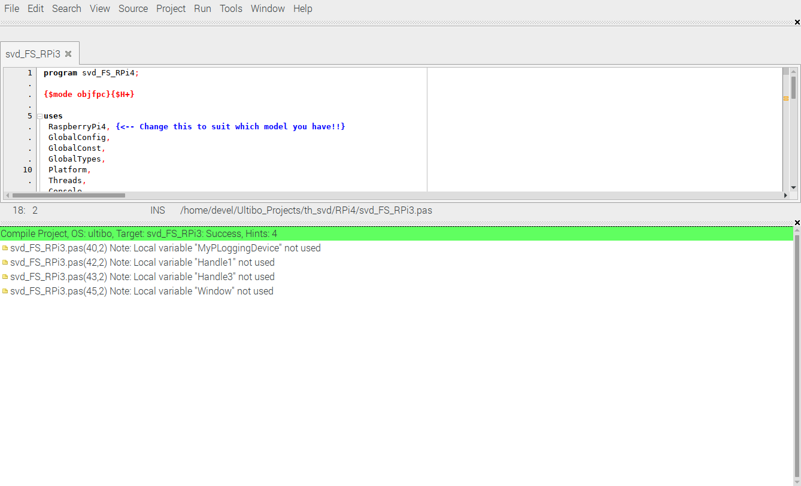
Depressing the Run/Compile creates the kernel7l.img.
-rwxr-xr-x 1 devel devel 3067936 May 15 09:24 kernel7l.img

project options

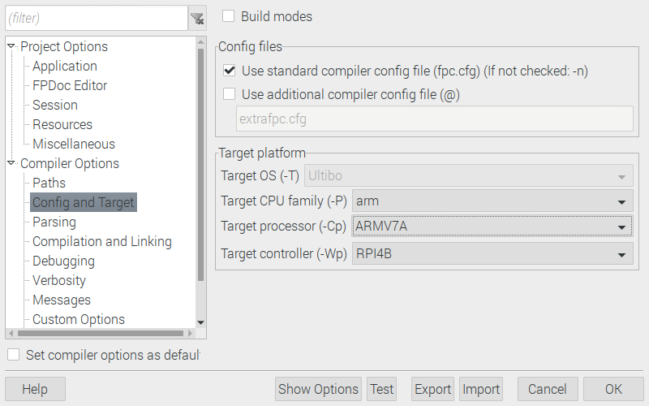
Depressing the Run/Compile creates the kernel7l.img

