*******************Default*******************
Upgrading oppenjpeg lib
QEMU RPi RPi2
06/08/26
*******************Defualt*******************

devel@pi4-50:~ $ . ./qemu.sh
#!/bin/bash
export QEMU_PATH=$HOME/qemu-6.2.0-rpios/bin
export PATH=$QEMU_PATH:$PATH
echo $PATH

devel@pi4-50:~ $ cd Ultibo_Projects/jpeg2000/src/

devel@pi4-50:~/Ultibo_Projects/jpeg2000/src $
modified: dwt.c
modified: dwt.h
modified: j2k.c
modified: j2k.h
modified: jp2.c
modified: jp2.h
modified: mct.c
modified: mct.h
modified: mqc.c
modified: mqc.h
modified: openjpeg.c
modified: openjpeg.h
modified: pi.c
modified: t1.c
modified: t1.h
modified: t2.c
modified: t2.h
modified: tcd.c
modified: tcd.h
devel@pi4-50:~/Ultibo_Projects/jpeg2000/src $ ./compile_ultibo.sh
#!/bin/bash
rm -f *.o
rm -f libopenjp2.a

arm-none-eabi-gcc -O3 -mabi=aapcs -marm -march=armv7-a -mfpu=vfpv3-d16 -mfloat-abi=hard -c bio.c -o bio.o
arm-none-eabi-gcc -O3 -mabi=aapcs -marm -march=armv7-a -mfpu=vfpv3-d16 -mfloat-abi=hard -c cio.c -o cio.o
arm-none-eabi-gcc -O3 -mabi=aapcs -marm -march=armv7-a -mfpu=vfpv3-d16 -mfloat-abi=hard -c dwt.c -o dwt.o
arm-none-eabi-gcc -O3 -mabi=aapcs -marm -march=armv7-a -mfpu=vfpv3-d16 -mfloat-abi=hard -c event.c -o event.o
arm-none-eabi-gcc -O3 -mabi=aapcs -marm -march=armv7-a -mfpu=vfpv3-d16 -mfloat-abi=hard -c function_list.c -o function_list.o
arm-none-eabi-gcc -O3 -mabi=aapcs -marm -march=armv7-a -mfpu=vfpv3-d16 -mfloat-abi=hard -c image.c -o image.o
arm-none-eabi-gcc -O3 -mabi=aapcs -marm -march=armv7-a -mfpu=vfpv3-d16 -mfloat-abi=hard -c invert.c -o invert.o
arm-none-eabi-gcc -O3 -mabi=aapcs -marm -march=armv7-a -mfpu=vfpv3-d16 -mfloat-abi=hard -c j2k.c -o j2k.o
arm-none-eabi-gcc -O3 -mabi=aapcs -marm -march=armv7-a -mfpu=vfpv3-d16 -mfloat-abi=hard -c jp2.c -o jp2.o
arm-none-eabi-gcc -O3 -mabi=aapcs -marm -march=armv7-a -mfpu=vfpv3-d16 -mfloat-abi=hard -c mct.c -o mct.o
arm-none-eabi-gcc -O3 -mabi=aapcs -marm -march=armv7-a -mfpu=vfpv3-d16 -mfloat-abi=hard -c mqc.c -o mqc.o
arm-none-eabi-gcc -O3 -mabi=aapcs -marm -march=armv7-a -mfpu=vfpv3-d16 -mfloat-abi=hard -c opj_clock.c -o opj_clock.o
arm-none-eabi-gcc -O3 -mabi=aapcs -marm -march=armv7-a -mfpu=vfpv3-d16 -mfloat-abi=hard -c opj_malloc.c -o opj_malloc.o
arm-none-eabi-gcc -O3 -mabi=aapcs -marm -march=armv7-a -mfpu=vfpv3-d16 -mfloat-abi=hard -c pi.c -o pi.o
arm-none-eabi-gcc -O3 -mabi=aapcs -marm -march=armv7-a -mfpu=vfpv3-d16 -mfloat-abi=hard -c t1.c -o t1.o
arm-none-eabi-gcc -O3 -mabi=aapcs -marm -march=armv7-a -mfpu=vfpv3-d16 -mfloat-abi=hard -c rd-wr-ops.c -o rd-wr-ops.o

arm-none-eabi-gcc -O3 -mabi=aapcs -marm -march=armv7-a -mfpu=vfpv3-d16 -mfloat-abi=hard -c t2.c -o t2.o
arm-none-eabi-gcc -O3 -mabi=aapcs -marm -march=armv7-a -mfpu=vfpv3-d16 -mfloat-abi=hard -c tcd.c -o tcd.o
arm-none-eabi-gcc -O3 -mabi=aapcs -marm -march=armv7-a -mfpu=vfpv3-d16 -mfloat-abi=hard -c tgt.c -o tgt.o
arm-none-eabi-gcc -O3 -mabi=aapcs -marm -march=armv7-a -mfpu=vfpv3-d16 -mfloat-abi=hard -c thread.c -o thread.o
arm-none-eabi-gcc -O3 -mabi=aapcs -marm -march=armv7-a -mfpu=vfpv3-d16 -mfloat-abi=hard -c openjpeg.c -o openjpeg.o

arm-none-eabi-gcc -O3 -mabi=aapcs -marm -march=armv7-a -mfpu=vfpv3-d16 -mfloat-abi=hard -c sparse_array.c -o sparse_array.o
arm-none-eabi-ar rcs libopenjp2.a *.o
arm-none-eabi-ar t libopenjp2.a > libopenjp2_obj.txt
echo "The word count here should be 22"
echo "the word count in /home/pi/jpeg-2000-test/bare-metal/openjp"
echo "when ./libbuild.sh is executed should be 22"
wc libopenjp2_obj.txt

devel@pi4-50:~/Ultibo_Projects/jpeg2000/RPi2 $ cat libbuild.sh
#!/bin/bash

rm -f dwtlift.o
rm -f libdwtlift.a
rm -f libopenjp2.a
#cp libopenjp2_816f53.a libopenjp2.a
cp ../src/libopenjp2.a libopenjp2.a

arm-none-eabi-gcc -L. -llibopenjp2 -O3 -mabi=aapcs -marm -march=armv7-a -mfpu=vfpv3-d16 -mfloat-abi=hard -c dwtlift.c

arm-none-eabi-ar rcs libopenjp2.a dwtlift.o

cp libopenjp2.a libdwtlift.a
arm-none-eabi-ar t libdwtlift.a > libdwtlift_obj.txt
echo "when ./libbuild.sh is executed should be 23"
wc libdwtlift_obj.txt
devel@pi4-50:~/Ultibo_Projects/jpeg2000/QEMU $ ./libbuild.sh

QEMU
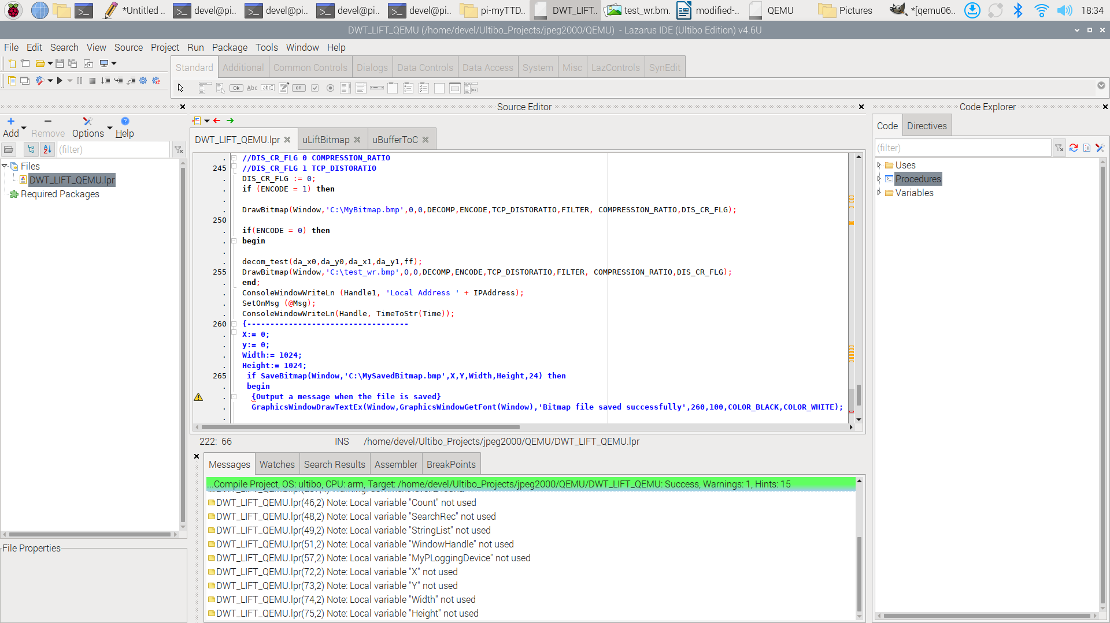

devel@pi4-50:~/Ultibo_Projects/jpeg2000/RPi2 $ ./libbuild.sh
RPi2

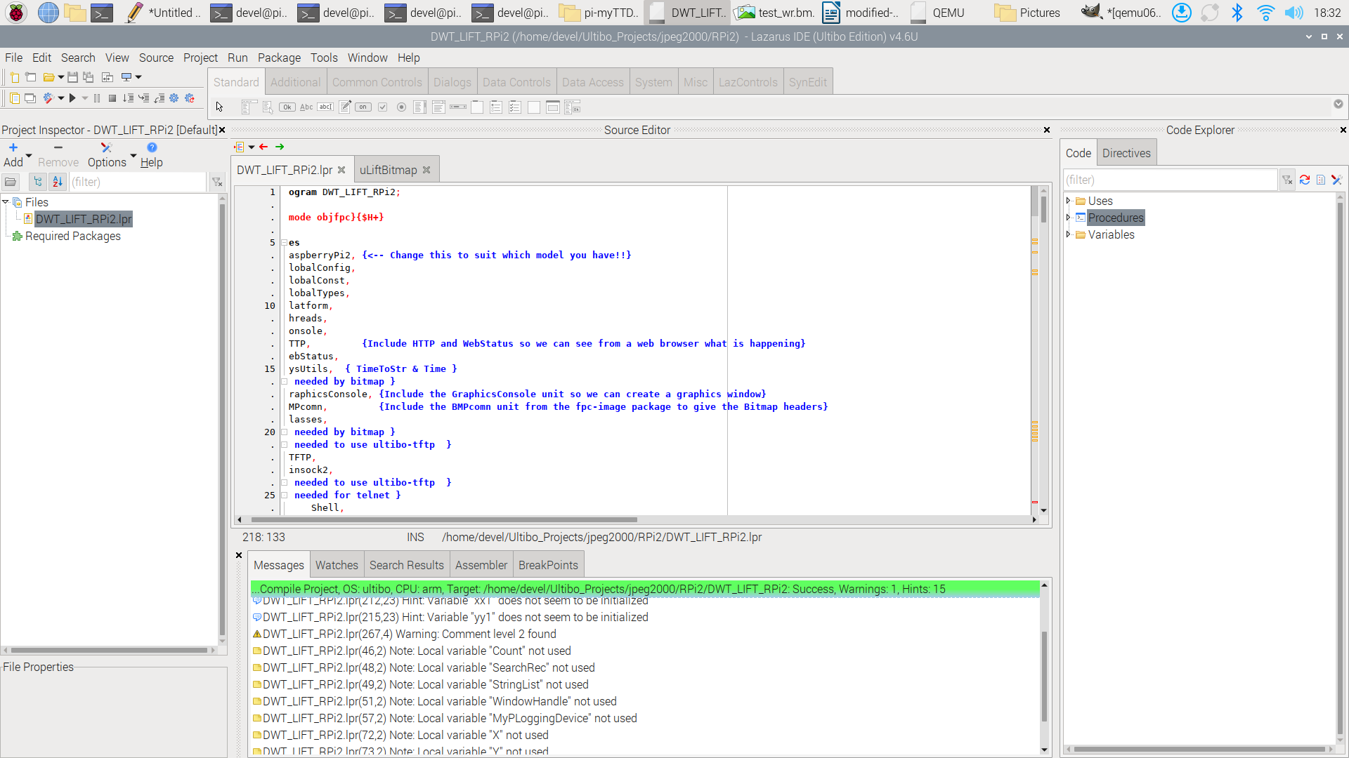

devel@pi4-50:~/Ultibo_Projects/jpeg2000/RPi $ ./libbuild.sh
RPi

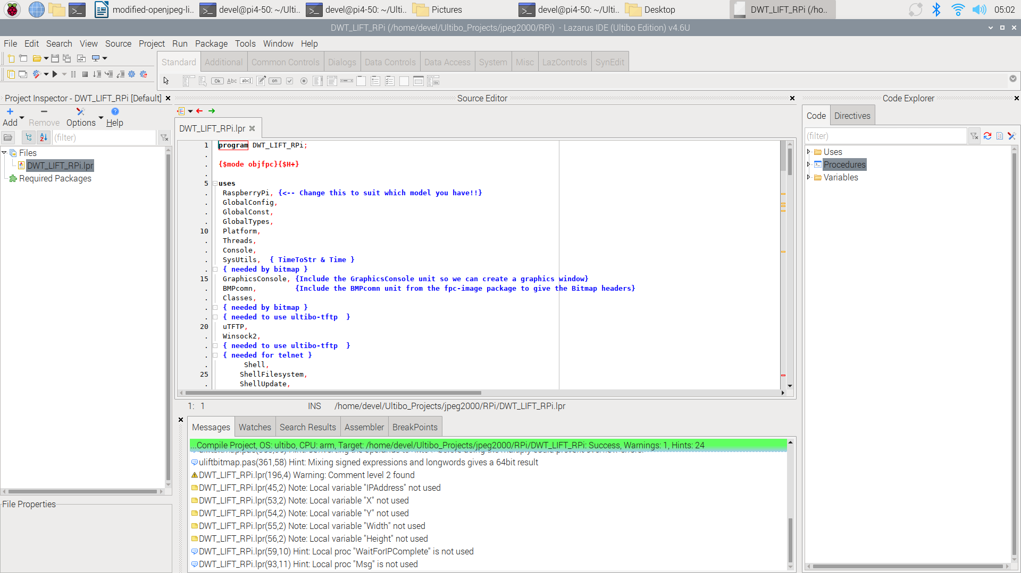

startqemu.sh
#!/bin/bash
qemu-system-arm -machine versatilepb -cpu cortex-a8 -kernel kernel.bin \
-net user,hostfwd=tcp::5080-:80,hostfwd=tcp::5023-:23,hostfwd=udp::5069-:69,hostfwd=tcp::6050-:5050 -net nic \
-drive file=disk.img,if=sd,format=raw

devel@pi4-50:~/Ultibo_Projects/jpeg2000/QEMU $ ./startqemu.sh

The image below was following the openjpeg update on 06/08/26
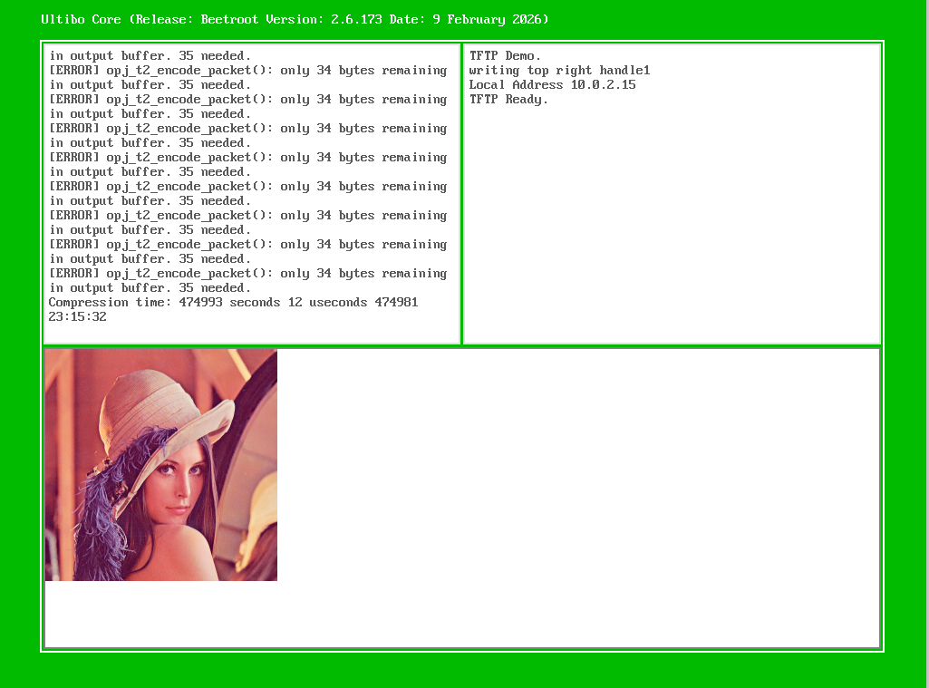
To create the test.j2k the file 256com needs to be copied to testfile. In addition the MyBitmap.bmp is the file to be compressed.
od -x 256com
0000000 0019 0000 0001 0000 0000 0000 0000 0000
0000020 0100 0000 0100 0000
CR 0019 0000
Perform compress 0001 0000
devel@pi4-50:~/Ultibo_Projects/jpeg2000/QEMU/tmp $ tftp pi4-50 5069
tftp> binary
tftp> get testfile
tftp> get 256com
tftp> get 256decom
tftp> quit
devel@pi4-50:~/Ultibo_Projects/jpeg2000/QEMU/tmp $ shasum *
8f06328e4016b235ab6c0acbcc000d2bccda1315 256com
98fb712d8639e310b3a4cec437fc41c141fddd13 256decom
8f06328e4016b235ab6c0acbcc000d2bccda1315 testfile
devel@pi4-50:~/Ultibo_Projects/jpeg2000/QEMU/tmp $ od -x 256decom
0000000 0019 0000 0000 0000 0000 0000 0000 0000
0000020 0100 0000 0100 0000
0000030
To create the test_wr.bmp 256decom needs to be copied to testfile.

devel@pi4-50:~ $ telnet pi4-50 5023
Ultibo Core (Release: Beetroot Version: 2.6.173 Date: 9 February 2026)
(Type HELP for a list of available commands)
>
xx
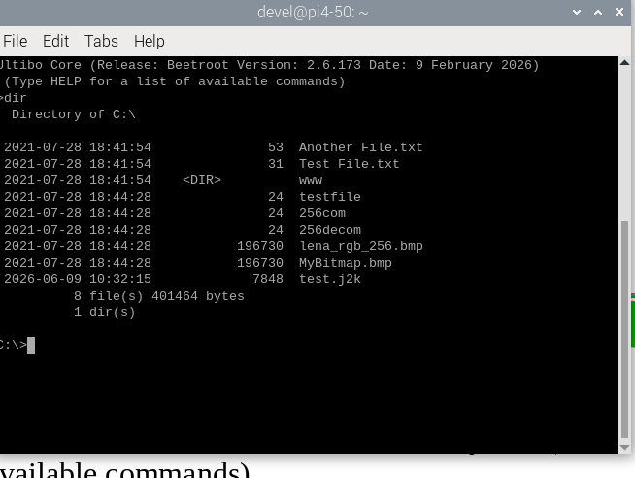

xx
Both the QEMU & Rpi2 were rebuilt using the Lazarus IDE (ultibo-edition)

devel@pi4-50:~/Ultibo_Projects/jpeg2000/RPi2 $ tftp 192.168.12.160
tftp> binary
tftp> put kernel7.img
tftp> quit
RPi2 reboots

devel@pi4-50:~/Ultibo_Projects/jpeg2000/src $ cd ~/dwtlift-pi/pi-myTTDecoder/
devel@pi4-50:~/dwtlift-pi/pi-myTTDecoder $ git diff
diff --git a/pi-myTTDecoder/myTTDecoder.c b/pi-myTTDecoder/myTTDecoder.c
index 9148dd6..a9c038d 100644
--- a/pi-myTTDecoder/myTTDecoder.c
+++ b/pi-myTTDecoder/myTTDecoder.c
@@ -95,8 +95,8 @@ printf("CR = %d flg = %d bp = %d imgsz = %d \n",CR, flg, bp, imgsz);

printf("da_x0 = %d da_y0 = %d da_x1 = %d da_y1 = %d\n",da_x0, da_y0, da_x1, da_y1);

@@ -106,4 +106,4 @@ printf("calling decom_test\n");
//decom_test(int da_x0, int da_y0, int da_x1, int da_y1, char *ff);
decom_test(da_x0,da_y0,da_x1,da_y1,ff);
return 0;
-}
\ No newline at end of file
*/
da_x0 = 0;
da_y0 = 0;
-da_x1 = 2048;
-da_y1= 2048;
+da_x1 = 256;
+da_y1= 256;

xx

