**************************Draft**************************
Lazarus IDE on both 32bit Pi O/S & 64 bit Pi O/S
03/22/22
**************************Draft**************************

https://ultibo.org/forum/viewtopic.php?f=4&t=1630

Beta Ultibo release with updated FreePascal and Lazarus

Post by Ultibo » Mon Mar 21, 2022 12:02 am
ultibo2.1.341-032122.img
284495872 Mar 22 06:16 ultibo2.1.301-20922.img
381886464 Mar 22 07:29 ultibo2.1.341-032122.img

Testing ultiboinstaller-beta.sh 03/22/22 on RPi4B 8Gb 32bit Pi O/S
Top was at 4+ most of the time I did see a time when top was over 8.
RPi4B 4Gb 64bit Pi O/S
Top on 64bit Pi O/S was at 2.45 always lower than 32bit Pi O/S
Free Pascal and Lazarus (Ultibo edition) install complete
Tested compiling ~/Ultibo_Projects/Crypto-Socket/QEMU/Srv.lpi using Lazarus IDE (Ultibo-Edition)
Linux pi4-26 5.10.92-v8+ #1514 SMP PREEMPT Mon Jan 17 17:39:38 GMT 2022 aarch64 GNU/Linux
ls -la kernel.bin
-rwxr-xr-x 1 devel devel 2679492 Mar 22 09:47 kernel.bin
QEMU ran ok as on 32Bit Pi O/S
{Global constants}
const
{Version constants}
ULTIBO_RELEASE_DATE = '9 February 2022';
ULTIBO_RELEASE_NAME = 'Beetroot';
ULTIBO_RELEASE_VERSION = '2.1.301';
ULTIBO_RELEASE_VERSION_MAJOR = 2;
ULTIBO_RELEASE_VERSION_MINOR = 1;
ULTIBO_RELEASE_VERSION_REVISION = 301;

Saved my working ver to ultibo2.1.301-20922.img
created ultiboinstaller-beta.sh from https://github.com/develone/Tools/blob/master/Installer/Core/Linux/ultiboinstaller-beta.sh
Linux installer for Free Pascal and Lazarus (Ultibo edition)
------------------------------------------------------------
This installation will download the sources for:
Ultibo core
Ultibo tools
Ultibo examples
Free Pascal (Ultibo edition)
Lazarus IDE (Ultibo edition)

Then it will build all of the above, this will take several
minutes to complete depending on the speed of your system.

The installation will not interfere with any existing
development environments including other installations
of Free Pascal and Lazarus.

Continue (y/n)?

Do you want to build and install the Lazarus IDE (y/n)?

Installing and building Free Pascal requires several tools
from the build essentials package including make, ld and as
as well as the unzip utility.

These can be installed on Debian based distributions using:

sudo apt-get install build-essential unzip

Lazarus IDE requires the GTK2 and X11 dev packages which
can be installed on Debian based distributions by using:

sudo apt-get install libgtk2.0-dev libcairo2-dev \
libpango1.0-dev libgdk-pixbuf2.0-dev libatk1.0-dev \
libghc-x11-dev

Cross compiling Ultibo applications from Linux requires the
arm-none-eabi build of the binutils package, this can be
installed on Debian based distributions using:

sudo apt-get install binutils-arm-none-eabi

Press return to check for these prerequisites

Enter an installation folder or press return to
accept the default install location

[/home/devel/ultibo/core]:

The install folder will be:
/home/devel/ultibo/core

Continue? (y,n):

Directory already exists
Remove the entire folder and overwrite? (y,n):

After install do you want a shortcut created in:
/home/devel/.local/share/applications (y/n)?

Do you want to build the Hello World examples (y/n)?

Downloading FPC minimal stable 3.2.2
Extracting FPC minimal stable 3.2.2
Downloading Ultibo core
Downloading Ultibo examples
Downloading Ultibo tools
Downloading Free Pascal (Ultibo edition)
Downloading Lazarus (Ultibo edition)
Extracting Ultibo core
Extracting Ultibo examples
Extracting Ultibo tools
Extracting Free Pascal (Ultibo edition)

{Global constants}
const
{Version constants}
ULTIBO_RELEASE_DATE = '21 March 2022';
ULTIBO_RELEASE_NAME = 'Beetroot';
ULTIBO_RELEASE_VERSION = '2.1.341';
ULTIBO_RELEASE_VERSION_MAJOR = 2;
ULTIBO_RELEASE_VERSION_MINOR = 1;
ULTIBO_RELEASE_VERSION_REVISION = 341;

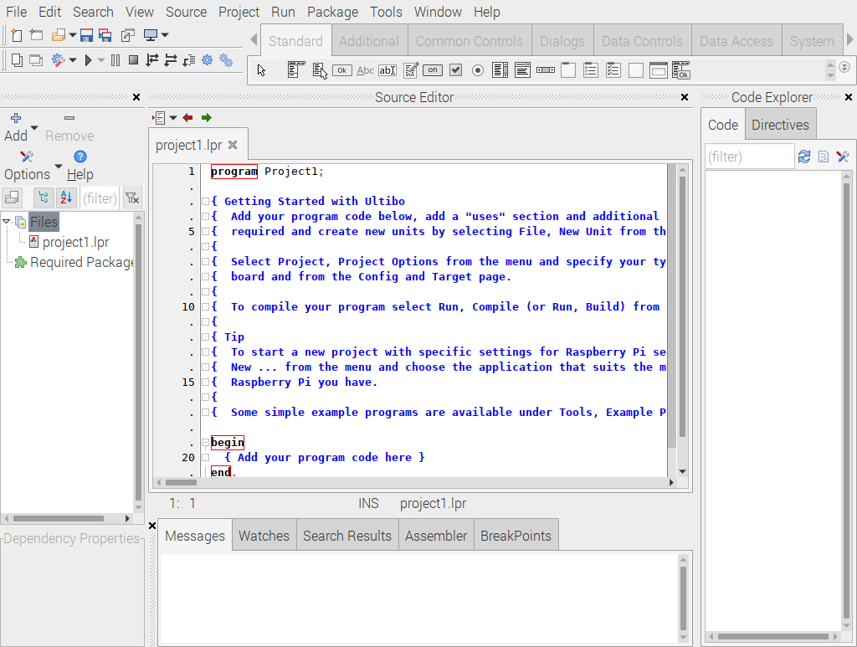
xxx
