******************DRAFT******************
Single Value Decomposition SVD using thread
Ultibo bare metal
07/01/20
******************DRAFT******************

devel@mypi3-20:~ $ export PATH=/home/devel/ultibo/core/fpc/bin:$PATH
devel@mypi3-20:~ $ cd Ultibo_Projects/th_svd/RPi3
devel@mypi3-20:~/Ultibo_Projects/th_svd/RPi3 $ ./buildlib.sh
Compiling example ultibo_th_svd
devel@mypi3-20:~/Ultibo_Projects/th_svd/RPi3 $ fpc -vi -B -Tultibo -Parm -CpARMV7A -WpRPI3B @/home/devel/ultibo/core/fpc/bin/RPI3.CFG -O4 svd_FS_RPi3.lpr
Free Pascal Compiler version 3.1.1 [2020/06/17] for arm
Copyright (c) 1993-2015 by Florian Klaempfl and others
Target OS: Ultibo
Compiling svd_FS_RPi3.lpr
Compiling uTFTP.pas
Assembling utftp
svd_FS_RPi3.lpr(40,2) Note: Local variable "MyPLoggingDevice" not used
svd_FS_RPi3.lpr(42,2) Note: Local variable "Handle1" not used
svd_FS_RPi3.lpr(43,2) Note: Local variable "Handle3" not used
svd_FS_RPi3.lpr(45,2) Note: Local variable "Window" not used
Assembling svd_fs_rpi3
Linking svd_FS_RPi3
687 lines compiled, 1.9 sec, 2878204 bytes code, 94520 bytes data
4 note(s) issued
devel@mypi3-20:~/Ultibo_Projects/th_svd/RPi3 $ tftp 192.168.1.69 < cmdstftp
tftp> tftp> Sent 2942416 bytes in 6.0 seconds
tftp> devel@mypi3-20:~/Ultibo_Projects/th_svd/RPi3 $ ./getsvdresults.sh
retrieve svd results
tftp> tftp> Error code 5: 56075
Received 2048 bytes in 5.0 seconds
tftp> Error code 5: 59590
Received 2048 bytes in 5.1 seconds
tftp> Error code 5: 58020
Received 2048 bytes in 5.0 seconds
tftp> tftp> Error code 5: 58395
Received 1048576 bytes in 8.1 seconds
tftp> Error code 5: 34075
Received 1048576 bytes in 8.5 seconds
tftp> Error code 5: 49860
Received 1048576 bytes in 8.3 seconds
tftp> tftp> done

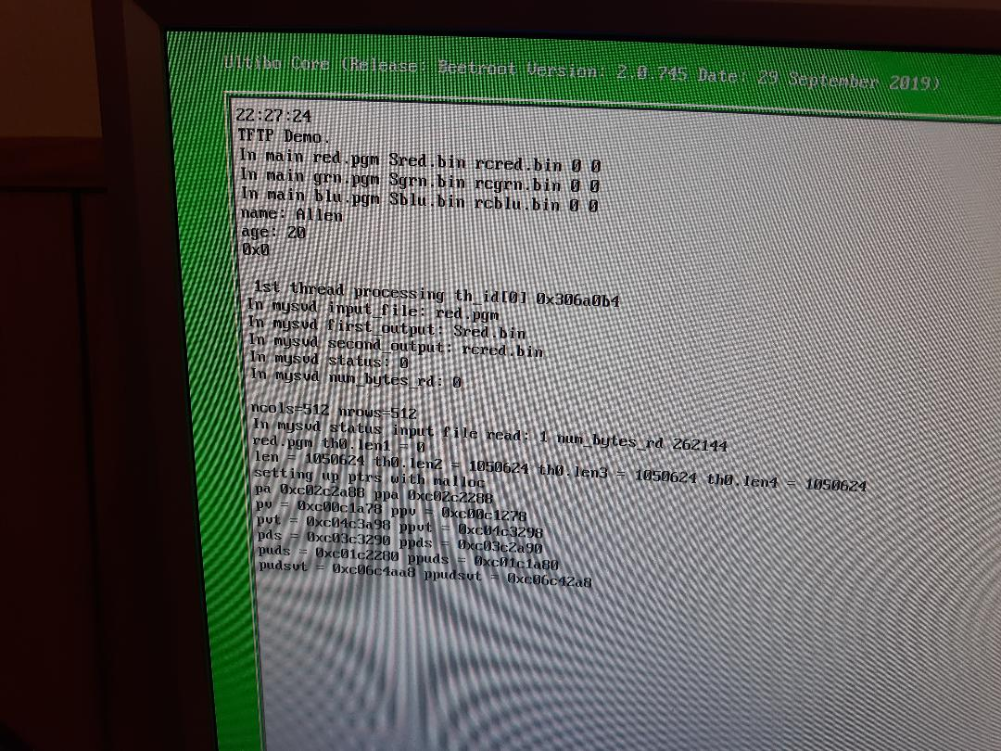
2nd thread

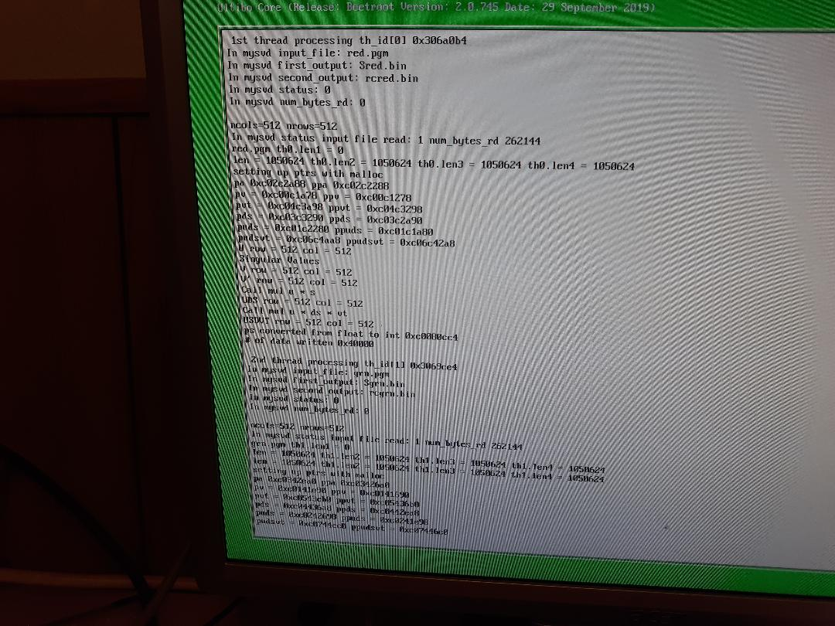
3rd and transfer

