***********************Draft***********************
QEMU Ultibo Bare Metal
Socket Test using AraratSynapse
with
Remote Shell and Web Status
07/26/21
***********************Draft***********************

Note:
https://ultibo.org/forum/viewtopic.php?f=13&t=1303&p=11632#p11632

By Ultibo Wed Jul 21, 2021 9:01 pm

I suspect the version of QEMU that you have on the RPI3B+ is later than the one on the RPi4, try doing qemu-system-arm -version on each one.
We recently discovered that the Ultibo SD card driver was not compatible with the latest versions of QEMU, a fix for this is included in the release from today (Ultibo core 2.1.079) so if you update your RTL to the latest either using the RTL Builder or by rerunning the ultiboinstaller script then it should work now.
https://en.m.wikipedia.org/wiki/QEMU. On the pi400-1 I ran
./ultiboinstaller.sh on pi400-1.

QEMU is a hosted virtual machine monitor: it emulates the machine's processor through dynamic binary translation and provides a set of different hardware and device models for the machine, enabling it to run a variety of guest operating systems. It also can be used with Kernel-based Virtual Machine (KVM) to run virtual machines at near-native speed (by taking advantage of hardware extensions such as Intel VT-x). QEMU can also do emulation for user-level processes, allowing applications compiled for one architecture to run on another.[3]

Note : Additional software is needed to run QEMU “sudo apt-get install qemu-system-arm”.
The following programs are added.

/usr/bin/qemu-img /usr/bin/qemu-nbd /usr/bin/qemu-system-aarch64
/usr/bin/qemu-io /usr/bin/qemu-pr-helper /usr/bin/qemu-system-arm

The command line for starting Lazarus IDE (Ultibo Edition) “~/ultibo/core/lazarus.sh”

Project/Open Project

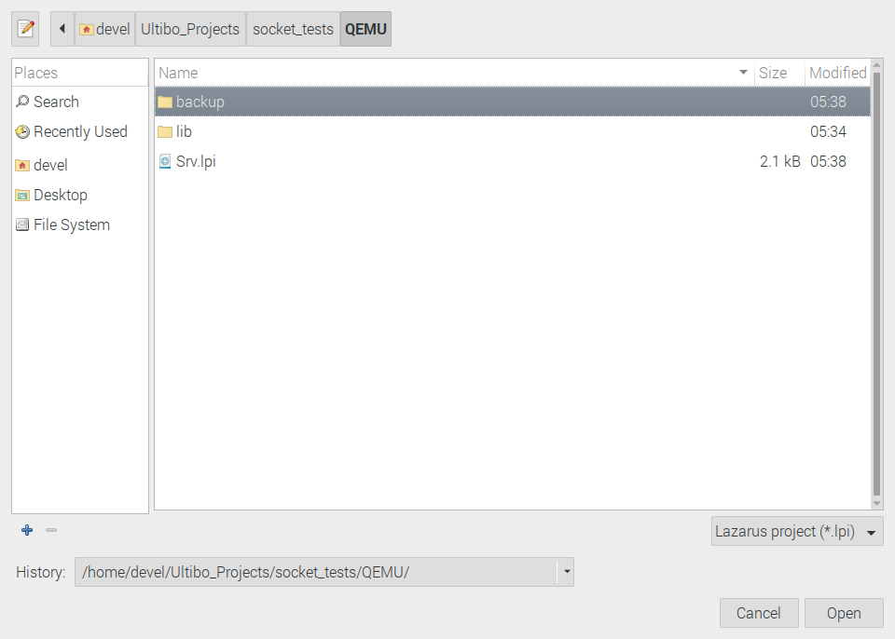
Select Srv.lpi

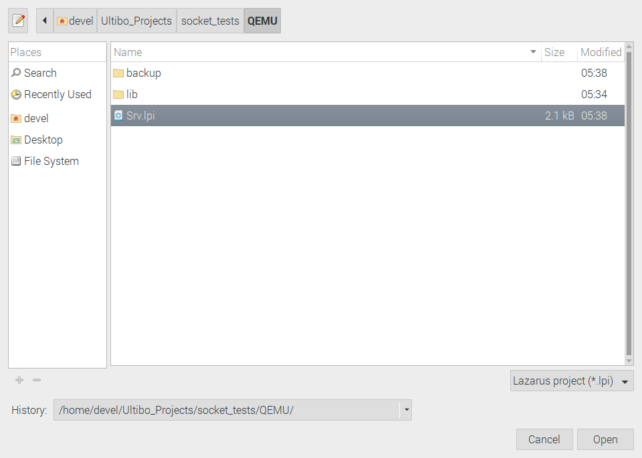
Depreess Open

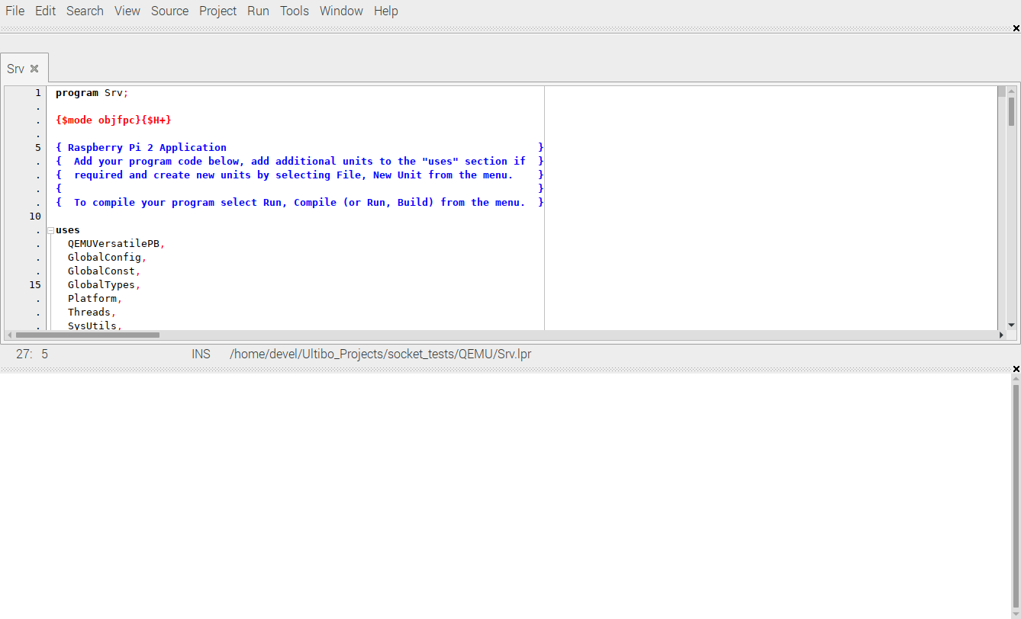
Run/Compile The kernel.bin is created when the Grean bar appears.

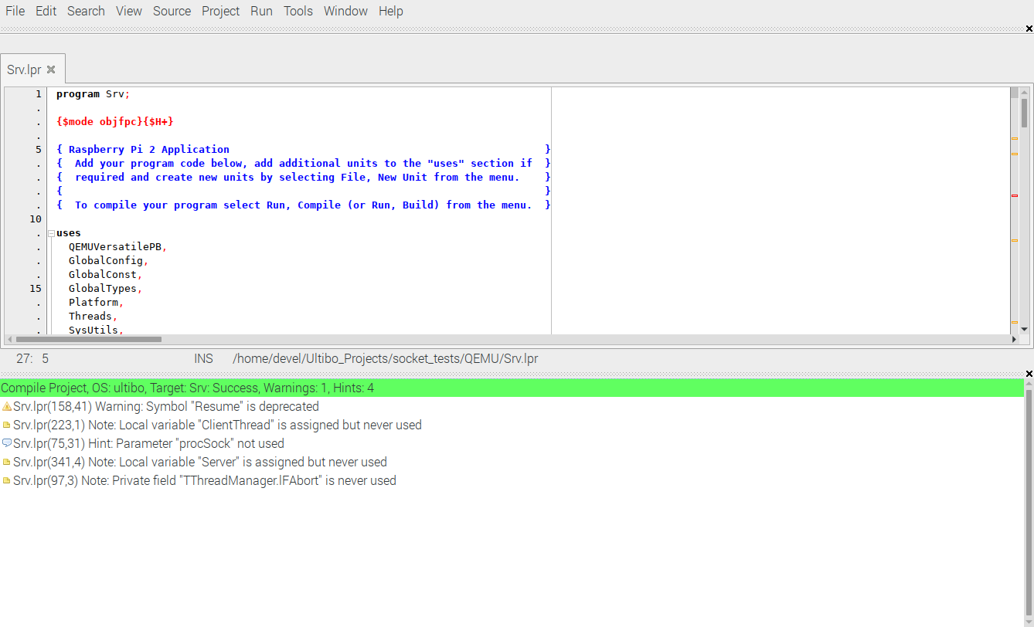
startqemu.sh

#!/bin/bash
qemu-system-arm -machine versatilepb -cpu cortex-a8 -kernel kernel.bin \
-net user,hostfwd=tcp::5080-:80,hostfwd=tcp::5023-:23,hostfwd=tcp::5069-:69,hostfwd=tcp::6050-:5050 -net nic \
-drive file=disk.img,if=sd,format=raw

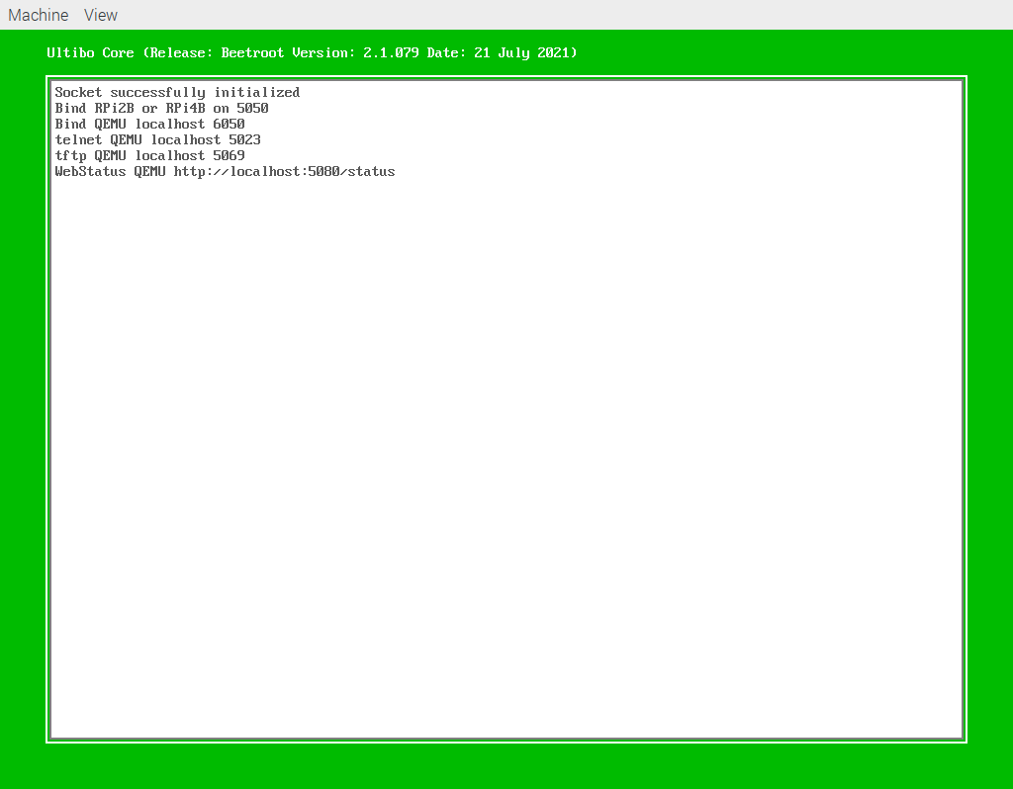

Webstatus General

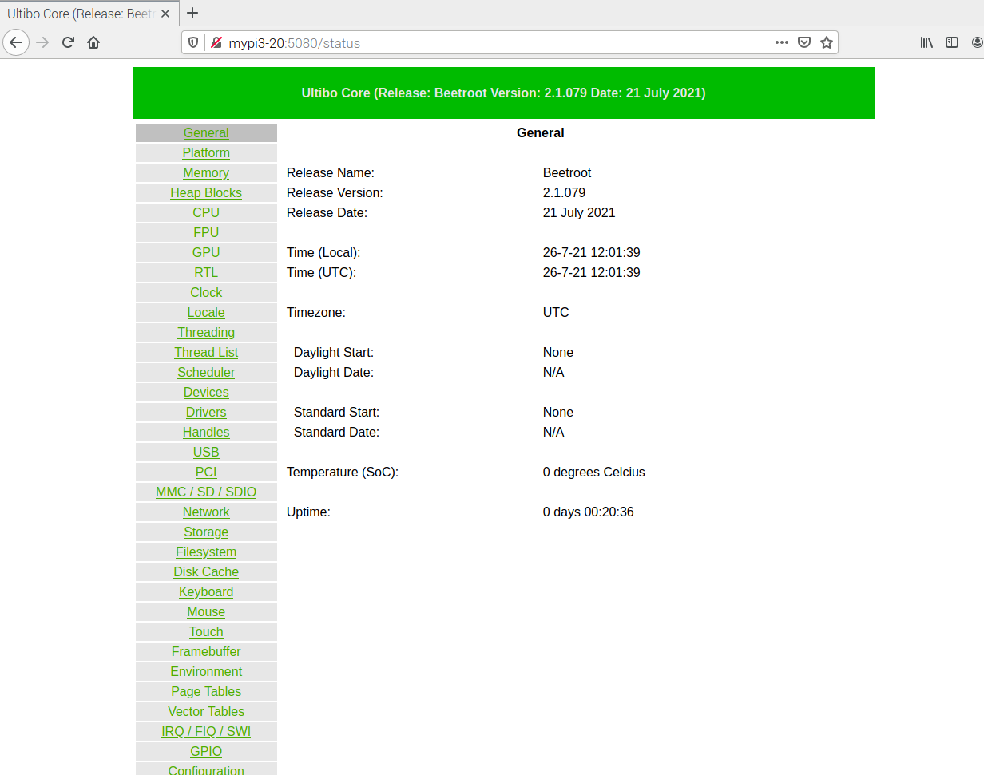
Webstatus Memory

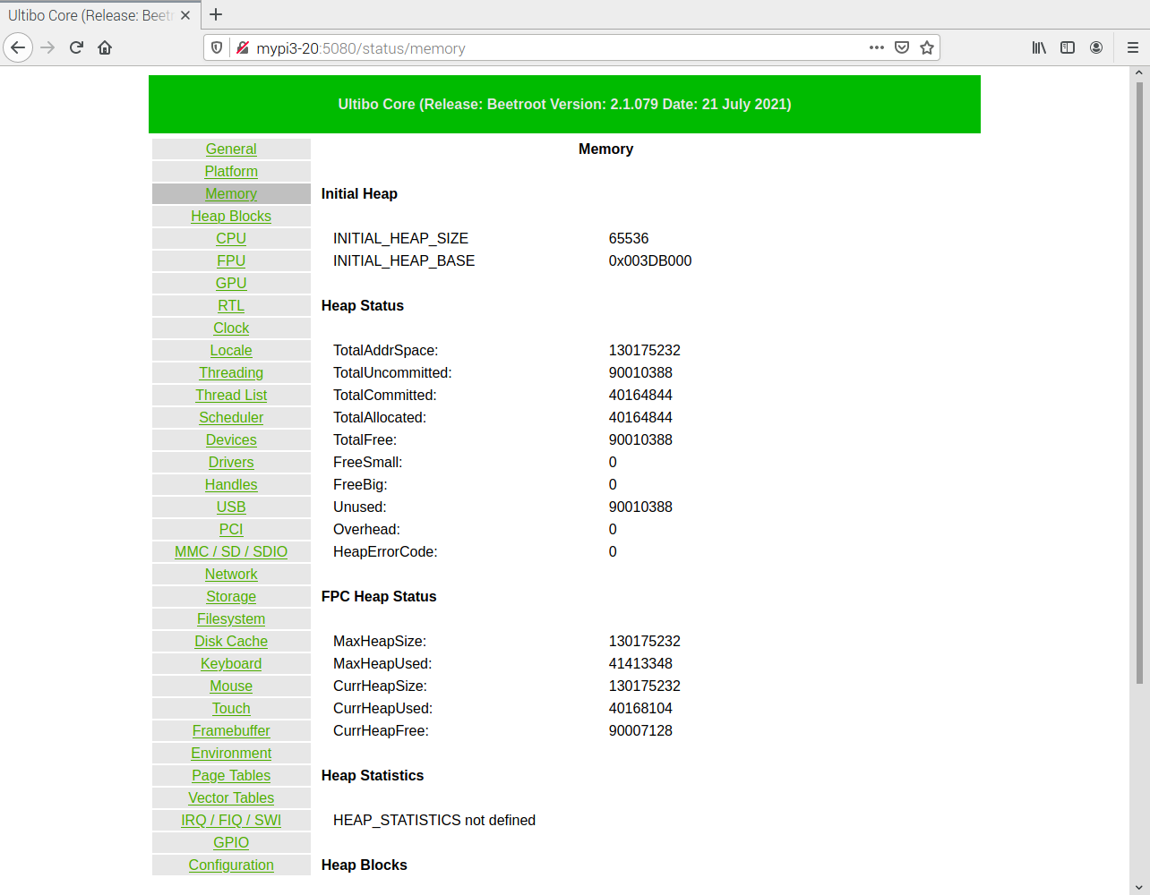
Webstatus Platform

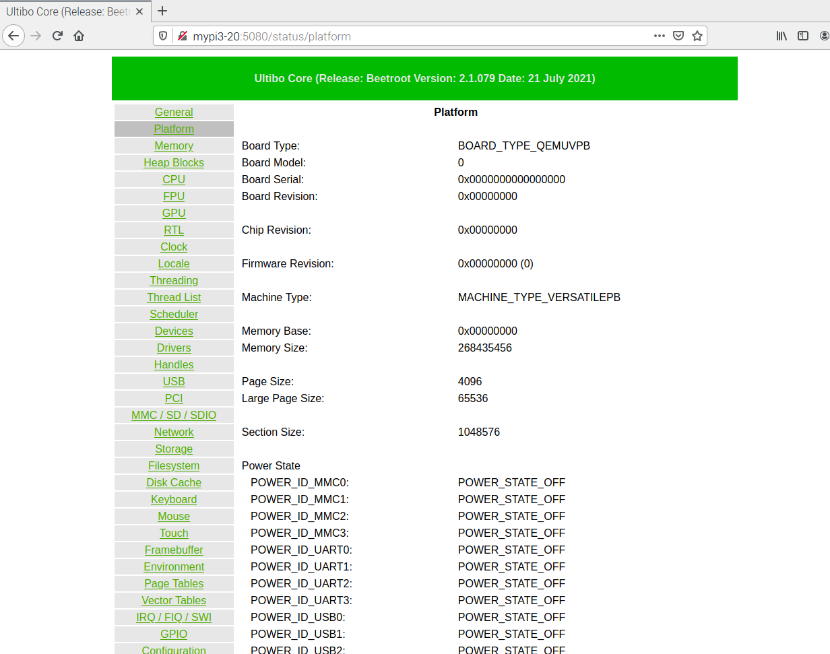

Webstatus MMC / SD / SDIO
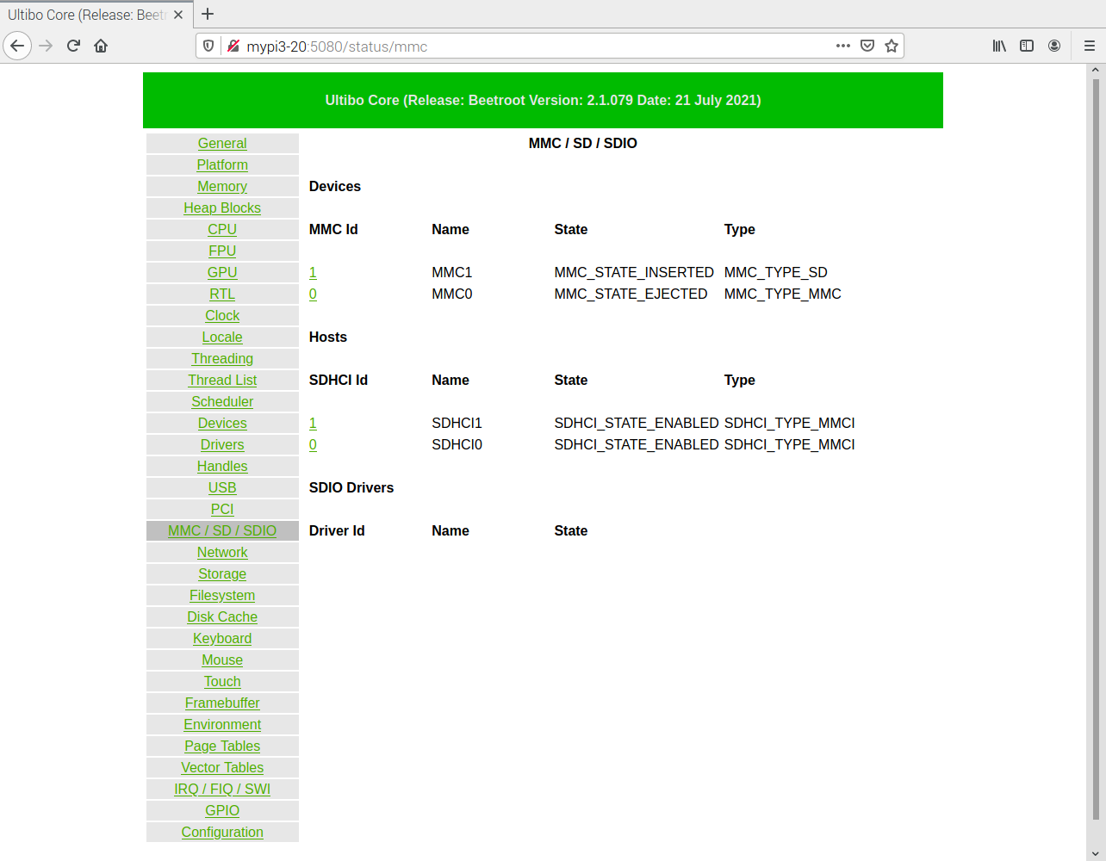

Telnet Using port 5023

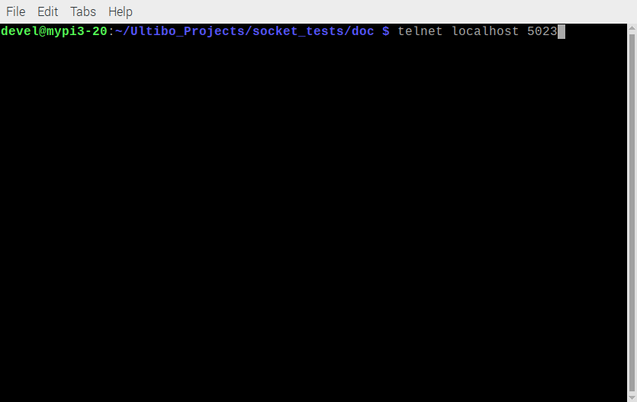
dir

type "Test File.txt"

type "Another File.txt"

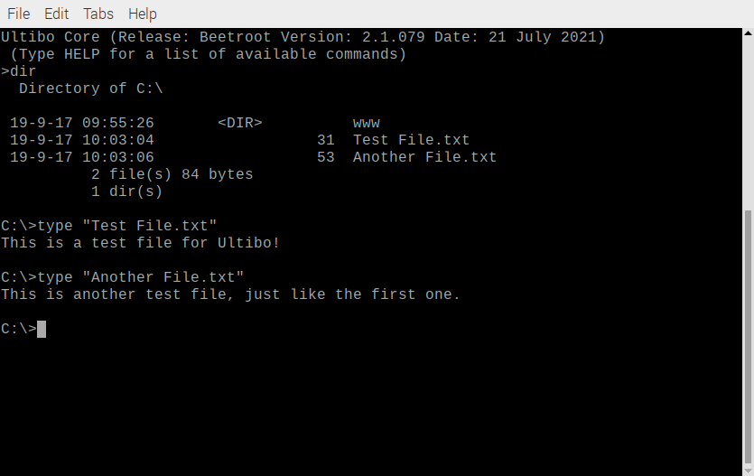

clear

cd www

dir

type "index.html"

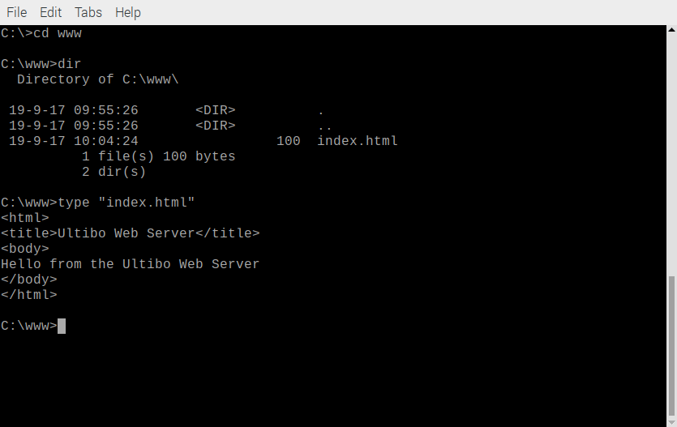

logout

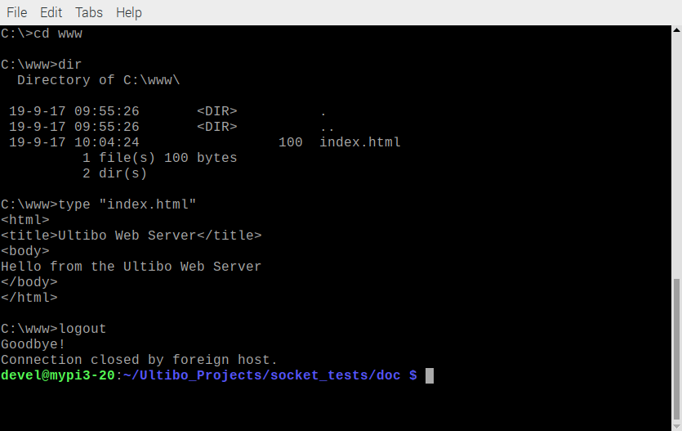
pi400-1 is connected wireless and running QEMU.

With a Fire 10 tablet which is also connected wireless.

