***************DRAFT***************
Testing Latest OPENJPEG
Thu Feb 13 2020
02/20/20
***************DRAFT***************

{Global constants}
const
{Version constants}
ULTIBO_RELEASE_DATE = '29 September 2019';
ULTIBO_RELEASE_NAME = 'Beetroot';
ULTIBO_RELEASE_VERSION = '2.0.745';
ULTIBO_RELEASE_VERSION_MAJOR = 2;
ULTIBO_RELEASE_VERSION_MINOR = 0;
ULTIBO_RELEASE_VERSION_REVISION = 745;

Ultibo_Projects

commit 7a3d12531cd436b8e203b43d233a35917ef406a7 (HEAD -> master, origin/master, origin/HEAD)
Author: Edward Vidal Jr <develone@sbcglobal.net>
Date: Thu Oct 3 11:40:52 2019 -0600

adding missing files needed to compile on a new system

There has been modifications to the following files in the openjpeg repo which are not part of Ultibo_Projects/jpeg2000/src.

-rw-r--r-- 1 devel devel 786554 Feb 18 10:02 lena_rgb_512.bmp
-rw-r--r-- 1 devel devel 6234 Feb 18 09:52 test.j2k
Compression ratio 126.1716394 without these new modifications.

#dwt.c & dwt.h
#jp2.c & jp2.h
#mct.c & mct.h
#mqc.c & mqc.h
#openjpeg.c & openjpeg,h
#pi.c & pi.h
#t1.c & t1.h
#t2.c & t2.h
#thread.c & thread.h

Below is the bitmap image tested on Ultibo.

The file test.j2k was decompressed on Raspbian ultibo.bmp.

commit 563ecfb55ca77c0fc5ea19e4885e00f55ec82ca9 (HEAD -> master, upstream/master, origin/master, origin/HEAD)
Author: Even Rouault <even.rouault@spatialys.com>
Date: Thu Feb 13 09:59:17 2020 +0100

opj_compress: improve help message regarding new IMF switch

devel@mypi3-15:~/openjpeg/build/bin $ ./opj_compress -r 125 -i lena_rgb_512.bmp -o test2.j2k

Error, invalid green mask value 0
Unable to load bmp file

devel@mypi3-15:~/Ultibo_Projects/jpeg2000/src $ ./compile_ultibo.sh
The word count here should be 21
the word count in /home/pi/jpeg-2000-test/bare-metal/openjp
when ./libbuild.sh is executed should be 22
21 21 161 libopenjp2_obj.txt

devel@mypi3-15:~/Ultibo_Projects/jpeg2000/RPi2 $ ./libbuild.sh
dwtlift.c: In function 'decompress':
dwtlift.c:658:3: warning: implicit declaration of function 'octave_write_byte'; did you mean 'opj_write_tile'? [-Wimplicit-function-declaration]
octave_write_byte(r_decompress_fn,r_decompress,da_x1*da_y1);
^~~~~~~~~~~~~~~~~
opj_write_tile

Used Lazarus IDE (Ultibo Edition) to compile kernel7.img

devel@mypi3-15:~/Ultibo_Projects/jpeg2000/RPi2 $ scrot -d 10 -s laz.png

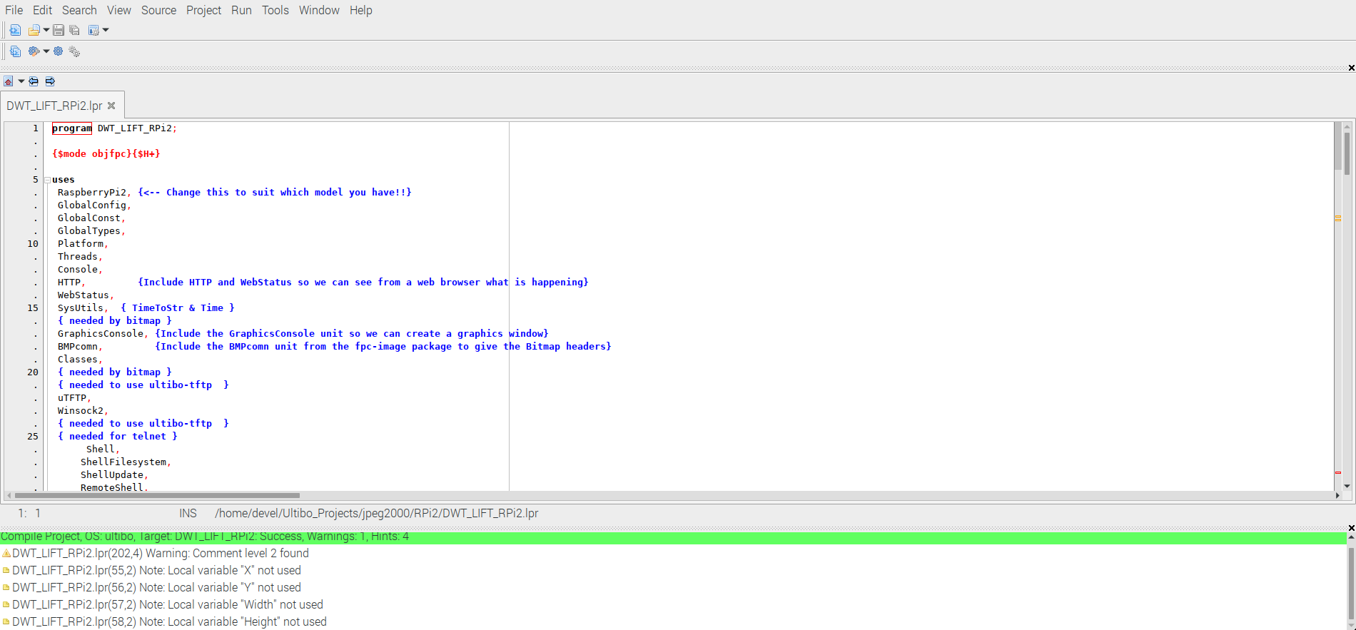
devel@mypi3-15:~/openjpeg/build/bin $ ./opj_decompress -i test.j2k -o ultibo.bmp

[INFO] Start to read j2k main header (0).
[INFO] Main header has been correctly decoded.
[INFO] No decoded area parameters, set the decoded area to the whole image
[INFO] Header of tile 1 / 1 has been read.
[INFO] Generated Outfile ultibo.bmp
decode time: 144 msxx

