***************Draft***************

UDPServerGPS
04/27/19

***************Draft***************

Using the browser to find the IP of the Ultibo System.

Device IP Address / Name Status Connection Radio, Type, Name
99.184.183.104 / ws010 off Ethernet
192.168.1.65 / uverse_DVR_ETH_08:80:39:11:88:a2 on Ethernet
192.168.1.71 / vidals-iPad on Wi-Fi Wi-Fi 1 bar 2.4 GHz, Home, ATT9x2x9j7
192.168.1.93 / mypi3-4 on Ethernet
192.168.1.143 / unknown68ee96256c06 on Ethernet
192.168.1.154 / unknown702559c68dbe on Ethernet
192.168.1.155 / uverse_NODE_WIFI_84:8d:c7:8f:bd:a3 on Ethernet
192.168.1.169 / mypi3-3wifi on Wi-Fi Wi-Fi 5 bars 2.4 GHz, Home, ATT9x2x9j7
192.168.1.179 / localhost on Ethernet
192.168.1.185 / localhost off Ethernet
192.168.1.197 / unknown702559a5077a on Ethernet
192.168.1.198 / uverse_NODE_WIFI_84:8d:c7:29:73:72 on Ethernet
192.168.1.215 / mypi3-1 on Ethernet
192.168.1.220 / mypi3-7wifi on Wi-Fi Wi-Fi 4 bars 2.4 GHz, Home, ATT9x2x9j7
192.168.1.224 / Galaxy-J7-V on Wi-Fi Wi-Fi 5 bars 2.4 GHz, Home, ATT9x2x9j7
192.168.1.225 / Galaxy-J7-V on Wi-Fi Wi-Fi 5 bars 2.4 GHz, Home, ATT9x2x9j7

Before compiling the kernel7.img from UDPServerGPS.lpi
pi@mypi3-1:~/Ultibo_Projects/gpsudpserver/RPi2 $ ./libbuild.sh WR
Compiling checksum_ultibo.c
Compiling with -D WR
Creating libgps.a
Sat Apr 27 10:28:14 MDT 2019
-rw-r--r-- 1 pi pi 1644 Apr 27 10:28 checksum_ultibo.o
-rw-r--r-- 1 pi pi 1884 Apr 27 10:28 libgps.a
pi@mypi3-1:~/Ultibo_Projects/gpsudpserver/RPi2 $ ./libbuild.sh
Compiling checksum_ultibo.c
./libbuild.sh: line 5: [: =: unary operator expected
Not compiling with -D WR
Creating libgps.a
Sat Apr 27 10:28:20 MDT 2019
-rw-r--r-- 1 pi pi 1332 Apr 27 10:28 checksum_ultibo.o
-rw-r--r-- 1 pi pi 1572 Apr 27 10:28 libgps.a

The program /home/pi/Ultibo_Projects/gpsudpserver/RPi2/Client_Server_Ex/
pi@mypi3-1:~/Ultibo_Projects/gpsudpserver/RPi2/Client_Server_Ex $ gcc -o server server.c

pi@mypi3-1:~/Ultibo_Projects/gpsudpserver/RPi2/Client_Server_Ex $ ./server
displays the messages from Ultibo System

These are the logging message sent from Ultibo System.

Waiting for data...Received packet from 192.168.1.179:49215
Data: <14>Apr 27 16:14:30 192.168.1.179 00000AA8 - 004699DC:0 -
$GPVTG,68.42,T,,M,1.68,N,3.11,K,D*0C
5467,W,1.68,68.42,270419,,,D*4C
000,0000*6D

These are the lines in file InitUnitGPS.pas that describle the port & IP where to send the logging messages.

{Set SysLog to send logs to our UDP server}
SYSLOG_SERVER_DEFAULT:='192.168.1.215';
SYSLOG_PORT_DEFAULT:=8888;
SYSLOG_PROTOCOL_DEFAULT:=LOGGING_PROTOCOL_UDP;

This are the line in file ServerUnitGPS.pas
SendDataTo('192.168.1.215',8888,PChar(MessageText),Length(MessageText));

Open a new project
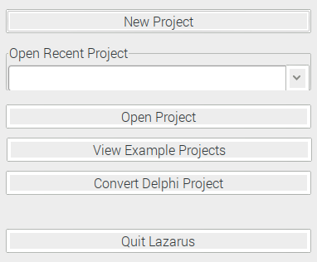

Select the UDPServerGPS.lpi

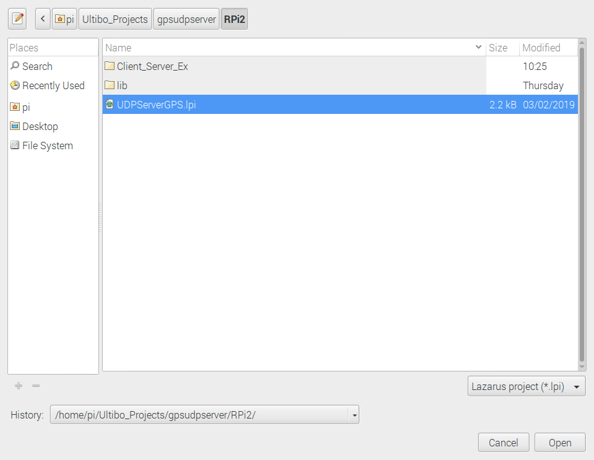

This displays the files used in the project.

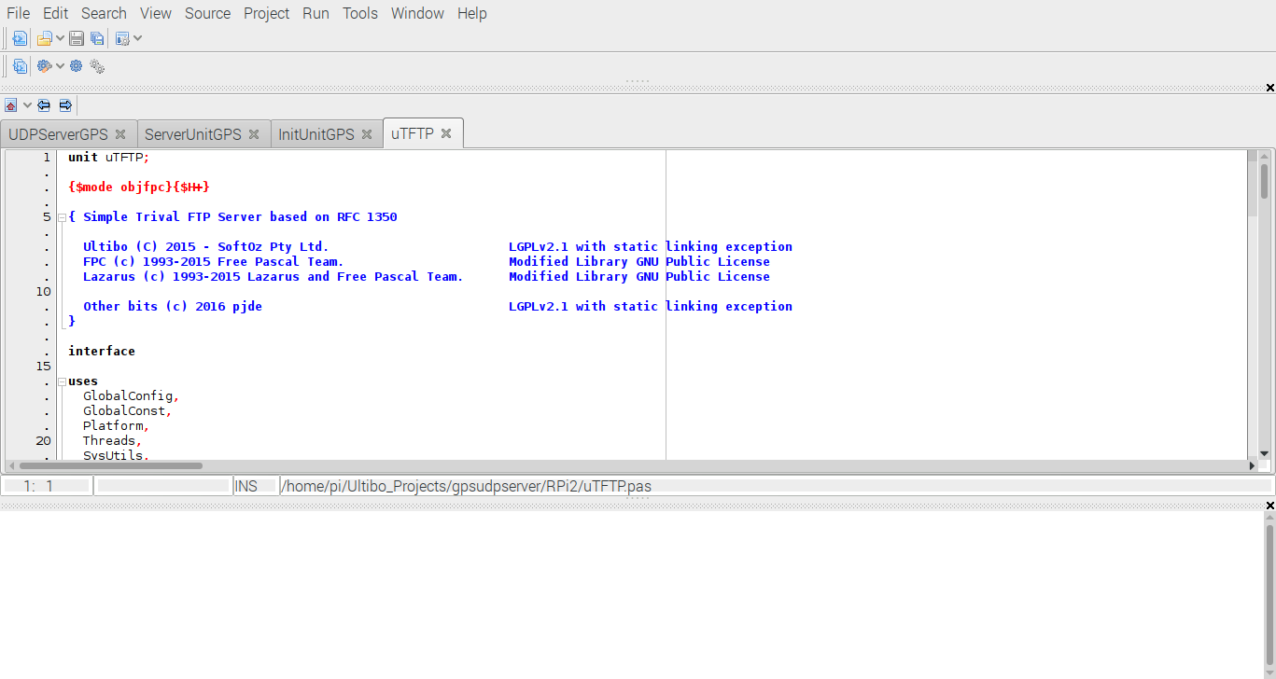
From Run/Clean up and Build

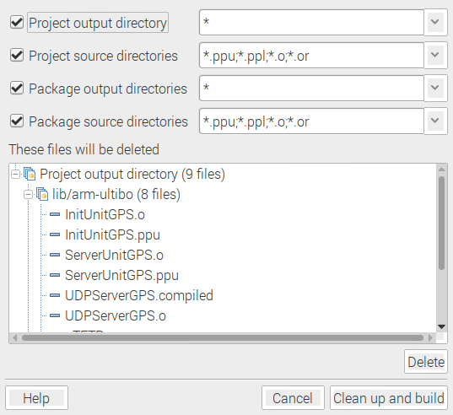

Depress Clean up and build

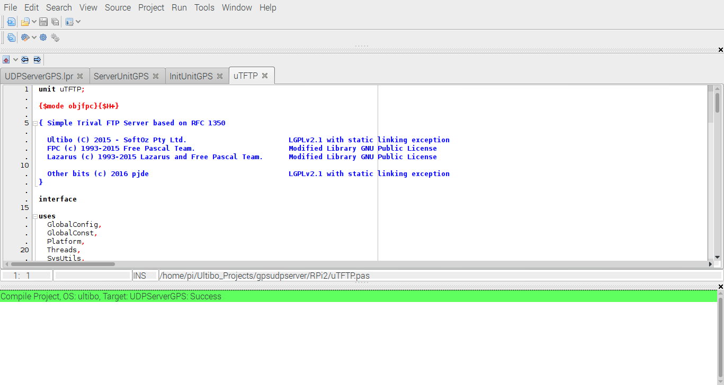
The kernel7.img can now be transferred to Ultibo System with GPS connected to Rpi2B RX.

pi@mypi3-1:~/Ultibo_Projects/gpsudpserver/RPi2 $ tftp 192.168.1.179 < cmdstftp
tftp> tftp> Sent 2880960 bytes in 16.5 seconds

Following the reboot the follow image wil be displayed.

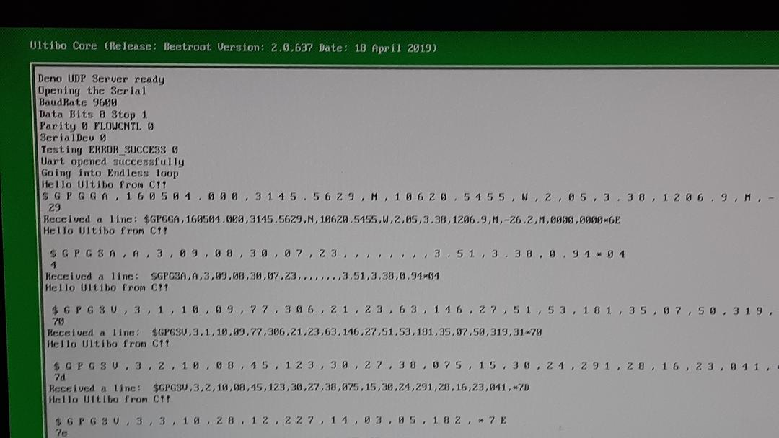
A telnet session can also be established with the Ultibo System.

pi@mypi3-1:~/Ultibo_Projects/gpsudpserver/doc $ telnet 192.168.1.179

Ultibo Core (Release: Beetroot Version: 2.0.637 Date: 18 April 2019)
(Type HELP for a list of available commands)
Available commands:
HELP
INFO
VER
TIME
CLS
RESTART
SHUTDOWN
UPTIME
THREAD
MEMORY
DEVICE
FILESYSTEM
CONTROLLER
DISK
PARTITION
VOLUME
DRIVE
CACHE
DIR
CD
MD
RD
TYPE
COPY
MOVE
DEL
REN
ATTRIB
TOUCH
VOL
LABEL
DELTREE
XCOPY
UPDATE
LOGOUT

The server receiving data from the Ultibo System

