*******************Default*******************
Pico_W BLE Client/Server
04/13/23

*******************Default*******************

Forked from this link
https://github.com/ErichStyger/mcuoneclipse
found in the google post
https://mcuoneclipse.com/2023/03/19/ble-with-wifi-and-freertos-on-raspberry-pi-pico-w/

Build steps on pi4-50

git clone https://github.com/develone/mcuoneclipse.git

cd mcuoneclipse

cd Examples

cd RaspberryPiPico/

cd pico_W_BLE/

cmake -G"Unix Makefiles" -DCMAKE_BUILD_TYPE=Debug .

make

[ 27%] Building C object build/src/CMakeFiles/SrcLib.dir/Shell.c.obj
/home/devel/xx/mcuoneclipse/Examples/RaspberryPiPico/pico_W_BLE/src/Shell.c:19:12: fatal error: MinINI/McuFlash.h: No such file or directory
#include "MinINI/McuFlash.h"

cp -R ../McuLib/minIni/ src/

mv src/minIni/ src/MinINI

make

[100%] linking CXX executable pico_W_BLE.elf
[100%] Built target pico_W_BLE

ls -la
total 11048
drwxr-xr-x 9 devel devel 4096 Apr 15 19:42 .
drwxr-xr-x 9 devel devel 4096 Apr 15 19:08 ..
drwxr-xr-x 4 devel devel 4096 Apr 15 19:30 build
-rw-r--r-- 1 devel devel 327 Apr 15 19:08 clean.bat
-rw-r--r-- 1 devel devel 19255 Apr 15 19:30 CMakeCache.txt
-rw-r--r-- 1 devel devel 14582 Apr 15 19:30 CMakeDoxyfile.in
-rw-r--r-- 1 devel devel 20173 Apr 15 19:30 CMakeDoxygenDefaults.cmake
drwxr-xr-x 6 devel devel 4096 Apr 15 19:42 CMakeFiles
-rw-r--r-- 1 devel devel 52 Apr 15 19:08 'cmake init.bat'
-rw-r--r-- 1 devel devel 1995 Apr 15 19:30 cmake_install.cmake
-rw-r--r-- 1 devel devel 1314 Apr 15 19:08 CMakeLists.txt
-rw-r--r-- 1 devel devel 14107 Apr 15 19:08 .cproject
drwxr-xr-x 6 devel devel 4096 Apr 15 19:30 elf2uf2
drwxr-xr-x 3 devel devel 4096 Apr 15 19:30 generated
-rw-r--r-- 1 devel devel 196 Apr 15 19:08 .gitignore
-rw-r--r-- 1 devel devel 418538 Apr 15 19:30 Makefile
drwxr-xr-x 6 devel devel 4096 Apr 15 19:30 pico-sdk
-rw-r--r-- 1 devel devel 3165 Apr 15 19:08 pico_sdk_import.cmake
-rwxr-xr-x 1 devel devel 474260 Apr 15 19:42 pico_W_BLE.bin
-rw-r--r-- 1 devel devel 7674 Apr 15 19:08 'pico_W_BLE Debug J-Link.launch'
-rw-r--r-- 1 devel devel 5900 Apr 15 19:08 'pico_W_BLE-Debug_picoHouse OpenOCD Debug.launch'
-rw-r--r-- 1 devel devel 3540785 Apr 15 19:42 pico_W_BLE.dis
-rwxr-xr-x 1 devel devel 2990928 Apr 15 19:42 pico_W_BLE.elf
-rw-r--r-- 1 devel devel 1431999 Apr 15 19:42 pico_W_BLE.elf.map
-rw-r--r-- 1 devel devel 1334036 Apr 15 19:42 pico_W_BLE.hex
-rw-r--r-- 1 devel devel 948736 Apr 15 19:42 pico_W_BLE.uf2
drwxr-xr-x 3 devel devel 4096 Apr 15 19:31 pioasm
-rw-r--r-- 1 devel devel 968 Apr 15 19:08 .project
-rw-r--r-- 1 devel devel 1055 Apr 15 19:08 readme.txt
drwxr-xr-x 3 devel devel 4096 Apr 15 19:38 src

Copied the folder mcuoneclipse to pi4-20.

Modified the file src/app_platform.h

git diff src/app_platform.h
diff --git a/Examples/RaspberryPiPico/pico_W_BLE/src/app_platform.h b/Examples/RaspberryPiPico/pico_W_BLE/src/app_platform.h
index 382d935d4..8a9517fac 100644
--- a/Examples/RaspberryPiPico/pico_W_BLE/src/app_platform.h
+++ b/Examples/RaspberryPiPico/pico_W_BLE/src/app_platform.h
@@ -8,7 +8,7 @@
#define APP_PLATFORM_H_

/* client: getting data from the server */
-#define PL_CONFIG_STANDALONE_BLE_CLIENT (0) /* << change this to switch between client and server implementation */
+#define PL_CONFIG_STANDALONE_BLE_CLIENT (1) /* << change this to switch between client and server implementation */

/* server: providing temperature values to the client */
#define PL_CONFIG_STANDALONE_BLE_SERVER (1 && !PL_CONFIG_STANDALONE_BLE_CLIENT)

Used the following script to program the Server/Client using openocd.

#!/bin/bash
openocd -f interface/raspberrypi-swd.cfg -f target/rp2040.cfg -c "program pico_W_BLE.elf verify reset exit"

Server start

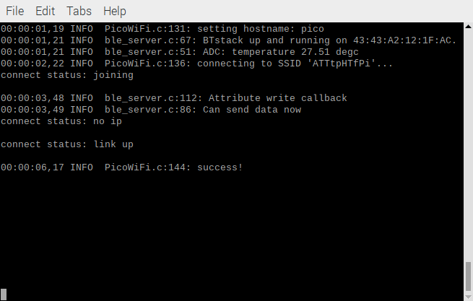
Serving sending data to client

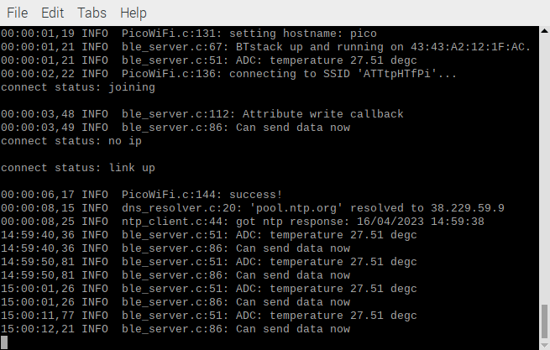
Client receiving the temperature data from Server using BLE
