There are 54 general-purpose I/O (GPIO) lines split into two banks. All GPIO pins have at
least two alternative functions within BCM. The alternate functions are usually peripheral IO
and a single peripheral may appear in each bank to allow flexibility on the choice of IO
voltage. Details of alternative functions are given in section 6.2. Alternative Function
Assignments.

The GPIO peripheral has three dedicated interrupt lines. These lines are triggered by the
setting of bits in the event detect status register. Each bank has its’ own interrupt line with the
third line shared between all bits.
The Alternate function table also has the pull state (pull-up/pull-down) which is applied after
a power down.

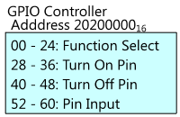

The GPIO has 41 registers. All accesses are assumed to be 32-bit
6.1 Register View

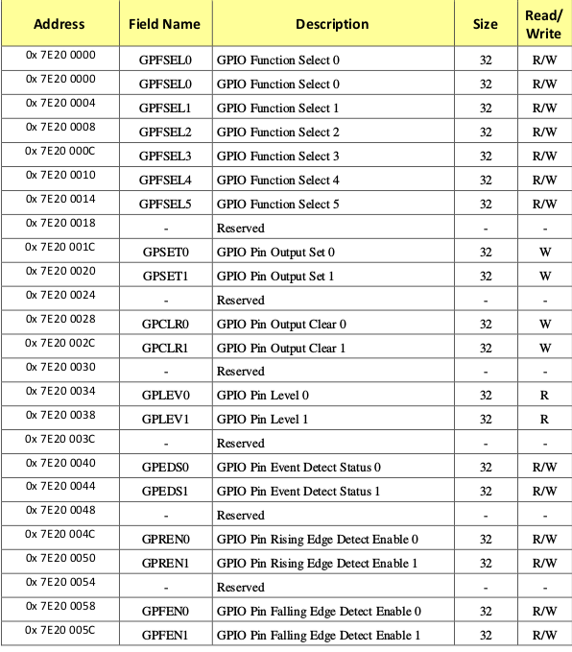
6.1 Register View continued

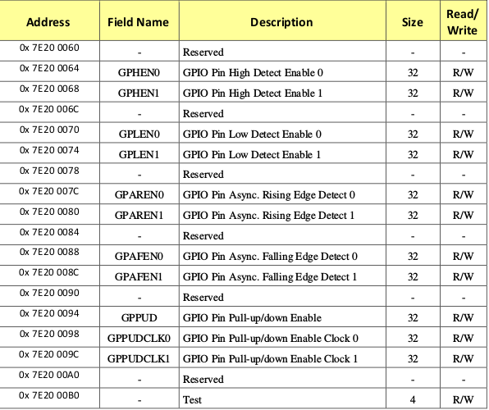

GPIO Function Select

******************************************
{Physical memory addresses of BCM2836 peripherals (See: BCM2835-ARM-Peripherals.pdf)}
BCM2836_PERIPHERALS_BASE = $3F000000; {Mapped to VC address 7E000000}
BCM2836_PERIPHERALS_SIZE = SIZE_16M;
{Pin Output Set Registers}
BCM2836_GPSET0 = $0000001C; {GPIO Pin Output Set 0}
BCM2836_GPSET1 = $00000020; {GPIO Pin Output Set 1}

0x7E20 0000
{GPIO (See Section 6)}
BCM2836_GPIO_REGS_BASE = BCM2836_PERIPHERALS_BASE + $200000;
******************************************
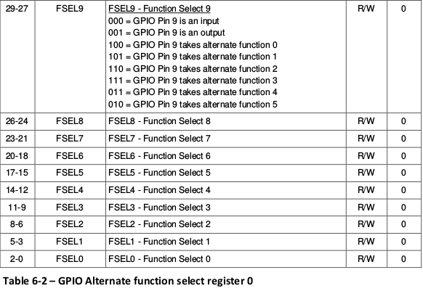
GPIO Function Select

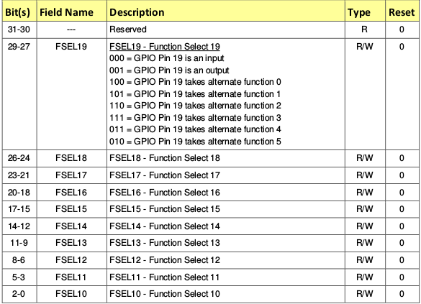

pin layout

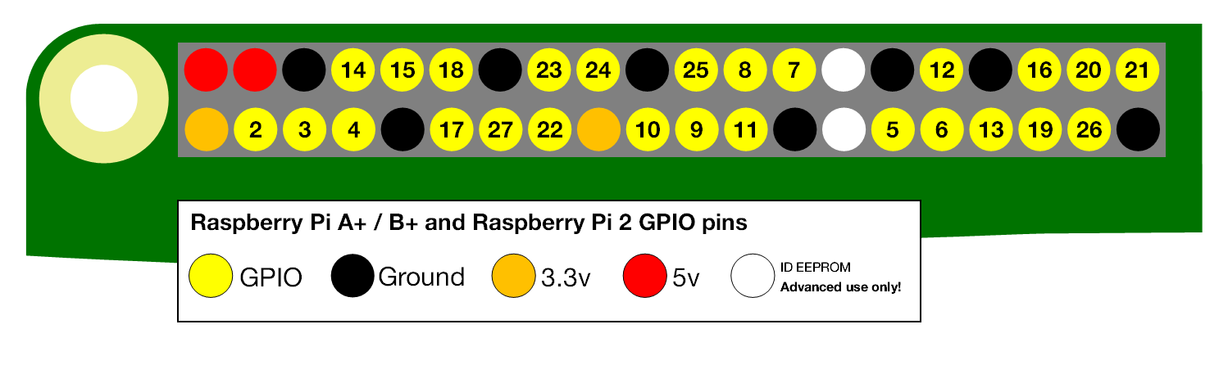

http://www.science.smith.edu/dftwiki/index.php/Tutorial:_Assembly_Language_with_the_Raspberry_Pi

as -o first.o first.s
gcc -o first first.o

./first | echo $?

@ first.s

@ from thinkingeek.com

@ http://thinkingeek.com/2013/01/09/arm-assembler-raspberry-pi-chapter-1/

@ Defines a main function that returns 2 as an exit code.

@ as -o first.o first.s

@ gcc -o first first.o

@ ./first | echo $?

.global main

main: mov r0, #2 @ load immediate value 2 into Register r0

bx lr @ return 2 to Operating Sytem

as -o hello.o hello.s
gcc -o hello hello.o
/hello

@ hello.s
@ D. Thiebaut
@ Just your regular Hello World program!
@
@ as -o hello.o hello.s
@ gcc -o hello hello.o
@ ./hello
@
@ Hello World!
@ ---------------------------------------
@ Data Section
@ ---------------------------------------

.data
string: .asciz "\nHello World!\n"

@ ---------------------------------------
@ Code Section
@ ---------------------------------------

.text
.global main
.extern printf

main:
push {ip, lr}
ldr r0,=0x7e200000
mov r2,#1
str r2,r0
ldr r1,=0x7e20001c
ldr r0, =string
bl printf

pop {ip, pc}

Blinking LED
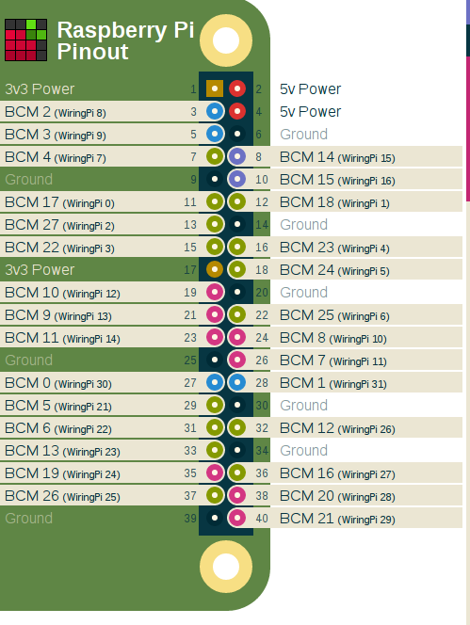

C program

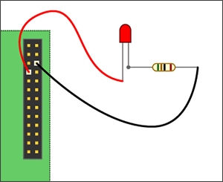

/* blink.c
D. Thiebaut
taken from https://www.raspberrypi.org/forums/viewtopic.php?f=33&t=23090
blinks Physical Pin 7 On and Off, 10 times.

to compile and run:
gcc -o blink blink.c -lwiringPi
sudo ./blink
*/

#include <wiringPi.h>
#include <stdio.h>
#include <stdlib.h>

int main ( void ) {
int pin = 7;
printf("Raspberry Pi wiringPi blink test\n");

if (wiringPiSetup() == -1) {
printf( "Setup didn't work... Aborting." );
exit (1);
}

pinMode(pin, OUTPUT);

int i;
for ( i=0; i<10; i++ ) {
digitalWrite(pin, 1);
delay(250);

digitalWrite(pin, 0);
delay(250);
}

return 0;
}

Assembly Version

as -o blink.o blink.s
gcc -o blink2 blink.o -lwiringPi
sudo ./blink2
@ blink.s
@ D. Thiebaut
@ based on the following C program:
@
@ #include <wiringPi.h>
@ #include <stdio.h>
@ #include <stdlib.h>
@
@ int main (void) {
@ int pin = 7;
@ printf("Raspberry Pi wiringPi blink test\n");
@
@ if (wiringPiSetup() == -1) {
@ printf( "Setup didn't work... Aborting." );
@ exit (1);
@ }
@
@ pinMode(pin, OUTPUT);
@ int i;
@ for ( i=0; i<10; i++ ) {
@ digitalWrite(pin, 1);
@ delay(250);
@
@ digitalWrite(pin, 0);
@ delay(250);
@ }
@
@ return 0;
@ }
@
@ To assemble, link, and run:
@
@ as -o blink.o blink.s
@ gcc -o blink2 blink.o -lwiringPi
@ sudo ./blink2

@ ---------------------------------------
@ Data Section
@ ---------------------------------------

.data
.balign 4
Intro: .asciz "Raspberry Pi wiringPi blink test\n"
ErrMsg: .asciz "Setup didn't work... Aborting...\n"
pin: .int 7
i: .int 0
delayMs: .int 250
OUTPUT = 1

@ ---------------------------------------
@ Code Section
@ ---------------------------------------

.text
.global main
.extern printf
.extern wiringPiSetup
.extern delay
.extern digitalWrite
.extern pinMode

main: push {ip, lr} @ push return address + dummy register
@ for alignment

@ printf( "blink..." ) ;
ldr r0, =Intro
bl printf

@ if (wiringPiSetup() == -1) {
@ printf( "Setup didn't work... Aborting." ) ;
@ exit (1) ;
@ }
bl wiringPiSetup
mov r1,#-1
cmp r0, r1
bne init
ldr r0, =ErrMsg
bl printf
b done

@ pinMode(pin, OUTPUT) ;
init:
ldr r0, =pin
ldr r0, [r0]
mov r1, #OUTPUT
bl pinMode

@ for ( i=0; i<10; i++ ) {
ldr r4, =i
ldr r4, [r4]
mov r5, #10
forLoop:
cmp r4, r5
bgt done

@ digitalWrite(pin, 1) ;
ldr r0, =pin
ldr r0, [r0]
mov r1, #1
bl digitalWrite

@ delay(250) ;
ldr r0, =delayMs
ldr r0, [r0]
bl delay

@ digitalWrite(pin, 0) ;
ldr r0, =pin
ldr r0, [r0]
mov r1, #0
bl digitalWrite

@ delay(250) ;
ldr r0, =delayMs
ldr r0, [r0]
bl delay

add r4, #1
b forLoop

done:
pop {ip, pc} @ pop return address into pc

binary hex gpio
1000 0000 0000 0000 0000 0000 0000 0000 80000000 pin 31
0100 0000 0000 0000 0000 0000 0000 0000 40000000 pin 30
0010 0000 0000 0000 0000 0000 0000 0000 20000000 pin 29
0001 0000 0000 0000 0000 0000 0000 0000 10000000 pin 28
0000 1000 0000 0000 0000 0000 0000 0000 08000000 pin 27
0000 0100 0000 0000 0000 0000 0000 0000 04000000 pin 26
0000 0010 0000 0000 0000 0000 0000 0000 02000000 pin 25
0000 0001 0000 0000 0000 0000 0000 0000 01000000 pin 24
0000 0000 1000 0000 0000 0000 0000 0000 00800000 pin 23
0000 0000 0100 0000 0000 0000 0000 0000 00400000 pin 22
0000 0000 0010 0000 0000 0000 0000 0000 00200000 pin 21
0000 0000 0001 0000 0000 0000 0000 0000 00100000 pin 20

binary hex gpio
0000 0000 0000 1000 0000 0000 0000 0000 00080000 pin 19
0000 0000 0000 0100 0000 0000 0000 0000 00040000 pin 18
0000 0000 0000 0010 0000 0000 0000 0000 00020000 pin 17
0000 0000 0000 0001 0000 0000 0000 0000 00010000 pin 16
0000 0000 0000 0000 1000 0000 0000 0000 00008000 pin 15
0000 0000 0000 0000 0100 0000 0000 0000 00004000 pin 14
0000 0000 0000 0000 0010 0000 0000 0000 00002000 pin 13
0000 0000 0000 0000 0001 0000 0000 0000 00001000 pin 12
0000 0000 0000 0000 0000 1000 0000 0000 00000800 pin 11
0000 0000 0000 0000 0000 0100 0000 0000 00000400 pin 10

binary hex gpio
0000 0000 0000 0000 0000 0010 0000 0000 00000200 pin 9
0000 0000 0000 0000 0000 0001 0000 0000 00000100 pin 8
0000 0000 0000 0000 0000 0000 1000 0000 00000080 pin 7
0000 0000 0000 0000 0000 0000 0100 0000 00000040 pin 6
0000 0000 0000 0000 0000 0000 0010 0000 00000020 pin 5
0000 0000 0000 0000 0000 0000 0001 0000 00000010 pin 4
0000 0000 0000 0000 0000 0000 0000 1000 00000008 pin 3
0000 0000 0000 0000 0000 0000 0000 0100 00000004 pin 2
0000 0000 0000 0000 0000 0000 0000 0010 00000002 pin 1

0000 0000 0000 0000 0000 0000 0000 0001 00000001 pin 0

http://www.pieter-jan.com/node/15

#define INP_GPIO(g) *(gpio.addr + ((g)/10)) &= ~(7<<(((g)%10)*3))
This macro sets pin "g" as an input. How?

In the datasheet at page 91 we find that the GPFSEL registers are organised per 10 pins.
So one 32-bit register contains the setup bits for 10 pins. *gpio.addr + ((g))/10 is the
register address that contains the GPFSEL bits of the pin "g" (and 9 other pins we are
not interested in). Remember that the result of a division on integers in C does not
contain the part behind the komma. There are three GPFSEL bits per pin (000: input, 001: output).
The location of these three bits inside the GPFSEL register is given by ((g)%10)*3 (three times the remainder, remember the modulo % operator).

So to set pin "g" as an input, we need to set these bits to "000". This is done with a
AND-operation between the GPSEL register and a string of which everything except those
bits are 1. This string is created by bitshifting 7, which is binary 111, over ((g)%10)*3
places, and taking the inverse of that.

A little example: Say that we want to use gpio4 as an input.

The GPSEL address containing the function select bits for gpio4 is *gpio.addr + 4/10=*gpio.addr + 0
Inside this 32-bit register, the bits concerning gpio4 start from bit (4%10)*3=12
If we bitshift binary 111 over 12 positions we get: 00000000000000000111000000000000
We have to make those three bits zero in the GPFSEL register, so we have to invert that 32-bit
string and perform an AND operation with the GPSEL register. (X = unknown)

#define OUT_GPIO(g) *(gpio.addr + ((g)/10)) |= (1<<(((g)%10)*3))

To set pin "g" as an output, we have to set its setup bits to 001. This is done in the same way as before, but now we bitshift a 1, and use a OR operation on the normal (not inverted) string.
This is also the reason that the comment says to "always use INP_GPIO(x) before using OUT_GPIO(x)". This way you are sure that the other 2 bits are 0, and justifies the use of a OR operation here. If you don't do that, you are not sure those bits will be zero and you might have given the pin "g" a different setup.

