Draft 08/12/19

Met with Dr. Watson and tested the openmv-cam.
The GUI is QT based for Windows the exe contains everything needed.
Not good for embedded operation. The box on left is the Rpi2B with camera mypi3-8 RaspBian buster . The Rpi3B+ near the power strip is the Ultibo Bare Metal. To left of magzine is a Rpi3B+ mypi3-11 RasBian buster. The Rpi3B+ mypi3-11 provides a NFS file system to the lab.
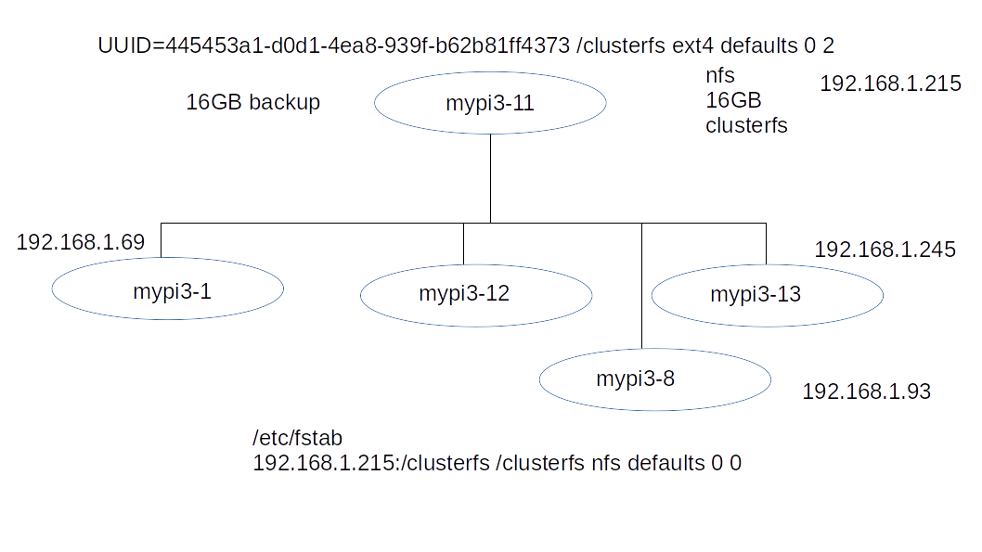
In the area above Rpi3B+ is a HDMI 3 in 1out switch a USB Hub, and a 4 port Ethernet hub.
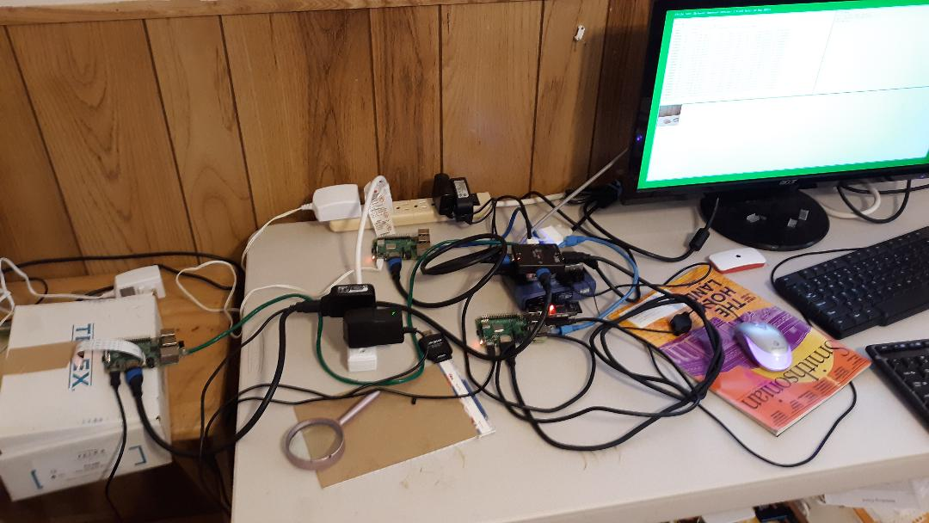

Started looking at Rpi2
Was able to get a number of frames collected in bmp format.

Edge

541 frames in 5 min 300 sec 1.8 sec /frame Is this fast enough?

frame0000.bmp to framexxxxx.bmp
The tested the image obtained on Raspbian using Ultibo Bare Metal JPEG2000
Openjpeg which is made up 22 C files which is quite a bit of processing.

/home/devel/Ultibo_Projects/jpeg2000/src/bio.c
/home/devel/Ultibo_Projects/jpeg2000/src/cio.c
/home/devel/Ultibo_Projects/jpeg2000/src/dwt.c
/home/devel/Ultibo_Projects/jpeg2000/src/event.c
/home/devel/Ultibo_Projects/jpeg2000/src/function_list.c
/home/devel/Ultibo_Projects/jpeg2000/src/image.c
/home/devel/Ultibo_Projects/jpeg2000/src/invert.c
/home/devel/Ultibo_Projects/jpeg2000/src/j2k.c
/home/devel/Ultibo_Projects/jpeg2000/src/jp2.c
/home/devel/Ultibo_Projects/jpeg2000/src/mct.c
/home/devel/Ultibo_Projects/jpeg2000/src/mqc.c
/home/devel/Ultibo_Projects/jpeg2000/src/openjpeg.c
/home/devel/Ultibo_Projects/jpeg2000/src/opj_clock.c
/home/devel/Ultibo_Projects/jpeg2000/src/opj_malloc.c
/home/devel/Ultibo_Projects/jpeg2000/src/pi.c
/home/devel/Ultibo_Projects/jpeg2000/src/raw.c
/home/devel/Ultibo_Projects/jpeg2000/src/t1.c
/home/devel/Ultibo_Projects/jpeg2000/src/t2.c
/home/devel/Ultibo_Projects/jpeg2000/src/tcd.c
/home/devel/Ultibo_Projects/jpeg2000/src/tgt.c
/home/devel/Ultibo_Projects/jpeg2000/src/thread.c

15-5-19 22:24:28 3197924 kernel7.img
firmware
devel@mypi3-8:/clusterfs/firmwar_for_ultibo $ ls 042519/
bootcode.bin fixup.dat fixup_x.dat start.elf start_x.elf

13-8-19 06:13:04 49206 frame0000.bmp
Input to openjeg program
13-8-19 06:13:04 49206 MyBitmap.bmp
output
3-8-19 15:23:52 409 test.j2k
devel@mypi3-8:~/camerawatson/timelapse $ tftp 192.168.1.247
tftp> binary
tftp> get test.j2k
Received 409 bytes in 0.0 seconds
tftp> quit
devel@mypi3-8:~/camerawatson/timelapse $ /clusterfs/t_ultibo/build/bin/opj_decompress -i test.j2k -o tt.bmp

[INFO] Start to read j2k main header (3481168).
[INFO] Main header has been correctly decoded.
[INFO] No decoded area parameters, set the decoded area to the whole image
[INFO] Header of tile 1 / 1 has been read.
[INFO] Generated Outfile tt.bmp
decode time: 8 ms
The decompressed image

bare metal
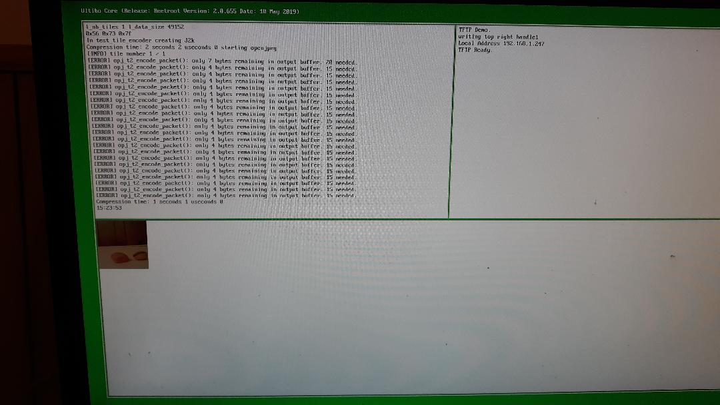

Items unknown
time between frames
type of processing Singular Value Decomposition SVD on 128 x 128 image is plan
The SVD currently uses a rgb_pack.bin which has 3 values for the image is a single 32 bit word used by FPGA processing & th_svd
https://github.com/develone/Ultibo_Projects/blob/master/th_svd/doc/threaded_svd_ex.pdf
These also use octave for visualization of the images the RaspBian version buster is not currently working the RaspBian stretch version is okay which is on some of the older Rpi3B+ mypi3-1.

This currently executes on RaspBian or Ultibo Bare Metal.
This requires modify to read bitmap or conversion of bitmap to rgb_packed.bin a single 32 bit word.
type of jig for camera
requires externel light
mirrors
processing capability
current tests with a Raspberry Pi 2 B V1.1 Quad Core running RaspBian (buster) Linux
with camera.

The Ultibo Bare metal supports NFS I have not done any testing at this time.
Is NFS needed?
If all work done on Rpi4B maybe will not need a NFS file system. Maybe just RaspBian Linux.
I have not tested the camera on a Rpi4B.
watson1 & watson2
gzip -dc 2019-06-20-raspbian-buster-full.zip | dd bs=4M status='progress' of=/dev/sda
watson1 will with RPi4 2GB & watson2 will be used on RPi Zero with camera
change hostname /etc/hostname
1693 packages
apt-get update --allow-releaseinfo-change

extra_pkgs.sh

#!/bin/bash
sudo apt-get update
sudo apt-get install octave vlc kicad hexchat \
ecryptfs-utils gawk gimp gtkwave iverilog clang \
samba samba-common-bin smbclient cifs-utils \
libftdi-dev libmpc-dev libmpfr-dev verilator bc mercurial \
libbison-dev libgmp-dev libelf-dev ncurses-dev ctags \
default-jdk libreadline-dev xdot graphviz minicom xpdf lrzsz \
libusb-1.0.0 exuberant-ctags gparted ffmpeg qt5-default \
mesa-utils libboost-all-dev freeglut3 freeglut3-dev \
python3-dev libgtk2.0-dev libcairo2-dev libpango1.0-dev \
libgdk-pixbuf2.0-dev libatk1.0-dev libghc-x11-dev binutils-arm-none-eabi \
gcc-arm-none-eabi diffuse gitk tcl-dev telnet tftp hexedit cmake flex bison \
gtkmm-3.0 gperf build-essential qt5-default nfs-kernel-server gpac
2201 packages
This provides encrypted files
Revision Control software

Ultibo Bare Metal FPC & Lazarus IDE Very fast compiler

pi@watson2:~ $ diff /etc/hostname /etc/hostname.orig
1c1
< watson2
---
> raspberrypi
root@watson2:/etc# diff dphys-swapfile.orig dphys-swapfile
16c16
< CONF_SWAPSIZE=100
---
> CONF_SWAPSIZE=1000
ultiboinstaller.sh provides Ultibo Bare Metal

devel@watson2:~/Ultibo_Projects $ find . -name kernel7.img
./HelloVideo/RPi2/kernel7.img
./WebServer/RPi2/kernel7.img
./RemoteLed/RPi2/kernel7.img
./Ultibo_PWM_TFTP/RPi2/kernel7.img
./svd/RPi2/kernel7.img
./HelloPi/HelloVideo_TFTP/RPi2/kernel7.img
./th_svd/RPi2/kernel7.img
./RaspiVid_TFTP/RPi2/kernel7.img
./HelloAudio/RPi2/kernel7.img
./OpenGLES/HelloGLES/RPi2/kernel7.img
./wall/RPi2/kernel7.img
./jpeg2000/RPi2/kernel7.img
./gpsudpserver/RPi2/kernel7.img
./Demo/RPi2/kernel7.img
./HelloTeapot/Rpi2/kernel7.img
08/15/19
pi@watson2:$ sudo raspivid -vf -hf -w 256 -h 256 -t 30000 -o video.h264
pi@watson2:$ MP4Box -add video.h264 video.mp4
pi@watson2:~/cameratest $ ffmpeg -i video.h264 thumb%04d.bmp -hide_banner
pi@watson2:~/cameratest $ ls *.bmp | wc
897 897 12558

testing push to github
pi@watson2:~ $ cd camerawatson/
pi@watson2:~/camerawatson $ git add doc/cammerwifitest.txt
pi@watson2:~/camerawatson $ git config --global user.email "rwwatsondds@gmail.com"
pi@watson2:~/camerawatson $ git config --global user.name "Robert Watson"
pi@watson2:~/camerawatson $ git commit doc/cammerwifitest.txt

