08/27/19
Test camera mount and ir-sw.

Styrofoam sides 6 1/2 in. high 7 ½ in wide. Spacing between sides 5 ¾ in touching mirror mounts.
Styrofoam 7/8 in. thick.
Half of the Raspberry Pi Zero case for the camera is mounted below the cross member .

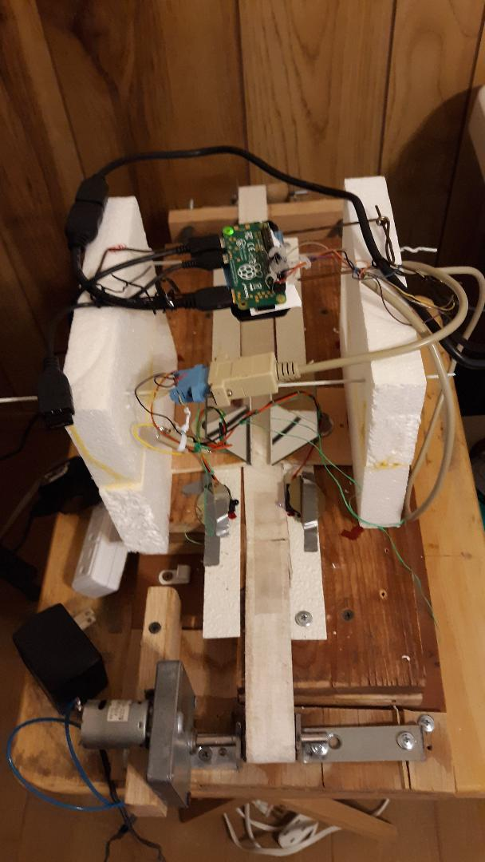
Bottom right stryrofoam
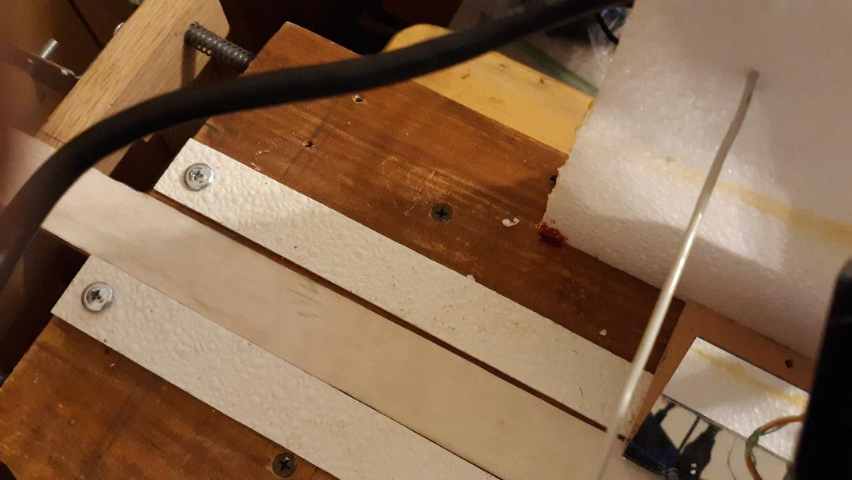
Top left camera mout and bottom left stryrofoam

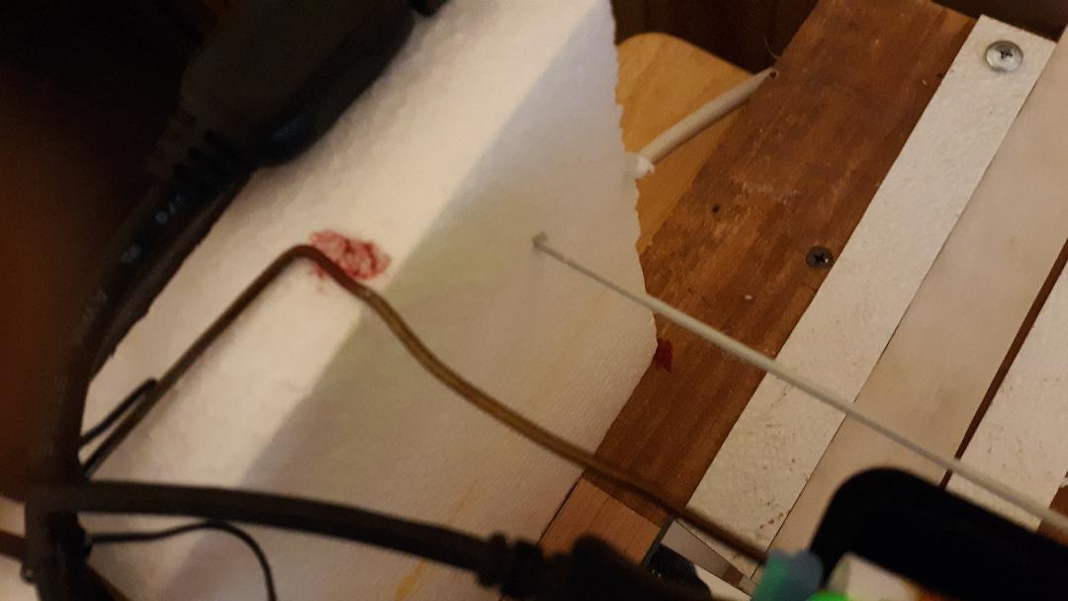
Bottom left styrofoam and receiver .

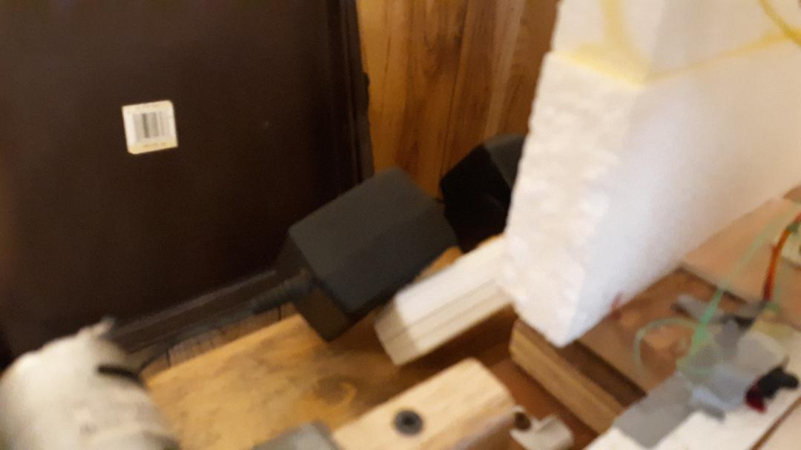
Top left camera mount HDMI.

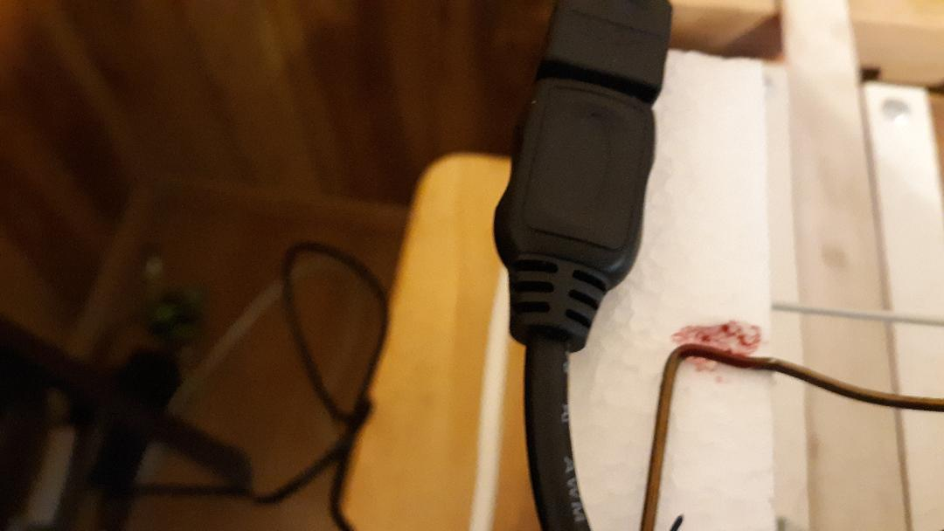
Bottom right styrofoam
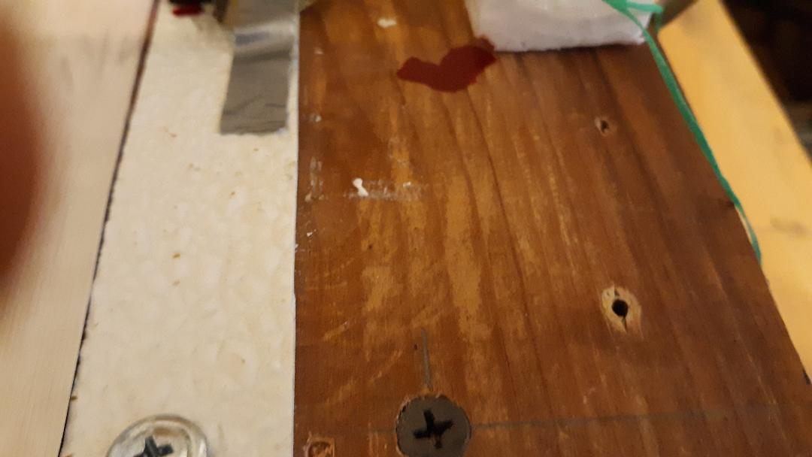
Top camera mount

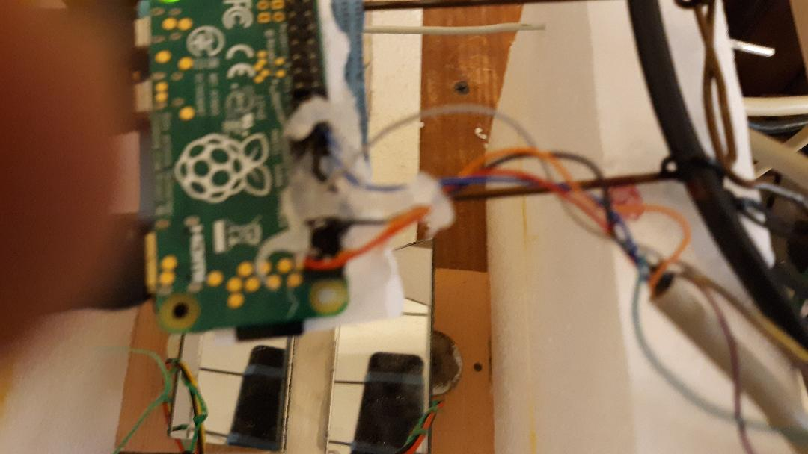
Receiver& Transmitter.



