***********Draft***********
Principal component analysis (PCA)
09/09/19
***********Draft***********

Using an extraction of 80 x 50. This required several changes to get the extracted images correct for the klt program.
q
Top View of canera mount lower with screw to adjust the height.
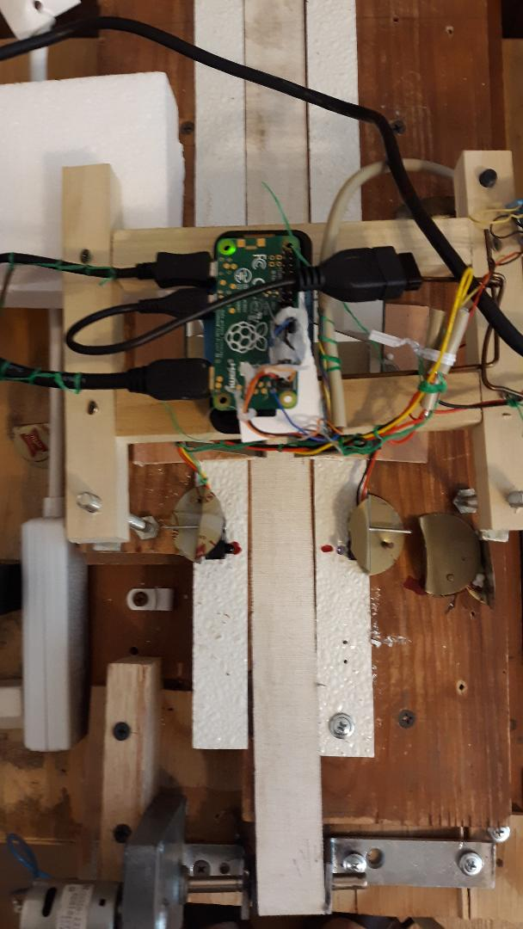

Front view

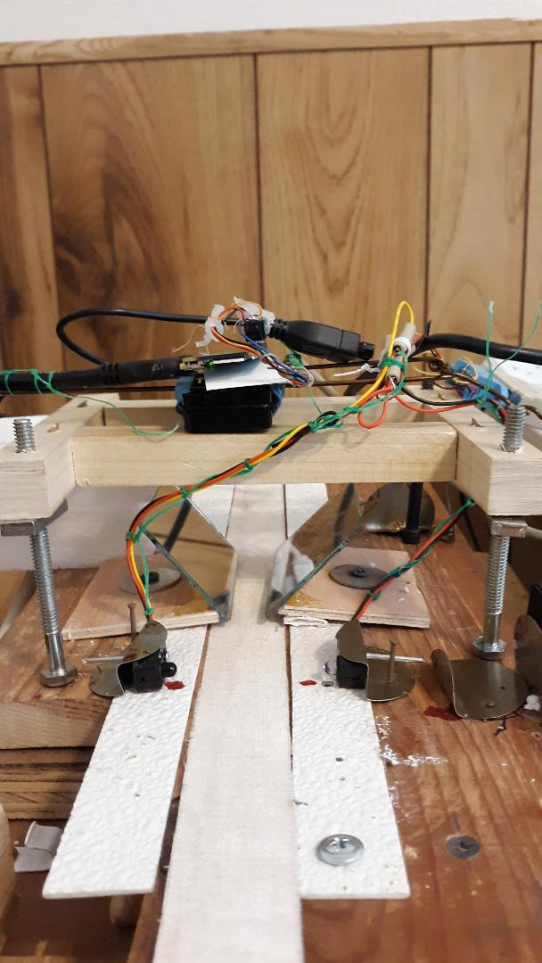
Front view

r1thumb0000.bmp

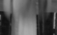

r1thumb0000.pgm

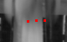
r1feat1.ppm

Feel free to place comments here.

!!!!!!!!!!!!!!!!!!!!!!!!!!!!!!!!!!!!!!!!!!!!!!!!!!!!!!!!!!!!!!!!!!!!!!!!!
!!! Warning: This is a KLT data file. Do not modify below this line !!!

------------------------------
KLT Feature List
------------------------------

nFeatures = 10

feature | (x,y)=val
--------+-----------------
0 | ( 53, 24)= 537
1 | ( 33, 25)= 205
2 | ( 43, 24)= 26
3 | ( -1, -1)= -1
4 | ( -1, -1)= -1
5 | ( -1, -1)= -1
6 | ( -1, -1)= -1
7 | ( -1, -1)= -1
8 | ( -1, -1)= -1
9 | ( -1, -1)= -1

r1feat1.txt

r2thumb0000.bmp not cracked

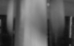

r2thumb0000.pgm

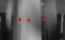

r2feat1.ppm
Feel free to place comments here.

!!!!!!!!!!!!!!!!!!!!!!!!!!!!!!!!!!!!!!!!!!!!!!!!!!!!!!!!!!!!!!!!!!!!!!!!!
!!! Warning: This is a KLT data file. Do not modify below this line !!!

------------------------------
KLT Feature List
------------------------------

nFeatures = 10

feature | (x,y)=val
--------+-----------------
0 | ( 53, 24)= 495
1 | ( 35, 25)= 72
2 | ( 24, 24)= 51
3 | ( -1, -1)= -1
4 | ( -1, -1)= -1
5 | ( -1, -1)= -1
6 | ( -1, -1)= -1
7 | ( -1, -1)= -1
8 | ( -1, -1)= -1
9 | ( -1, -1)= -1

r2feat1.txt

r3thumb0000.bmp

r3thumb0000.pgm

r3feat1.ppm

Feel free to place comments here.

!!!!!!!!!!!!!!!!!!!!!!!!!!!!!!!!!!!!!!!!!!!!!!!!!!!!!!!!!!!!!!!!!!!!!!!!!
!!! Warning: This is a KLT data file. Do not modify below this line !!!

------------------------------
KLT Feature List
------------------------------

nFeatures = 10

feature | (x,y)=val
--------+-----------------
0 | ( 53, 24)= 495
1 | ( 35, 25)= 72
2 | ( 24, 24)= 51
3 | ( -1, -1)= -1
4 | ( -1, -1)= -1
5 | ( -1, -1)= -1
6 | ( -1, -1)= -1
7 | ( -1, -1)= -1
8 | ( -1, -1)= -1
9 | ( -1, -1)= -1

r3feat1.txt

r4thumb0000.bmp



r4thumb0000.pgm

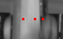

r4feat1.ppm

Feel free to place comments here.

!!!!!!!!!!!!!!!!!!!!!!!!!!!!!!!!!!!!!!!!!!!!!!!!!!!!!!!!!!!!!!!!!!!!!!!!!
!!! Warning: This is a KLT data file. Do not modify below this line !!!

------------------------------
KLT Feature List
------------------------------

nFeatures = 10

feature | (x,y)=val
--------+-----------------
0 | ( 54, 24)= 807
1 | ( 44, 24)= 50
2 | ( 29, 24)= 22
3 | ( -1, -1)= -1
4 | ( -1, -1)= -1
5 | ( -1, -1)= -1
6 | ( -1, -1)= -1
7 | ( -1, -1)= -1
8 | ( -1, -1)= -1
9 | ( -1, -1)= -1

r4feat1.txt

r5thumb0000.bmp

r

5thumb0000.pgm

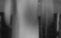

r5feat1.ppm

Feel free to place comments here.

!!!!!!!!!!!!!!!!!!!!!!!!!!!!!!!!!!!!!!!!!!!!!!!!!!!!!!!!!!!!!!!!!!!!!!!!!
!!! Warning: This is a KLT data file. Do not modify below this line !!!

------------------------------
KLT Feature List
------------------------------

nFeatures = 10

feature | (x,y)=val
--------+-----------------
0 | ( 52, 24)= 696
1 | ( 42, 25)= 35
2 | ( 24, 24)= 28
3 | ( -1, -1)= -1
4 | ( -1, -1)= -1
5 | ( -1, -1)= -1
6 | ( -1, -1)= -1
7 | ( -1, -1)= -1
8 | ( -1, -1)= -1
9 | ( -1, -1)= -1

r5feat1.txt

r6thumb0000.bmp

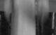

r6thumb0000.pgm

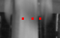

r6feat1.ppm

Feel free to place comments here.

!!!!!!!!!!!!!!!!!!!!!!!!!!!!!!!!!!!!!!!!!!!!!!!!!!!!!!!!!!!!!!!!!!!!!!!!!
!!! Warning: This is a KLT data file. Do not modify below this line !!!

------------------------------
KLT Feature List
------------------------------

nFeatures = 10

feature | (x,y)=val
--------+-----------------
0 | ( 53, 24)= 656
1 | ( 30, 24)= 118
2 | ( 43, 24)= 18
3 | ( -1, -1)= -1
4 | ( -1, -1)= -1
5 | ( -1, -1)= -1
6 | ( -1, -1)= -1
7 | ( -1, -1)= -1
8 | ( -1, -1)= -1
9 | ( -1, -1)= -1
r4feat1.txt

