*********Draft*********
Camera & Raspberry Pi Zero RPi Zero
08/17/19
*********Draft*********

Received the RPi Zero & Camera from Amazon. Inserted the micro sd that I had created for RaspBian system watson2. This micro sd started out with 1693 package on first boot and many packages were added and now have 2201 packages.
The file pkgs.txt was created with “dpkg -l sort > pkgs.txt”

The file watson2.txt was created with “dpkg -l sort > watson2.txt”

The RPi Zero is vertical with the connections (HDMI, USB, and Power) on the left side.
This document is being prepared on the RPi Zero using LibreOffice Writer.

“scrot -d 10 -s watson2.png”

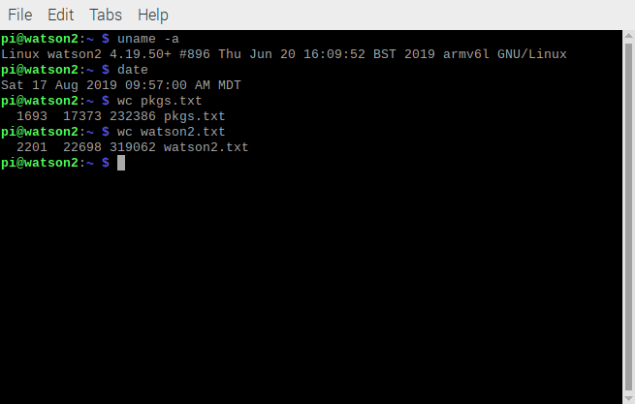

“sudo raspistill -o nohorflip.jpg”

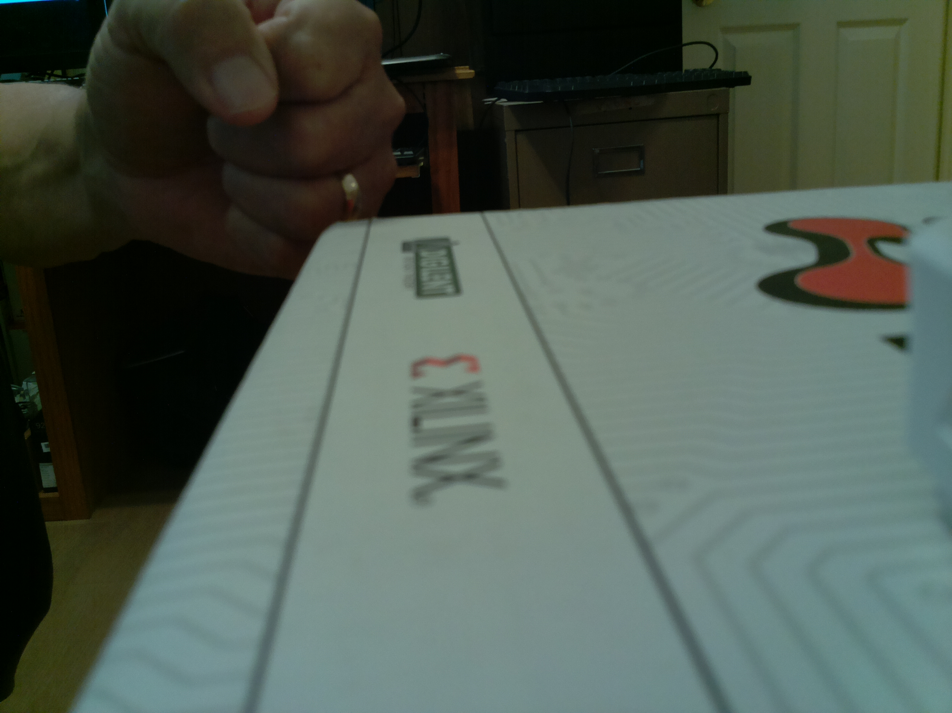

“sudo raspistill -hf -o horflip.jpg”

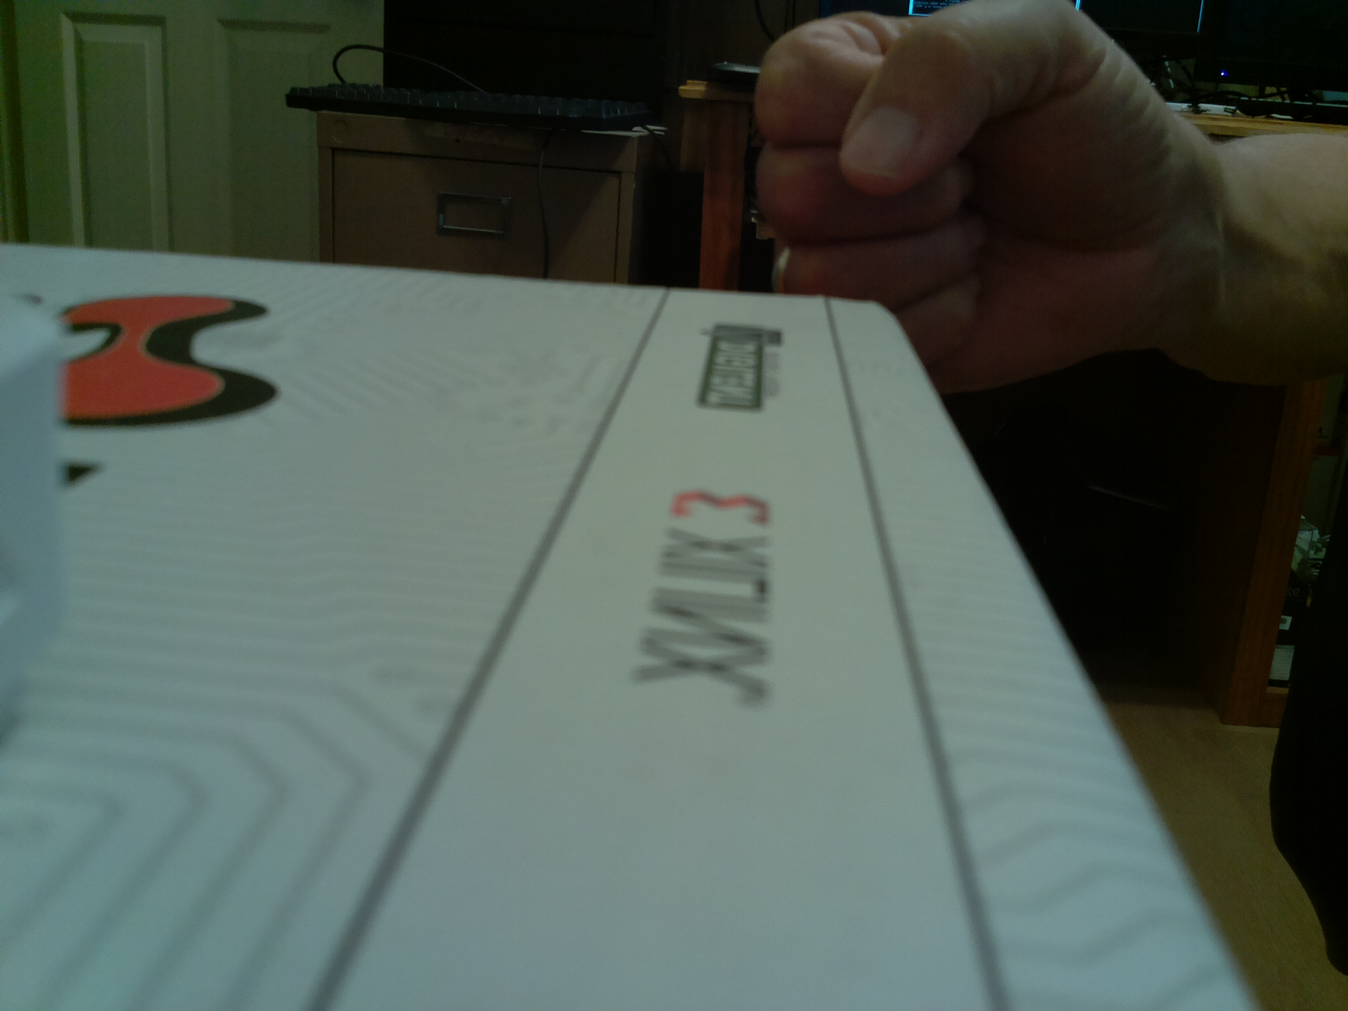
thumb0038.bmp entering the field of view.

thumb0076.bmp leaving the field of view.

