http://allcomputerprograms.blogspot.com/2011/09/linear-convolution.html

Octave Convolution Example

camerawatson/octave/conv.m

%linear convolution program

clc;
clear all;
close all;
disp('linear convolution program');

x=input('enter i/p x(n):');
m=length(x);
h=input('enter i/p h(n):');
n=length(h);

x=[x,zeros(1,n)];
subplot(2,2,1), stem(x);
title('i/p sequencce x(n)is:');
xlabel('---->n');
ylabel('---->x(n)');grid;

h=[h,zeros(1,m)];
subplot(2,2,2), stem(h);
title('i/p sequencce h(n)is:');
xlabel('---->n');
ylabel('---->h(n)');grid;
disp('convolution of x(n) & h(n) is y(n):');
y=zeros(1,m+n-1);

for i=1:m+n-1
y(i)=0;
for j=1:m+n-1
if(j<i+1)
y(i)=y(i)+x(j)*h(i-j+1);
end
end
end

y
subplot(2,2,[3,4]),stem(y);
title('convolution of x(n) & h(n) is :');
xlabel('---->n');
ylabel('---->y(n)');grid;
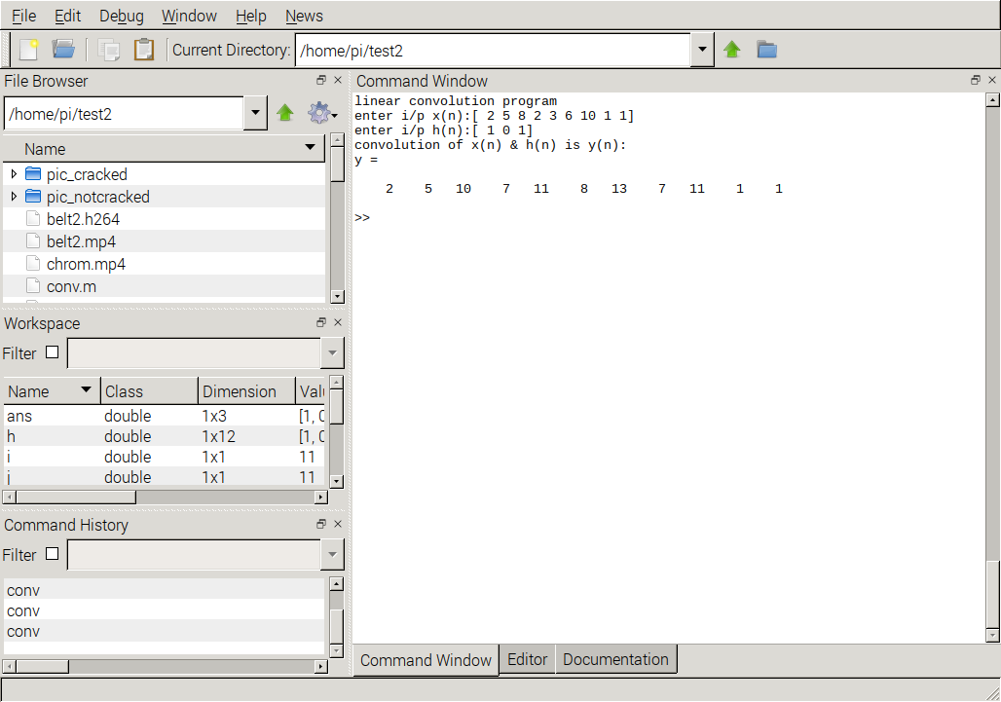
Result is 3 plot s in a figure.
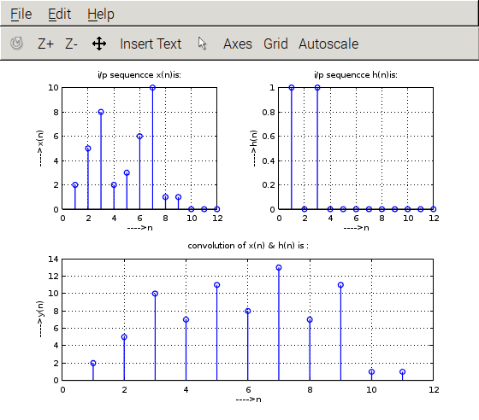
C implementation

gcc conv_ex.c -o conv_ex

#include<stdio.h>

int x[15],h[15],y[15];

main()
{ int i,j,m,n;

printf("\n enter value for m");
scanf("%d",&m);
printf("\n enter value for n");
scanf("%d",&n);

printf("Enter values for i/p x(n):\n");

for(i=0;i<m;i++)
scanf("%d",&x[i]);

printf("Enter Values for i/p h(n) \n");
for(i=0;i<n; i++)
scanf("%d",&h[i]);

// padding of zeors

for(i=m;i<=m+n-1;i++)

x[i]=0;

for(i=n;i<=m+n-1;i++)

h[i]=0;

/* convolution operation */

for(i=0;i<m+n-1;i++)

{

y[i]=0;

for(j=0;j<=i;j++)

{

y[i]=y[i]+(x[j]*h[i-j]);

}

}

//displaying the o/p

for(i=0;i<m+n-1;i++)

printf("\n The Value of output y[%d]=%d",i,y[i]);

}
The Value of output y[8]=25devel@mypi3-13:/clusterfs/camerawatson/C $ ./conv_ex

devel@mypi3-13:/clusterfs/camerawatson/C $ ./conv_ex

enter value for m5

enter value for n5
Enter values for i/p x(n):
1 2 3 4 5
Enter Values for i/p h(n)
1 2 3 4 5

The Value of output y[0]=1
The Value of output y[1]=4
The Value of output y[2]=10
The Value of output y[3]=20
The Value of output y[4]=35
The Value of output y[5]=44
The Value of output y[6]=46
The Value of output y[7]=40

enter value for m9

enter value for n3
Enter values for i/p x(n):
2 5 8 2 3 6 10 1 1
Enter Values for i/p h(n)
1 0 1

The Value of output y[0]=2
The Value of output y[1]=5
The Value of output y[2]=10
The Value of output y[3]=7
The Value of output y[4]=11
The Value of output y[5]=8
The Value of output y[6]=13
The Value of output y[7]=7
The Value of output y[8]=11
The Value of output y[9]=1

