Two imgaes were used thumb0000yes.bmp & thumb0000no.bmp.
The top row is the cracked, hor,ver, and sobel.
The lower is not cracked, hor, ver, and sobel.
kx= [1 ,0 ,-1; 2,0,-2; 1, 0 ,-1];
ky= [1,2,1; 0,0, 0; -1, -2 ,-1];
hor is obtained with the ky filter

ver is obtained with the kx filter

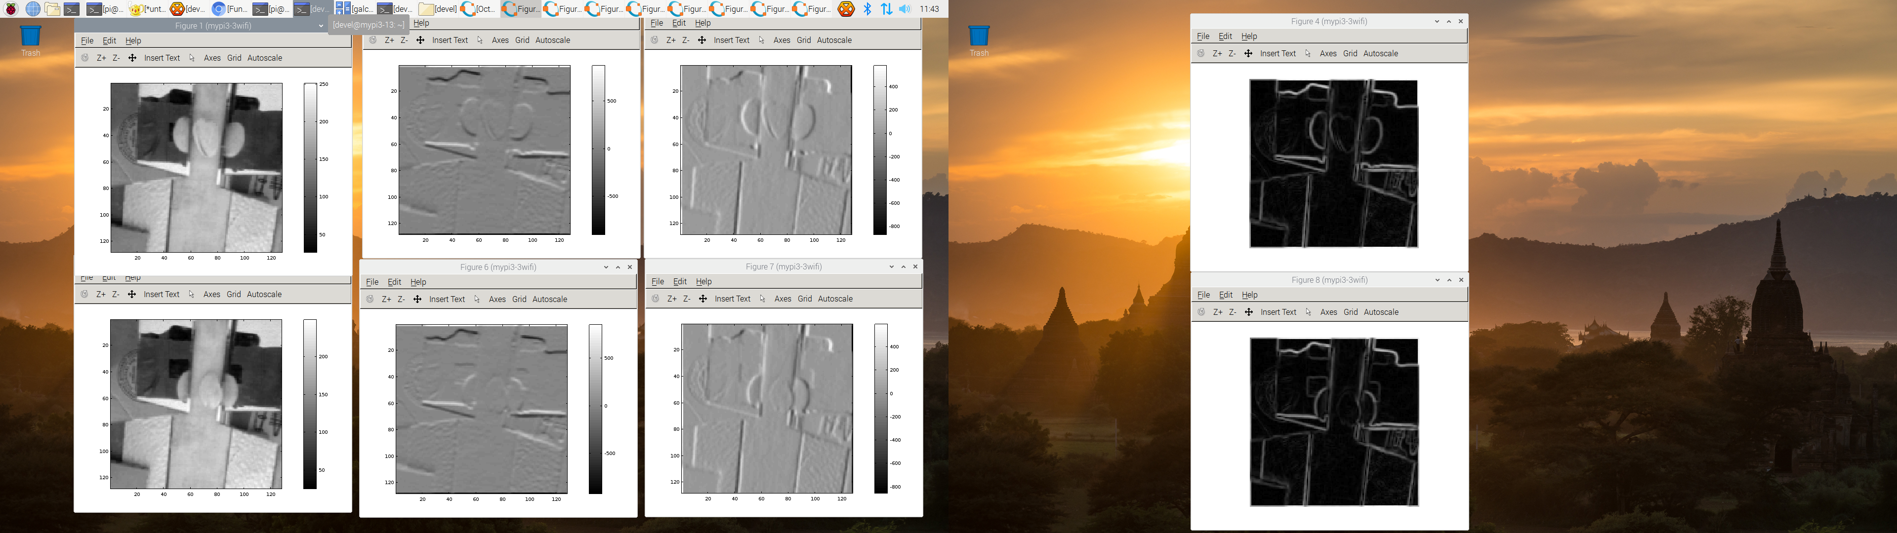
clear
w = 128;
h = 128;

kx= [1 ,0 ,-1; 2,0,-2; 1, 0 ,-1];
ky= [1,2,1; 0,0, 0; -1, -2 ,-1];

I = imread("thumb0000no.bmp");
for i = 1:w
for j= 1:h
im1(i,j) =I(i,j,1);
endfor
endfor
figure
imagesc(im1)
colormap 'gray'
colorbar

hor=conv2(double(im1),ky,'same');
figure
imagesc(hor)
colormap 'gray'
colorbar

ver=conv2(double(im1),kx,'same');
figure
imagesc(ver)
colormap 'gray'
colorbar

EE = sqrt(hor.*hor + ver.*ver); % or sqrt(H.^2+V.^2)
figure
imshow(EE, [])

