***********Draft***********
Principal component analysis (PCA)
09/07/19
***********Draft***********

The -t parameter of the raspistill is dependent on the position of the camera with the ir-sw and the speed of the belt.
Tests indicate that the lowest value of -t is 260 msec since the image at -t 250 is quite dark.

t250thumb.png

t260thumb.png

t275thumb.png

t300thumb.png

***********Draft***********
Principal component analysis (PCA)
09/06/19
***********Draft***********
In this test the pistachio was pre postioned and the ir-sw was trigged manually.

-t 275
offset = 30;
endofline = headInfo.width - offset - ncols;
ncols = 50;//number of cols to be extracted
nrows = 50;//number of rows to be extracted
rows = 17;
If the pistachio travels 2 1/4 in. from the ir-sw
the cracked pistachio has a quite high value of 1325.
the results are in files /data/savedklt090619/r1*.
if the not cracked pistachio travels 2 1/4 in from the ir-sw
the not cracked pistachio has a much lower value of 409
the results are in files /data/savedklt090619/r2*.
Feel free to place comments here.

!!!!!!!!!!!!!!!!!!!!!!!!!!!!!!!!!!!!!!!!!!!!!!!!!!!!!!!!!!!!!!!!!!!!!!!!!
!!! Warning: This is a KLT data file. Do not modify below this line !!!

------------------------------
KLT Feature List
------------------------------

nFeatures = 10

feature | (x,y)=val
--------+-----------------
0 | ( 24, 24)= 1325

Feel free to place comments here.

!!!!!!!!!!!!!!!!!!!!!!!!!!!!!!!!!!!!!!!!!!!!!!!!!!!!!!!!!!!!!!!!!!!!!!!!!
!!! Warning: This is a KLT data file. Do not modify below this line !!!

------------------------------
KLT Feature List
------------------------------

nFeatures = 10

feature | (x,y)=val
--------+-----------------
0 | ( 24, 25)= 409

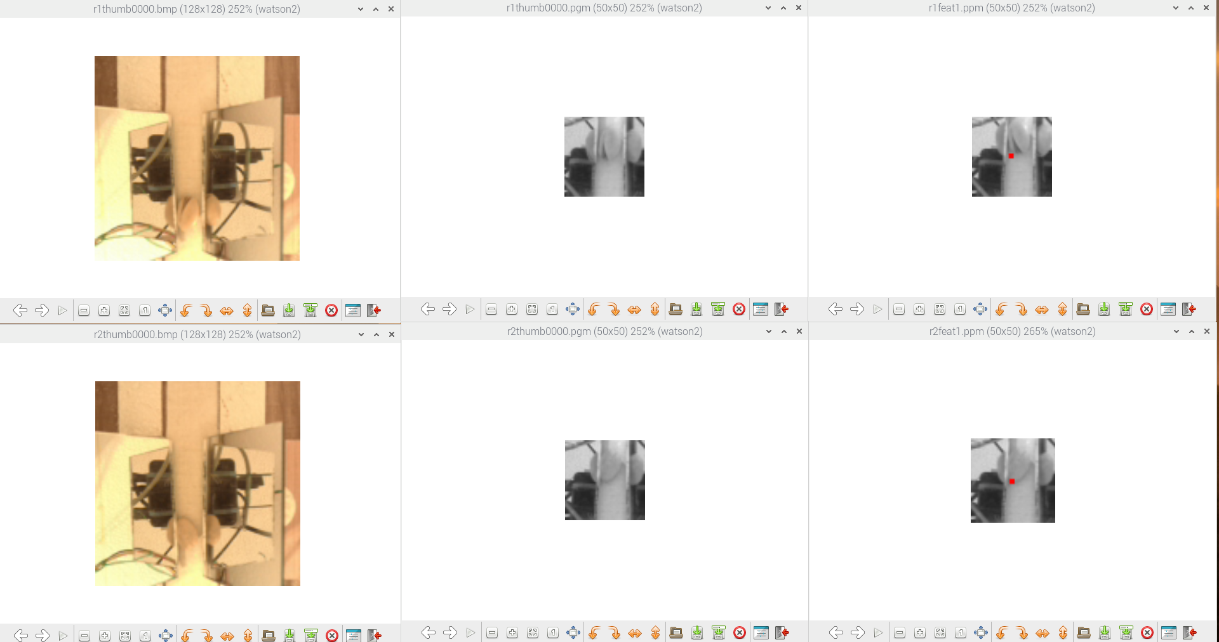
***********Draft***********
Principal component analysis (PCA)
09/05/19
***********Draft***********

exe1.c
- rows = 19;
+ rows = 17;

r2thumb0000.bmp cracked

r3thumb0000.bmp not cracked
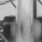

r2thumb0000.pgm cracked
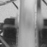

r3thumb0000.pgm not cracked

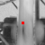

r2feat1.ppm cracked

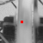

r3feat1.ppm not cracked
Feel free to place comments here.

!!!!!!!!!!!!!!!!!!!!!!!!!!!!!!!!!!!!!!!!!!!!!!!!!!!!!!!!!!!!!!!!!!!!!!!!!
!!! Warning: This is a KLT data file. Do not modify below this line !!!

------------------------------
KLT Feature List
------------------------------

nFeatures = 10

feature | (x,y)=val
--------+-----------------
0 | ( 25, 25)= 274
1 | ( -1, -1)= -1
2 | ( -1, -1)= -1
3 | ( -1, -1)= -1
4 | ( -1, -1)= -1
5 | ( -1, -1)= -1
6 | ( -1, -1)= -1
7 | ( -1, -1)= -1
8 | ( -1, -1)= -1
9 | ( -1, -1)= -1

r2feat1.txt cracked

Feel free to place comments here.

!!!!!!!!!!!!!!!!!!!!!!!!!!!!!!!!!!!!!!!!!!!!!!!!!!!!!!!!!!!!!!!!!!!!!!!!!
!!! Warning: This is a KLT data file. Do not modify below this line !!!

------------------------------
KLT Feature List
------------------------------

nFeatures = 10

feature | (x,y)=val
--------+-----------------
0 | ( 25, 25)= 74
1 | ( -1, -1)= -1
2 | ( -1, -1)= -1
3 | ( -1, -1)= -1
4 | ( -1, -1)= -1
5 | ( -1, -1)= -1
6 | ( -1, -1)= -1
7 | ( -1, -1)= -1
8 | ( -1, -1)= -1
9 | ( -1, -1)= -1
r3feat1.txt not cracked

There are several variables the control the extraction of the image
where the feature is tested from the original image.
As can be seen below if the cracked image is placed correctly the value
increases to 0 | ( 24, 25)= 402

offset = 30;
endofline = headInfo.width - offset - ncols;
ncols = 50;//number of cols to be extracted
nrows = 50;//number of rows to be extracted
rows = 19;
rowsdn = (headInfo.width * rows) + offset;
pr = pr + rowsdn; //rows + 1 lines dn + offset
for (j = (rows+1); j <(rows+1+nrows);j++) {
for (i = offset; i <ncols+offset ; i++) {
*prwr = *pr;
pr++;
prwr++;
}
pr = pr + endofline;//headInfo.width - offset - ncols
pr = pr + offset;
}
pr = pr - rowsdn - ((50*50)+(78*50));
prwr = prwr - (50*50);

Feel free to place comments here.

!!!!!!!!!!!!!!!!!!!!!!!!!!!!!!!!!!!!!!!!!!!!!!!!!!!!!!!!!!!!!!!!!!!!!!!!!
!!! Warning: This is a KLT data file. Do not modify below this line !!!

------------------------------
KLT Feature List
------------------------------

nFeatures = 10

feature | (x,y)=val
--------+-----------------
0 | ( 24, 25)= 402
1 | ( -1, -1)= -1

diff --git a/C/klt/exe1.c b/C/klt/exe1.c
index b60fa95..a0eff20 100644
--- a/C/klt/exe1.c
+++ b/C/klt/exe1.c
@@ -46,7 +46,7 @@ int main(void) {
KLT_FeatureList fl;
int nFeatures = 10;
int ncols, nrows;
-
+ int rowsdn,rows,offset,endofline;
wiringPiSetup();

pinMode(PIN_SW, INPUT);
@@ -156,17 +156,23 @@ int main(void) {
}
//befor free the memory need to restore the pointers
pr = pr - headInfo.width*headInfo.height;
- pr = pr + 2462; //19 lines dn + 60
- for (j = 20; j <70;j++) {
- for (i = 30; i <80 ; i++) {
+ offset = 30;
+ endofline = headInfo.width - offset - ncols;
+ ncols = 50;//number of cols to be extracted
+ offset = 30;
+ endofline = headInfo.width - offset - ncols;
+ ncols = 50;//number of cols to be extracted
+ nrows = 50;//number of rows to be extracted
+ rows = 19;
+ rowsdn = (headInfo.width * rows) + offset;
+ pr = pr + rowsdn; //rows + 1 lines dn + offset
+ for (j = (rows+1); j <(rows+1+nrows);j++) {
+ for (i = offset; i <ncols+offset ; i++) {
*prwr = *pr;
pr++;
prwr++;
}
- pr = pr + 48;//110 -128 end of row
- pr = pr + 30;
+ pr = pr + endofline;//headInfo.width - offset - ncols
+ pr = pr + offset;
}
- pr = pr - 2462 - ((50*50)+(78*50));
+ pr = pr - rowsdn - ((50*50)+(78*50));
prwr = prwr - (50*50);
pg = pg - headInfo.width*headInfo.height;
pb = pb - headInfo.width*headInfo.height;

r1thumb0000.bmp
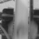

r1thumb0000.pgm
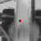

r1feat1.ppm
Feel free to place comments here.

!!!!!!!!!!!!!!!!!!!!!!!!!!!!!!!!!!!!!!!!!!!!!!!!!!!!!!!!!!!!!!!!!!!!!!!!!
!!! Warning: This is a KLT data file. Do not modify below this line !!!

------------------------------
KLT Feature List
------------------------------

nFeatures = 10

feature | (x,y)=val
--------+-----------------
0 | ( 24, 25)= 402
1 | ( -1, -1)= -1
2 | ( -1, -1)= -1
3 | ( -1, -1)= -1
4 | ( -1, -1)= -1
5 | ( -1, -1)= -1
6 | ( -1, -1)= -1
7 | ( -1, -1)= -1
8 | ( -1, -1)= -1
9 | ( -1, -1)= -1

r1feat1.txt

***********Draft***********
Principal component analysis (PCA)
09/04/19
***********Draft***********

Test run Tue 03 Sep 2019 09:26:52 PM MDT
The files subimg.m & im1.m are needed to determime
the values needed to extract from the 128 x 128 to 50 x 50.
when determining the thumb0000.pgm from thumb0000.bmp.
This needs to be run on a stetch version of octave.

The number of cables causes a problem positioning and keeping the
camera in the correct position.

Belt speed, and camera postion are very critical in determining the feature
value obtained.
Feature #0: (24.000000,25.000000) with value of 125.

diff --git a/C/klt/exe1.c b/C/klt/exe1.c
index 62cd705..b60fa95 100644
--- a/C/klt/exe1.c
+++ b/C/klt/exe1.c
@@ -85,7 +85,7 @@ int main(void) {

while (flag == 1) {
// 0123456789012345678901234567890123456789012345678901234567
- char cam_pre[] = "sudo raspistill -e bmp -vf -h 128 -w 128 -t 300 -o thumb";
+ char cam_pre[] = "sudo raspistill -e bmp -vf -h 128 -w 128 -t 275 -o thumb";
char s3[] = "thumb";
printf("%s %d\n",cam_pre,sizeof(cam_pre));
sprintf(pframe_suf, "%04d.bmp",count);
@@ -156,17 +156,17 @@ int main(void) {
}
//befor free the memory need to restore the pointers
pr = pr - headInfo.width*headInfo.height;
- pr = pr + 2492; //19 lines dn + 60
+ pr = pr + 2462; //19 lines dn + 60
for (j = 20; j <70;j++) {
@@ -156,17 +156,17 @@ int main(void) {
}
//befor free the memory need to restore the pointers
pr = pr - headInfo.width*headInfo.height;
- pr = pr + 2492; //19 lines dn + 60
+ pr = pr + 2462; //19 lines dn + 60
for (j = 20; j <70;j++) {
- for (i = 60; i <110 ; i++) {
+ for (i = 30; i <80 ; i++) {
*prwr = *pr;
pr++;
prwr++;
}
- pr = pr + 18;//110 -128 end of row
- pr = pr + 60;
+ pr = pr + 48;//110 -128 end of row
+ pr = pr + 30;
}
- pr = pr - 2492 - ((50*50)+(78*50));
+ pr = pr - 2462 - ((50*50)+(78*50));
prwr = prwr - (50*50);
pg = pg - headInfo.width*headInfo.height;
pb = pb – headInfo.width*headInfo.height;

r1thumb0000.bmp

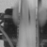

r1thumb0000.pgm
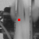

r1feat1.ppm

Feel free to place comments here.

!!!!!!!!!!!!!!!!!!!!!!!!!!!!!!!!!!!!!!!!!!!!!!!!!!!!!!!!!!!!!!!!!!!!!!!!!
!!! Warning: This is a KLT data file. Do not modify below this line !!!

------------------------------
KLT Feature List
------------------------------

nFeatures = 10

feature | (x,y)=val
--------+-----------------
0 | ( 24, 25)= 125
1 | ( -1, -1)= -1
2 | ( -1, -1)= -1
3 | ( -1, -1)= -1
4 | ( -1, -1)= -1
5 | ( -1, -1)= -1
6 | ( -1, -1)= -1
7 | ( -1, -1)= -1
8 | ( -1, -1)= -1
r1feat1.txt

***********Draft***********
Principal component analysis (PCA)
09/02/19
***********Draft***********
Took the 128 x 128 from the camera and wrote a subimage of 50 x 50 to the file
thumb0000.pgm.
This 50 x 50 image was processed with example1.c which both img1 & img2
used thumb0000.pgm.
the images in data/savedklt090219 r1* are with a cracked pistachio crack is on the right.
0 | ( 25, 24)= 285
the images in data/savedklt090219 r2* are with a not cracked pistachio
0 | ( 24, 24)= 45
the images in data/savedklt090219 r3* are with a cracked pistachio crack is on the left.
0 | ( 24, 25)= 101
the image in data/savedklt090219 r4* are with a cracked pistachio now the code
from example1.c is included in exe1.c increased the -t variable from
275 to 300 msec which moves the pistachio into the field of view.

r1Thumb0000.bmp

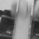

r1Thumb0000.pgm

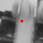

r1feat1.ppm

feature | (x,y)=val
--------+-----------------
0 | ( 25, 24)= 285
r1feat1.txt

r2Thumb0000.bmp

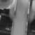

r2Thumb0000.pgm

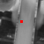

r2feat1.ppm
feature | (x,y)=val
--------+-----------------
0 | ( 24, 24)= 45

r2feat1.txt

r3Thumb0000.bmp

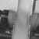

r3Thumb0000.pgm

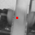

r3feat1.ppm

feature | (x,y)=val
--------+-----------------
0 | ( 24, 25)= 101

r3feat1.txt

r4Thumb0000.bmp
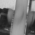

r4Thumb0000.pgm

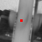

r4feat1.ppm
feature | (x,y)=val
--------+-----------------
0 | ( 25, 24)= 152
r4feat1.txt

***********Draft***********
Principal component analysis (PCA)
08/31/19
***********Draft***********

Created a smaller set of images which were a cut from thumb0000yes1.pgm & thumb0000no1.pgm. These were then used in example1.c.

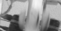

Thumb0000yes1sm.pgm

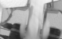

Thumb0000no1sm.pgm

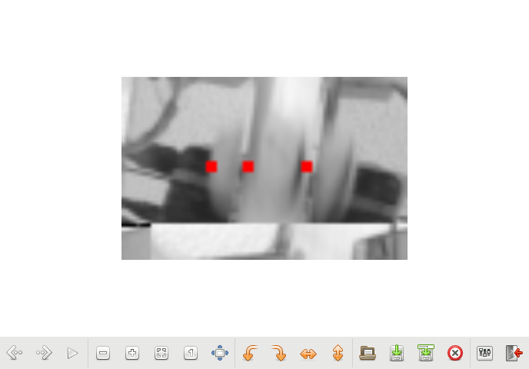

The image above is 78 x 50 zoom of 476%.

Feel free to place comments here.

!!!!!!!!!!!!!!!!!!!!!!!!!!!!!!!!!!!!!!!!!!!!!!!!!!!!!!!!!!!!!!!!!!!!!!!!!
!!! Warning: This is a KLT data file. Do not modify below this line !!!

------------------------------
KLT Feature List
------------------------------

nFeatures = 100

feature | (x,y)=val
--------+-----------------
0 | ( 50, 24)= 2280
1 | ( 34, 24)= 747
2 | ( 24, 24)= 635

***********Draft***********
Principal component analysis (PCA)
08/31/19
***********Draft***********

Looking the feature extraction from ultibo_numlib/klt. Converted the 4 test images bmp images to pgm which was the format that was used.
Modified example1.c to use thumb0000yes1.pgm and thumb0000yes2.pgm

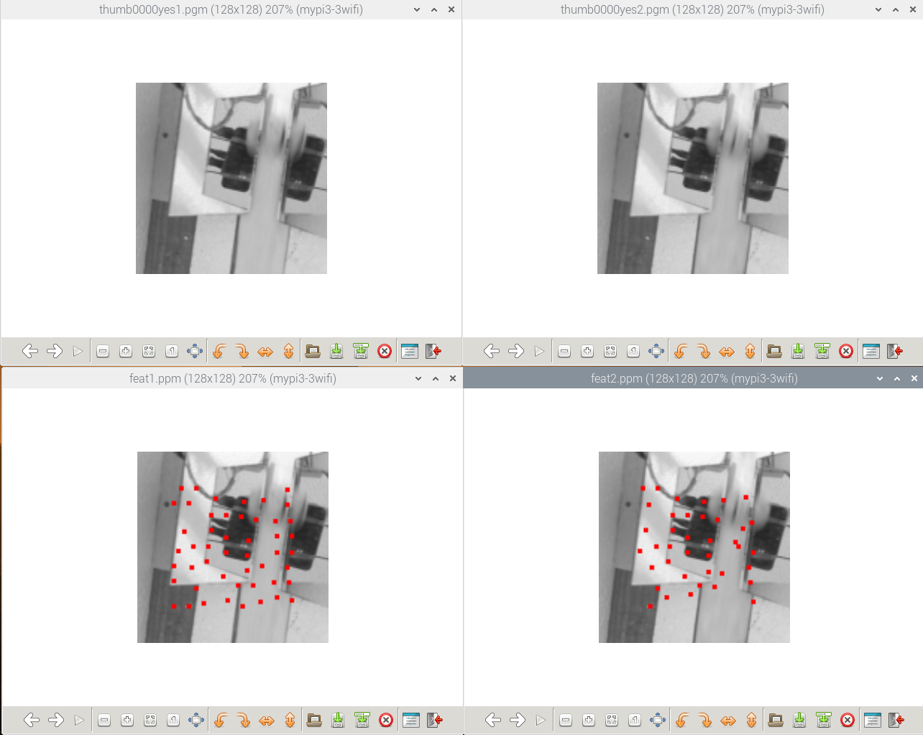

feat1.txt
Feel free to place comments here.

!!!!!!!!!!!!!!!!!!!!!!!!!!!!!!!!!!!!!!!!!!!!!!!!!!!!!!!!!!!!!!!!!!!!!!!!!
!!! Warning: This is a KLT data file. Do not modify below this line !!!

------------------------------
KLT Feature List
------------------------------

nFeatures = 100

feature | (x,y)=val
--------+-----------------
0 | ( 59, 42)=12494
1 | ( 49, 52)=11437
2 | ( 71, 33)=11096
3 | ( 39, 91)=10412
4 | ( 59, 67)=10405
5 | (100, 77)= 9171
6 | ( 73, 69)= 8453
7 | ( 24, 86)= 8441
8 | ( 52, 31)= 7226
9 | ( 49, 42)= 5225
10 | ( 67, 89)= 3450
11 | ( 74, 59)= 3192
12 | (100, 35)= 2280
13 | (101, 87)= 2264
14 | ( 59, 57)= 1547
15 | (103, 99)= 1533
16 | (100, 25)= 1514
17 | ( 46, 73)= 1183
18 | (103, 67)= 1166
19 | ( 79, 45)= 1089
20 | ( 84, 32)= 1085
21 | ( 47, 63)= 906
22 | (102, 46)= 836
23 | ( 39, 24)= 757
24 | ( 34,103)= 730
25 | ( 69, 43)= 473
26 | ( 57, 83)= 468
27 | ( 31, 53)= 407
28 | ( 24, 34)= 270
29 | ( 24, 76)= 236
30 | ( 92, 46)= 210
31 | ( 73, 79)= 168
32 | (103, 56)= 145
33 | ( 27, 66)= 130
34 | ( 29, 24)= 97
35 | ( 93, 56)= 80
36 | ( 24,103)= 65
37 | ( 93, 97)= 52
38 | ( 36, 77)= 44
39 | ( 77, 89)= 40
40 | ( 44,101)= 28
41 | ( 60, 99)= 25
42 | ( 34, 34)= 21
43 | ( 93, 67)= 15
44 | ( 91, 87)= 13
45 | ( 70,103)= 5
46 | ( 82,100)= 4
47 | ( 83, 76)= 4
48 | ( 37, 63)= 1
49 | ( -1, -1)= -1
50 | ( -1, -1)= -1
51 | ( -1, -1)= -1
52 | ( -1, -1)= -1
53 | ( -1, -1)= -1
54 | ( -1, -1)= -1
55 | ( -1, -1)= -1
56 | ( -1, -1)= -1
57 | ( -1, -1)= -1
58 | ( -1, -1)= -1
59 | ( -1, -1)= -1
60 | ( -1, -1)= -1
61 | ( -1, -1)= -1
62 | ( -1, -1)= -1
63 | ( -1, -1)= -1
64 | ( -1, -1)= -1
65 | ( -1, -1)= -1
66 | ( -1, -1)= -1
67 | ( -1, -1)= -1
68 | ( -1, -1)= -1
69 | ( -1, -1)= -1
70 | ( -1, -1)= -1
71 | ( -1, -1)= -1
72 | ( -1, -1)= -1
73 | ( -1, -1)= -1
74 | ( -1, -1)= -1
75 | ( -1, -1)= -1
76 | ( -1, -1)= -1
77 | ( -1, -1)= -1
78 | ( -1, -1)= -1
79 | ( -1, -1)= -1
80 | ( -1, -1)= -1
81 | ( -1, -1)= -1
82 | ( -1, -1)= -1
83 | ( -1, -1)= -1
84 | ( -1, -1)= -1
85 | ( -1, -1)= -1
86 | ( -1, -1)= -1
87 | ( -1, -1)= -1
88 | ( -1, -1)= -1
89 | ( -1, -1)= -1
90 | ( -1, -1)= -1
91 | ( -1, -1)= -1
92 | ( -1, -1)= -1
93 | ( -1, -1)= -1
94 | ( -1, -1)= -1
95 | ( -1, -1)= -1
96 | ( -1, -1)= -1
97 | ( -1, -1)= -1
98 | ( -1, -1)= -1
99 | ( -1, -1)= -1

feat2.txt
Feel free to place comments here.

!!!!!!!!!!!!!!!!!!!!!!!!!!!!!!!!!!!!!!!!!!!!!!!!!!!!!!!!!!!!!!!!!!!!!!!!!
!!! Warning: This is a KLT data file. Do not modify below this line !!!

------------------------------
KLT Feature List
------------------------------

nFeatures = 100

feature | (x,y)=val
--------+---------------------
0 | ( 59.1, 42.1)= 0
1 | ( 49.2, 52.0)= 0
2 | ( 70.3, 33.2)= 0
3 | ( 38.9, 91.1)= 0
4 | ( 59.1, 66.9)= 0
5 | (100.0, 76.9)= 0
6 | ( 73.0, 68.8)= 0
7 | ( -1.0, -1.0)= -4
8 | ( 52.2, 31.1)= 0
9 | ( 49.1, 42.1)= 0
10 | ( 66.9, 89.2)= 0
11 | ( 74.0, 58.9)= 0
12 | ( -1.0, -1.0)= -4
13 | (101.0, 87.1)= 0
14 | ( 59.1, 56.9)= 0
15 | (102.8, 99.5)= 0
16 | ( 98.0, 29.9)= 0
17 | ( 46.2, 72.8)= 0
18 | (103.0, 66.9)= 0
19 | ( 79.3, 45.3)= 0
20 | ( 83.2, 32.1)= 0
21 | ( 47.2, 62.8)= 0
22 | (102.1, 47.5)= 0
23 | ( 39.2, 24.2)= 0
24 | ( 33.8,102.9)= 0
25 | ( 68.7, 43.5)= 0
26 | ( 57.5, 82.9)= 0
27 | ( 31.0, 52.1)= 0
28 | ( -1.0, -1.0)= -4
29 | ( -1.0, -1.0)= -4
30 | ( 95.9, 50.8)= 0
31 | ( 73.5, 80.0)= 0
32 | ( -1.0, -1.0)= -4
33 | ( 26.9, 66.3)= 0
34 | ( 28.9, 24.4)= 0
35 | ( 90.7, 59.8)= 0
36 | ( -1.0, -1.0)= -4
37 | ( -1.0, -1.0)= -3
38 | ( 35.3, 77.3)= 0
39 | ( 77.3, 89.6)= 0
40 | ( 44.9, 96.9)= 0
41 | ( 60.9, 95.4)= 0
42 | ( 33.3, 35.3)= 0
43 | ( 93.0, 62.8)= 0
44 | ( -1.0, -1.0)= -3
45 | ( -1.0, -1.0)= -4
46 | ( -1.0, -1.0)= -4
47 | ( 81.6, 81.2)= 0
48 | ( 37.8, 63.2)= 0
49 | ( -1.0, -1.0)= -1
50 | ( -1.0, -1.0)= -1
51 | ( -1.0, -1.0)= -1
52 | ( -1.0, -1.0)= -1
53 | ( -1.0, -1.0)= -1
54 | ( -1.0, -1.0)= -1
55 | ( -1.0, -1.0)= -1
56 | ( -1.0, -1.0)= -1
57 | ( -1.0, -1.0)= -1
58 | ( -1.0, -1.0)= -1
59 | ( -1.0, -1.0)= -1
60 | ( -1.0, -1.0)= -1
61 | ( -1.0, -1.0)= -1
62 | ( -1.0, -1.0)= -1
63 | ( -1.0, -1.0)= -1
64 | ( -1.0, -1.0)= -1
65 | ( -1.0, -1.0)= -1
66 | ( -1.0, -1.0)= -1
67 | ( -1.0, -1.0)= -1
68 | ( -1.0, -1.0)= -1
69 | ( -1.0, -1.0)= -1
70 | ( -1.0, -1.0)= -1
71 | ( -1.0, -1.0)= -1
72 | ( -1.0, -1.0)= -1
73 | ( -1.0, -1.0)= -1
74 | ( -1.0, -1.0)= -1
75 | ( -1.0, -1.0)= -1
76 | ( -1.0, -1.0)= -1
77 | ( -1.0, -1.0)= -1
78 | ( -1.0, -1.0)= -1
79 | ( -1.0, -1.0)= -1
80 | ( -1.0, -1.0)= -1
81 | ( -1.0, -1.0)= -1
82 | ( -1.0, -1.0)= -1
83 | ( -1.0, -1.0)= -1
84 | ( -1.0, -1.0)= -1
85 | ( -1.0, -1.0)= -1
86 | ( -1.0, -1.0)= -1
87 | ( -1.0, -1.0)= -1
88 | ( -1.0, -1.0)= -1
89 | ( -1.0, -1.0)= -1
90 | ( -1.0, -1.0)= -1
91 | ( -1.0, -1.0)= -1
92 | ( -1.0, -1.0)= -1
93 | ( -1.0, -1.0)= -1
94 | ( -1.0, -1.0)= -1
95 | ( -1.0, -1.0)= -1
96 | ( -1.0, -1.0)= -1
97 | ( -1.0, -1.0)= -1
98 | ( -1.0, -1.0)= -1
99 | ( -1.0, -1.0)= -1
end of feat.txt
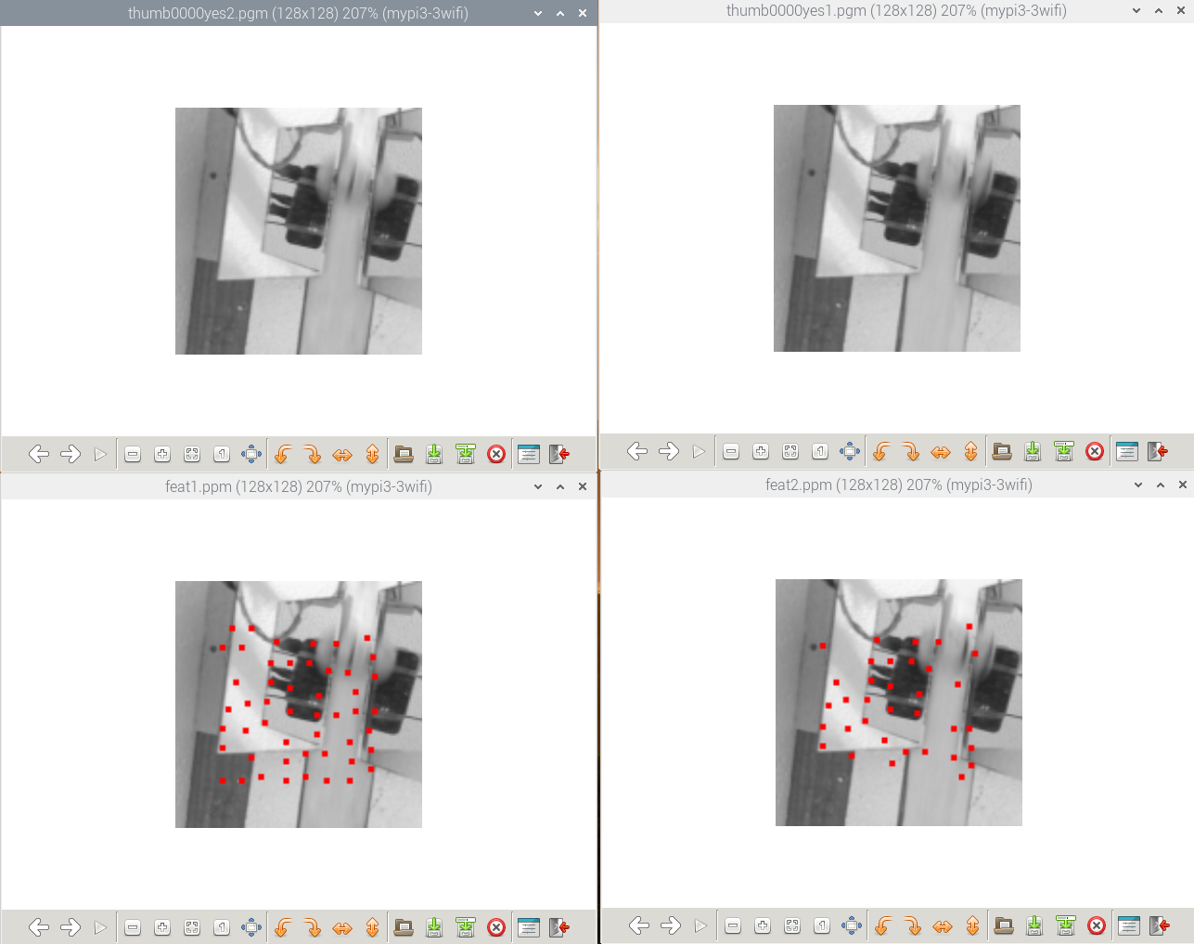

Modified example1.c to use thumb0000yes2.pgm and thumb0000yes1.pgm

feat1.txt
Feel free to place comments here.

!!!!!!!!!!!!!!!!!!!!!!!!!!!!!!!!!!!!!!!!!!!!!!!!!!!!!!!!!!!!!!!!!!!!!!!!!
!!! Warning: This is a KLT data file. Do not modify below this line !!!

------------------------------
KLT Feature List
------------------------------

nFeatures = 100

feature | (x,y)=val
--------+-----------------
0 | ( 59, 42)=12951
1 | ( 71, 32)=11510
2 | ( 49, 52)=11472
3 | ( 59, 67)=10930
4 | ( 39, 91)=10416
5 | (100, 77)= 9166
6 | ( 73, 69)= 8837
7 | ( 24, 86)= 8779
8 | ( 52, 31)= 7268
9 | ( 49, 42)= 5364
10 | ( 74, 59)= 3307
11 | ( 67, 89)= 2881
12 | (101, 87)= 2445
13 | ( 83, 32)= 1920
14 | (102, 39)= 1830
15 | (101, 97)= 1785
16 | (103, 49)= 1728
17 | ( 59, 55)= 1637
18 | (103, 67)= 1183
19 | ( 46, 73)= 1097
20 | ( 79, 46)= 1035
21 | ( 69, 42)= 974
22 | ( 47, 62)= 929
23 | ( 89, 47)= 928
24 | ( 99, 29)= 804
25 | ( 39, 24)= 781
26 | ( 34,103)= 731
27 | ( 57, 83)= 470
28 | ( 31, 52)= 415
29 | ( 24, 34)= 256
30 | ( 73, 79)= 253
31 | ( 24, 76)= 232
32 | ( 93, 57)= 121
33 | ( 27, 66)= 121
34 | ( 29, 24)= 93
35 | ( 91, 93)= 60
36 | ( 24,103)= 57
37 | ( 36, 77)= 54
38 | ( 77, 89)= 42
39 | ( 67,101)= 33
40 | ( 34, 34)= 24
41 | ( 44,101)= 23
42 | ( 90,103)= 23
43 | ( 78,103)= 19
44 | ( 93, 67)= 15
45 | ( 57, 93)= 8
46 | ( 90, 83)= 7
47 | ( 57,103)= 7
48 | ( 37, 63)= 2
49 | ( 83, 69)= 2
50 | ( -1, -1)= -1
51 | ( -1, -1)= -1
52 | ( -1, -1)= -1
53 | ( -1, -1)= -1
54 | ( -1, -1)= -1
55 | ( -1, -1)= -1
56 | ( -1, -1)= -1
57 | ( -1, -1)= -1
58 | ( -1, -1)= -1
59 | ( -1, -1)= -1
60 | ( -1, -1)= -1
61 | ( -1, -1)= -1
62 | ( -1, -1)= -1
63 | ( -1, -1)= -1
64 | ( -1, -1)= -1
65 | ( -1, -1)= -1
66 | ( -1, -1)= -1
67 | ( -1, -1)= -1
68 | ( -1, -1)= -1
69 | ( -1, -1)= -1
70 | ( -1, -1)= -1
71 | ( -1, -1)= -1
72 | ( -1, -1)= -1
73 | ( -1, -1)= -1
74 | ( -1, -1)= -1
75 | ( -1, -1)= -1
76 | ( -1, -1)= -1
77 | ( -1, -1)= -1
78 | ( -1, -1)= -1
79 | ( -1, -1)= -1
80 | ( -1, -1)= -1
81 | ( -1, -1)= -1
82 | ( -1, -1)= -1
83 | ( -1, -1)= -1
84 | ( -1, -1)= -1
85 | ( -1, -1)= -1
86 | ( -1, -1)= -1
87 | ( -1, -1)= -1
88 | ( -1, -1)= -1
89 | ( -1, -1)= -1
90 | ( -1, -1)= -1
91 | ( -1, -1)= -1
92 | ( -1, -1)= -1
93 | ( -1, -1)= -1
94 | ( -1, -1)= -1
95 | ( -1, -1)= -1
96 | ( -1, -1)= -1
97 | ( -1, -1)= -1
98 | ( -1, -1)= -1
99 | ( -1, -1)= -1

feat2.txt
Feel free to place comments here.

!!!!!!!!!!!!!!!!!!!!!!!!!!!!!!!!!!!!!!!!!!!!!!!!!!!!!!!!!!!!!!!!!!!!!!!!!
!!! Warning: This is a KLT data file. Do not modify below this line !!!

------------------------------
KLT Feature List
------------------------------

nFeatures = 100

feature | (x,y)=val
--------+---------------------
0 | ( 58.8, 41.9)= 0
1 | ( 71.7, 31.9)= 0
2 | ( 48.8, 52.0)= 0
3 | ( 58.9, 67.0)= 0
4 | ( 39.1, 90.9)= 0
5 | (100.0, 77.1)= 0
6 | ( 73.0, 69.1)= 0
7 | ( 24.1, 85.9)= 0
8 | ( 51.9, 30.9)= 0
9 | ( 49.0, 41.9)= 0
10 | ( 74.0, 59.1)= 0
11 | ( 67.1, 88.8)= 0
12 | (101.0, 86.9)= 0
13 | ( 83.7, 31.9)= 0
14 | (102.8, 38.2)= 0
15 | (101.3, 96.2)= 0
16 | ( -1.0, -1.0)= -4
17 | ( 58.9, 55.0)= 0
18 | ( -1.0, -1.0)= -4
19 | ( 45.9, 73.2)= 0
20 | ( 78.7, 45.7)= 0
21 | ( 69.6, 41.8)= 0
22 | ( 46.9, 62.3)= 0
23 | ( -1.0, -1.0)= -5
24 | (100.3, 24.0)= 0
25 | ( -1.0, -1.0)= -4
26 | ( -1.0, -1.0)= -4
27 | ( 56.4, 83.0)= 0
28 | ( 31.0, 52.9)= 0
29 | ( 24.1, 33.9)= 0
30 | ( -1.0, -1.0)= -3
31 | ( 24.1, 75.6)= 0
32 | ( 93.8, 54.0)= 0
33 | ( 27.2, 65.4)= 0
34 | ( -1.0, -1.0)= -4
35 | ( 92.4, 92.2)= 0
36 | ( -1.0, -1.0)= -4
37 | ( 36.7, 76.6)= 0
38 | ( 76.7, 88.6)= 0
39 | ( -1.0, -1.0)= -4
40 | ( -1.0, -1.0)= -3
41 | ( -1.0, -1.0)= -4
42 | ( 96.3,102.3)= 0
43 | ( -1.0, -1.0)= -3
44 | ( -1.0, -1.0)= -3
45 | ( 59.7, 94.7)= 0
46 | ( 91.6, 77.4)= 0
47 | ( -1.0, -1.0)= -4
48 | ( 35.9, 62.4)= 0
49 | ( -1.0, -1.0)= -3
50 | ( -1.0, -1.0)= -1
51 | ( -1.0, -1.0)= -1
52 | ( -1.0, -1.0)= -1
53 | ( -1.0, -1.0)= -1
54 | ( -1.0, -1.0)= -1
55 | ( -1.0, -1.0)= -1
56 | ( -1.0, -1.0)= -1
57 | ( -1.0, -1.0)= -1
58 | ( -1.0, -1.0)= -1
59 | ( -1.0, -1.0)= -1
60 | ( -1.0, -1.0)= -1
61 | ( -1.0, -1.0)= -1
62 | ( -1.0, -1.0)= -1
63 | ( -1.0, -1.0)= -1
64 | ( -1.0, -1.0)= -1
65 | ( -1.0, -1.0)= -1
66 | ( -1.0, -1.0)= -1
67 | ( -1.0, -1.0)= -1
68 | ( -1.0, -1.0)= -1
69 | ( -1.0, -1.0)= -1
70 | ( -1.0, -1.0)= -1
71 | ( -1.0, -1.0)= -1
72 | ( -1.0, -1.0)= -1
73 | ( -1.0, -1.0)= -1
74 | ( -1.0, -1.0)= -1
75 | ( -1.0, -1.0)= -1
76 | ( -1.0, -1.0)= -1
77 | ( -1.0, -1.0)= -1
78 | ( -1.0, -1.0)= -1
79 | ( -1.0, -1.0)= -1
80 | ( -1.0, -1.0)= -1
81 | ( -1.0, -1.0)= -1
82 | ( -1.0, -1.0)= -1
83 | ( -1.0, -1.0)= -1
84 | ( -1.0, -1.0)= -1
85 | ( -1.0, -1.0)= -1
86 | ( -1.0, -1.0)= -1
87 | ( -1.0, -1.0)= -1
88 | ( -1.0, -1.0)= -1
89 | ( -1.0, -1.0)= -1
90 | ( -1.0, -1.0)= -1
91 | ( -1.0, -1.0)= -1
92 | ( -1.0, -1.0)= -1
93 | ( -1.0, -1.0)= -1
94 | ( -1.0, -1.0)= -1
95 | ( -1.0, -1.0)= -1
96 | ( -1.0, -1.0)= -1
97 | ( -1.0, -1.0)= -1
98 | ( -1.0, -1.0)= -1
99 | ( -1.0, -1.0)= -1
end of feat.txt

***********Draft***********
Principal component analysis (PCA)
08/29/19
***********Draft***********

Principal component analysis (PCA) is a statistical procedure that uses an
orthogonal transformation to convert a set of observations of possibly
correlated variables (entities each of which takes on various numerical
values) into a set of values of linearly uncorrelated variables called
principal components.

Machine Learning — Singular Value Decomposition (SVD) & Principal Component Analysis (PCA)

Analysis of 4 images 2 cracked and 2 not cracked. The (SVD) or (PCA) does appears to track
that pistachios that are cracked do have a higher (PCA) than pistachios that are
not cracked.
Thumb0000yes1.bmp

thumb0000no1.bmp

Thumb0000yes2.bmp

thumb0000n2.bmp

thumb0000yes1.bmp thumb0000no1.bmp thumb0000yes2.bmp thumb0000n2.bmp
pca1(1:20)
ans =

2.5118e+04 2.4510e+04 2.5212e+04 2.4252e+04
4.1047e+03
1.7342e+03
1.3414e+03
1.3223e+03
1.0863e+03
8.6049e+02
7.6984e+02
6.8771e+02
6.0650e+02
5.2599e+02
4.5459e+02
4.4436e+02
3.8315e+02
3.7725e+02
3.3203e+02
3.1981e+02
2.7991e+02
2.7412e+02
2.5770e+02

pca2(1:20)
ans =

2.0217e+04 1.9552e+04 2.0434e+04 1.9248e+04
3.8104e+03
1.5775e+03
1.3825e+03
1.1628e+03
1.0376e+03
7.8174e+02
7.4592e+02
6.8873e+02
5.8089e+02
5.1885e+02
4.6897e+02
4.5024e+02
4.0410e+02
3.6088e+02
3.2620e+02
3.0089e+02
2.8690e+02
2.6073e+02
2.4677e+02

pca3(1:20)
ans =

1.3455e+04 1.2802e+04 1.3600e+04 1.2537e+04
2.7543e+03
1.2505e+03
1.0014e+03
8.8897e+02
7.7139e+02
6.2903e+02
5.8134e+02
5.3249e+02
4.6860e+02
4.0902e+02
3.9088e+02
3.6356e+02
3.4791e+02
3.0013e+02
2.6766e+02
2.5222e+02
2.3809e+02
2.1705e+02
2.0159e+02

thumb0000no1.bmp
pca1(1:20)
ans =

2.4510e+04
4.0433e+03
1.9649e+03
1.4272e+03
1.3475e+03
9.9684e+02
8.2375e+02
7.9589e+02
6.8341e+02
5.8102e+02
5.0413e+02
4.6857e+02
4.2710e+02
4.0367e+02
3.7746e+02
3.4601e+02
3.3557e+02
2.9683e+02
2.8394e+02
2.5602e+02

pca2(1:20)
ans =

1.9552e+04
3.6803e+03
1.6822e+03
1.4549e+03
1.1840e+03
9.1180e+02
7.5005e+02
7.1683e+02
6.8642e+02
5.3968e+02
4.8279e+02
4.4007e+02
4.3046e+02
4.0756e+02
3.5801e+02
3.3369e+02
3.1684e+02
2.8013e+02
2.6143e+02
2.4284e+02

pca3(1:20)
ans =

1.2802e+04
2.6358e+03
1.2603e+03
1.1070e+03
8.7383e+02
7.0593e+02
5.8519e+02
5.8225e+02
5.2708e+02
4.2259e+02
3.9897e+02
3.7471e+02
3.5758e+02
3.3290e+02
3.1216e+02
2.7739e+02
2.5960e+02
2.3723e+02
2.1209e+02
2.0476e+02

thumb0000yes2.bmp
pca1(1:20)
ans =

2.5212e+04
4.0210e+03
1.8347e+03
1.4258e+03
1.3558e+03
1.0733e+03
8.3836e+02
7.6427e+02
6.8187e+02
6.1109e+02
5.2345e+02
4.8893e+02
4.5993e+02
4.1018e+02
4.0371e+02
3.5510e+02
3.3618e+02
2.9982e+02
2.6943e+02
2.5862e+02

pca2(1:20)
ans =

2.0434e+04
3.7564e+03
1.6314e+03
1.4176e+03
1.2380e+03
1.0131e+03
7.6505e+02
7.4708e+02
6.7221e+02
5.7194e+02
5.2257e+02
4.7293e+02
4.6234e+02
4.2547e+02
3.7508e+02
3.3221e+02
3.3095e+02
2.8798e+02
2.6839e+02
2.5635e+02

pca3(1:20)
ans =

1.3600e+04
2.7226e+03
1.2751e+03
1.0553e+03
9.2998e+02
7.9118e+02
6.0423e+02
5.9610e+02
5.1626e+02
4.6031e+02
4.2646e+02
4.0938e+02
3.8739e+02
3.5952e+02
3.1919e+02
2.8066e+02
2.6825e+02
2.4342e+02
2.2798e+02
2.1238e+02

thumb0000n2.bmp

pca1(1:20)
ans =

2.4252e+04
4.3798e+03
1.6566e+03
1.4539e+03
1.2313e+03
9.4545e+02
8.6362e+02
7.0752e+02
6.3207e+02
5.8339e+02
5.0927e+02
4.6314e+02
4.3968e+02
3.7103e+02
3.2726e+02
3.1503e+02
2.9399e+02
2.7929e+02
2.6932e+02
2.6126e+02

>> pca2(1:20)
ans =

1.9248e+04
3.8751e+03
1.6063e+03
1.3434e+03
1.0795e+03
8.8676e+02
7.6481e+02
6.9949e+02
5.9415e+02
5.6022e+02
4.9497e+02
4.3213e+02
4.0966e+02
3.5401e+02
3.1833e+02
2.9621e+02
2.8560e+02
2.7431e+02
2.5903e+02
2.4629e+02

>> pca3(1:20)
ans =

1.2537e+04
2.7423e+03
1.2570e+03
1.0034e+03
7.9929e+02
6.7685e+02
5.8549e+02
5.6615e+02
4.7492e+02
4.3317e+02
4.0130e+02
3.5044e+02
3.3603e+02
3.0458e+02
2.7552e+02
2.5449e+02
2.4492e+02
2.2631e+02
2.1090e+02
2.0487e+02

