Simulations with iverilog and for testing HDL designs

A test verilog code is used to test the design (see counter_tb.v & counter_tb_vcd.v below).
File counter.v

module counter(out, clk, reset);

parameter WIDTH = 8;

output [WIDTH-1 : 0] out;
input clk, reset;

reg [WIDTH-1 : 0] out;
wire clk, reset;

always @(posedge clk)
out <= out + 1;

always @reset
if (reset)
assign out = 0;
else
deassign out;

endmodule // counter

File counter_tb.v
module test;

/* Make a reset that pulses once. */
reg reset = 0;
initial begin
# 17 reset = 1;
# 11 reset = 0;
# 29 reset = 1;
# 11 reset = 0;
# 100 $stop;
end

/* Make a regular pulsing clock. */
reg clk = 0;
always #5 clk = !clk;

wire [7:0] value;
counter c1 (value, clk, reset);

initial
$monitor("At time %t, value = %h (%0d)",
$time, value, value);
endmodule // test
The following command “iverilog -o my_design counter_tb.v counter.v” creates the “my_design”. In Appendix A. File generated with the iverilog command “iverilog -o my_design counter_tb.v counter.v” is found.
The following command “vvp my_design” will simulate the counter.v verilog file.
At time 0, value = xx (x)

At time 17, value = 00 (0)

At time 35, value = 01 (1)

At time 45, value = 02 (2)

At time 55, value = 03 (3)

At time 57, value = 00 (0)

At time 75, value = 01 (1)

At time 85, value = 02 (2)

At time 95, value = 03 (3)

At time 105, value = 04 (4)

At time 115, value = 05 (5)

At time 125, value = 06 (6)

At time 135, value = 07 (7)

At time 145, value = 08 (8)

At time 155, value = 09 (9)

At time 165, value = 0a (10)

** VVP Stop(0) **

** Flushing output streams.

** Current simulation time is 168 ticks.

Adding a few lines to the file counter_tb.v to dump the results to a vcd file that can be used with GTKWave.
initial
begin
$dumpfile("test.vcd");
$dumpvars(0,test);
end

The file counter_tb_vcd.v
module test;
initial
begin
$dumpfile("test.vcd");
$dumpvars(0,test);
end

/* Make a reset that pulses once. */
reg reset = 0;
initial begin
# 17 reset = 1;
# 11 reset = 0;
# 29 reset = 1;
# 11 reset = 0;
# 100 $stop;
end

/* Make a regular pulsing clock. */
reg clk = 0;
always #5 clk = !clk;

wire [7:0] value;
counter c1 (value, clk, reset);

initial
$monitor("At time %t, value = %h (%0d)",
$time, value, value);
endmodule // test

The following command “iverilog -o my_design_vcd counter_tb_vcd.v counter.v” creates the “my_design_vcd”. In Appendix B. File generated with the iverilog command “iverilog -o my_design_vcd counter_tb_vcd.v counter.v” is found.

Now the results of the simulation can be viewed with GTKWave.

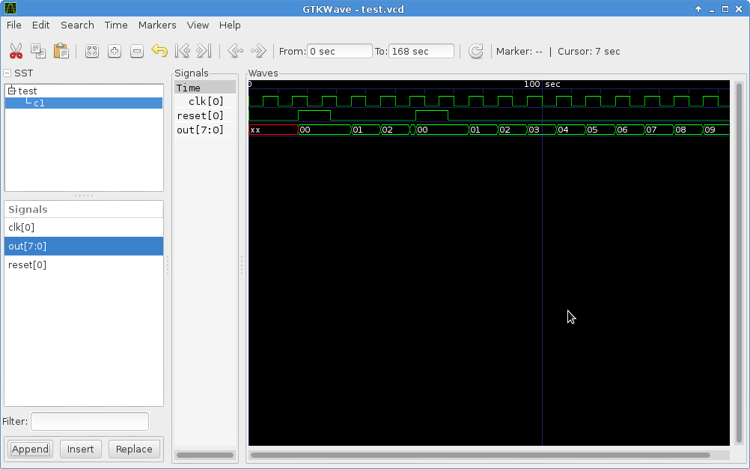
Appendix A. File generated with the iverilog command “iverilog -o my_design counter_tb.v counter.v”.

#! /usr/local/bin/vvp
:ivl_version "0.9.7 " "(v0_9_7-7-g9b38de5)";
:vpi_time_precision + 0;
:vpi_module "system";
:vpi_module "v2005_math";
:vpi_module "va_math";
S_0x1edd730 .scope module, "test" "test" 2 1;
.timescale 0 0;
v0x1f112a0_0 .var "clk", 0 0;
v0x1f11370_0 .var "reset", 0 0;
v0x1f11420_0 .net "value", 7 0, v0x1f11160_0; 1 drivers
S_0x1f01060 .scope module, "c1" "counter" 2 18, 3 1, S_0x1edd730;
.timescale 0 0;
P_0x1eff2c8 .param/l "WIDTH" 3 3, +C4<01000>;
v0x1f01180_0 .net "clk", 0 0, v0x1f112a0_0; 1 drivers
v0x1f11160_0 .var "out", 7 0;
v0x1f11200_0 .net "reset", 0 0, v0x1f11370_0; 1 drivers
E_0x1edd3a0 .event edge, v0x1f11200_0;
E_0x1f01150 .event posedge, v0x1f01180_0;
.scope S_0x1f01060;
T_0 ;
%wait E_0x1f01150;
%load/v 8, v0x1f11160_0, 8;
%mov 16, 0, 24;
%addi 8, 1, 32;
%ix/load 0, 8, 0;
%assign/v0 v0x1f11160_0, 0, 8;
%jmp T_0;
.thread T_0;
.scope S_0x1f01060;
T_1 ;
%wait E_0x1edd3a0;
%load/v 8, v0x1f11200_0, 1;
%jmp/0xz T_1.0, 8;
%cassign/v v0x1f11160_0, 0, 8;
%jmp T_1.1;
T_1.0 ;
%deassign v0x1f11160_0, 0, 8;
T_1.1 ;
%jmp T_1;
.thread T_1, $push;
.scope S_0x1edd730;
T_2 ;
%set/v v0x1f11370_0, 0, 1;
%end;
.thread T_2;
.scope S_0x1edd730;
T_3 ;
%delay 17, 0;
%set/v v0x1f11370_0, 1, 1;
%delay 11, 0;
%set/v v0x1f11370_0, 0, 1;
%delay 29, 0;
%set/v v0x1f11370_0, 1, 1;
%delay 11, 0;
%set/v v0x1f11370_0, 0, 1;
%delay 100, 0;
%vpi_call 2 10 "$stop";
%end;
.thread T_3;
.scope S_0x1edd730;
T_4 ;
%set/v v0x1f112a0_0, 0, 1;
%end;
.thread T_4;
.scope S_0x1edd730;
T_5 ;
%delay 5, 0;
%load/v 8, v0x1f112a0_0, 1;
%inv 8, 1;
%set/v v0x1f112a0_0, 8, 1;
%jmp T_5;
.thread T_5;
.scope S_0x1edd730;
T_6 ;
%vpi_call 2 21 "$monitor", "At time %t, value = %h (%0d)", $time, v0x1f11420_0, v0x1f11420_0;
%end;
.thread T_6;
# The file index is used to find the file name in the following table.
:file_names 4;
"N/A";
"<interactive>";
"counter_tb.v";
"counter.v";

Appendix B. File generated with the iverilog command “iverilog -o my_design_vcd counter_tb_vcd.v counter.v”.

#! /usr/local/bin/vvp
:ivl_version "0.9.7 " "(v0_9_7-7-g9b38de5)";
:vpi_time_precision + 0;
:vpi_module "system";
:vpi_module "v2005_math";
:vpi_module "va_math";
S_0x237fab0 .scope module, "test" "test" 2 1;
.timescale 0 0;
v0x23b3ab0_0 .var "clk", 0 0;
v0x23b3b80_0 .var "reset", 0 0;
v0x23b3c30_0 .net "value", 7 0, v0x23b3970_0; 1 drivers
S_0x23a3510 .scope module, "c1" "counter" 2 23, 3 1, S_0x237fab0;
.timescale 0 0;
P_0x23a1778 .param/l "WIDTH" 3 3, +C4<01000>;
v0x23a3630_0 .net "clk", 0 0, v0x23b3ab0_0; 1 drivers
v0x23b3970_0 .var "out", 7 0;
v0x23b3a10_0 .net "reset", 0 0, v0x23b3b80_0; 1 drivers
E_0x237f720 .event edge, v0x23b3a10_0;
E_0x23a3600 .event posedge, v0x23a3630_0;
.scope S_0x23a3510;
T_0 ;
%wait E_0x23a3600;
%load/v 8, v0x23b3970_0, 8;
%mov 16, 0, 24;
%addi 8, 1, 32;
%ix/load 0, 8, 0;
%assign/v0 v0x23b3970_0, 0, 8;
%jmp T_0;
.thread T_0;
.scope S_0x23a3510;
T_1 ;
%wait E_0x237f720;
%load/v 8, v0x23b3a10_0, 1;
%jmp/0xz T_1.0, 8;
%cassign/v v0x23b3970_0, 0, 8;
%jmp T_1.1;
T_1.0 ;
%deassign v0x23b3970_0, 0, 8;
T_1.1 ;
%jmp T_1;
.thread T_1, $push;
.scope S_0x237fab0;
T_2 ;
%vpi_call 2 4 "$dumpfile", "test.vcd";
%vpi_call 2 5 "$dumpvars", 1'sb0, S_0x237fab0;
%end;
.thread T_2;
.scope S_0x237fab0;
T_3 ;
%set/v v0x23b3b80_0, 0, 1;
%end;
.thread T_3;
.scope S_0x237fab0;
T_4 ;
%delay 17, 0;
%set/v v0x23b3b80_0, 1, 1;
%delay 11, 0;
%set/v v0x23b3b80_0, 0, 1;
%delay 29, 0;
%set/v v0x23b3b80_0, 1, 1;
%delay 11, 0;
%set/v v0x23b3b80_0, 0, 1;
%delay 100, 0;
%vpi_call 2 15 "$stop";
%end;
.thread T_4;
.scope S_0x237fab0;
T_5 ;
%set/v v0x23b3ab0_0, 0, 1;
%end;
.thread T_5;
.scope S_0x237fab0;
T_6 ;
%delay 5, 0;
%load/v 8, v0x23b3ab0_0, 1;
%inv 8, 1;
%set/v v0x23b3ab0_0, 8, 1;
%jmp T_6;
.thread T_6;
.scope S_0x237fab0;
T_7 ;
%vpi_call 2 26 "$monitor", "At time %t, value = %h (%0d)", $time, v0x23b3c30_0, v0x23b3c30_0;
%end;
.thread T_7;
# The file index is used to find the file name in the following table.
:file_names 4;
"N/A";
"<interactive>";
"counter_tb_vcd.v";
"counter.v";

