***********************Draft***********************
Icarus Simulator
helloworld simulation
repo 102121icozip
10/10/23

***********************Draft***********************

The helloworld_tb.v needs to be created. See catboard-relook/doc/iverilog/helloworld_tb.v

devel@pi4-20:~ $ cd 102121icozip/rtl/uart/

devel@pi4-20:~/102121icozip/rtl/uart $ iverilog -o dsn helloworld_tb.v helloworld.v
The following
initial
begin
#1920000
$finish();
end

devel@pi4-20:~/102121icozip/rtl/uart $ vvp dsn
VCD info: dumpfile helloworld.vcd opened for output.
devel@pi4-20:~/102121icozip/rtl/uart $

devel@pi4-20:~/102121icozip/rtl/uart $ vvp dsn
VCD info: dumpfile helloworld.vcd opened for output.
Killed

devel@pi4-20:~ $ kill -9 9093

devel@pi4-20:~/102121icozip/rtl/uart $ gtkwave helloworld.vcd

GTKWave Analyzer v3.3.104 (w)1999-2020 BSI

[0] start time.
[1920000000] end time.

devel@pi4-20:~/102121icozip/rtl/uart $ gtkwave helloworld.vcd

GTKWave Analyzer v3.3.104 (w)1999-2020 BSI

Near byte 57770007, Unknown VCD identifier: '11101100101000010010'
[0] start time.
[9697700] end time.

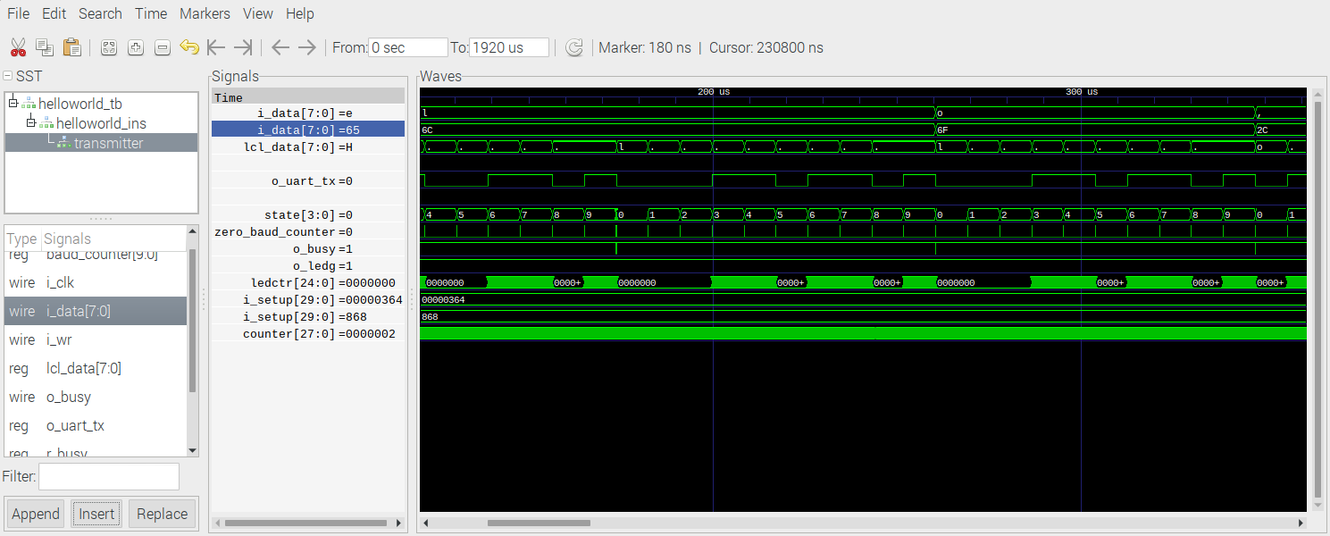
The above image has time where as the image below time is unknown.

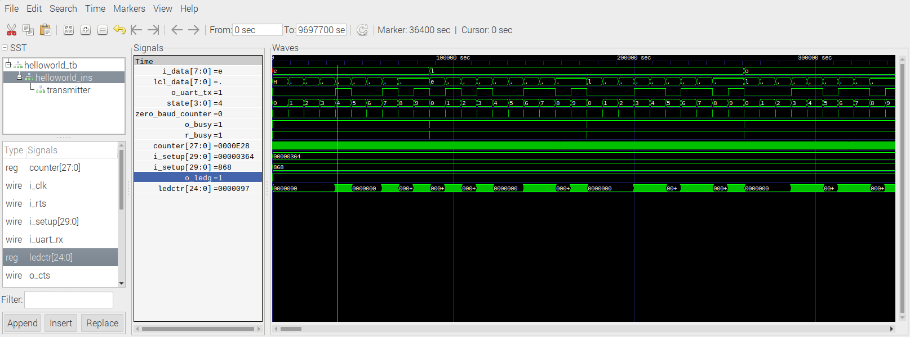
i_setup is 0x364 or 868 is for a baudrate 115200.

100000000 | 115200 | 868.055555555556
100000000 | 230400 | 434.027777777778
100000000 | 345600 | 289.351851851852
100000000 | 460800 | 217.013888888889
100000000 | 921600 | 108.506944444444
100000000 | 1843200 | 54.2534722222222

state is 0-9 for the 10 bits to transmit 1 ASCII chacter.

devel@pi4-20:~/102121icozip/rtl/uart $ git diff helloworld.pcf
diff --git a/rtl/uart/helloworld.pcf b/rtl/uart/helloworld.pcf
index 8337466..b12f38f 100644
--- a/rtl/uart/helloworld.pcf
+++ b/rtl/uart/helloworld.pcf
@@ -13,6 +13,6 @@ set_io o_ledg A9 #IOT_194 LED1
#set_io o_ledr B7 #IOT_207 LED4

set_io i_rts A1 #IOT_220 PM2-A1 i_rts
-set_io o_uart_tx B3 #IOT_214 PM2-A3
-set_io i_uart_rx B5 #IOT_223 PM2-A2
+set_io o_uart_tx B3 #IOT_214 PM2-A2
+set_io i_uart_rx B5 #IOT_223 PM2-A3
set_io o_cts B6 #IOT_208 PM2-A4 o_cts

