*************************Default*************************
01/26/24
jpeg lifting lo & hi pass filters

*************************Default*************************
cd virtual-python-xstools/

python3 -m venv env ; source env/bin/activate

cd SDRAM_Controller/wkg/

python3 jpeg.py

// File: jpeg.v
// Generated by MyHDL 0.11.43
// Date: Fri Jan 26 17:36:41 2024

`timescale 1ns/10ps

module jpeg (
clk,
l_s,
r_s,
s_s,
res_s,
lohipass,
fwd_inv,
ex
);

input clk;
input signed [15:0] l_s;
input signed [15:0] r_s;
input signed [15:0] s_s;
output signed [15:0] res_s;
reg signed [15:0] res_s;
input lohipass;
input fwd_inv;
input ex;

// lohipass 1 lo 0 hi pass filter
// fwd_inv 1 fwd 0 inv
always @(posedge clk) begin: JPEG_JPEG_HDL
if (ex) begin
if (lohipass) begin
if (fwd_inv) begin
res_s <= (s_s - ($signed(l_s >>> 1) + $signed(r_s >>> 1)));
end
else begin
res_s <= (s_s + ($signed(l_s >>> 1) + $signed(r_s >>> 1)));
end
end
else begin
if (fwd_inv) begin
res_s <= (s_s + $signed(((l_s + r_s) + 2) >>> 2));
end
else begin
res_s <= (s_s - $signed(((l_s + r_s) + 2) >>> 2));
end
end
end
end

endmodule

module tb_jpeg;

reg clk;
reg [15:0] l_s;
reg [15:0] r_s;
reg [15:0] s_s;
wire [15:0] res_s;
reg lohipass;
reg fwd_inv;
reg ex;

always #5 clk = (clk === 1'b0);

jpeg dut(
clk,
l_s,
r_s,
s_s,
res_s,
lohipass,
fwd_inv,
ex
);

initial
begin
# 100 ex = 0;
# 200 lohipass = 1;

# 200 l_s = 215;
# 1 s_s = 216;
# 1 r_s = 217;
# 210 lohipass = 1;
# 1 fwd_inv = 1;
# 1 ex = 1;
# 10 s_s = res_s;
# 10 fwd_inv = 0;
//# 10 lohipass = 0;
# 20 ex = 0;
//# 320 s_s = res_s;

# 1 ex = 1;
# 20 ex = 0;
# 400 s_s = 216;
# 410 lohipass = 0;
# 1 fwd_inv = 1;
# 1 ex = 1;
# 450 s_s = res_s;
# 10 fwd_inv = 0;
end
initial

begin
// Required for EDA Playground
$dumpfile("dump.vcd");
$dumpvars(0);
end
initial
begin
#91000;
$finish();
end
endmodule

iverilog -o dsn -f filelist

vvp dsn

gtkwave dump.vcd
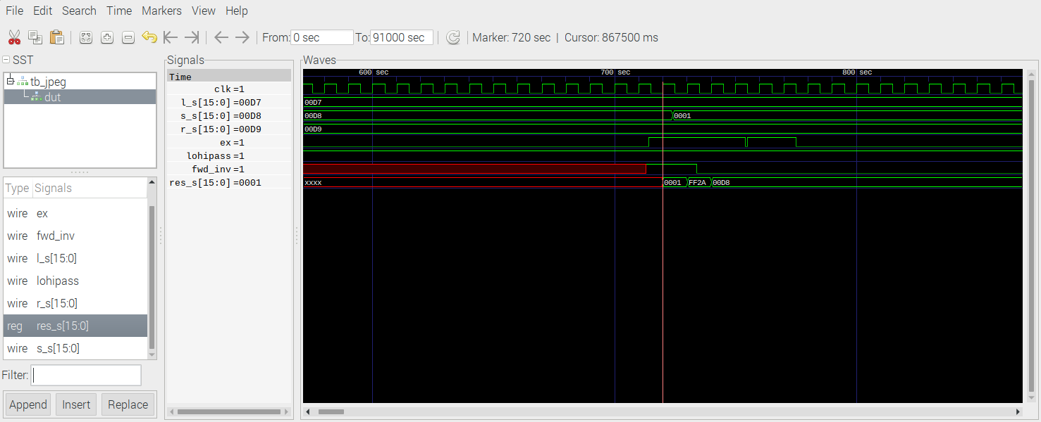
Given 0x00d7, 0xx00d8, & 0x00d9 results 0x0001 lo pass fwd lifting step.
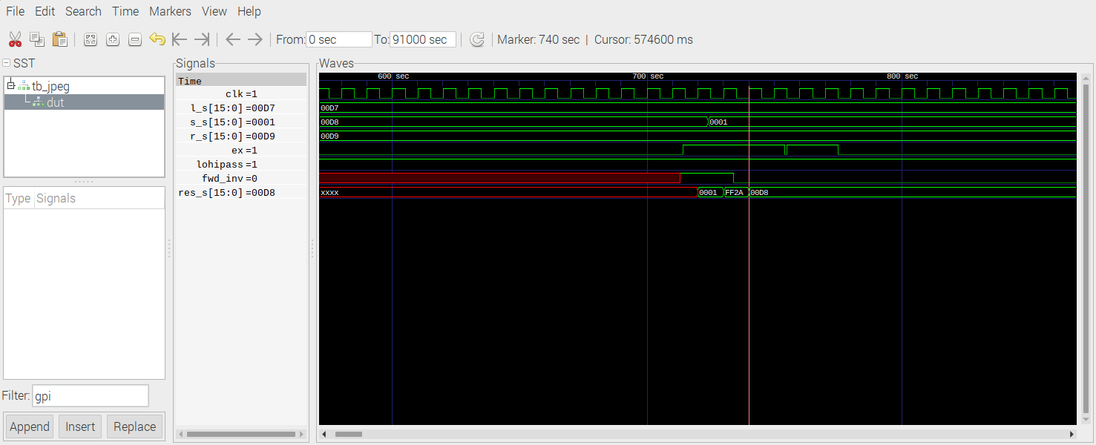

Given 0x00d7, 0x0001, & 0x00d9 results 0x00d8 lo pass inv lifting step.

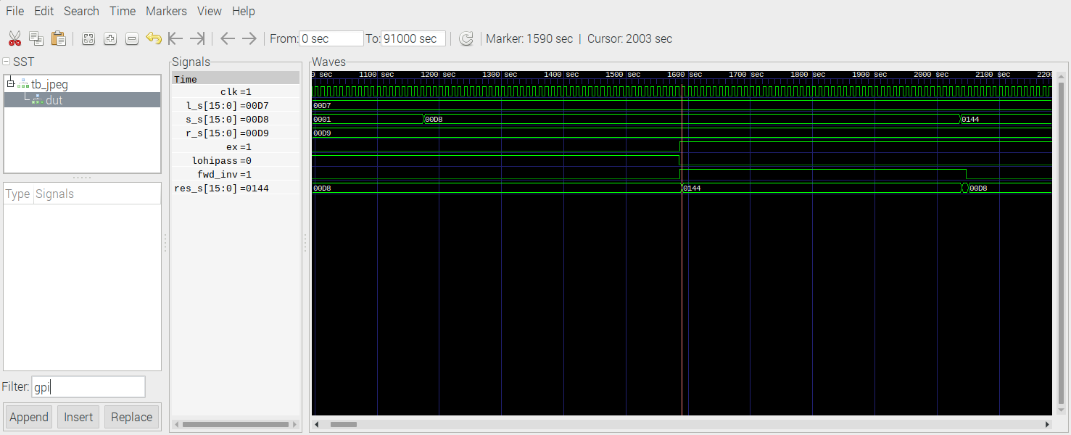
Given 0x00d7, 0x00d8, & 0x00d9 results 0x0144 hi pass fwd lifting step.

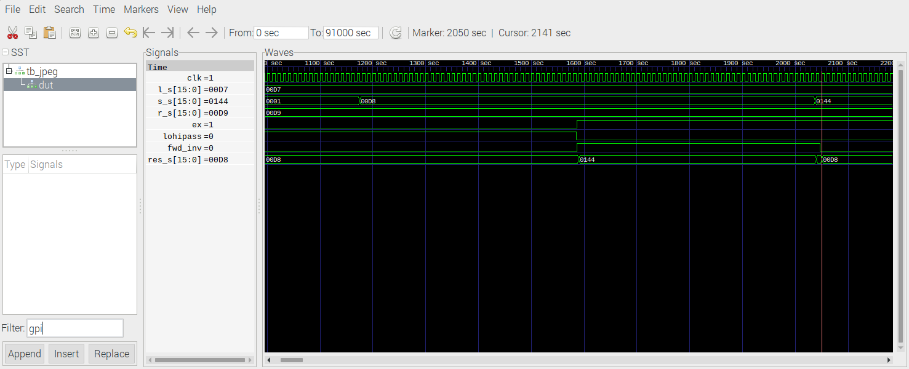
Given 0x00d7, 0x0144, & 0x00d9 results 0x00d8 hi pass inv lifting step.
./buildpi_lift.sh
./pi_jpeg 0 1
buf_red = 0x9eff5010
fwd_inv = 0xbad552a0
spliting red sub band
fwd lifting step only
w = 0x100 buf_red wptr = 0x9eff5010 alt = 0x9f035010 fwd_inverse = 0xbad552a0 fwd_inverse = 0x1
starting red dwt
finished ted dwt
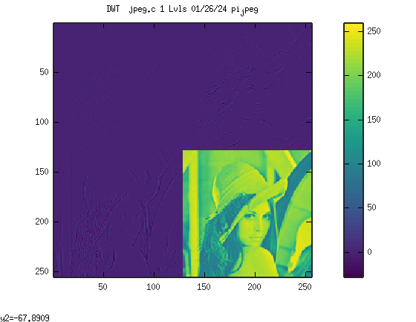
octave
rgb

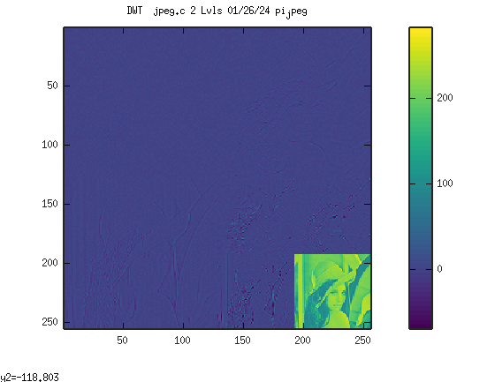
octave
rgb
