04/16/18

MyHDL & RHEA were used to create the initial “catboard.v”, “catboard.pcf”, then with Yosys the “catboard.blif” was created. This was folowed with Arachne-pnr to create the “catboard.txt” and finally Icepack to create the “catboard.bin”.

This was done with the command “python ex_catboard.py” in the folder “pi/rhea/examples/build”.
Created the folder iceriver/
build_iceriver.log catboard.blif catboard.txt catboard.ys catboard.bin catboard.pcf catboard.v

When the FPGA is programmed with the catboard.bin The leds are scrolled on starting at the botton to the top.

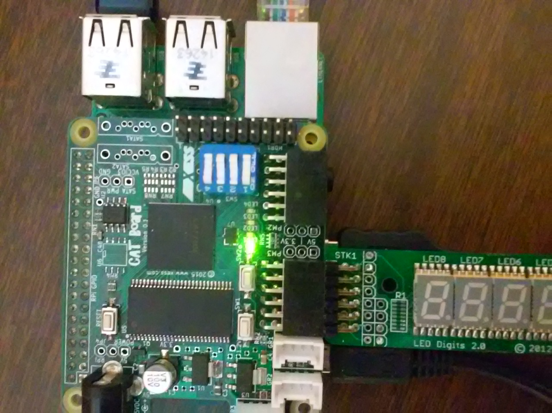

The repository of Jamie Iles https://github.com/jamieiles/uart was forked
to https://github.com/develone/uart.git
The code was based on a 50MHz while the code in catboard.v was driven from the 100 MHz clock on the CATBoard.

The command below creates testbench with the iverilog command using the Verilog files
testbench.v, baud_rate_gen.v, receiver.v, and transmitter.v. The design under test of the “uart.v” module.

“iverilog -Wall testbench.v baud_rate_gen.v receiver.v transmitter.v -o testbench”
The command execute the testbench created with the command above and creates the
file “uart.vcd” which can be viewed using GtkWAVE.
“vvp ./testbench”

RX_ACC_MAX = 50000000 / (115200 * 16)

27.126736111 = 50000000 / 1843200

TX_ACC_MAX = 50000000 / 115200;
434.027777778 = 50000000 / 115200

RX_ACC_WIDTH = $clog2(RX_ACC_MAX)
log(27.126736111)
3.3005

TX_ACC_WIDTH = $clog2(TX_ACC_MAX)
log(434.027777778)
6.0731

The command below is used to view the value change data.

“gtkwave uart.vcd”

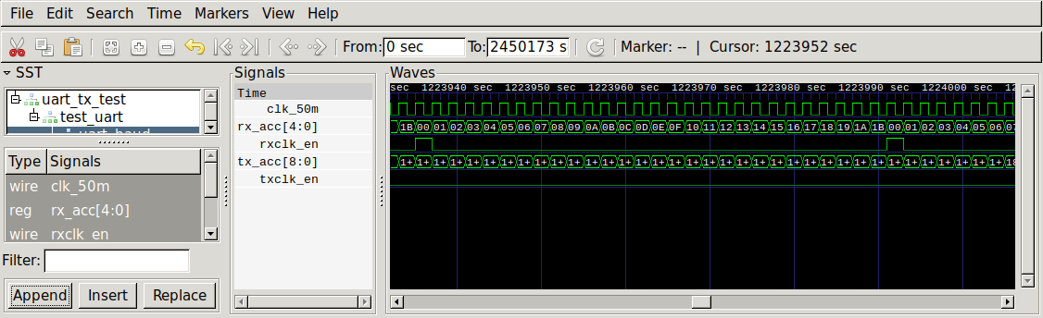
xxx

