********************Draft********************
Hardware Testing Sdram, Bkram, and GPIO
04/12/21
********************Draft********************

- bkram(wx) : ORIGIN = 0x00a00000, LENGTH = 0x00002000
- sdram(wx) : ORIGIN = 0x01000000, LENGTH = 0x00800000
+ bkram(wx) : ORIGIN = 0x01400000, LENGTH = 0x00002000
+ sdram(wx) : ORIGIN = 0x02000000, LENGTH = 0x01000000
The goal with the chg below was trying to fix the above in hopes of getting arm-zipload working.

This chg in auto-data/sdramdev.txt

-@$NADDR=(1<<(@$THIS.LGMEMSZ-3))
+@$NADDR=(1<<(@$THIS.LGMEMSZ-2))
Results in 703 3108 24939 ../NADDR1.txt

In several files.
modified: auto-data/bkram.ld
modified: auto-data/flashram.ld
modified: auto-data/sdram.ld
modified: auto-data/sdram_only.ld
modified: auto-data/sdramdev.txt
modified: doc/hardware-testing.odt
modified: rtl/catzip/builddate.v
modified: rtl/catzip/main.v
modified: sim/verilated/main_tb.cpp
modified: sw/board/board.h
modified: sw/board/board.ld
modified: sw/board/boardram.ld
modified: sw/host/regdefs.h
modified: sw/host/wr.sh
modified: sw/host/wr1.sh
modified: sw/zlib/board.h
With change in sdram required changes in rdsdram.cpp & wrsdram.cpp.
diff --git a/sw/host/wrsdram.cpp b/sw/host/wrsdram.cpp
index 538a1c4..b8a6911 100644
--- a/sw/host/wrsdram.cpp
+++ b/sw/host/wrsdram.cpp
@@ -53,10 +53,10 @@
FPGA *m_fpga;

//#define DUMPMEM SDRAMBASE
-#define DUMPMEM 0x0100f120
+#define DUMPMEM 0x0200f120
//#define DUMPWORDS (FLASHLEN>>2) // 16MB Flash
//#define DUMPWORDS (4000>>2)
-#define DUMPWORDS 65535
+#define DUMPWORDS 65536
void usage(void) {
printf("USAGE:\tdumpflash [-n host] [-p port] filename.bin\n"
"\n"
diff --git a/sw/host/rdsdram.cpp b/sw/host/rdsdram.cpp
index 435eb01..7350a65 100644
--- a/sw/host/rdsdram.cpp
+++ b/sw/host/rdsdram.cpp
@@ -53,10 +53,10 @@
FPGA *m_fpga;

//#define DUMPMEM SDRAMBASE
-#define DUMPMEM 0x0100f120
+#define DUMPMEM 0x0200f120
//#define DUMPWORDS (FLASHLEN>>2) // 16MB Flash
//#define DUMPWORDS (4000>>2)
-#define DUMPWORDS 65535
+#define DUMPWORDS 65536
void usage(void) {
printf("USAGE:\tdumpflash [-n host] [-p port] filename.bin\n"
"\n"
The above changes were tested on hardware. The following 4 images show the write/read to sdram.

sdram1
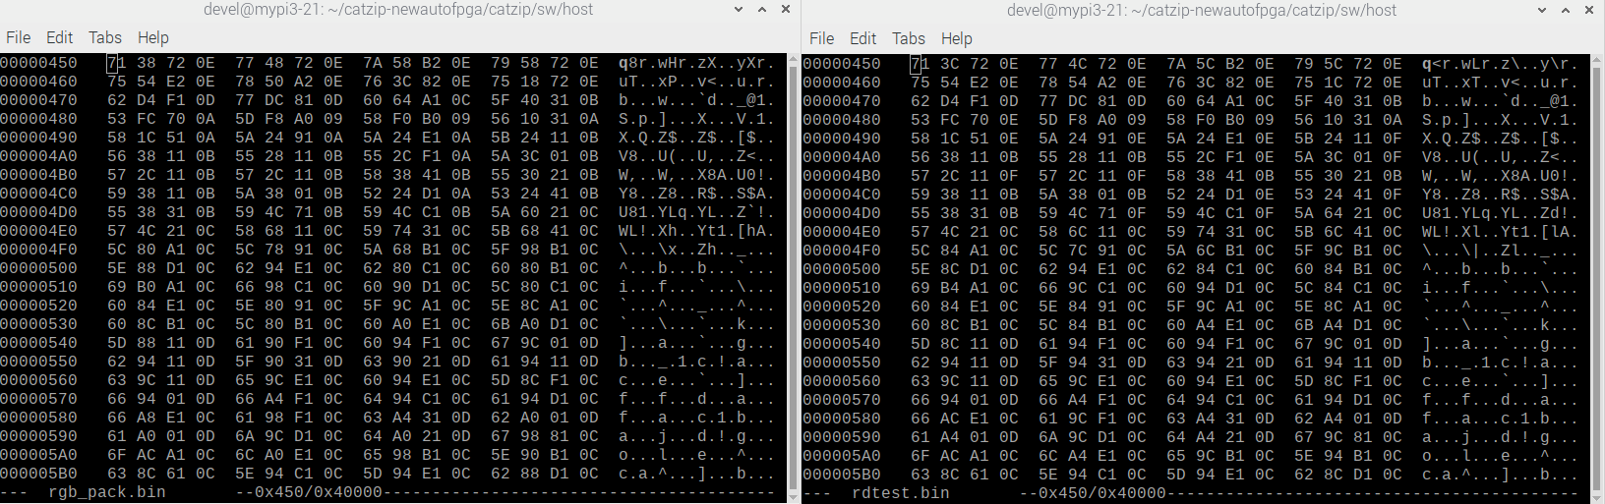
sdram2
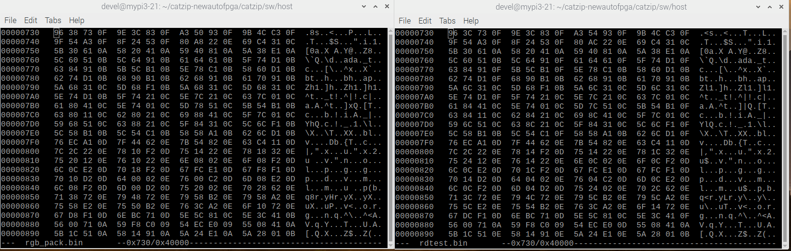
sdram3

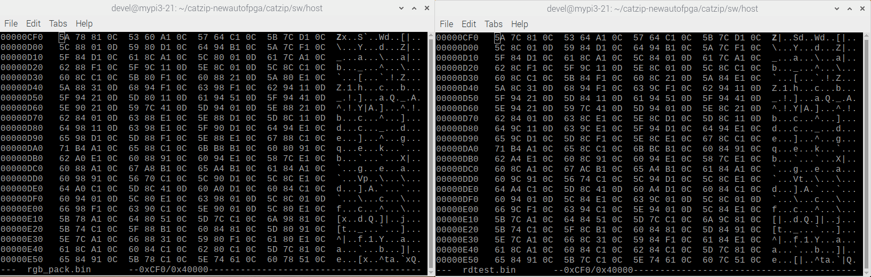
sdram4

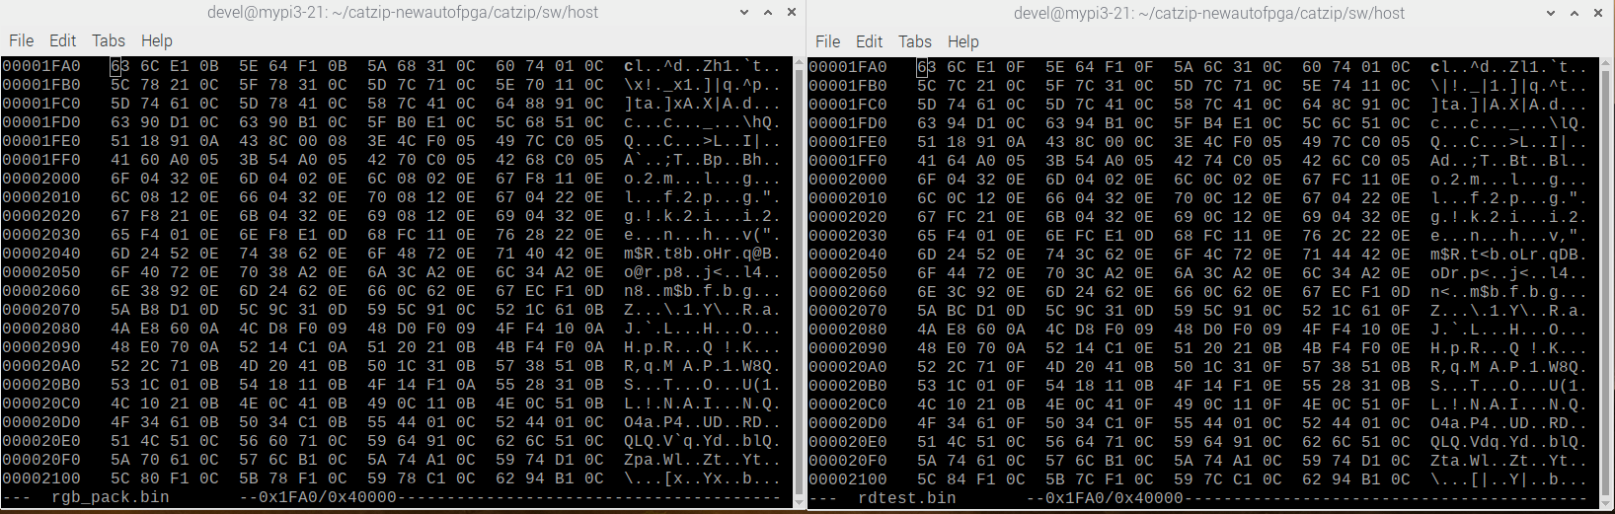

Make a copy of the working software to test on RPi3 with Catboard.

devel@mypi3-16:~/testbuilds $ rsync -avl catzip-newautofpga mypi3-21:~/

devel@mypi3-21:~ $ cd catzip-newautofpga/catzip/sw/host

Program the FPGA using config_cat

devel@mypi3-21:~/catzip-newautofpga/catzip/sw/host $ sudo config_cat ../../rtl/catzip/catzip.bin

GPIO 25 not exported, trying to export...
GPIO 17 not exported, trying to export...
GPIO 22 not exported, trying to export...

OK: SPI driver loaded

Setting GPIO directions
out
out
in
Setting output to low
0
Reseting FPGA
0
1
Checking DONE pin
0
Continuing with configuration procedure
263+1 records in
263+1 records out
135100 bytes (135 kB, 132 KiB) copied, 0.0268802 s, 5.0 MB/s
Setting output to high
1
Checking DONE pin
1
Start the software that listens to local port & a remote port.

devel@mypi3-21:~/catzip-newautofpga/catzip/sw/host $ sudo ./arm-netpport
Listening on port 8363
Listening on port 8364

Check the date the catzip was created using local software.

devel@mypi3-21:~/catzip-newautofpga/catzip/sw/host $ ./arm-wbregs version
01000014 ( VERSION) : [.!..] 20210410

Check the date the catzip was created using remote software.

devel@mypi3-16:~/testbuilds/catzip-newautofpga/catzip/sw/host $ ./arm-wbregs -n mypi3-21 -p 8363 version
00800014 ( VERSION) : [.!..] 20210408

The address of both sdram & bkram changed.

#define R_BKRAM 0x01400000 // 01400000, wbregs names: RAM
#define R_SDRAM 0x02000000 // 02000000, wbregs names: SDRAM

devel@mypi3-21:~/catzip-newautofpga/catzip/sw/host $ cat wr.sh
#!/bin/bash
./arm-wbregs 33554432 0x55
./arm-wbregs 33554436 0xaa
./arm-wbregs 33554440 0x01
./arm-wbregs 33554444 0x02
./arm-wbregs 33554448 0x00010000
./arm-wbregs 33554452 0x00020000
./arm-wbregs 33554432
./arm-wbregs 33554436
./arm-wbregs 33554440
./arm-wbregs 33554444
./arm-wbregs 33554448
./arm-wbregs 33554452

devel@mypi3-21:~/catzip-newautofpga/catzip/sw/host $ cat wr1.sh
#!/bin/bash
./arm-wbregs 20971520 0x55
./arm-wbregs 20971524 0xaa
./arm-wbregs 20971528 0x01
./arm-wbregs 20971532 0x02
./arm-wbregs 20971536 0x00010000
./arm-wbregs 20971540 0x00020000
./arm-wbregs 20971520
./arm-wbregs 20971524
./arm-wbregs 20971528
./arm-wbregs 20971532
./arm-wbregs 20971536
./arm-wbregs 20971540

devel@mypi3-21:~/catzip-newautofpga/catzip/sw/host $ ./wr1.sh
01400000 ( RAM)-> 00000055
01400004 ( )-> 000000aa
01400008 ( )-> 00000001
0140000c ( )-> 00000002
01400010 ( )-> 00010000
01400014 ( )-> 00020000
01400000 ( RAM) : [...U] 00000055
01400004 ( ) : [....] 000000aa
01400008 ( ) : [....] 00000001
0140000c ( ) : [....] 00000002
01400010 ( ) : [....] 00010000
01400014 ( ) : [....] 00020000

A prorgram using ./arm-wbregs which is Poke & Peek to the FPGA.
devel@mypi3-21:~/catzip-newautofpga/catzip/sw/host $ ./wr.sh
02000000 ( SDRAM)-> 00000055
02000004 ( )-> 000000aa
02000008 ( )-> 00000001
0200000c ( )-> 00000002
02000010 ( )-> 00010000
02000014 ( )-> 00020000
02000000 ( SDRAM) : [...U] 00000055
02000004 ( ) : [....] 000000aa
02000008 ( ) : [....] 00000001
0200000c ( ) : [....] 00000002
02000010 ( ) : [....] 00010000
02000014 ( ) : [....] 00020000

devel@mypi3-21:~/catzip-newautofpga/catzip/sw/host $ ./arm-wbregs 20971520
01000004 ( ) : [....] 000000aa
devel@mypi3-21:~/catzip-newautofpga/catzip/sw/host $ ./arm-wbregs 20971540
01000014 ( ) : [....] 00020000
devel@mypi3-21:~/catzip-newautofpga/catzip/sw/host $ ./arm-wbregs 0x02000000
01000000 ( SDRAM) : [...U] 00000055
devel@mypi3-21:~/catzip-newautofpga/catzip/sw/host $ ./arm-wbregs 0x02000010
01000010 ( ) : [....] 00010000

Turns on Led4
devel@mypi3-21:~/testbuilds/catzip-newautofpga/catzip/sw/host $ ./arm-wbregs gpio 0x00010001
0080000c ( GPIO)-> 00010001

Turns on Led2
devel@mypi3-21:~/testbuilds/catzip-newautofpga/catzip/sw/host $ ./arm-wbregs gpio 0x00020002
0080000c ( GPIO)-> 00020002
devel@mypi3-21:~/testbuilds/catzip-newautofpga/catzip/sw/host $ ./arm-wbregs gpio 0x00070000
0080000c ( GPIO)-> 00070000

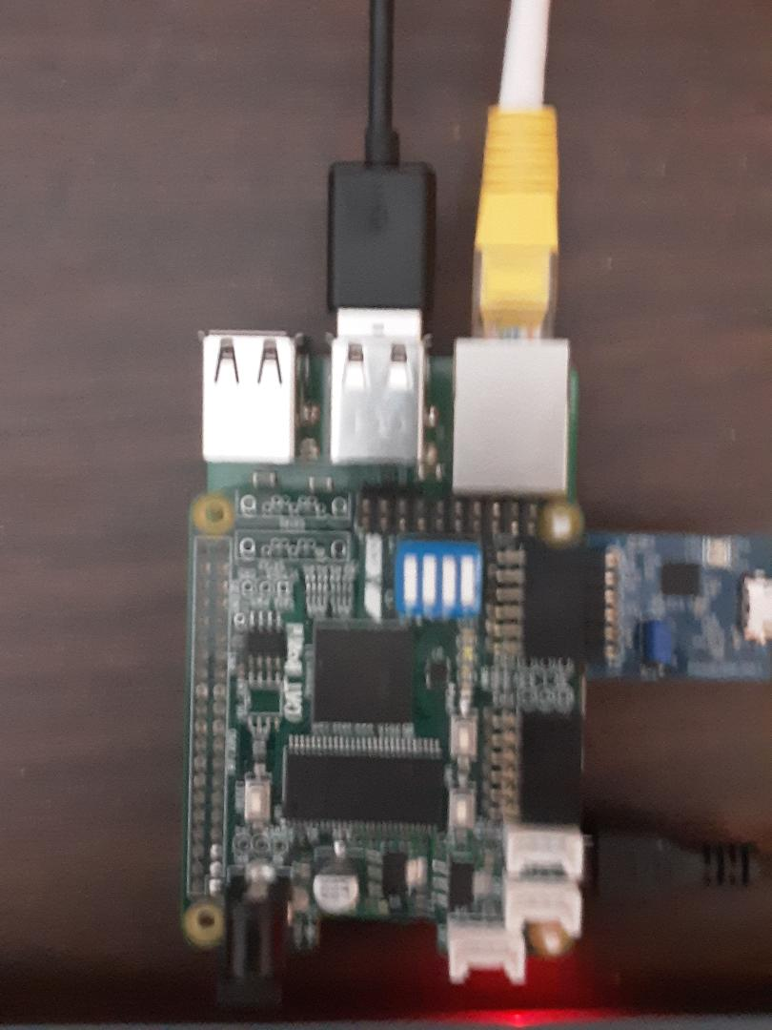

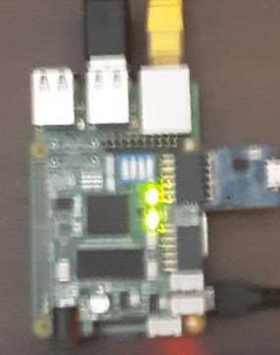
Leds 4 & 2 on.

