***********DRAFT***********
./jpeg tests HX8K
04/16/19
***********DRAFT***********

pi@mypi3-1:~/testbuilds/catzip/sw/board $ make clean ; make ; make jpeg.txt
1000058: 2a 03 00 80 LDI 0x0100f1fc,R5 // 100f1fc <ptrs>

pi@mypi3-1:~/testbuilds/catzip/sw/host $ ./arm-wbregs 0x00A01000 0x0
00a01000 ( )-> 00000000
pi@mypi3-1:~/testbuilds/catzip/sw/host $ ./arm-wbregs 0x00A01004 0x1
00a01004 ( )-> 00000001
pi@mypi3-1:~/testbuilds/catzip/sw/host $ ./arm-zipload -v ../board/jpeg
Halting the CPU
Memory regions:
Block RAM: 00a00000 - 00a02000
SDRAM : 01000000 - 02000000
Loading: ../board/jpeg
Section 0: 01000000 - 0104f26c
Writing to MEM: 01000000-0104f26c
Clearing the CPUs registers
Setting PC to 01000000
The CPU should be fully loaded, you may now
start it (from reset/reboot) with:
> wbregs cpu 0x0f

CPU Status is: 0000060f
pi@mypi3-1:~/testbuilds/catzip/sw/host $ ./arm-wrsdram rgb_pack.bin
The size of the buffer is 0x00ffff or 65535 words

READ-COMPLETE
pi@mypi3-1:~/testbuilds/catzip/sw/host $ ./arm-wbregs cpu 0x0f
02000000 ( )-> 0000000f

. ptrs.inpbuf = 0x100f1fc buf_red = 0x104f278
. fwd_inv = 0x10cf280
. x = 0xe22247c sp = 0xe2 z = 0xe200000
. x = 0xde22083 sp = 0xde z = 0xde00000
. x = 0xe221475 sp = 0xe2 z = 0xe200000
. x = 0xe32207b sp = 0xe3 z = 0xe300000
. x = 0xa812055 sp = 0xa8 z = 0xa800000
. x = 0xb210c4c sp = 0xb2 z = 0xb200000
. spliting red sub band
. fwd lifting step only
. w = 0x100 wptr = 0x104f278 alt = 0x108f278 fwd_inverse = 0x10cf280 fwd_inverse = 0x1
. starting red dwt
. ip = 0x104f278 tp = 0x108f278
. in lifting
. in singlelift
. in singlelift
. back from singlelift
. in lifting
. in singlelift
. in singlelift
. back from singlelift
. in lifting
. in singlelift
. in singlelift
. back from singlelift
. testing test_fwd
. finished ted dwt

pi@mypi3-1:~/testbuilds/catzip/sw/host $ rm -f dwt.bin ;./arm-rdsdram dwt.bin

Write-COMPLETE
The size of the buffer is 0x00ffff or 65535 words
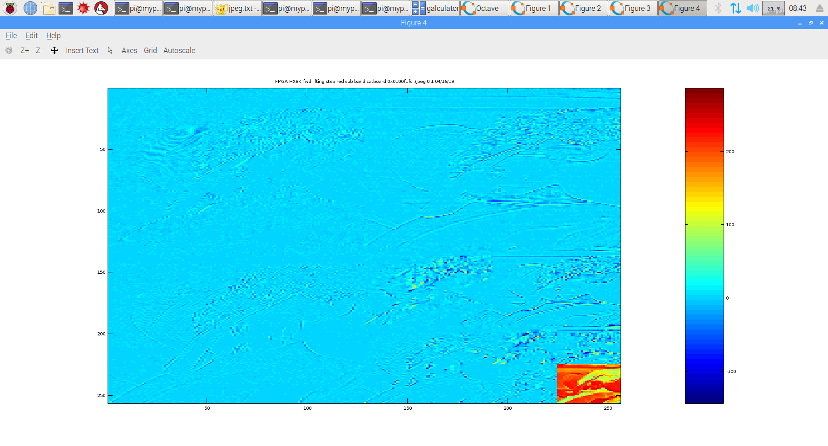
pi@mypi3-1:~/testbuilds/catzip/sw/host $ ./arm-wbregs 0x00A01000 0x1
00a01000 ( )-> 00000001
pi@mypi3-1:~/testbuilds/catzip/sw/host $ ./arm-wbregs 0x00A01004 0x1
00a01004 ( )-> 00000001
pi@mypi3-1:~/testbuilds/catzip/sw/host $ ./arm-zipload -v ../board/jpeg
Halting the CPU
Memory regions:
Block RAM: 00a00000 - 00a02000
SDRAM : 01000000 - 02000000
Loading: ../board/jpeg
Section 0: 01000000 - 0104f26c
Writing to MEM: 01000000-0104f26c
Clearing the CPUs registers
Setting PC to 01000000
The CPU should be fully loaded, you may now
start it (from reset/reboot) with:
> wbregs cpu 0x0f

CPU Status is: 0000060f
pi@mypi3-1:~/testbuilds/catzip/sw/host $ ./arm-wrsdram rgb_pack.bin
The size of the buffer is 0x00ffff or 65535 words

READ-COMPLETE
pi@mypi3-1:~/testbuilds/catzip/sw/host $ ./arm-wbregs cpu 0x0f
02000000 ( )-> 0000000f
. ptrs.inpbuf = 0x100f1fc buf_red = 0x104f278
. fwd_inv = 0x10cf280
. x = 0xe22247c sp = 0x224 z = 0x22400
. x = 0xde22083 sp = 0x220 z = 0x22000
. x = 0xe221475 sp = 0x214 z = 0x21400
. x = 0xe32207b sp = 0x220 z = 0x22000
. x = 0xa812055 sp = 0x120 z = 0x12000
. x = 0xb210c4c sp = 0x10c z = 0x10c00
. spliting green sub band
. fwd lifting step only
. w = 0x100 wptr = 0x104f278 alt = 0x108f278 fwd_inverse = 0x10cf280 fwd_inverse = 0x1
. starting red dwt
. ip = 0x104f278 tp = 0x108f278
. in lifting
. in singlelift
. in singlelift
. back from singlelift
. in lifting
. in singlelift
. in singlelift
. back from singlelift
. in lifting
. in singlelift
. in singlelift
. back from singlelift
. testing test_fwd
. finished ted dwt
pi@mypi3-1:~/testbuilds/catzip/sw/host $ rm -f dwt.bin ;./arm-rdsdram dwt.bin

Write-COMPLETE
The size of the buffer is 0x00ffff or 65535 words
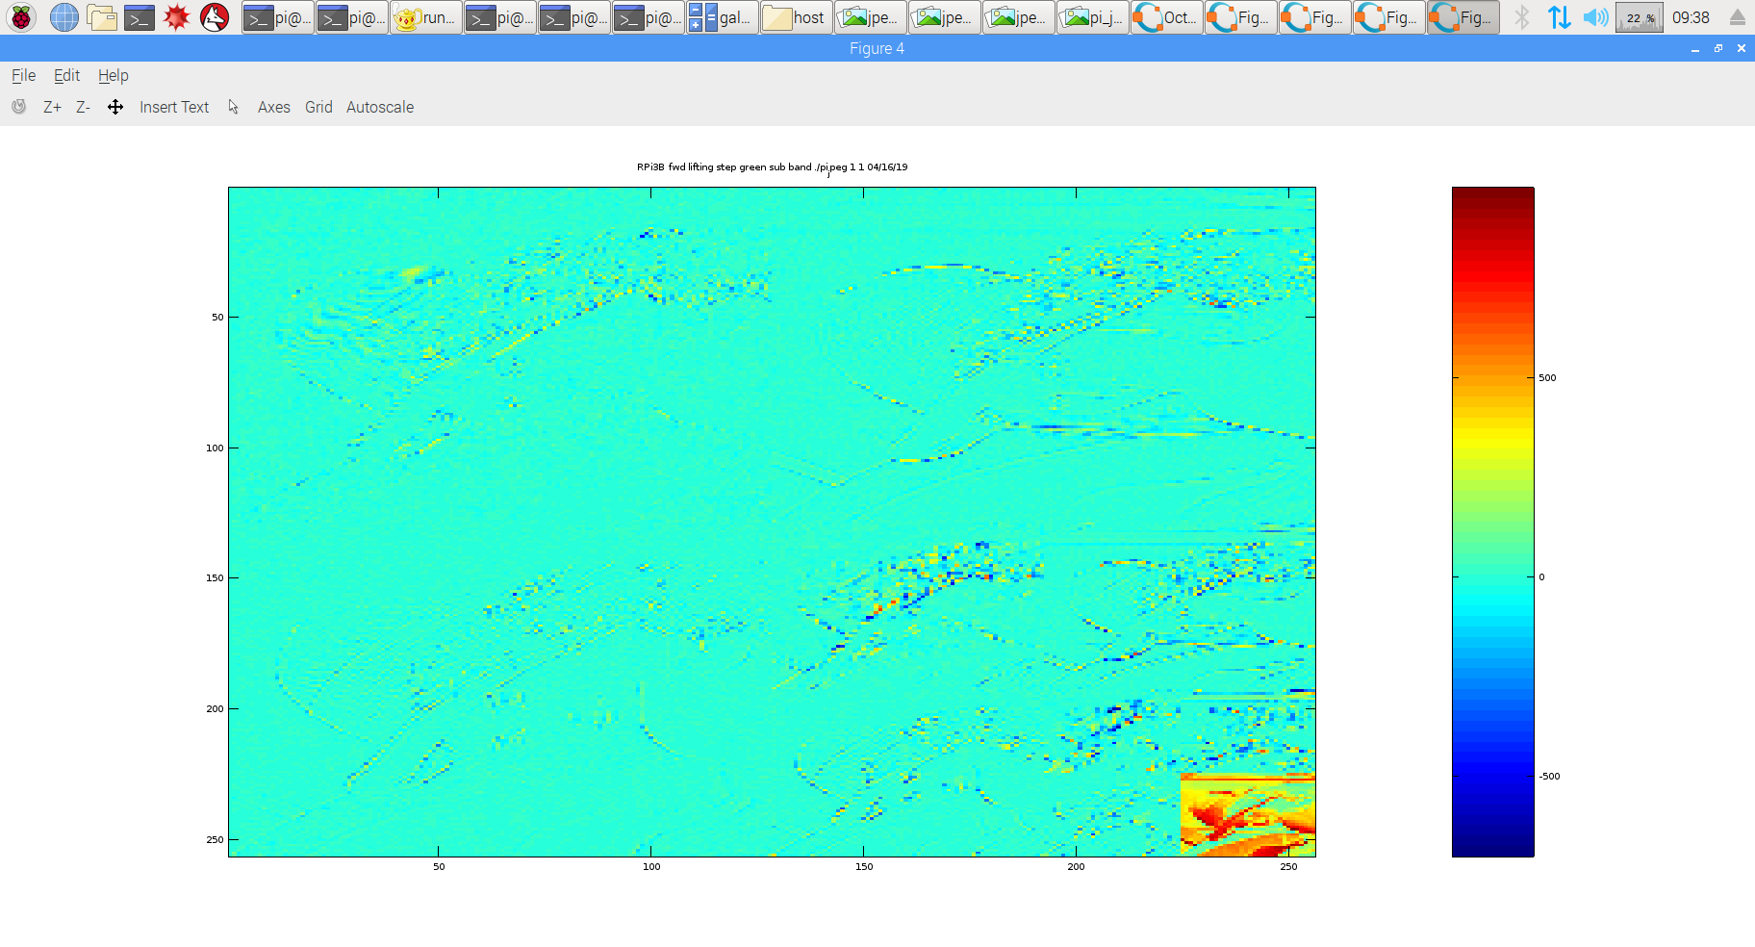

pi@mypi3-1:~/testbuilds/catzip/sw/host $ ./arm-wbregs 0x00A01000 0x2
00a01000 ( )-> 00000002
pi@mypi3-1:~/testbuilds/catzip/sw/host $ ./arm-wbregs 0x00A01004 0x1
00a01004 ( )-> 00000001
pi@mypi3-1:~/testbuilds/catzip/sw/host $ ./arm-zipload -v ../board/jpeg
Halting the CPU
Memory regions:
Block RAM: 00a00000 - 00a02000
SDRAM : 01000000 - 02000000
Loading: ../board/jpeg
Section 0: 01000000 - 0104f26c
Writing to MEM: 01000000-0104f26c
Clearing the CPUs registers
Setting PC to 01000000
The CPU should be fully loaded, you may now
start it (from reset/reboot) with:
> wbregs cpu 0x0f

CPU Status is: 0000060f
pi@mypi3-1:~/testbuilds/catzip/sw/host $ ./arm-wrsdram rgb_pack.bin
The size of the buffer is 0x00ffff or 65535 words

READ-COMPLETE
pi@mypi3-1:~/testbuilds/catzip/sw/host $ ./arm-wbregs cpu 0x0f
02000000 ( )-> 0000000f
. ptrs.inpbuf = 0x100f1fc buf_red = 0x104f278
. fwd_inv = 0x10cf280
. x = 0xe22247c sp = 0x7c z = 0x7c
. x = 0xde22083 sp = 0x83 z = 0x83
. x = 0xe221475 sp = 0x75 z = 0x75
. x = 0xe32207b sp = 0x7b z = 0x7b
. x = 0xa812055 sp = 0x55 z = 0x55
. x = 0xb210c4c sp = 0x4c z = 0x4c
. spliting blue sub band
. fwd lifting step only
. w = 0x100 wptr = 0x104f278 alt = 0x108f278 fwd_inverse = 0x10cf280 fwd_inverse = 0x1
. starting red dwt
. ip = 0x104f278 tp = 0x108f278
. in lifting
. in singlelift
. in singlelift
. back from singlelift
. in lifting
. in singlelift
. in singlelift
. back from singlelift
. in lifting
. in singlelift
. in singlelift
. back from singlelift
. testing test_fwd
. finished ted dwt
pi@mypi3-1:~/testbuilds/catzip/sw/host $ rm -f dwt.bin ;./arm-rdsdram dwt.bin

Write-COMPLETE
The size of the buffer is 0x00ffff or 65535 words

