***********DRAFT***********
./pi_jpeg tests Rpi3B+
04/16/19
***********DRAFT***********

To compile the code
pi@mypi3-1:~/testbuilds/catzip/sw/board $ ./buildpi_lift.sh
pi@mypi3-1:~/testbuilds/catzip/sw/board $ cp pi_jpeg ../host
/* First parameter is used to tell the program which sub band to use
* 0 Red
* 1 Green
* 2 Blue
* 2nd parameter is used to tell the program to compute the fwd lifting step only or fwd lifting then inv lifting step
* 0 fwd lifting then inv lifting step
* 1 fwd lifting step only
* ./pi_jpeg 0 1 or ./pi_jpeg 0 0
* ./pi_jpeg 1 1 or ./pi_jpeg 1 0
* ./pi_jpeg 2 1 or ./pi_jpeg 2 0
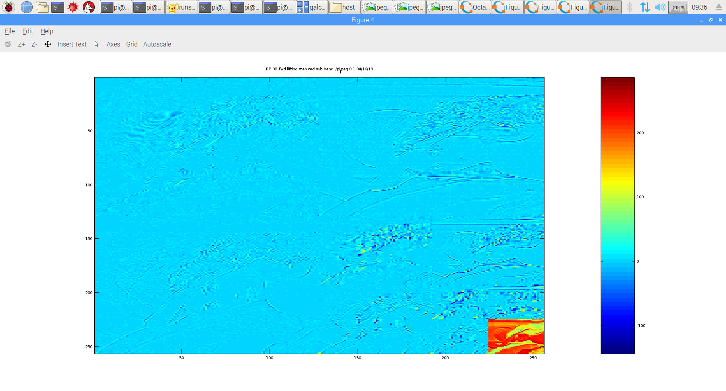
rm -f dwt.bin ; ./pi_jpeg 0 1
buf_red = 0x76d51008
fwd_inv = 0x1b72008
spliting red sub band
fwd lifting step only
x = 0xe22247c sp = 0xe2 z = 0xe200000
x = 0xde22083 sp = 0xde z = 0xde00000
x = 0xe221475 sp = 0xe2 z = 0xe200000
x = 0xe32207b sp = 0xe3 z = 0xe300000
x = 0xa812055 sp = 0xa8 z = 0xa800000
x = 0xb210c4c sp = 0xb2 z = 0xb200000
w = 0x100 buf_red wptr = 0x76d51008 alt = 0x76d91008 fwd_inverse = 0x1b72008 fwd_inverse = 0x1
starting red dwt
ip = 0x76d51008 tp = 0x76d91008
in lifting
in singlelift
in singlelift
back from singlelift
in lifting
in singlelift
in singlelift
back from singlelift
in lifting
in singlelift
in singlelift
back from singlelift
testing test_fwd
finished ted dwt
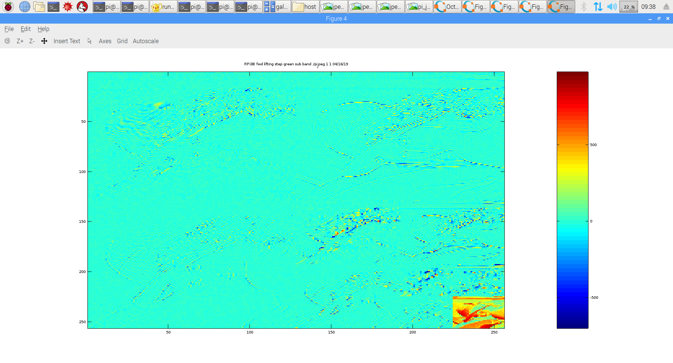
rm -f dwt.bin ; ./pi_jpeg 1 1
buf_red = 0x76d15008
fwd_inv = 0x124b008
spliting green sub band
fwd lifting step only
x = 0xe22247c sp = 0x224 z = 0x22400
x = 0xde22083 sp = 0x220 z = 0x22000
x = 0xe221475 sp = 0x214 z = 0x21400
x = 0xe32207b sp = 0x220 z = 0x22000
x = 0xa812055 sp = 0x120 z = 0x12000
x = 0xb210c4c sp = 0x10c z = 0x10c00
w = 0x100 buf_red wptr = 0x76d15008 alt = 0x76d55008 fwd_inverse = 0x124b008 fwd_inverse = 0x1
starting red dwt
ip = 0x76d15008 tp = 0x76d55008
in lifting
in singlelift
in singlelift
back from singlelift
in lifting
in singlelift
in singlelift
back from singlelift
in lifting
in singlelift
in singlelift
back from singlelift
testing test_fwd
finished ted dwt
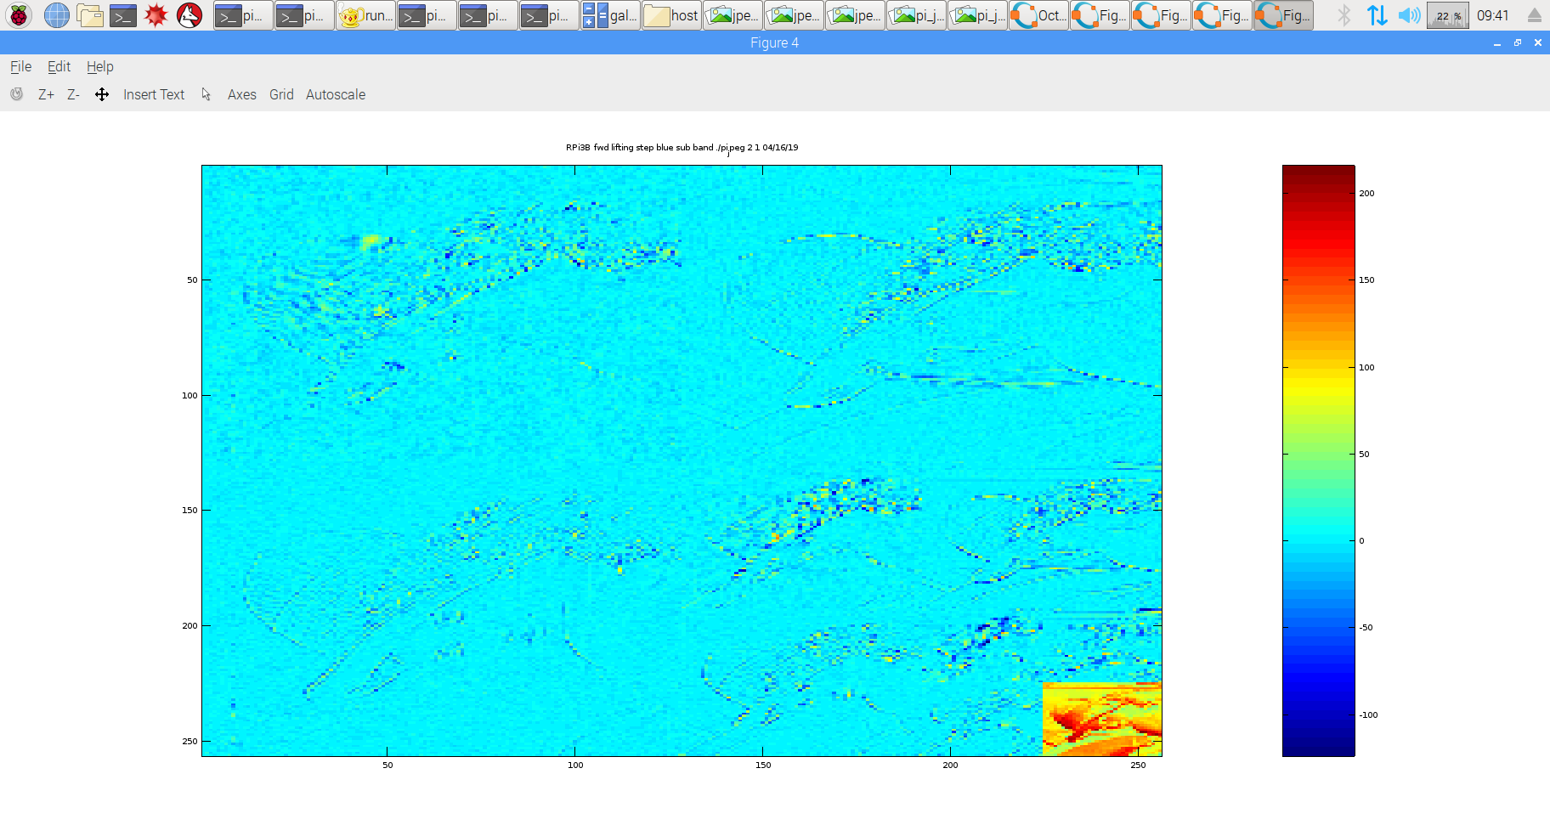
rm -f dwt.bin ; ./pi_jpeg 2 1
buf_red = 0x76d9d008
fwd_inv = 0xe64008
spliting blue sub band
fwd lifting step only
x = 0xe22247c sp = 0x7c z = 0x7c
x = 0xde22083 sp = 0x83 z = 0x83
x = 0xe221475 sp = 0x75 z = 0x75
x = 0xe32207b sp = 0x7b z = 0x7b
x = 0xa812055 sp = 0x55 z = 0x55
x = 0xb210c4c sp = 0x4c z = 0x4c
w = 0x100 buf_red wptr = 0x76d9d008 alt = 0x76ddd008 fwd_inverse = 0xe64008 fwd_inverse = 0x1
starting red dwt
ip = 0x76d9d008 tp = 0x76ddd008
in lifting
in singlelift
in singlelift
back from singlelift
in lifting
in singlelift
in singlelift
back from singlelift
in lifting
in singlelift
in singlelift
back from singlelift
testing test_fwd
finished ted dwt

