Catboard HX8K
11/28/19

Catboard mounted in Rpi3B+
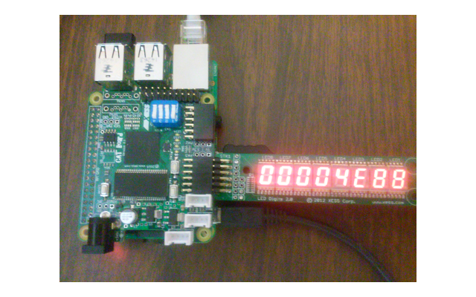

Raspbian Buster with desktop and recommended software
September 2019
Version:
2019-09-26
Release date:
4.19
Kernel version:
2541 MB
Size:

SHA-256:549da0fa9ed52a8d7c2d66cb06afac9fe856638b06d8f23df4e6b72e67ed4cea
devel@mypi3-16:~/Downloads $ ls -la 2019-09-26-raspbian-buster-full.zip
-rw-r--r-- 1 devel devel 2664314355 Nov 29 09:51 2019-09-26-raspbian-buster-full.zip
devel@mypi3-16:~/Downloads $ sha256sum 2019-09-26-raspbian-buster-full.zip
549da0fa9ed52a8d7c2d66cb06afac9fe856638b06d8f23df4e6b72e67ed4cea 2019-09-26-raspbian-buster-full.zip
gzip -dc 2019-06-20-raspbian-buster-full.zip | dd bs=4M status='progress' of=/dev/sda
5286559744 bytes (5.3 GB, 4.9 GiB) copied, 295 s, 17.9 MB/s
gzip: 2019-06-20-raspbian-buster-full.zip: invalid compressed data--length error

0+146238 records in
0+146238 records out
5289017344 bytes (5.3 GB, 4.9 GiB) copied, 302.261 s, 17.5 MB/s
Additonal software required is installed with “extra_pkgs.sh”.

#!/bin/bash
sudo apt-get update
sudo apt-get install octave vlc kicad hexchat \
ecryptfs-utils gawk gimp gtkwave iverilog clang \
samba samba-common-bin smbclient cifs-utils \
libftdi-dev libmpc-dev libmpfr-dev verilator bc mercurial \
libbison-dev libgmp-dev libelf-dev ncurses-dev ctags \
default-jdk libreadline-dev xdot graphviz minicom xpdf lrzsz \
libusb-1.0.0 exuberant-ctags gparted ffmpeg qt5-default \
mesa-utils libboost-all-dev freeglut3 freeglut3-dev \
python3-dev libgtk2.0-dev libcairo2-dev libpango1.0-dev \
libgdk-pixbuf2.0-dev libatk1.0-dev libghc-x11-dev binutils-arm-none-eabi \
gcc-arm-none-eabi diffuse gitk tcl-dev telnet tftp hexedit cmake flex bison \
gtkmm-3.0 gperf build-essential qt5-default nfs-kernel-server gpac

Change hostname in file “/etc/hostname”
< mypi3-16
---
> raspberrypi
Increase the swap space size in file “/etc/dphys-swapfile”
16c16
< CONF_SWAPSIZE=1000
---
> CONF_SWAPSIZE=100
Conterts of “/home/devel/.octaverc”
graphics_toolkit("gnuplot");
1.0 catzip

2.0 autofpga
https://github.com/develone/autofpga.git forked from https://github.com/ZipCPU/autofpga.git

commit 32f036a6fcc1b099b27e0202dd6cb63f29080a26 (HEAD -> master, origin/master, origin/HEAD)
Author: ZipCPU <dgisselq@ieee.org>
Date: Sat Jul 27 09:13:30 2019 -0400

Missing refs to peripherals that can create errors now do so

devel@mypi3-16:~/autofpga $ make

Create links in “/usr/local/bin”
lrwxrwxrwx 1 root root 32 Nov 28 10:59 autofpga -> /home/devel/autofpga/sw/autofpga

3.0 zipcpu
https://github.com/develone/zipcpu.git forked from
https://github.com/ZipCPU/zipcpu.githttps://github.com/ZipCPU/zipcpu.git

commit 006f4c6a0ace5a1e6badcc583520b57cc9212e33 (HEAD -> master, origin/master, origin/HEAD)
Author: ZipCPU <dgisselq@ieee.org>
Date: Mon Apr 1 14:52:50 2019 -0400

Updated interrupt controller, simplified cascades

1. Updated the interrupt controller to create atomic accesses to enable
particular interrupts without also enabling (or disabling) the master
interrupt enable.

2. Logic simplification within the CPU in an attempt to balance multiplexers,
using case statements instead of cascaded ifs

4.0 icestorm
https://github.com/develone/icestorm.git forked from https://github.com/cliffordwolf/icestorm.git
commit 8cac6c584044034210fe0ba1e6b930ff1cc59465 (HEAD, upstream/master, origin/master, origin/HEAD, master)
Author: Clifford Wolf <clifford@clifford.at>
Date: Mon Jul 30 16:04:04 2018 +0200

Also install text timing databases

Signed-off-by: Clifford Wolf <clifford@clifford.at>

5.0 yosys
https://github.com/develone/yosys.git forked from https://github.com/YosysHQ/yosys.git

commit e275692e84c935d0cdf42c2a4adf7ac949a88132 (HEAD -> master, upstream/master, origin/master, origin/HEAD)
Author: Clifford Wolf <clifford@clifford.at>
Date: Sun Jul 22 18:44:05 2018 +0200

Verific: Produce errors for instantiating unknown module

Because if the unknown module is connected to any constants, Verific will
actually break all constants in the same module, even if they have nothing
to do structurally with that instance of an unknown module.

Signed-off-by: Clifford Wolf <clifford@clifford.at>

6.0 nextpnr
https://github.com/develone/nextpnr.git forked from https://github.com/YosysHQ/nextpnr.git
commit 7d5dba3ad378563869657b4330c178ecd8c24931 (HEAD -> master, origin/master, origin/HEAD)
Author: Miodrag Milanovic <mmicko@gmail.com>
Date: Sat Aug 4 16:27:33 2018 +0200

compile fix

7.0 arachne-pnr
https://github.com/develone/arachne-pnr.git forked from https://github.com/YosysHQ/arachne-pnr.git

commit 5d830dd94ad956d17d77168fe7718f22f8b55b33 (HEAD -> master, upstream/master, origin/master, origin/HEAD)
Merge: 3a40328 9763e6e
Author: Clifford Wolf <clifford@clifford.at>
Date: Sun May 13 20:58:41 2018 +0200

Merge pull request #115 from awygle/lm

Add basic lm4k support (no hard IP)

8.0 catboard_yosys
https://github.com/develone/catboard_yosys.git
Create links in “/usr/local/bin”
lrwxrwxrwx 1 root root 37 Nov 29 08:15 config_cat -> /home/devel/catboard_yosys/config_cat

lrwxrwxrwx 1 root root 36 Nov 29 08:15 reset_cat -> /home/devel/catboard_yosys/reset_cat

9.0 verilator
http://git.veripool.org/git/verilator

commit c8e437c45cf0a9849e0a0465ecca882dbb66933a (HEAD, tag: verilator_3_926, tag: v3.926)
Author: Wilson Snyder <wsnyder@wsnyder.org>
Date: Wed Aug 22 18:09:06 2018 -0400

Version bump

devel@mypi3-16:~/testbuilds/catzip/sw/host $ sudo ./arm-netpport

Listening on port 8363
Listening on port 8364
The jpeg program is loaded in memory
The rgb_bin data is read into memory an split in a r b g images

. ptrs.inpbuf = 0x100f120 buf_red = 0x104f198
. fwd_inv = 0x10cf1a0
. x = 0xe22247c sp = 0x7c z = 0x7c
. x = 0xde22083 sp = 0x83 z = 0x83
. x = 0xe221475 sp = 0x75 z = 0x75
. x = 0xe32207b sp = 0x7b z = 0x7b
. x = 0xa812055 sp = 0x55 z = 0x55
. x = 0xb210c4c sp = 0x4c z = 0x4c
. spliting blue sub band
. fwd lifting step only
. w = 0x100 wptr = 0x104f198 alt = 0x108f198 fwd_inverse = 0x10cf1a0 fwd_inver. = 0x1
. starting red dwt
. in singlelift
. in singlelift
. in singlelift
. in singlelift
. in singlelift
. in singlelift
. testing test_fwd
. finished ted dwt
devel@mypi3-16:~/testbuilds/catzip/sw/host $ ./runjpeg.sh
devel@mypi3-16:~/testbuilds/catzip/sw/host $ ./runjpeg.sh
00a01000 ( )-> 00000002
00a01004 ( )-> 00000001
Halting the CPU
Memory regions:
Block RAM: 00a00000 - 00a02000
SDRAM : 01000000 - 02000000
Loading: ../board/jpeg
Section 0: 01000000 - 0104f190
Writing to MEM: 01000000-0104f190
Clearing the CPUs registers
Setting PC to 01000000
The CPU should be fully loaded, you may now
start it (from reset/reboot) with:
> wbregs cpu 0x0f

CPU Status is: 0000060f
The size of the buffer is 0x00ffff or 65535 words

READ-COMPLETE
02000000 ( )-> 0000000f

Write-COMPLETE
The size of the buffer is 0x00ffff or 65535 words
devel@mypi3-16:~/testbuilds/catzip/sw/host $ octave

red image

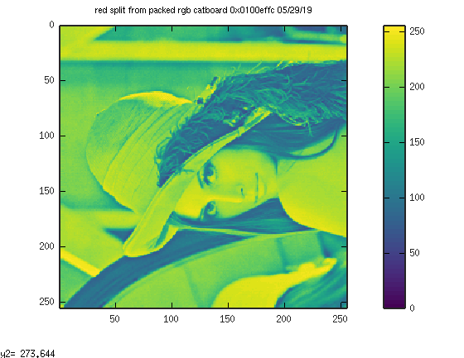

green image
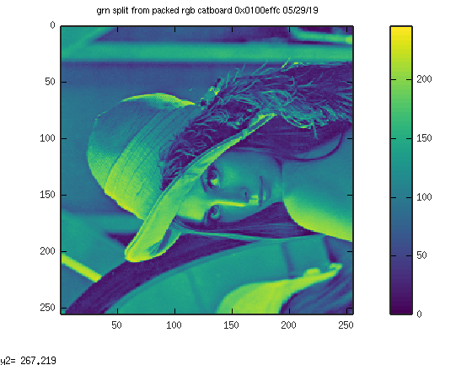

blue image

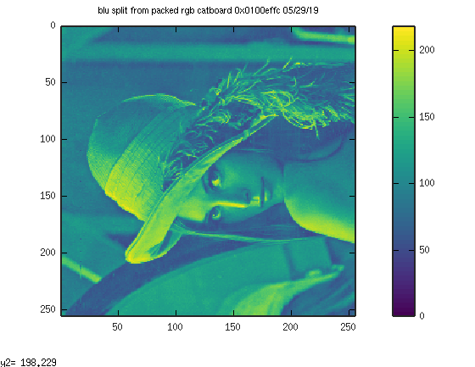

dwt image
