20021f4: 32 00 00 40 LDI 0x02003e14,R6 // 2003e14 <testlist>
20021f8: 32 40 3e 14
20021fc: 0b 41 80 00 MOV R6,R1
2002200: 13 41 80 80 MOV $128+R6,R2
2002204: 06 7f ff ff LDI $-1,R0
2002208: 04 c4 40 00 SW R0,(R1)
200220c: 08 80 00 04 ADD $4,R1
2002210: 14 04 40 00 CMP R1,R2
2002214: 78 ab ff ec BNZ @0x02002204 // 2002204 <entry+0x30>
2002218: 0a 00 02 00 BREV $512,R1
200221c: 02 03 ff fe BREV $-2,R0
2002220: 04 c4 40 00 SW R0,(R1)
2002224: 0a 00 00 40 LDI 0x02003d78,R1 // 2003d78 <entry+0x1ba4>
2002228: 0a 40 3d 78
200222c: 03 43 c0 01 JSR 0x02001120 // 2001120 <txstr>

r1r2

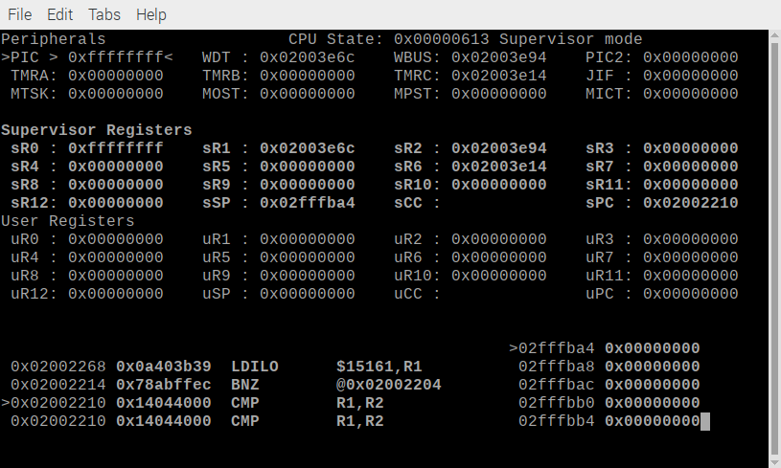
r11r2a

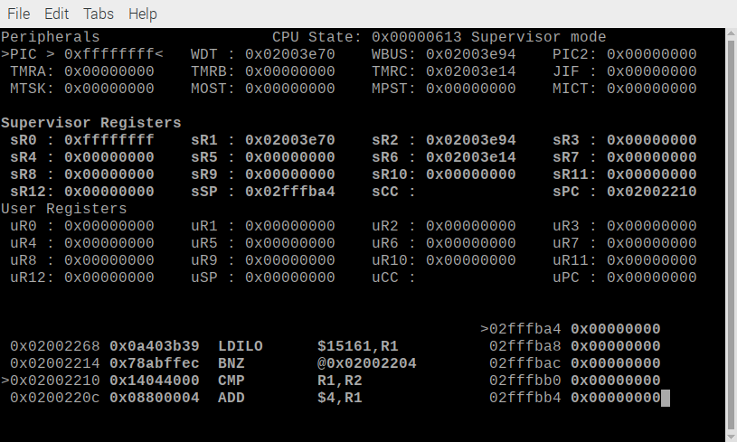
r1r2f

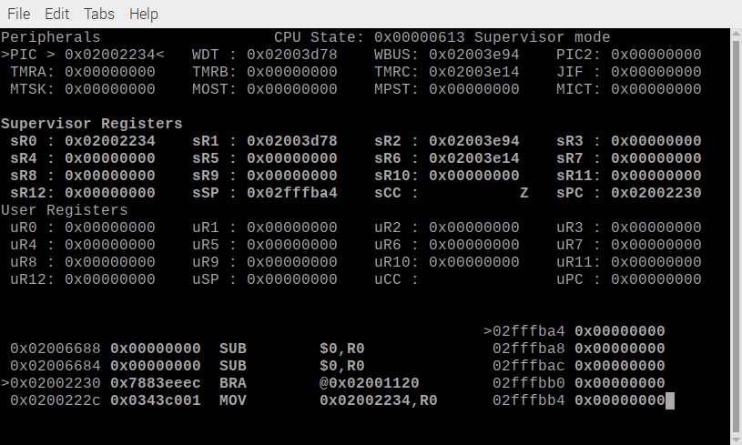
r1r2b

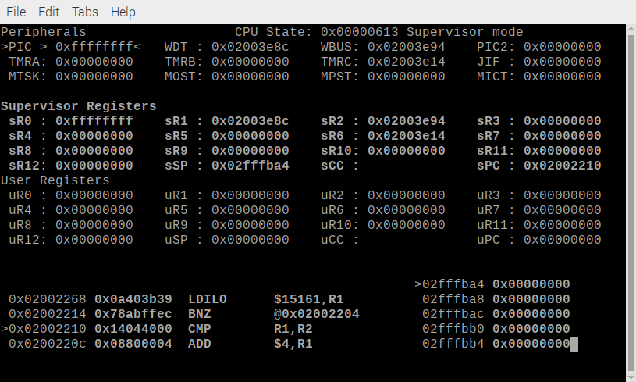

r1r2c

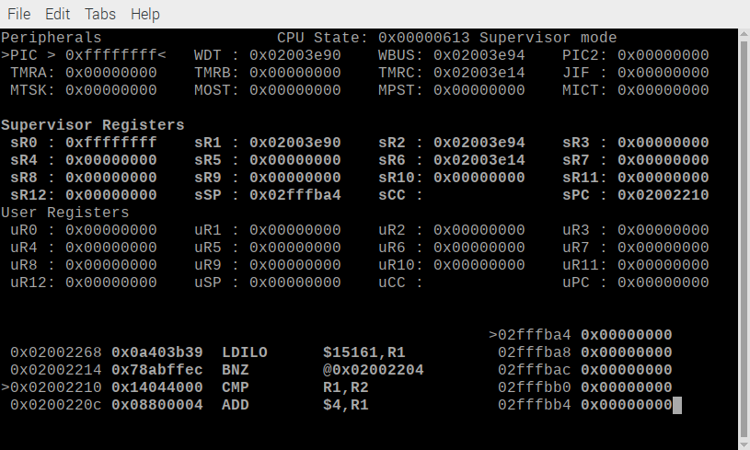
r1r2d

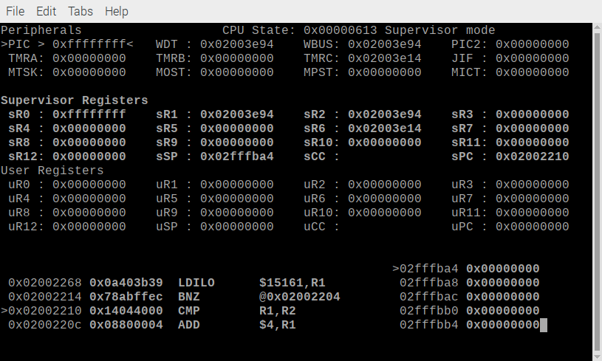
r1r2e

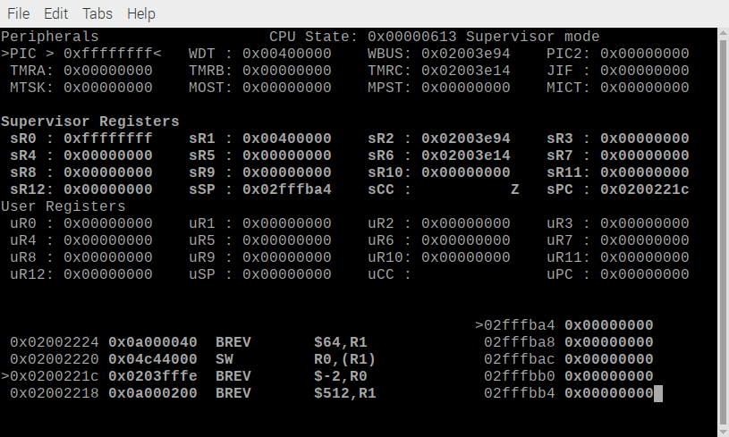
r1r2f

r1r2g

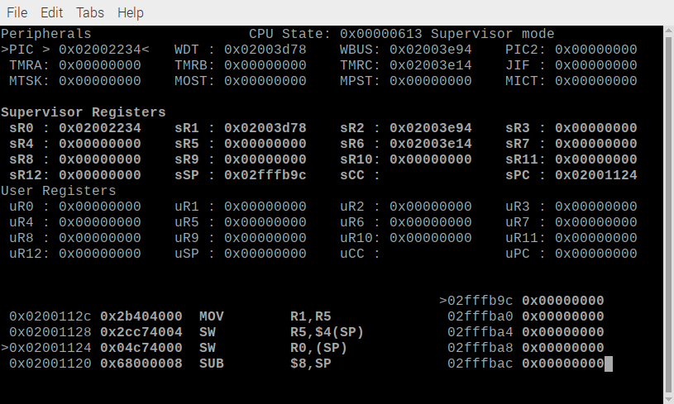
r1r2h

