This is an attempt at trying to understand why cputest and jpeg fail in hardware on mypi3-21. Several software packages aree needed (autofpga, icestorm, nextpnr, yoysys, zipcpu, and verilator).
Additional Verilog (wbxbar, skidbuffer.v, and addrdecode.v) files were needed with autofpga ver 08/14/20.

On tb3-20 ver 20210419 & tb3-16 ver 20200702 show same results with jpeg.

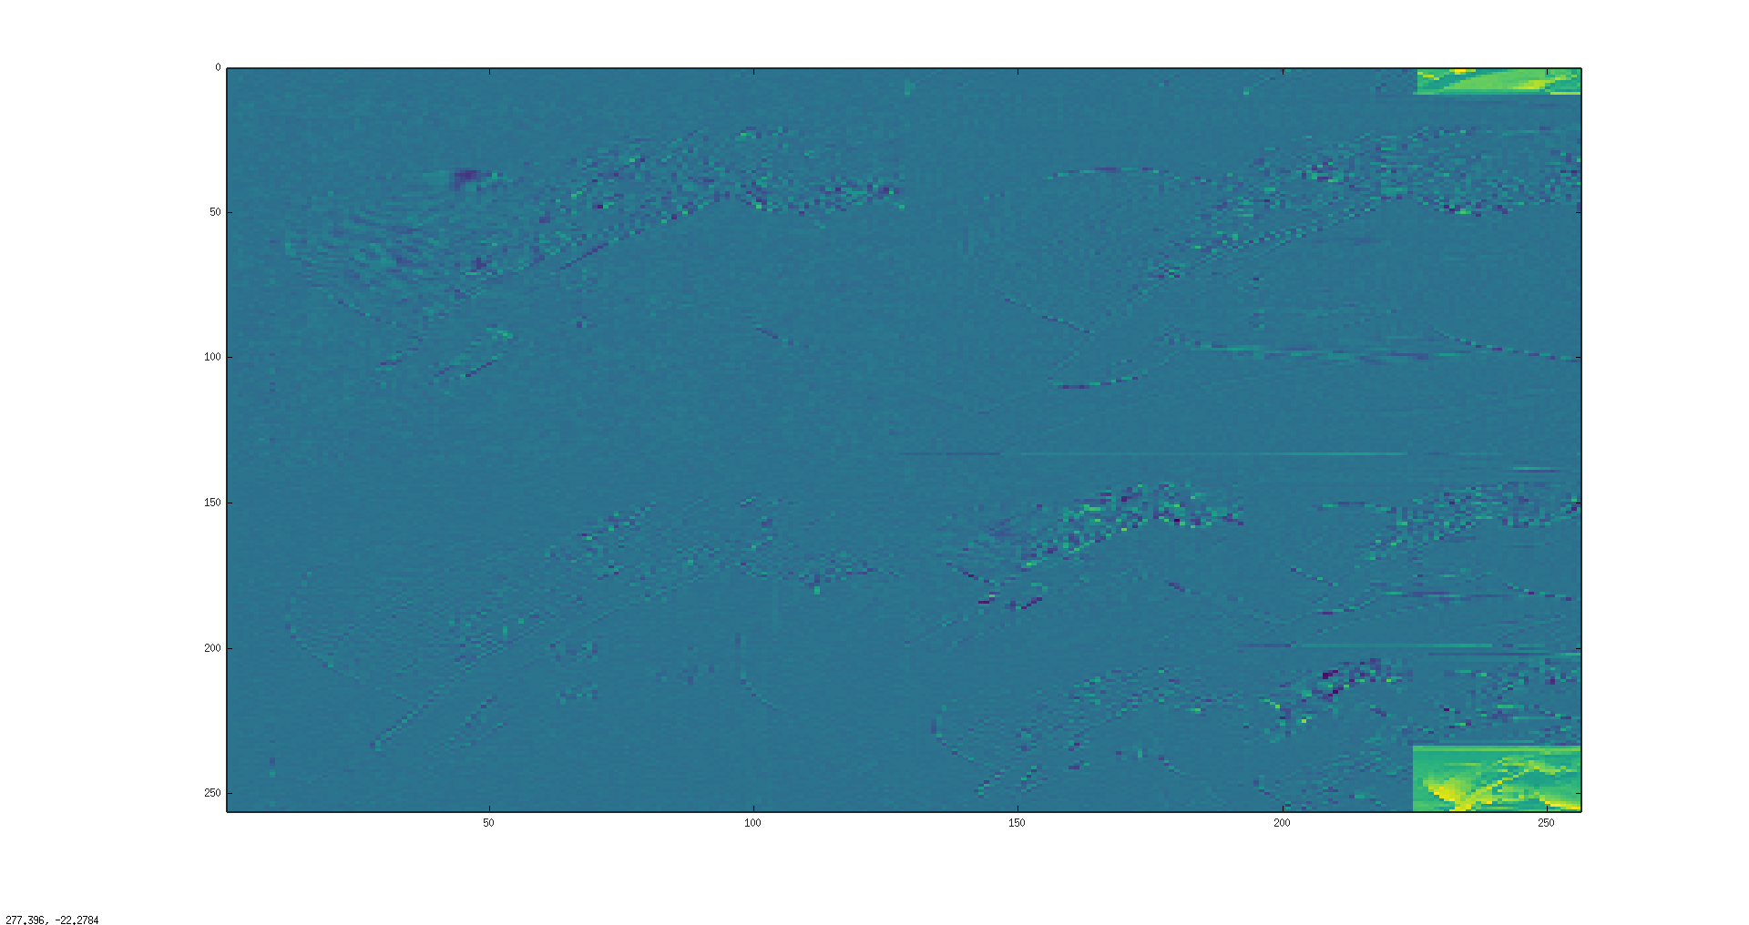
octave:3> im4(1:10,1:1)
ans =

237118588
232923267
237114485
238166139
236071034
237115516
235018352
233970337
230821997
0
octave:5 im4(1:10,1:1)=0;
octave:6> imagesc(im4)

Additonal notes are found in fpgatools-upgrade-mypi3-18.txt & fpgatools-upgrade-mypi3-20.txt.

Testing upgrading yosys which does not work. Testing upgrading nextpnr.

upgrade yosys & dn-grading autofpga

devel@mypi3-20:~ $ mv yosys/ yosys-pre
devel@mypi3-20:~ $ sudo unsquashfs -d yosys /media/devel/1b763776-4e1d-499c-9f24-a116a58c161f/fpgatools/testing03021/yosys033021_0ccc722.img
[sudo] password for devel:
Parallel unsquashfs: Using 4 processors
6720 inodes (14490 blocks) to write

[===========================================================|] 14490/14490 100%

created 6720 files
created 412 directories
created 0 symlinks
created 0 devices
created 0 fifos
devel@mypi3-20:~ $ cd yosys
devel@mypi3-20:~/yosys $ sudo make install
[Makefile.conf] CONFIG := gcc
mkdir -p /usr/local/bin
cp yosys yosys-config yosys-abc yosys-filterlib yosys-smtbmc /usr/local/bin
strip -S /usr/local/bin/yosys
strip /usr/local/bin/yosys-abc
strip /usr/local/bin/yosys-filterlib
mkdir -p /usr/local/share/yosys
cp -r share/. /usr/local/share/yosys/.

downgrading autofpga
devel@mypi3-20:~ $ mv autofpga autofpga-upgraded
devel@mypi3-20:~ $ cp -R autofpga033021/ autofpga

devel@mypi3-20:~/autofpga $ ls -la /usr/local/bin/autofpga
lrwxrwxrwx 1 root root 32 Jun 17 2020 /usr/local/bin/autofpga -> /home/devel/autofpga/sw/autofpga

verilator -Wno-TIMESCALEMOD -O3 -Mdir ./obj-arm -trace -cc -y cpu -y ../hexbus -y ../pport main.v
cd ./obj-arm; make -f Vmain.mk
/usr/bin/perl /usr/local/share/verilator/bin/verilator_includer -DVL_INCLUDE_OPT=include Vmain.cpp Vmain__Dpi.cpp Vmain__Trace.cpp Vmain__Slow.cpp Vmain__Syms.cpp Vmain__Trace__Slow.cpp > Vmain__ALL.cpp
g++ -I. -MMD -I/usr/local/share/verilator/include -I/usr/local/share/verilator/include/vltstd -DVM_COVERAGE=0 -DVM_SC=0 -DVM_TRACE=1 -faligned-new -fcf-protection=none -Wno-bool-operation -Wno-sign-compare -Wno-uninitialized -Wno-unused-but-set-variable -Wno-unused-parameter -Wno-unused-variable -Wno-shadow -std=gnu++14 -Os -c -o Vmain__ALL.o Vmain__ALL.cpp
Archive ar -cr Vmain__ALL.a Vmain__ALL.o
yosys -ql simple.log -p synth_ice40 -blif catzip.blif -json catzip.json -top toplevel ...
Warning: reg '\txf_wb_write' is assigned in a continuous assignment at ../hexbus/console.v:301.10-301.39.
Warning: reg '\txf_wb_data' is assigned in a continuous assignment at ../hexbus/console.v:302.10-302.38.
ERROR: Cell port main.genbus.o_wb_sel is driving constant bits: \hb_sel <= \genbus.o_wb_sel
make[2]: *** [Makefile:108: catzip.blif] Error 1
make[1]: *** [Makefile:68: catzip] Error 2
make: *** [Makefile:156: rtl] Error 2

devel@mypi3-20:~/testbuilds/catzip $ git diff rtl/catzip/Makefile
diff --git a/rtl/catzip/Makefile b/rtl/catzip/Makefile
index 1102df7..a38dfa5 100644
--- a/rtl/catzip/Makefile
+++ b/rtl/catzip/Makefile
@@ -68,7 +68,7 @@ verilated: $(VDIRFB)/Vmain__ALL.a
$(VDIRFB)/Vmain.cpp: $(VDIRFB)/Vmain.h
$(VDIRFB)/Vmain.mk: $(VDIRFB)/Vmain.h
$(VDIRFB)/Vmain.h: main.v $(VFLIST)
- verilator -Wno-TIMESCALEMOD -O3 -Mdir $(VDIRFB) -trace -cc $(AUTOVDIRS) main.v
+ verilator -Wall -Wno-TIMESCALEMOD -O3 -Mdir $(VDIRFB) -trace -cc $(AUTOVDIRS) main.v

cpudefs.h: cpu/cpudefs.v
@echo "Building cpudefs.h"

dn-grading yosys & dn-grading autofpga

devel@mypi3-20:~ $ mv yosys yosys-upgraded
devel@mypi3-20:~ $ cp -R yosys-pre/ yosys
devel@mypi3-20:~ $ cd yosys
devel@mypi3-20:~/yosys $ sudo make install
[ 0%] Building kernel/driver.o
[ 1%] Building kernel/register.o
[ 1%] Building kernel/log.o
[ 2%] Building kernel/calc.o
[ 7%] Building libs/ezsat/ezminisat.o

[ 77%] Building backends/smv/smv.o
[ 77%] Building backends/blif/blif.o
[ 78%] Building backends/smt2/smt2.o
[ 78%] Building backends/spice/spice.o
[100%] Building yosys
[100%] Building yosys-abc

mkdir -p /usr/local/bin
cp yosys yosys-config yosys-abc yosys-filterlib yosys-smtbmc /usr/local/bin
strip -S /usr/local/bin/yosys
strip /usr/local/bin/yosys-abc
strip /usr/local/bin/yosys-filterlib
mkdir -p /usr/local/share/yosys
cp -r share/. /usr/local/share/yosys/.

devel@mypi3-20:~/yosys $ yosys -V
Yosys 0.9+1706 (git sha1 7cc9d487, clang 7.0.1-8+rpi3+deb10u2 -fPIC -Os)

devel@mypi3-20:~/testbuilds/catzip $ git checkout rtl/catzip/Makefile
devel@mypi3-20:~/testbuilds/catzip $ make clean; make

upgrading nextpnr

sudo mv nextpnr nextpnr-pre

devel@mypi3-20:~ $ sudo unsquashfs -d nextpnr /media/devel/1b763776-4e1d-499c-9f24-a116a58c161f/fpgatools/testing03021/nextpnr032621_4419c36.img

cd nextpnr

sudo make install

devel@mypi3-20:~/testbuilds/catzip $ nextpnr-ice40 -V
nextpnr-ice40 -- Next Generation Place and Route (Version 4419c36d)

devel@mypi3-20:~/nextpnr $ git log
commit 4419c36db5556d2a7f600517d6a4b5673067579d (HEAD -> master, upstream/master)
Merge: 0e9a1abc d0bc033a
Author: gatecat <gatecat@ds0.me>
Date: Fri Mar 26 18:39:18 2021 +0000

testing testbuilds/tb3-20b
devel@mypi3-20:~/testbuilds $ rsync -avl --delete catzip mypi3-21:~/testbuilds/tb3-20b/

devel@mypi3-21:~/testbuilds/tb3-20b/catzip/sw/host $ sudo config_cat ../../rtl/catzip/catzip.bin

devel@mypi3-21:~/testbuilds/tb3-20b/catzip/sw/host $ sudo ./arm-netpport
Listening on port 8363
Listening on port 8364

devel@mypi3-21:~/testbuilds/tb3-20b/catzip/sw/host $ ./arm-zipload -v ../board/cputest

Halting the CPU
Memory regions:
Block RAM: 00a00000 - 00a02000
SDRAM : 01000000 - 02000000
Loading: ../board/cputest
Section 0: 01000000 - 01003e94
Writing to MEM: 01000000-01003e94
Clearing the CPUs registers
Setting PC to 01000000
The CPU should be fully loaded, you may now
start it (from reset/reboot) with:
> wbregs cpu 0x0f

CPU Status is: 0000060f

devel@mypi3-21:~/testbuilds/tb3-20b/catzip/sw/host $ ./arm-wbregs cpu 0x0f
02000000 ( )-> 0000000f

. Running CPU self-test
. -----------------------------------
. SIM Instructions Pass
. CIS Instructions Supported
. Break test #1 Pass
. Break test #2 Pass
. Break test #3 Pass
. Early Branch test Pass
. Trap test/AND Pass
. Trap test/CLR Pass
. Overflow test Pass
. Carry test Pass
. Loop test Pass
. Shift test Pass
. Pipeline test Pass
. Mem-Pipeline test Pass
. Conditional Execution test Pass
. No-waiting pipeline test Pass
. Conditional Branching test Pass
. Ill Instruction test, NULL PC Pass
. Ill Instruction test, two Pass
. Comparison test, == Pass
. Comparison test, != Pass
. CC Register test Pass
. Multi-Arg test Pass
. Multiply test Pass
. Multiply HI-word test Pass
. Divide test Pass
.
. -----------------------------------
. All tests passed. Halting CPU.

devel@mypi3-21:~/testbuilds/tb3-20b/catzip/sw/host $ ./arm-wbregs version
00800010 ( VERSION) : [.!..] 20210420
FPGA was interrupted

devel@mypi3-21:~/testbuilds/tb3-20b/catzip/sw/host $ ./runjpeg.sh
00a01000 ( )-> 00000002
00a01004 ( )-> 00000001
Halting the CPU
Memory regions:
Block RAM: 00a00000 - 00a02000
SDRAM : 01000000 - 02000000
Loading: ../board/jpeg
Section 0: 01000000 - 0104f1b4
Writing to MEM: 01000000-0104f1b4
Clearing the CPUs registers
Setting PC to 01000000
The CPU should be fully loaded, you may now
start it (from reset/reboot) with:
> wbregs cpu 0x0f

CPU Status is: 0000060f
The size of the buffer is 0x010000 or 65536 words

READ-COMPLETE
02000000 ( )-> 0000000f

Write-COMPLETE
The size of the buffer is 0x010000 or 65536 words

. ptrs.inpbuf = 0x100f144 buf_red = 0xdd20c80
. fwd_inv = 0xdda0c88
. x = 0xde22c76 sp = 0x76 z = 0x76
. x = 0xdf2006a sp = 0x6a z = 0x6a
. x = 0xde20c69 sp = 0x69 z = 0x69
. x = 0xdb2106f sp = 0x6f z = 0x6f
. x = 0x0 sp = 0x0 z = 0x0
. x = 0x0 sp = 0x0 z = 0x0
. spliting blue sub band
. fwd lifting step only
. w = 0x100 wptr = 0xdd20c80 alt = 0xdd60c80 fwd_inverse = 0xdda0c88 fwd_inver. = 0x1
. starting red dwt
. in singlelift
. in singlelift
. in singlelift
. in singlelift
. in singlelift
. in singlelift
. testing test_fwd
. finished ted dwt

devel@mypi3-21:~/testbuilds/tb3-20b/catzip/sw/host $ octave
libEGL warning: DRI3: failed to query the version
libEGL warning: DRI2: failed to authenticate
GNU Octave, version 4.4.1
Copyright (C) 2018 John W. Eaton and others.
This is free software; see the source code for copying conditions.
There is ABSOLUTELY NO WARRANTY; not even for MERCHANTABILITY or
FITNESS FOR A PARTICULAR PURPOSE. For details, type 'warranty'.

Octave was configured for "arm-unknown-linux-gnueabihf".

Additional information about Octave is available at https://www.octave.org.

Please contribute if you find this software useful.
For more information, visit https://www.octave.org/get-involved.html

Read https://www.octave.org/bugs.html to learn how to submit bug reports.
For information about changes from previous versions, type 'news'.

octave:1> rgb
octave:2> im4(1:10,1:1)
ans =

237118588
232923267
237114485
238166139
236071034
237115516
235018352
233970337
230821997
0
octave:3> im4(1:10,1:1)=0;
octave:4> imagesc(im4)
nextpnr upgrades ok

